ASSIGNMENT 03A – Structural Study – Step 1

DUE DATE: TUESDAY MAY 5, 2020 8:30AM

In this assignment you will use the Readings in your Ching book, Building Construction Illustrated to complete the sketches and structural information below:
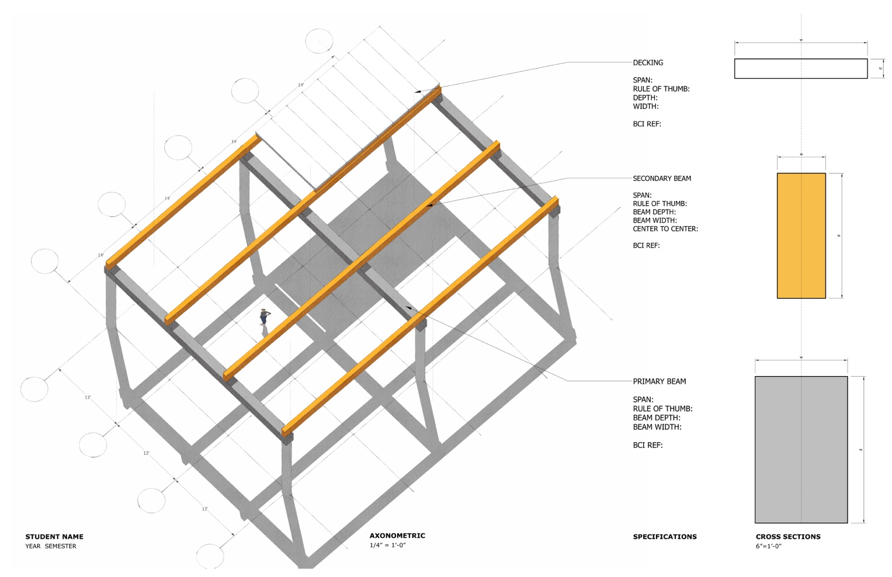
Using the above mock-up from this Module as a reference, make the following sketches and notes for each material -- Concrete, Steel, and Wood –

- Draw a 3-d sketch of each component – Primary Beam, Secondary Beam, Decking.
- Write the dimension choices, span range, and the rule of thumb for each component.

You will find the information you need to complete this assignment from the drawings, diagrams, dimension information, and rules of thumb in these Ching pages:

Reading #6 Structural Systems Building Construction Illustrated
Concrete:
Reinforced Concrete 4.04-4.07
Precast Concrete 4.11-4.13
Concrete Columns 5.04-5.05
Steel:
Steel Framing, Beams 4.14-4.18
Steel Decking 4.22
Steel Columns, Framing 5.35-5.38
Wood:
Wood Horizontal Struct 4.26-4.40
Wood Columns + Framing 5.47-5.49

