Gavin Chetram
CDMG 1111
Maya Koenig
Everything is Design
Paul Rand is one of the most influential designers of his time. His work is still inspirational today. It is because of him that companies started to see the importance of using good design. He has been an inspiration to me after visiting an exhibit dedicated to him at The Museum of the City of New York. After some research I found that Paul Rand and I share some similarities.
Paul Rand is a graphic designer most famous for his IBM logo design amongst other works. Paul Rand was born in Brooklyn on August 15, 1914 as Peretz Rosenbaum. At an early age Rand used to help his father paint signs for his grocery store but his father believed that art would not provide him with a suitable career. Rand studied at Pratt Institute, the Parsons School of Design, and the Art Students League. Rand taught design at Yale University and was in the New York Art Directors Club Hall of Fame in 1972 (paul-rand.com)
Rand started his career creating images for a syndicate that provided graphics for newspapers and magazines. At that time his work was inspired by the German advertising style Sachplakat (Fig 1) and Gustav Jensen. During this time he decided to change his name from Peretz Rosenbaum to his current name. He shortened his first name to Paul and got Rand from his uncle. He decided to change his name to create a brand for himself. Rand’s early work involved page design and he did such a good job with the Apparel Arts magazine anniversary issue that it got him a job offer as art director for the Esquire-Coronet magazines. He declined the offer because he felt his skills were not good enough but eventually took the job a year later. In 1956, Rand worked on the IBM logo and created its striped version in 1972 (Fig. 2). Rand also worked with Steve Jobs and created the NeXT Computer logo for him (Fig. 3). Jobs loved his work so much that he said he was “the greatest living graphic designer” (paul-rand.com).
Like Paul Rand, I also grew up in Brooklyn. From an early age I wanted a career in design that involved art. Much like Rand’s father, my parents also believed that an art career would not be financially beneficial for me. My father wanted me to follow in his footsteps in managing his properties. Like Rand, I also helped my father with making signs for his business. Even though our parents disagreed with our career choices we still went to school for design. Paul Rand felt that he was self-taught and that design school was not much help for him. I also taught myself skills and techniques I use for my assignments and projects that had not been taught to me by my professors.
At the time, Paul Rand’s style was unique and never been seen before, “He merged text with images, photographs and line-drawings, collages and artwork. Even his own handwriting for the look and feel of what he called ‘Friendliness,’ (everything is design). His work has inspired me because of its simplicity. He is a pioneer of the design world because “He almost singlehandedly convinced business that design was an effective tool. Anyone designing in the 1950s and 1960s owed much to Rand, who largely made it possible for us to work. He more than anyone else made the profession reputable. We went from being commercial artists to being graphic designers largely on his merits” (paul-rand.com). His use of color and repetition fascinates me. When working on a design I prefer to go with a simpler one than something more complex.
Paul Rand had a very influential career in design. His work with IBM, ABC, UPS, and Westinghouse’s corporate identities are still being used today (Fig. 4). He made businesses see the importance of using good design with his visually appealing logos and design. Rand’s style of design was ahead of its time. Both Rand and I knew we wanted a career in design from an early age even though both our parents did not want that kind of career for us. Regardless of what our parents wanted we both went to design school anyway. Although attending design we both had to teach ourselves the skills we needed for design. His work inspired my simple designs. His modernist designs from the 1950s and 1960s are still going to continue to inspire.

Figure References
Fig 1
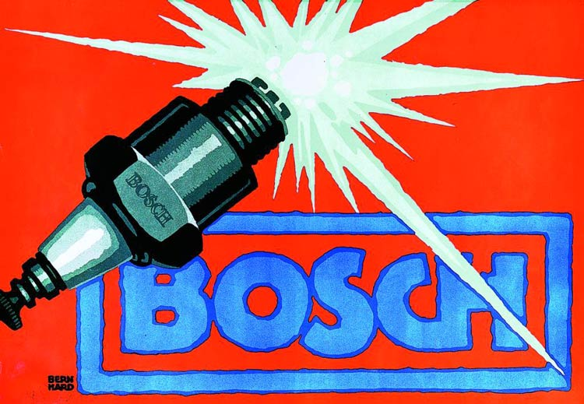
Designhistory.com

Fig 2
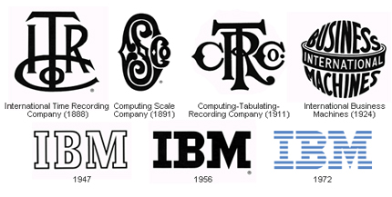

famouslogos.us

Fig. 3
logodesignlove.com

Fig. 4
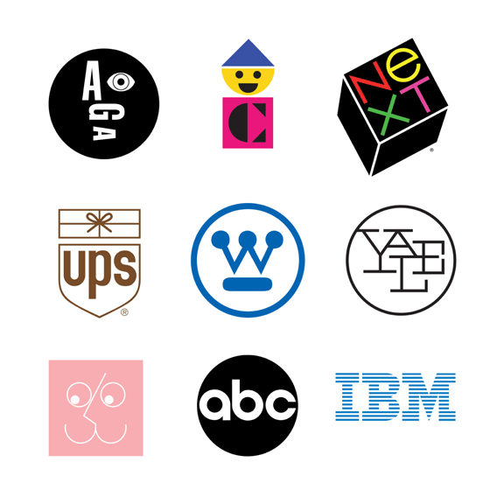
artsatl.com

Works Cited
"Everything Is Design: The Work of Paul Rand at The Museum of the City of New York."
Untapped Cities RSS. N.p., 26 Feb. 2015. Web. 18 Apr. 2016.
<http://untappedcities.com/2015/02/26/everything-is-design-the-work-of-paul-rand-at-
the-museum-of-the-city-of-new-york/>.
Paul-Rand.com. Biography. Ed. Daniel Lewandowski. N.p., 11 Apr. 2007. Web. 18 Apr.
2016. <http://www.paul-rand.com/foundation/biography/>.

