Gabriel Celik
Professor Tonya Goetz
COMD 1112 E080
December 20, 2022
The Grey Area Between Black and White
The name Virgil Abloh may not sound familiar to you, but if you know some of the projects he has undertaken, then you can understand how he arguably is one of the most influential fashion designers of our generation.
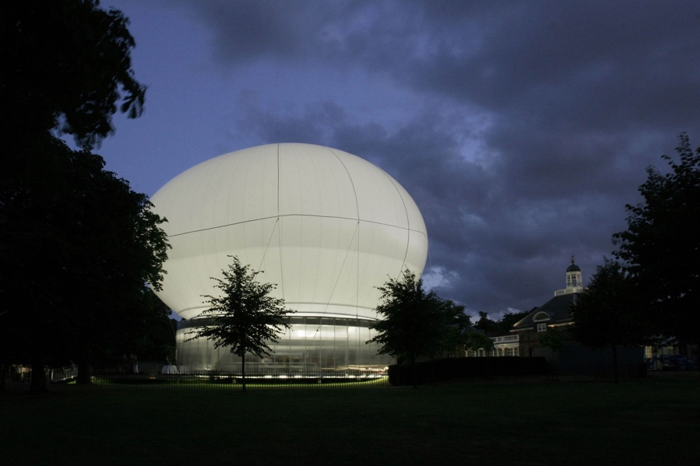
Abloh was born September 30, 1980 right outside Chicago in a neighboring city, Rockford. His mother was a seamstress, which is where we can see inspiration for fashion early on. Abloh acquired his undergraduate degree in civil engineering at the University of Wisconsin-Madison and sequentially his master’s degree in architecture from Illinois Institute of Technology (IIT). During his tenure at IIT, “a Rem Koolhaas building is completed, which Abloh says, ‘piqued my interest and opened my gateway into fashion’” (Vogue). Specifically in 2006, Rem Koolhaus collaborated with Cecil Balmond to design the building for the Serpentine Gallery in 2006. “Made from translucent material, the structure was illuminated from within at night. The canopy was raised into the air or lowered to cover the amphitheatre below according to the weather. The walled enclosure below the canopy functioned as a café and forum for daily televised and recorded public programmes, including live talks and film screenings in the Time Out Park Nights and the Serpentine Gallery programme” (Serpentine).
Pavilion of the Serpentine Gallery, 2006
Photo Courtesy: https://www.metalocus.es/
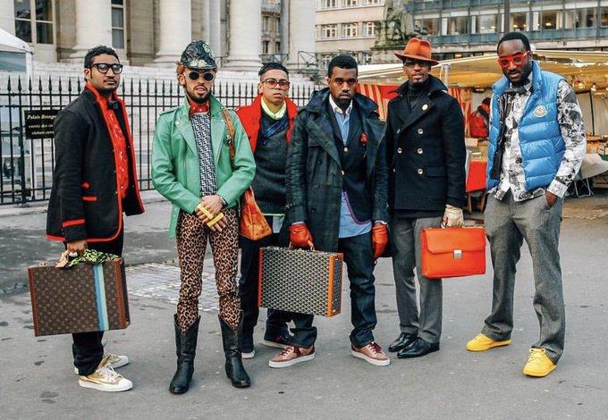
In 2009, Abloh and Kanye West jointly interned at Fendi in Rome. Under Michael Burke, then chief executive of Fendi, Abloh and West took over the fashion game at the time. “I was really impressed with how they brought a whole new vibe to the studio and were disruptive in the best way. Virgil could create a metaphor and a new vocabulary to describe something as old-school as Fendi.” (Friedman and Paton)

West, Abloh, and Co. at Paris Fashion Week, 2009
Photo Courtesy: https://www.complex.com/

But the real impact Abloh and West left on the fashion world was during Paris Fashion Week. Tommy Ton, a photographer, shot a picture for Style.com that went viral featuring Abloh, West, and their gang. “We were a generation that was interested in fashion and weren’t supposed to be there. We saw this as our chance to participate and make current culture. In a lot of ways, it felt like we were bringing more excitement than the industry was.” (Solway)

Soon after you can see the strides Abloh would take in the fashion design world. In 2012, Abloh launched his own brand Pyrex Vision. “It’s highly possible Pyrex simply bought a bunch of Rugby flannels, slapped ‘PYREX 23’ on the back, and re-sold them for an astonishing markup of about 700%. (Deleon)” And that’s exactly what Abloh did with Pyrex Vision. This was the start of the meteoric rise in Abloh’s career where we can see his influence on the culture. Anybody could have made these flannels, but Abloh allowed us to step into his world connecting the gaping bridge between high fashion and street culture.
Pyrex Vision, 2003
Photo Courtesy: https://icastore.org/
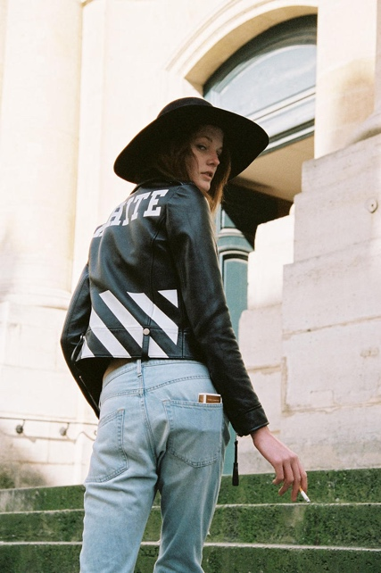
The following year, Abloh shut down Pyrex Vision and continued its legacy with his new label Off-White. “He centered the design aesthetic on diagonal lines and the iconography of American cities: White arrows. Plain labels. Industrial packaging with a signature zip tie. High-end fabrics and familiar streetwear shapes.” (Tiffany). And still, Abloh continued to break barriers as he introduced a women’s line for Off White in 2014 at Paris Fashion Week. The new line was well received by the public and was selected as a finalist for the LVMH Prize, a €300,000 grant and assistance from LVMH to develop your brand. This feat allowed him into conversations with powerful people in the fashion industry to continue growing his legacy.
“I Only Smoke When I Drink”
Off-White Women's Line PFW 2014
Photo Courtesy: https://hypebeast.com/
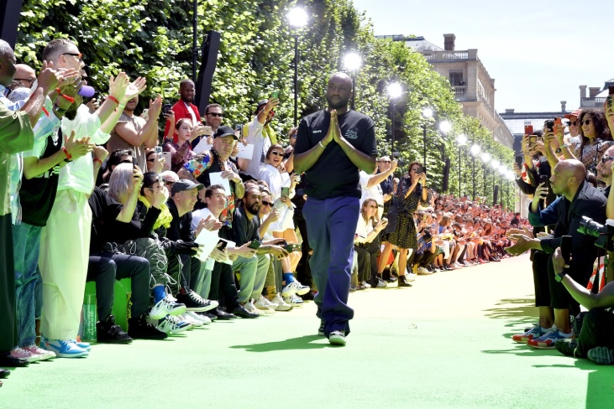
After countless projects, such as his collaboration with Nike on his famous The Ten collection, his collaborative exhibition with Japanese artist Takashi Murakami at Gagosian, and many more, Abloh was named the new creative director of Louis Vuitton in 2018 succeeding his former mentor and friend, Mr. Kim Jones. Michael Burke, his ex-boss at Fendi who hired Abloh and West, was the man who recommended Abloh for the position as Burke became the chief executive and CEO of Louis Vuitton in 2012. “Having followed with great interest Virgil's ascent since he worked with me at Fendi in 2006, I am thrilled to see how his innate creativity and disruptive approach have made him so relevant, not just in the world of fashion but in popular culture today. His sensibility towards luxury and savoir-faire will be instrumental in taking Louis Vuitton menswear into the future." (Renshaw).
Abloh concluding his first Louis Vuitton Collection SS19 at Paris Fashion Week
Photo Courtesy: https://footwearnews.com/
Abloh wouldn’t just stop there. He continued producing projects for brands such as Evian, Timberland, and he even designed a Boeing 767 for famous rapper and personal friend, Drake. Unfortunately, Abloh was battling a rare form of cancer, cardiac angiosarcoma, for the last 2 years and passed away late 2021. Even though Abloh has passed on, his works still remain relevant as ever as we continue to see people wearing his clothes on the streets and museums still showcasing his works.

Works Cited

DeLeon, J. (2020, April 19). No one Pyrex should have all those rugby flannels. Complex. Retrieved December 20, 2022, from https://www.complex.com/style/no-one-pyrex-should-have-all-those-rugby-flannels
Friedman, V., & Paton, E. (2018, March 26). Louis Vuitton Names Virgil Abloh as its New Men's Wear Designer. The New York Times. Retrieved December 20, 2022, from https://www.nytimes.com/2018/03/26/business/louis-vuitton-virgil-abloh.html
Renshaw, D. (2018, March 26). Virgil Abloh named New Louis Vuitton menswear designer. The FADER. Retrieved December 20, 2022, from https://www.thefader.com/2018/03/26/virgil-abloh-louis-vuitton
Serpentine Gallery Pavilion 2006 by Rem Koolhaas and Cecil Balmond with Arup. Serpentine Galleries. (2020, July 1). Retrieved December 20, 2022, from https://www.serpentinegalleries.org/whats-on/serpentine-gallery-pavilion-2006-rem-koolhaas-and-cecil-balmond-arup-0/
Solway, D. (2017, April 20). Virgil Abloh and his army of disruptors: How he became the king of social media superinfluencers. W Magazine. Retrieved December 20, 2022, from https://www.wmagazine.com/story/virgil-abloh-off-white-kanye-west-raf-simons
Tiffany, K. (2018, October 30). The hottest fashion brand in the world was built on irony and $1,000 sweatshirts. Vox. Retrieved December 20, 2022, from https://www.vox.com/the-goods/2018/10/30/18027074/off-white-timeline-history-luxury-streetwear-virgil-abloh
Yotka, S. (2018, March 28). A Brief History of Virgil Abloh's Meteoric Rise. Vogue. Retrieved December 20, 2022, from https://www.vogue.com/article/virgil-abloh-biography-career-timeline

