Ways to Teach Genre Awareness

• Type up a horoscope in poem format (short lines/verses). Ask a student to read this “poem.” Ask for comments on the features that make it a “poem.” Then reveal the true genre and discuss how one’s mental schema for a genre influences the way one reads and interprets texts.

• Ask students to make a list of 10 genres they regularly read. Have them pick three and describe how they read them differently. Do the same exercise with 10 genres students regularly write. Then hypothesize how the genre prescribes or influences the processes entailed in reading or writing them (from Scenes of Writing).

• Collect multiple samples of a short, simple genre: for example, obituaries, wedding announcements, news briefs, postcards, abstracts of journal articles. Using a matrix like the one on the next page (acknowledging its simplified format for describing genres), ask students to identify key genre features. Then discuss the social actions and values represented in these genre features.

• Give students a short reading selection without disclosing the source. Ask them to infer the genre, then discuss its properties and how that influences the meaning of the text. Some possible sources: newspaper or magazine editorials, song lyrics, advertising copy.
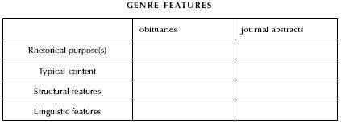

• Assign a brief topic and a genre students will use to write on the topic (for example, an ad to sell something in the newspaper). Then assign the same topic to be written in a different genre (a bulletin board notice? a listing on eBay?). Compare treatments of the subject in the two genres and how rhetorical purpose, content, structure, and linguistic features change (or not) in each genre (from Scenes of Writing).

• After students have collected multiple examples of a genre, analyzed the genre, and have written in that genre, have small groups write a “how to” guide for composing in this genre that other writers can use (Coe 1994).

