Ways to Teach the Concept of Discourse Community

• Introduce the concept with a definition such as this: “A discourse community is a social group that communicates at least in part via written texts and shares common goals, values, and writing standards, a specialized vocabulary and specialized genres.” Then present numerous examples of texts from very divergent discourse communities and ask students if they can discern which discourse community “owns” or uses the text (for example—the baseball scores reported in the daily newspaper, or lyrics from a rap song). Based on these text samples, students may speculate on what the features of the discourse community are, using the definition as a heuristic.

• For a given discourse community the students know (one’s major, or a social group one is associated with), brainstorm a list of all of the genres one uses in the discourse community. For each genre, ask students to identify common elements that are found in all of the genres that reflect on the discourse community’s goals, and norms for good writing. Have them compare the relationships between the genres.

• Ask students to bring to class sample texts from discourse communities they are members of. Remind them of the definition of discourse community. Have them do a brief freewrite on the ways that discourse community defines itself via its shared texts. Discuss their examples.

• Do a matrix such as the one below for the discourse communities of different academic disciplines. Have students who are familiar with (or majoring in) the different disciplines complete the matrix for their discipline. Have a whole group discussion of similarities and differences in the features of different academic discourse communities.
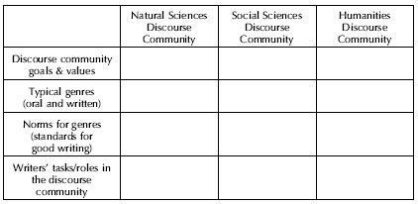

• Show students two texts on the same topic, but written for different discourse communities (for example, a science report in The New York Times and one on the same topic in a scientific journal such as Nature). Ask them to list the differences they see. Refer back to the definition of discourse community and ask students to infer what the discourse community that “owns” each text values, based on features of the sample genres.

• Have students join a listserv or newsgroup and “lurk” for two weeks (a virtual discourse community). Observe special terminology used, or common terms that are given special meaning. Observe who the members are. Answer these questions about the discourse community: What do you think the goals of the community are? How do the community’s goals and values shape what they write? What else do you notice about the writing of this group? What content is important to this group? What themes are expressed across multiple texts? Are there dissenting voices? (from Scenes of Writing)

• Assign an ethnography of communication for a discourse community of the student’s choice (an academic community, a social organization, a volunteer group they work for, a workplace setting, etc.). Teach the skills for taking field notes and conducting interviews and gathering written artifacts. Assign a library research component as well—what others have written about this discourse community. Discuss ways of parsing the definition of discourse community for analysis of the data. Have students prepare a final report on their research to describe the discourse community to an outsider. For examples of ethnographies of discourse communities, see Beaufort(1991), Fishman(1988), Heath(1983).

