What is an MRI?
An MRI (magnetic resonance imaging) scan is a medical imaging technique that uses magnetism, radio waves and a computer to make images of body structures. The MRI scanner is a tube that contains a giant circular magnet.

What are the risks of an MRI scan?
MRI has the benefit of not using X-ray radiation. It has no side effects other than a slight temporary rise in body temperature and the possibility of brief nerve stimulation.
However, because the strong magnetic field will interact with metal and electronics, MRI cannot be performed in people who have some types of implanted devices.
When an injected contrast agent is used for the MRI, there is a slight risk of allergic reaction. These contrast agents are also avoided in patients with severe kidney disease. Women who are pregnant, or who are trying to become pregnant, should inform their physician as well as the MRI technologist.
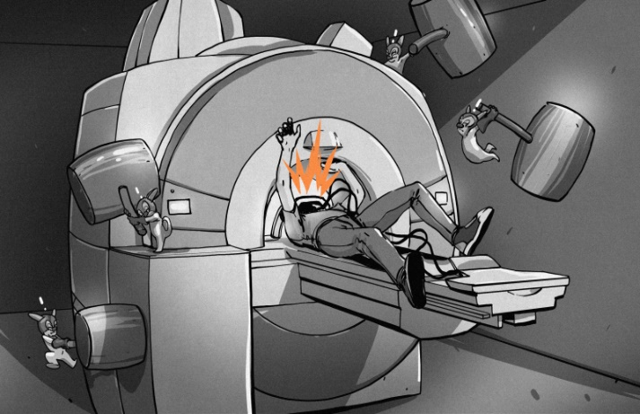

How do I prepare for an MRI?
When your MRI appointment is being set up, the scheduler will tell you if you need to stay away from food and liquids prior to exam.
If you are scheduled to have one of our nurses give you oral or IV medication for claustrophobia, we will ask you to arrive one hour prior to your scan time.

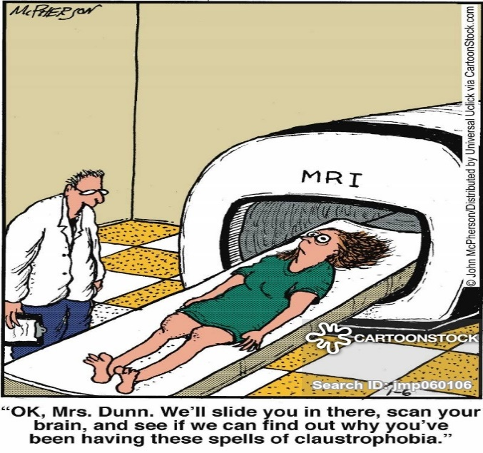
What happens during the MRI?
The MRI technologist will have you lie down on a table and you will slide into the scanner. The exam can last from 20 minutes to up to three hours. You will be given a squeeze ball to notify the technologist of any problem. You can communicate with technologist at any time through a speaker. We will ask you that you hold as still as possible throughout the exam. During the scan there is loud noise produced and you will be offered earplugs or earphones for the examination.

