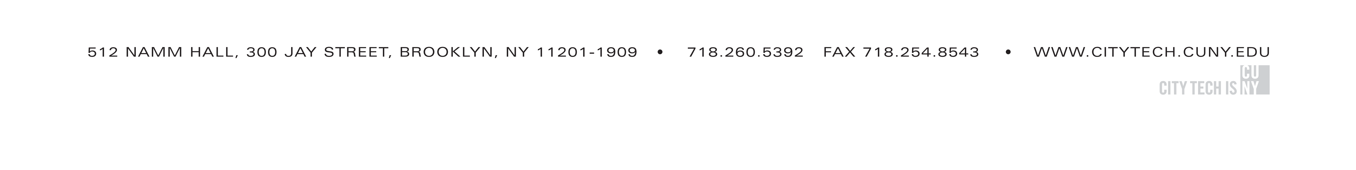
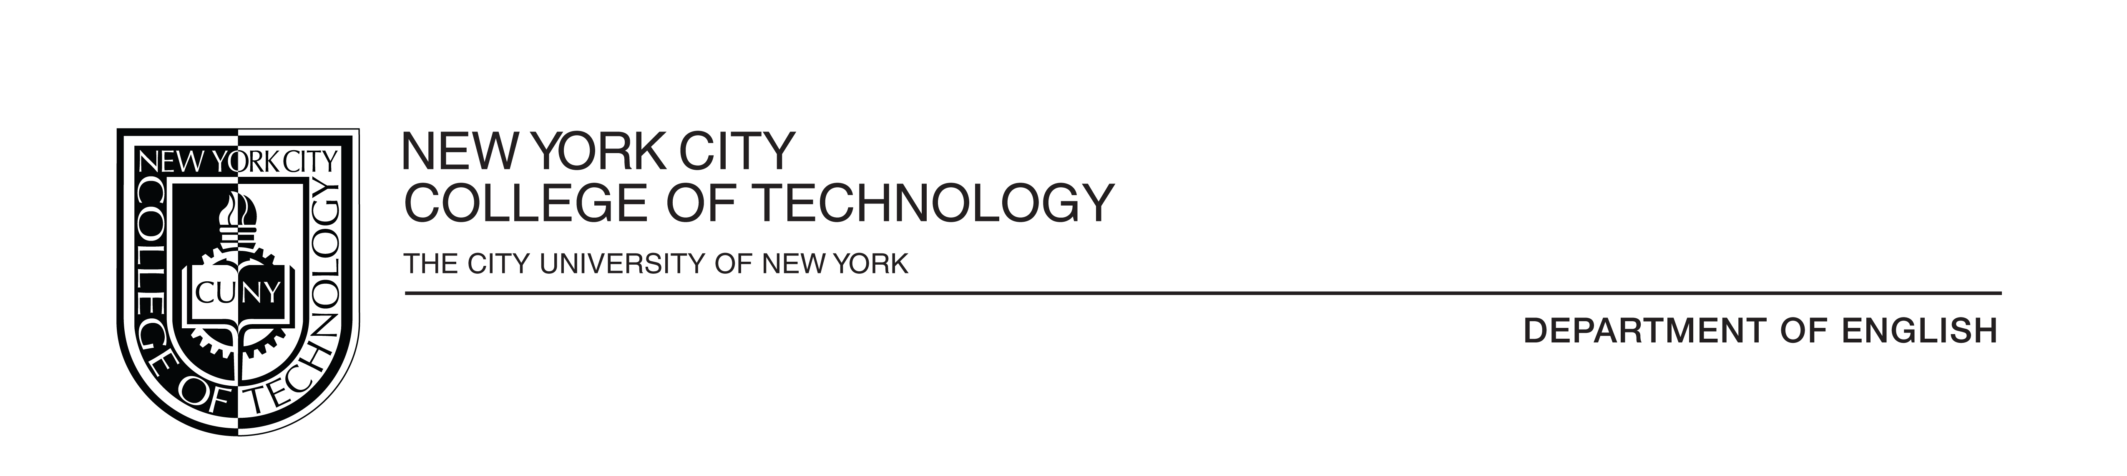

Minutes for First Year Writing Committee
November 21, 2020

- Review of the Minutes; (Oct. 10) minutes approved with changes to be made

- Chair’s Report
- 17 people enrolled in the Professional Development for spring 2020; 16 adjunct and full-time Ruth Garcia; Suzanne Miller will audit
- Compiling Unit Assignments for 1101 and 1121
- Funding for PD is assured in Spring 2020; funding afterward is less certain
- Assessment meetings have resulted in a final assignment for ENG 1101

- FYW Syllabi and Assignment Review
- Discussion of overseeing assignments for ENG 1101 and whether or not professors should include assignments when they turn in their syllabi.
- An informational document that includes items that have to appear on the syllabus is needed. This might include the attendance policy, learning objectives, and the disability act.
- The committee discussed the issue of professors who have been using their syllabi for a long time and have not updated them with current requirements.
- Robert Leston asked if the FYW Committee should review FYW syllabi.
- All syllabi are to have assessment measures and Gen Ed Learning Outcomes; many syllabi of full-time faculty do not list Gen Ed Learning Outcomes
- There was a proposal to create a checklist for all that will be looked for on syllabi.
- There was a proposal to request and review at least one assignment from each instructor.
- There was recognition that some syllabi might include assignments that are more “improv” or unplanned.
- Regarding assignments, one member suggested a survey might be made asking faculty what worked well and what needs changing?
- Some instructors are putting items on their syllabus that are not “student-friendly”. It was suggested that the Professional Development was put into place to review these kinds of items.
- The committee discussed creating a sample syllabus to demonstrate one with all of the necessary information on it?
- There was a discussion about the accessibility statement and how to address students using and misusing laptops in the classroom.

- Discussion of the Final Exam Reflection/Assignment
- Carrie Hall proposed a final exam assignment involving writing a cover letter.
- This exercise would allow student write in a different genre (transfer)
- The focus would be on writing process is different than before “rhetorical situation”
- Instructors discussed challenges. Among these were:
- they would have to address writing a cover letter and appropriate techniques before having this assignment
- How can this be applied to students in other programs (bio-informatics, etc)?
- Should the assignment be academic versus career oriented?
- Should the goal of the final consist of trying to asses “transfer”?
- General discussion regarding the final reflection
- Would the reflection would be part of the portfolio
- How consistent will this have to be throughout the years? Will it change?
- The assessment over years would work on different learning outcomes
- Robert Leston suggest there could be a reflection about student work over the course of the semester
- Discussion of how to make an assignment that is focused and not too open ended, yet still offer enough structure to be assessed.
- Responding to a text might still be a good way to do this if there is a second part that encourages students to respond to the process of the writing.

Meeting adjourned.

Minutes submitted by Jennifer Sears

