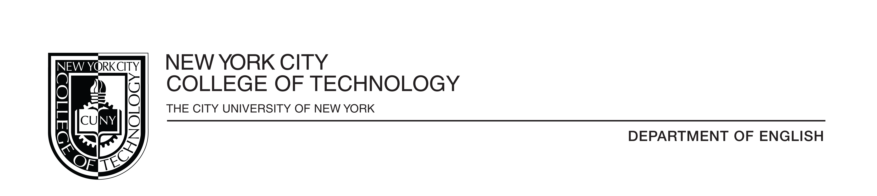

**Minutes of the First Year Writing Committee**

Meeting: 1 p.m., Thursday, Oct. 10, 2019

Namm Building, Room 519

Members Present: Donna Blain, George Guida, Carrie Hall (chair), Suzanne Miller, Jody Rosen, Pat Rudden, Jennifer Sears

1. Minutes from September meeting approved
2. Chair’s Report from Carrie Hall

Report on Professional Development Program:

* Other than issues for recording attendance, the current program is going well
* Regarding future programming, PD has secured funding for spring 2020 and is scheduling a three day planning session in January; much interest has been forthcoming from adjuncts regarding participation; an informational letter will soon be distributed.
* Currently 16 people have completed the training. The focus remains on training adjuncts.
* There is a future plan for all co-requisite teachers to participate
* Funding has been the main conflict; a discussion of fair pay for Carrie’s contribution for training was addressed by all members
* Summer trainings have focused on ENG 1101; throughout the semester in the fall, a semester is drawn up for 1121.

Update on Assessment/Creating a New Exit Assignment

* Three assessments are happening in the English department: PTW, literature course, and a critical course assessment on ENG 1101.
* Patrick Courbet and Rebecca Mazumdar and Carrie Hall are the ENG department assessment committee
* For this reason among others, Carrie expressed need to create an exit assignment for ENG 1101 that is consistent for all sections and can be critically expressed; the committee will also draft a rubric to accompany the new assignment.
* Goals of the new exit assignment include assessing how ENG 1101 students are doing, including comparing new curriculum versus old curriculum
* Ideally, this assessment tool could be created quickly, so that we can vote on the exam
* Discussion about applying concept of “transfer” to an exit assessment (Rosen)
* Goal is to keep a new tool consistent for at least two years (Hall)
* Carrie Hall brought up a suggestion from Robert Leston for ENG 1101, to have a diagnostic and and exit

1. Discussion of updated ENG 1101 Handbook (Suzanne Miller)

* Suzanne is working on this with Leigh Gold with a goal of having something by the end of the 2019-2020 academic year

1. Discussion the Annual Report (Jennifer Sears)

* Jennifer stated that the process of assessment will be part of the Annual Report

1. Discussion of the OpenLab/OER Project (Jody Rosen)

* Jody reported on updating the sources for the PD and adding a bibliography
* Jody will be surveying the department about OpenLab use
* CUNYFirst offers ZTC (zero textbook cost) designation for the courses; trying to add “low cost textbook”
* The committee discussed how and why students value books and the reasons for their reluctance for spending money on books, in addition to how this affects their relationship with reading

1. Pedagogy Presentations: Assignments committee members are currently using

George Guida

* George Guida shared an assignment he’s created based on materials for the Teagle Fund, which is designed around the Great Books Course from Columbia; among these are 4-5 lengthy texts
* one challenge is getting students invested in reading them.
* George has them complete a reading journal: students write about the parts that interested them
* Discussion of how to teach dense materials with more physicality

Suzanne Miller

* Suzanne Miller demonstrated how she helps her students consider their audience when writing by asking questions such as: “What do you want your reader to feel after reading your introduction?”
* She also guides them in writing a fairy tale version of their own essay, which enables them to link a new style of writing with a genre they are more familiar with.
* Both of these assignments emphasis the importance engagement and creating a sense of fun while learning in their English classrooms.

Pat Rudden

* Pat Rudden shared an exercise that encourages web site evaluation.
* Students choose from a list of domains to investigate and assess, considering whether or not they are credible sources. She offers students guiding questions allowing them to analyze the source’s purpose, authorship, and how to assess credibility, and decipher how to find information.
* This project will be developed into finding research for future papers and helps them think about how they make the decisions they’ve made.

7. Meeting adjourned.