Asmaa Bykbane
Professor Jacquelyn Blain
English 101, section LC47
5 December 2016
Project: Genetic Engineering
Genetic engineering is an important topic in our era, and has recently become one of the fastest developing fields of science. With this new technology, people are being able to fix and do things that were impossible in the past. Genetic engineering is a wild technique that covers so many fields beginning with modifying food down to human reproduction, which makes it an interesting topic to discover and know more about it.
Genetic engineering is the process of removing a gene from one organism and inserting it into another, which helps the receiver gain new abilities from the donor that the receiver didn’t have before. This process gives scientists the tools to make changes in living things, and create new species. In agriculture we are now able to produce more food: "GM soybeans and corn, which are widely grown in North and South America....also produce large aggregate welfare gains, currently estimated at $5 billion per year at the global level. Huge benefits are also projected for future GM crops that are more tolerant to drought or more efficient in nutrient use"(Qaim). We are able now to produce more agriculture crops in a short time and with less effort than before.
Genetic engineering technology has dramatically reduced the time required for the development of new commercial varieties of crops. Some investigators have suggested that the use of genetic markers could reduce the usual 10-15-year breeding cycles to only 2-3 years. Genetic engineering is rapidly replacing traditional plant breeding programs and has become the mainstay of agricultural crop improvement. ( Paoletti, Maurizio and Pimentel)
Animal genetic engineering allowed framers to improve the quality and quantity of animal products destined for human consumption. The pharmaceutical products available today are more efficient than in the past due to genetic engineering, these new products are created by cloning certain genes which help us increase the productivity and provide new sources of medicines. Now medicines are being made by changing the genetic structure of the plant cell,
another victory for synthetic biology. Researchers report today that they’ve engineered a common laboratory plant to produce the starting material for a potent chemotherapy drug originally harvested from an endangered Himalayan plant. The new work could ensure an abundant supply of the anticancer drug and make it easier for chemists to tweak the compound to come up with safer and more effective versions. (Robert F)
The Himalayan mayapple was the original source of Etoposide, a powerful anticancer compound.
Reduction of pollution, especially pollution of soil and groundwater caused by the excessive use of agricultural pesticides and its consequences on human and animals, become possible through genetic engineering."Important environmental benefits, such as controlling farm runoff that otherwise pollutes water systems, are associated with reduced spraying of chemical insecticides and highly toxic herbicides. Reduced mechanical weeding helps prevent the loss of topsoil. Health benefits result from reduced pesticide exposure for farmers and rural laborers and lower pesticide residues for consumers" (Qaim). Scientists have made important achievements over the past years in various domains through genetic engineering, which attracted many researchers and scientists to work in this field from around the world, in the hope of discovering more secrets and opportunities that are still hidden behind this science for mankind in the future. During their work on genetic engineering, scientists didn't only develop techniques to modify plants and animals but they were able to manipulate humans genes and even work to design humans in the future. This new possibility to enhance humans physical and intellectual abilities makes genetic engineering a controversial subject, which raised so many debates and questions about how far we should go with genetic engineering? Are there lines we should not cross? Why do we consider some genetic engineering acceptable as opposed to others? Is genetic engineering ethical?.
In all controversial subjects in the world we always find supporters and opponents. Each side has different point of view and they analyze things from different angles. In genetic engineering people are divided between those who are excited about this extraordinary technology and who are afraid of the consequences that may appear later. For so many people and scientists, genetic engineering is the magic tool that is going to open the door to save people and provide better living conditions for humanity. The destiny of our children and their dreams can be limited by their natural genes: "A short person, for example, would be unlikely to join the basketball team because his height makes it difficult for him to compete with his tall peers....A myopic kid who wears glasses will find it difficult to become a pilot. A student with an IQ of 75 will be unlikely to get into Harvard however hard he tries. In some way or another, our destinies are limited by the genes we are born with" (seck). However, Genetic Enhancement could help to change this reality by offering us the tools to follow our dreams. We now have the power to cure diseases and avoid genetic defects such as HIV, Familial hypercholesterolemia, Sickle-cell anemia, and Hemophilia by gene therapy. This technique works by repairing or replacing defective genes or introducing therapeutic genes to fight the disease. The more we learn the more we discover new things. In 2012 scientists succeeded in developing a system called "CRISPER" which is revolutionizing the field of genome editing. This achievement can be modified and redirected to become a powerful tool for genome editing in broad applications such as stem cell engineering, gene therapy, tissue and animal disease models and engineering disease-resistant transgenic plants.
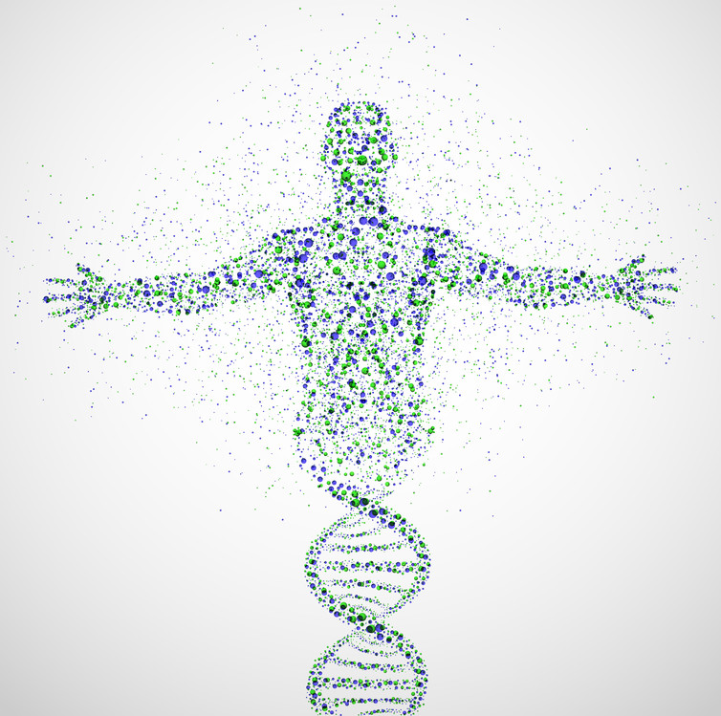https://www.thermofisher.com/us/en/home/life-science/genome-editing.html (thermofisher)
This new machine brings hope to eliminate deadly diseases such as malaria that are transmitted through mosquitoes and kill millions around the world. "Researchers have used Crisper to genetically engineer tons of malaria-resistant mosquitos. Even more awesome/terrifying, they’ve been able to use it to manipulate the genes so that they copy-and-paste themselves, making malaria resistance far more ubiquitous in their new generation of mosquitos than could have possibly been imagined—and upending what we know about biology" (Thu-Huong). Also this new invention bring worries, if we know that Crisper can "genetically engineer an animal that’s designed to destroy its entire species, for better or worse" (Thu-Huong) by copying itself generation after generation.
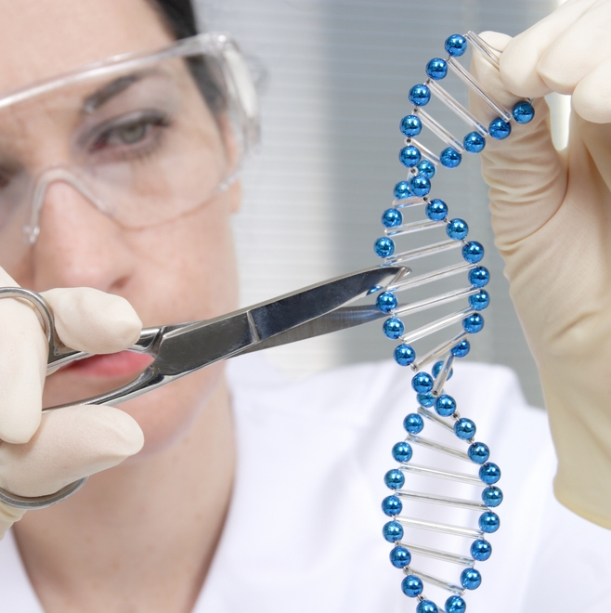
https://www.ted.com/talks/jennifer_kahn_gene_editing_can_now_change_an_entire_species_forever?language=en (Tedtalk).
Crisper not just allows scientist to prevent diseases and genetic disorders, but also to enhance or improve normal human traits."The new technology of genome editing, known as CRISPR/Cas9 (clustered regularly interspaced short palindromic repeats), which makes possible precise modifications of the genetics of organisms, changes things dramatically. Genetic modification of humans now looks all too possible" (Sparrow). This makes many people wonder about the ethics of this technology and the lines that not should be crossed.
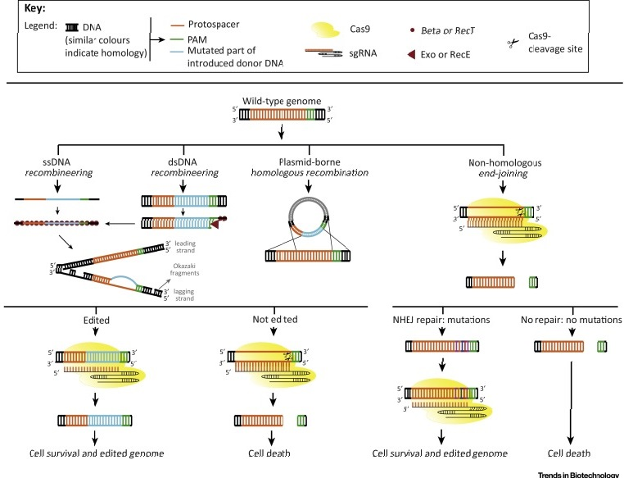
At this point most people stop to think if they really want this technique to be applied, and if they have enough trust to allow scientists to use it . The opponents in this issue believe that genetic engineering is trying to play the role of God, when scientists start to design babies with the choice to change every aspect of every characteristic of a child . Humanity is expressed by distinct attributes that characterize humans, it means to be diverse and unlike anyone else. For many people, playing in humans genes would destroy diversity in humanity, and no one will be individual and unique if anyone can choose to have the same traits. Another subject that came out with meddling with human abilities was about creating a society of enhanced versus unenhanced humans, where the rich benefit from genetic enhancements such as perfect eyesight, strong memory, and higher intelligence that the poor cannot afford. The idea about using science to enhance the human species still looks scary, many people feel worried about the risks of altering humans and most of them are not ready to put themselves or their babies under the hands of genetic engineering scientists. In the USA a recent survey by "Pew Research Center" that examines public opinions about the potential use of three emerging technologies using gene editing, brain chip implants and synthetic blood to change human capabilities, showed peoples wariness about these developments: "When Americans are questioned about the prospect of these specific kinds of enhancements for healthy people, their views are cautious and often resistant" (Funk, Kennedy and Scuipac).

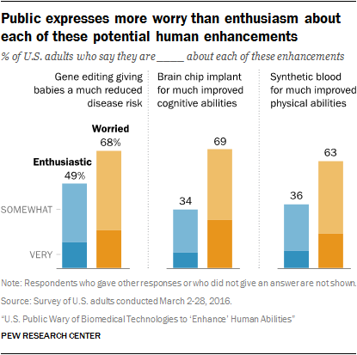This diagram demonstrate that :"Majorities of U.S. adults say they would be very or somewhat worried about gene editing (68%), brain chips (69%) and synthetic blood (63%), while no more than half say they would be enthusiastic about each of these developments. Some people say they would be both enthusiastic and worried, but, overall, concern outpaces excitement" (Funk, Kennedy and Scuipac). Another category that covered by Pew Research Center in their survey, shows differences in points of view about this topic between religious and non-religious. The most religious considered human genetic enhancement is meddling with nature, when the non-religious believe that this technique will allow humans to better themselves.
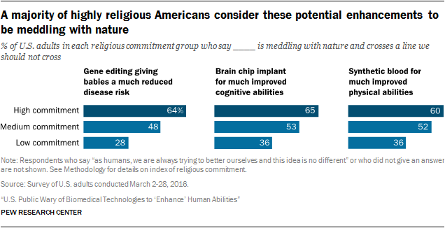Most of the People that stand against genetic engineering admit that this science helped humanity in so many fields, but their fears emerged when genetic engineering starts dealing with humans. Their arguments are depending on so many reasons such as lack of long term studies; mostly because the technology is not that old, they are worried about the risks of altering humans, and the future effects that are still unknown. As with any new technology, the full set of risks associated with genetic engineering have almost certainly not been identified. The ability to imagine what might go wrong with a technology is limited by the currently incomplete understanding of physiology, genetics, and nutrition. People also believe that modifying humans will discourage not encourage racial harmony and diversity, and the most dangerous part is the possibility of using this science as biological warfare by enemies."The danger of genetic misuse is equally threatening at the international level. What happens when some rogue country announces an ambitious program to improve the genetic stock of its citizens? In a world still barely able to contain the forces of nationalism, ethnocentrism and militarism, the last thing we need to worry about is a high-tech eugenic arms race" (Hayes). So for these reasons and so many others, people have called to legislate laws regulating this field and avoid any possible manipulations or even ban some types of genetic engineering such as editing human embryos.
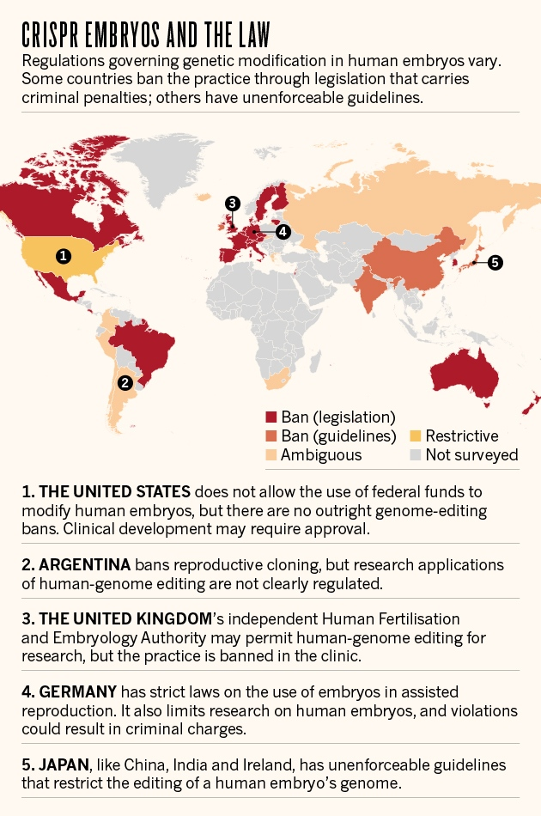
As for the rest of the world, there's a patchwork of laws addressing the possibility of editing the genomes of human embryos. In Russia, the Japanese researchers note, (germline gene modification for reproduction is not considered) by the relevant legislation. In Canada and many European countries, the bans are quite strict; in Austria, for example, any intervention involving the human germline is prohibited
( Friedman).
For such a controversial subject as genetic engineering, it is really hard to choose a side, or at least it take time to decide which part you feel comfortable to support. Both sides in this issue have points where they are right, and where they are not persuasive. For me genetic engineering since it started, invaded many domains and contributed to save many lives. Helped to provide foods, medication, and prevent many diseases, which urging me to stop and think how our lives would have been without this useful technology. I believe that this technology is the gateway that will allow humanity to reach another stage of technological advance, such as those we saw in science fiction movies. However watching science fiction movies always brings me mixed feelings between excitement and fear, the same as I feel now toward genetic engineering. This extraordinary field could has two faces, one is bright and carries a lot hopes and dreams about a future of successes and achievements. Another face could be harmful with unexpected results, if we let this magical science reach the wrong hands. In the past, we experienced so many times when science abandoned his noble goal, and turned to a deadly killing tool which results are still present in human memory, such as the terrible Nazi experiments performed in the name of science, and the invention of nuclear weapon that lead to the disaster of Hiroshima. These facts impose from my point of view the need to monitor sciences that may cause harm to the world if it gets out of its ethical boundaries.
Day after day humans learn and discover new sciences and new technologies that make us understand the world where we live, and solve this mysterious cipher. Genetic engineering is one of those codes that are going to help us to resolve the ambiguity of our world. We are now standing in front of the door that can take us to a world of fantasy, we just have to decide if we are ready to enter or we if prefer to stay in our place.

Bibliography

Friedman, Lauren. "These are the countries where it's 'legal' to edit human embryos (hint: the US is one)". Business insider. 23 Apr 2015. 02 December 2016.
<http://www.businessinsider.com/china-edited-human-genome-laws-2015-4>.
F, Robert. "Genetic engineering turns a common plant into a cancer fighter". American Association for the Advancement of Science. 10 Sep 2015. 28 November 2016.
<http://www.sciencemag.org/news/2015/09/genetic-engineering-turns-common-plant-cancer-fighter>.
Funk Cary, Kennedy Brian, and Podrebarac Sciupac Elizabeth. "U.S. Public Wary of Biomedical Technologies to Enhance Human Abilities". Pew Research Center. 26 JULY 2016.
02 December 2016.
<http://www.pewinternet.org/2016/07/26/u-s-public-wary-of-biomedical-technologies-to-enhance-human-abilities/>.
Hayes, Richard."Genetically Modified Humans? No Thanks". Washington post.
15 April 2008. 20 November 2016.
<http://www.washingtonpost.com/wpdyn/content/article/2008/04/15/AR2008041501620.html>.
Kahn, Jennifer. "Gene editing can now change an entire species-forever". Ted Talks.
2 June 2016. 12 November 2016.
<https://youtu.be/OI_OhvOumT0>.
Paoletti, Maurizio G, and Pimentel David. "Genetic Engineering in Agriculture and the Environment". Oxford University Press. October 1996. 3 December 2016.
<http://bioscience.oxfordjournals.org/content/46/9/665.full.pdf>.
Qaim, Matin. "The Benefits of Genetically Modified Crops—and the Costs of Inefficient Regulation". Resources for the Future. 2 Apr 2010. 28 November 2016.
<http://www.rff.org/blog/2010/benefits-genetically-modified-crops-and-costs-inefficient-regulation>.
Seck, Chris. "Arguing For and Against Genetic Engineering". The Stanford Review. 8 June 2007. 20 November 2016.
<http://stanfordreview.org/article/arguing-and-against-genetic-engineering/>.
Sparrow, Robert. "There is too much at stake: Just because we have the capability to perform enhancement it does not mean we should proceed". The pharmaceutical journal. 24 SEP 2015.
20 November 2016.
<http://www.pharmaceutical-journal.com/opinion/comment/genetically-engineering-humans-a-step-too-far/20069421.article>.
" The power of CISPR genome editing". Thermo Fisher Scientific. 18 June 2016.
14 November 2016.
<https://www.thermofisher.com/us/en/home/life-science/genome-editing.html>.
Thu-Huong, Ha. "Are we gods now? Jennifer Kahn talks CRISPR at TED2016". Ted Blog.
17 February 2016. 20 November 2016.
<http://blog.ted.com/are-we-gods-now-jennifer-kahn-talks-crispr-at-ted2016/>.

