NEW YORK CITY COLLEGE OF TECHNOLOGY.
THE CITY UNIVERSITY OF NEW YORK.

Student: Frederick Tetteh
Lab partner: Saad Ghaleb
Prof. Alassane Ngaide
EMT 1150 Lab, Section D364.

Experiment 5
Measurements in Parallel Circuits.

Date of experiment: 03/02/2018
Due date:03/09/2018

Experiment #5
Table of contents:
- Cover…………………………………………Page 1
- Table of contents……………………………..Page 2
- Objective and materials required……………..Page 3
- Procedure …………………………………….Page 4
- Data…………………………………………...Page 5
- Conclusion……………………………………Page 9
- Run #5 (Multisim)…………………………….Page 10
- Summary………………………………………Page 10

Objective
The objective of this experiment is to analyze the properties of a circuit with its components arranged in parallel. The current, voltage and resistance will be measured to observe how the circuit reacts and the influence it has on the current.

Materials
- Breadboard
- Multimeter
- Wire kit
- Switch
- DC power supply
- 47Ω resistor
- 470Ω resistor
- 4.7KΩ resistor
- 220Ω resistor
- 330Ω resistor

Procedure
- Wire multiple circuits in parallel corresponding to each schematic onto the breadboard using the materials.
- Measure and record the resistance, voltage and current to perform your analysis.
- Compare to the values measured with the values calculated to determine their similarities.
- Make your conclusions.

Data
Measurement of resistance in parallel

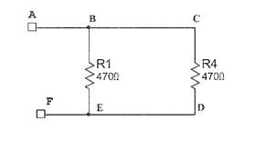
R_{AF} = 234Ω
R_{BE} = 468Ω
R_{CD} = 471Ω
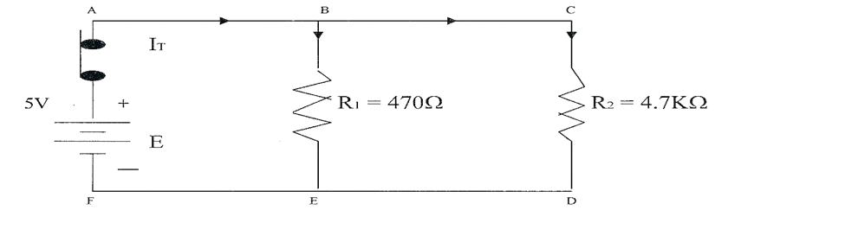

Run #2
- Measured voltage supplied by power supply: 4.99V
- Voltage across each resistor : V_{R1} = 4.99V V_{R2} = 4.99V
- Compare all the voltages: It is proved that voltage is constant across the components in the circuit placed parallel to each other. (V_{T =}V_{R1 =} V_{R2})
- Measure total current :11.7mA
- Current flow through each branch: I_{B1} = 10.6mA I_{B2} = 1.1mA
- Comparing the total current to sum of branch current: The sum of the branch currents equals the sum of the total current (I_{T} = I_{B1} + I_{B2})
- Total resistance and resistance of each branch: R_{B1} = 468 Ω R_{B2} = 4.72 KΩ R_{T} = 426Ω

Run #3
After adding a 220Ω resistor (R₃) in parallel with R_{2.}
- Total voltage =4.99V.
- V_{R1} = 4.99V V_{R2} = 4.99V V_{R3} = 4.99V
- Comparing the total voltage and the voltages across each resistor it is observed that the voltage is constant across each resistor.
- Total current = 34.5mA
- I_{B1} = 10.6mA I_{B2} = 1.1mA I_{B3} = 22.8mA
- The total current is equivalent to the sum of the branch currents
- Comparing I_{B1} and I_{B2} of this experiment to the previous experiment the values are equivalent.
- I_{T} of this experiment = 34.5mA and the I_{T} of the previous experiment is 11.7mA.
- R_{T} of this experiment is 145 Ω and the R_{T} of the previous experiment is 426 Ω.

Run #4
After adding a 47 Ω resistor in parallel to R_{3.} 135.6mA
- Total voltage =4.99V.
- V_{R1} = 4.99V V_{R2} = 4.99V V_{R3} = 4.99V V_{R4} = 4.99
- Comparing the total voltage and the voltages across each resistor it is observed that the voltage is constant across each resistor.
- Total current = 135.6mA
- I_{B1} = 10.5mA I_{B2} = 1.1mA I_{B3} = 22.7mA I_{B4} = 102mA
- The total current is equivalent to the sum of the branch currents
- The total current is equivalent to the sum of the branch currents
- Less current flows through I_{B1} and I_{B2} of the previous experiment as compared to this experiment because of the introduction of a new path with less resistance.
- Total current of this run is 135.6m A and the previous run is 34.5m A.
- R_{T} of this experiment is 36 Ω and the R_{T} of the previous experiment is 145Ω.

Calculations
- $I_{X}=I_{T}\left(\frac{R_{T}}{R_{X}}\right)$ $I_{B1}=11.7\left(\frac{422Ω}{468}\right)$ I_{B1} = 10.55m A $I_{B2}=11.7\left(\frac{422Ω}{4720Ω}\right)$ I_{B2} = 1.05m A
- $I_{B1}=34.5\left(\frac{145Ω}{468Ω}\right)$ I_{B1} = 10.7m A $I_{B2}=34.5\left(\frac{145Ω}{4720Ω}\right)$ I_{B2} = 1.06m A $I_{B3}=34.5\left(\frac{145Ω}{219Ω}\right)$ I_{B3} = 22.8 m A
- $I_{B1}=135.6\left(\frac{36Ω}{468Ω}\right)$ I_{B1} = 10.4m A $I_{B2}=135.6\left(\frac{36Ω}{4720Ω}\right)$ I_{B2} = 1.03m A $I_{B3}=135.6\left(\frac{36Ω}{219Ω}\right)$ I_{B3} = 22.8 m A
$I_{B4}=135.6\left(\frac{36Ω}{43.2Ω}\right)$ I_{B4} = 113 m A

Conclusion
- No, the total resistance is not equivalent to the summation of the component resistors .i.e. they are connected in parallel and not in series.
- The resistance value of R_{AF} is a little less than the of the original measured value of the 47 Ω resistor because an additional resistor has been introduced in the circuit.
- The measured value of R_{AF} is less than that of the measured value of R_{BE} and R_{CD} even though R_{BE} and R_{CD} have approximately the same value because in a parallel settings the total resistance is less than the lowest nominal resistance. Based on this it can be said that the total resistance of resistors of the same value in a parallel circuit is the equivalent to the nominal resistance of one resistor divided by the total number of resistors.
- The voltage is constant throughout a parallel circuit.
- The total current is the sum of the current flowing through each individual branch.
- The individual current depend the number of branches but the total current doesn’t depend upon the number of branches because of Kirchoff’s Law.
- The total resistance is reduced as more resistors are added to a parallel circuit.

Run # 5

- Total Resistance = 106.821 Ω.
- Total current = 93.616mA
- Total power = 936.147mW
- P=VI P=10V*93.61mA P=936.1mW
- The measurement is of power is equivalent to the calculated value
Summary
After running this lab experiment the properties of parallel circuit was identified and proved using the formula to calculate and measuring to see to see if the values match. And the conclusions I drew from this is in parallel circuit:
- Voltage is constant across the components.
- The total current equals the sum of all the currents flowing through each branch.
- The total resistance is 1/R_{T} = 1/R₁ + 1/R₂ + 1/R₃ + 1/R_{N}
- The total resistance is reduced as more resistors are added in parallel
- Kirchoff’s current law states that. “ the total current leaving a circuit is equal to that entering the circuit .i.e. no current is lost”
- Therefore I_{T} = I_{R1} + I_{R2} + I_{RN}

