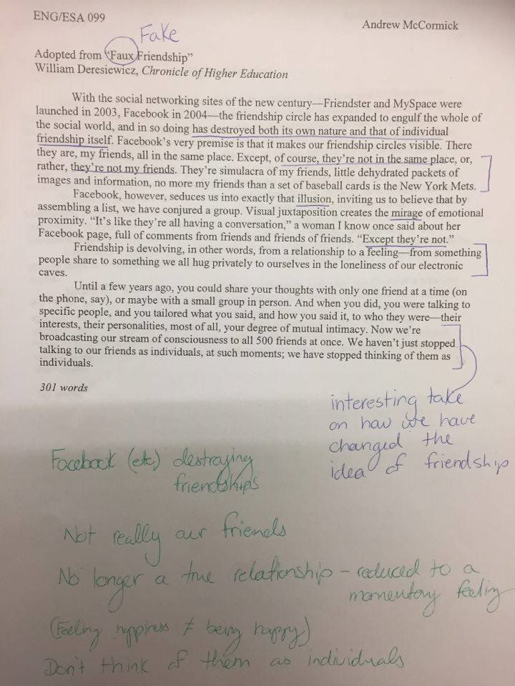

Faux Friendship Discussion
Main Idea:  1. Facebook is destroying/cheapening friendship  2. We think that our Facebook friends are “real” friends, but they are not  3. We feel like we're forming real relationships, but we aren't  4. Social media is isolating us, but also tricks us in to thinking we’re connected | Support:  1. “… has destroyed its own nature and that of individual friendship itself.”  1.2. “We have stopped thinking of them/talking to them as individuals”  2. Baseball card analogy  3. Seeing them all together in one place makes us feel closer to them, but we are not actually closer  4. Electronic caves analogy

Key Words:
Faux: fake
simulacra: representation
juxtaposition: compare side-by-side
mirage: false image
proximity: closeness, distance

Example Summary (with example thesis):
How many true friends do we all really have? In the article “Faux Friendship” by William Deresiewicz, he discusses how Facebook and other social media is destroying friendship as we know it. While we used to find great value in a small number of close friends, now it is easy to have hundreds of “friends” on our Facebook pages, but Deresiewicz believes that these “friends” are not actually valuable anymore, and are more of a representation of friendship than the real thing. The author goes on to explain that while we may feel like we have many friends thanks to social media, this technology has actually isolated us and encourages us to spend time alone and on the computer rather than going out and actually interacting with anyone in person. Additionally, Deresiewicz points out that even the interaction we do have online with our friends is no longer aimed at any one particular person, but instead we simply broadcast everything to all of our friends as one large, homogeneous group with no regard to their various interests or the differing levels of intimacy we may share with them. I definitely feel that the concept of friendship has changed with the advent of social media, and I don’t like the direction it has taken.

Other possible theses:
While Deresiewicz makes some good arguments, I have to say that I still see great value in my interactions between friends, and I don’t feel as if my relationships have changed much because of Facebook.

Deresiewicz brings up some interesting points in his article, but I have to disagree with his premise that this change in the way friendship works is a negative one. I think instead that social media has changed friendship for the better and improved the way people can interact with each other.

Etc…

Planning your response:

Questions (answering these could be a good start to a response):

Do you think that social media affects mutual intimacy?
Do you really think everyone in your friend group online is a faux friend?
Was the author being too general?
What was the author’s motive to write this article?
Can Facebook “friends” also be real friends?
Has Facebook really destroyed friendship?
-What point are you focusing on?
- What position are you taking?
- What experiences will you discuss?
- How are they related to the topic?
-What will you use from the article in your discussion?
- How will you discuss its relationship to your argument?

