What is Hookah?  A hookah is a water pipe used to smoke tobacco through cooled water. The tobacco is heated in the bowl at the top of the hookah and smoke is filtered through the water in the base of the hookah.  A bit of history…  The hookah tradition, dating back at least 500 years, originated in the Middle East regions of the world. Countries cited for the first use include Egypt, India, and Turkey. Smoking the hookah is one of the oldest, most popular Turkish traditions. The tradition has traveled to the United States and today there are more than 300 hookah establishment in the U.S. |  | Reference  - Hookah and its Dangerous Effects on Health & Body - List Dose (List Dose)  http://listdose.com/hookah-and-its-dangerous-effects-on-health-body/  - The Dangers of Hookah Smoking (Centers for Disease Control and Prevention)  http://www.cdc.gov/features/hookahsmoking/  - Hookah is not harmless, experts say (Fox News)  http://www.foxnews.com/health/2014/02/24/hookah-is-not-harmless-experts-say/  - The Effects of Smoking Shisha (Quit Shisha)  http://www.quitshisha.com/effects-of-shisha.html  - Quit smoking (Hookah smoking: Is it safer than cigarettes?)  - http://www.mayoclinic.org/healthy-living/quit-smoking/expert-answers/hookah/faq-20057920  Photo Reference  - www.internationaloddities.com  - nineronline.com  - www.pghcitypaper.com |  |  |  | Effects of Hookah Smoking  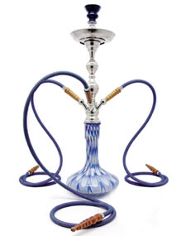    Fannyeu Liou  Lilia Meshalkina

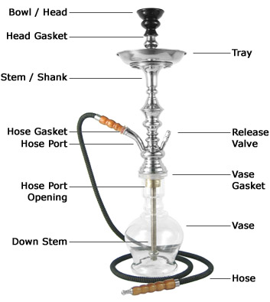  Parts of Hookah… |  |  | Hookah Myths and Truths…  Myth#1:  Hookah smoke is filtered through water so it filters out the harmful ingredients.  Truth#1:  Water does not filter out cancer-causing chemicals. Water-filtered smoke can damage the lungs and heart as much as cigarette smoke.  _____________________________________  Myth#2:  Inhaling hookah smoke does not burn the lungs, so it is not unhealthy.  Truth#2:  The hookah smoke does not burn the lungs when inhaled because it is cooled through the water in the base of the hookah. Even-through the smoke is cooled, it still contains carcinogens and it is still unhealthy.    ____________________________________ |  |  | Myth#3:  Smoking a hookah is not as addictive as smoking a cigarette because there is no nicotine.  Truth#3:  Just like regular tobacco, hookah contains nicotine. In fact, a 45-60 minute hookah session can expose the smoker to approximately the same amount of tar and nicotine as one pack of cigarettes.  ____________________________  Myth#3:  Smoking hookah is healthier than smoking cigarettes.  Truth#3:  Hookah smoke is just as dangerous as cigarette smoke. Hookah generates smoke in different ways: cigarette smoke is generated by burning tobacco, while hookah smoke is produced by heating tobacco in a bowl using charcoal. The end product is the same-smoke containing carcinogens.

