Faharia Afrin
Textiles BUF 2246-OL35
Professor Munroe
November 15, 2021
Black coffee in terms of fashion

In this research project, we will discuss many things that includes the topic of black coffee or coffee grounds in general. We will first discuss the origin of coffee beans, how it started being used as a source of drink, natural tie dye ingredient, chocolates, and other things as well. Then, we will go over the topic of how black coffee produces its colors on fabrics used to tie dye, the cost range of this product, and so on.
The term “coffee” itself originates from a variety of languages all over the world. It was given the label qahwah by Yemenis and was derived from an endearing phrase for what they called wine. Soon after in Turkey, the term was shortened to kahveh, which then changed to koffie in Dutch, and ultimately resulted in being spelled as coffee in the English language. In its most organic form, coffee is a fruit that is similar to cherries because as it ripens, it turns red. The coffee beans are situated in the middle of the ripened coffee which people use to make different types to products such as chocolate, black coffee, mixing coffee with other ingredients to make drinks, natural tie dye, etc.
Roasted coffee as we know it now emerged from Arabia in countries we know today as Yemen, Egypt, Iran, Turkey, and Syria. Coffee was quite prominently used among Muslims during the 1200s time period because of the incredible amount of energy source which were essential for them amid extended worship periods. Soon after European travelers brought back coffee with them from Arabia, coffee began to be used in the 1600s starting in Italy and made its way over to France. The first ever coffee farm was established in Sri Lanka in the year 1616 by the Dutch. In the Caribbean, coffee was cultivated by the French, while in Brazil, coffee was grown by the Portuguese. The Spaniards also produced coffee in Central America. At this time, coffee was mostly consumed by drinking concoctions. For so long, the ideal breakfast drink people would consume was wine and beer until coffee became known and replaced the alcoholic beverages. People drank coffee for the energizing properties they needed to get through their daily tasks and because it also tasted good despite its bitterness. According to The National Coffee Association USA, Thomas Jefferson once said “Coffee – the favorite drink of the civilized world.” (https://www.ncausa.org/About-Coffee/History-of-Coffee).
Although it is a common and well-liked drink by people all over the world, coffee is an expensive fruit to produce. Since each country has differences in availability of coffee as well as fluctuation in the market, the price of coffee is not linear. Specialty coffees such as Colombian, Cuban, Persian, and Hawaiian coffees are even more expensive than regular coffees because of the cultivating process and production.
While coffee is largely used for consumption, it can also be used in fashion! Many people use coffee grounds or black coffee as a natural dye solution for garments. An example would be a tie-dye cotton shirt made by coffee grounds or black coffee. The colors made by this natural ingredient would come in different shades of brown and tan depending on how much of the coffee is roasted and used on the fabric. This correlates with the colors of fashion today because neutral colors are definitely a trend in 2021. From dresses, to skirts, to jackets, and masks, people have been sporting tan/brown/nude colors. I discussed in class that my favorite colors are nude, beige, neutral colors and my favorite garment to wear is loungewear because it goes with everything any time of the day, and not as harsh as the shades black and white. You can also dress it up by wearing jewelry, accessories and heels. You can also choose to dress it down with comfortable sneakers instead. The neutral brown colors and earthy tones give me a calm feeling and makes me feel grounded, similar to the colors coffee grounds and black coffee give as well as the feeling people get from drinking coffee. It can give off a very earthy taste because it is derived from a fruit after all. A celebrity whose colorful style I admire is Adrienne Houghton because she has her own clothing line called Lavoute where she sells loungewear in neutral colors and she herself also wears those types of clothing daily.
https://shoplavoute.com/collections/lounge
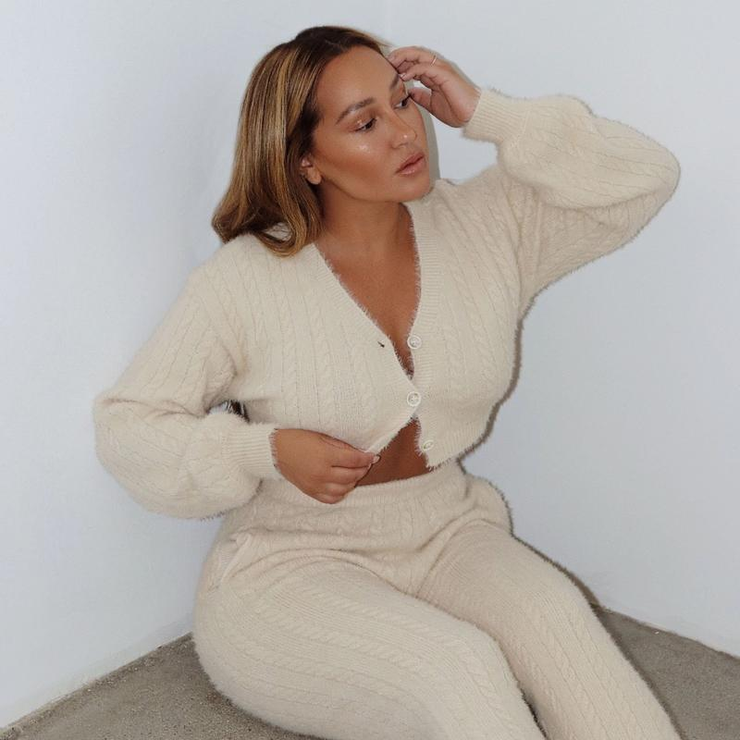
https://shoplavoute.com/collections/lounge

As you can see in these images above, this celebrity’s brand is based on lounge wear that comes in many neutral and brown colors such as tan, brown, beige, and nude. She incorporates different textures such as knits, cotton, and shape wear to her brand. These types of neutral colors are what is worn by many people for comfort and to wear for their “to-go” outfits when taking care of errands.
I used the natural solution of black coffee for my tie-dye experiment because I wanted my shirt to have that type of tan/brownish shade. I watched a youtube tutorial on how to tie-dye a white cotton shirt which is exactly what I used. I went with the pie shaped swirl technique where I scrunch up my shirt without folding it and take three rubber bands to separate where I am going to pour my natural tie-dye solution and where I’m not.
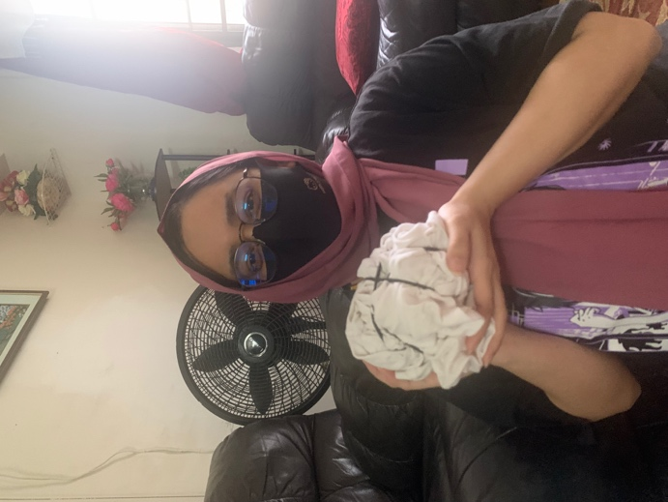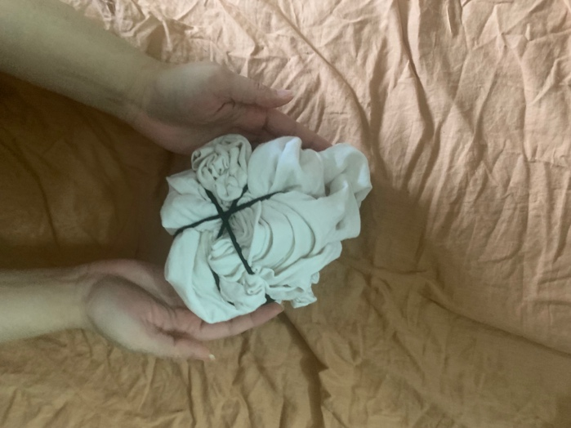;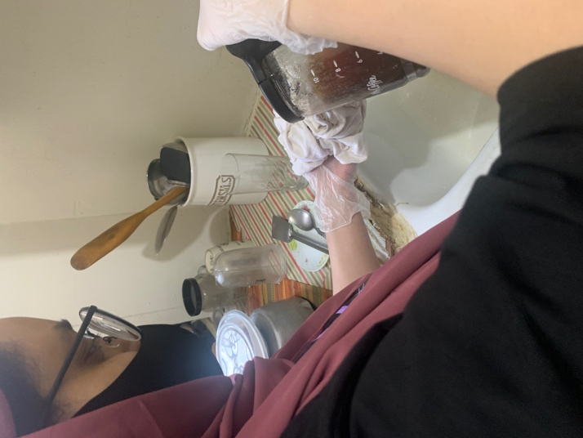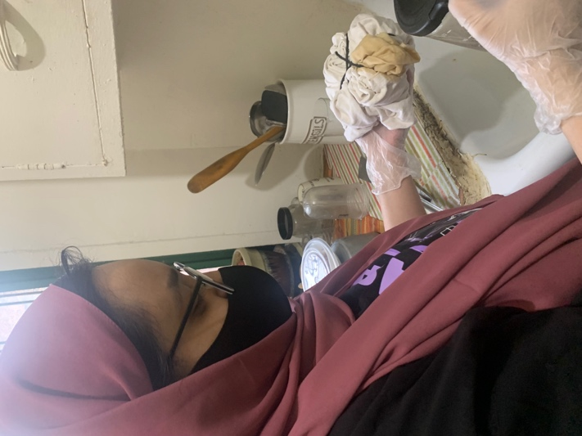
Step 1: Scrunch up your garment
Step 2: Take three rubber bands and wrap it on the shirt dividing the shirt into six sections
Step 3: Pour the natural dye solution on each part, and skip the next side leaving it white for the pattern to appear
Step 4: Continue doing the steps until all three parts are stained with the natural dye solution
Step 5: Take out the rubber bands and rinse off the shirt
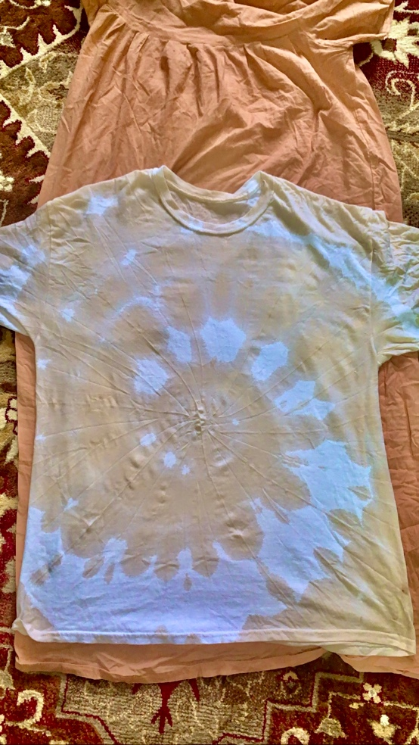
FINAL RESULT
In conclusion, I find that my project did not exactly turn out the way I expected. My natural tie-dye solution of black coffee definitely worked in staining the garment. However, my garment did not have a full circle of the pie shaped swirl I intended to create. I followed the youtube tutorial, but I may have not sectioned the rubber bands correctly and the coffee might have stained more parts of the shirt than what was supposed to. Or while I let it stain for a ten to fifteen minutes, the coffee might have seeped through to the other sections. I learned that black coffee is a great natural tie-dye solution to use for garments of any kind, preferably white cotton, but that it needs to be dealt with extra precaution, so it dyes the design you want it to.

References
Avey, Tori. (2013). The History Kitchen: The Caffeinated History of Coffee. Retrieved from
https://www.pbs.org/food/the-history-kitchen/history-coffee/

National Coffee Association, USA Est. 1911. The History of Coffee. Retrieved from https://www.ncausa.org/About-Coffee/History-of-Coffee

Jacquard Products. (2012). Jacquard Products Presents: Tying and Dyeing the Centered Rainbow Spiral (Pt. 1). Retrieved from
https://www.youtube.com/watch?v=PbjWkiQ5DtI

Perfect Daily Grind. (2018). How Much Does Your Coffee Actually Cost to Produce? Retrieved from
https://perfectdailygrind.com/2018/02/how-much-does-your-coffee-actually-cost-to-produce/

