**Faharia Afrin**

**Course: TEXTILES** Fall 2021 CUNY/NYC College of Technology

**Professor:** Dr. Nazanin Munroe **Business Dept. Office:** 718-260-5773

**Course/Section:** BUF 2246-OL35, 3 Credits/4 hours(lecture/lab)

**Meeting times:** Mondays & Wednesdays, 4-5:40 pm

**Lab #2-Stain test with organic materials**

**LAB REPORT** Answer these questions and submit your report, with thumbnails photos of your samples at 10 min. with staining agents, and after washing.

1. **How did the appearance of the staining agent differ on the swatches during the experiment? Jot down a brief note for each:**
   1. Sample 1/Agent 1: The cumin paste appears to be a darker brown shade.
   2. Sample 1/Agent 2: The Coca Cola appears to be a light brown shade, sitting still on top of the fabric. .
   3. Sample 2/Agent 1: The cumin paste appears to be a lighter brown shade.
   4. Sample 2/Agent 2: The Coca Cola completely dissolved in the fabric once it was placed and turned the fabric darker.
   5. Sample 3/Agent 1: The cumin paste appears to be a shade of orangish brown.
   6. Sample 3/Agent 2: The cocoa cola appears to be a light brown shade, sitting on top of the fabric.
2. **Which fabric was most affected by agent #1? List in order of darkest to lightest stain residue**

The fabric most affected by agent #1 (cumin paste) in order of darkest to lightest stain residue is:

Sample #2 (100% Polyester), Sample #1 (100% Cotton), and Sample #3 (65% Polyester, 35% Cotton).

1. **Which fabric was most affected by agent #2? List in order of darkest to lightest stain residue**

The fabric most affected by agent #2 (Coca cola) in order of darkest to lightest stain residue is:

Sample #2 (100% Polyester), Sample #3 (65% Polyester, 35% Cotton), and Sample #1 (100% Cotton).

1. **How much staining is left after washing? Indicate: none, some, most, or all**

Swatch 1, Agent 1: Some

Swatch 1, Agent 2: None

Swatch 2, Agent 1: Some

Swatch 2, Agent 2: None

Swatch 3, Agent 1: None

Swatch 3, Agent 2: None

1. **Write a brief summary (a paragraph) concluding your observations on the lab. Include:** *Which fiber was the least stain-resistant (i.e., the stain remained after washing)?**Were the results expected or unexpected? How do you think you can remove a difficult stain?* *How does this impact your clothing choices? Do you care if your clothes are stained; why or why not? Is there any upside to organic materials that stain your clothes?*

According to the observation data from the lab, it has come down to the following conclusions. The fiber that was the least stain-resistant was Sample #2 (100% Polyester). The results were expected because I knew the fiber cotton is harder to stain which was proven when I used Coca Cola on it and the content didn’t dissolve into the fiber, rather it sat still on top of it. I believe you can remove a difficult stain by immediately washing the fabric because the longer you let a stain sit in the fabric, the more and darker it stains which makes it harder to remove. This impacts my clothing choices in deciding not to wear white as much because it’s easier for stains to appear on white or light colored clothing rather than dark colors. I do care if my clothes are stained because I don’t like the feeling of being dirty and I don’t like when my clothes get ruined. I’m not sure if there is any benefits of organic materials that stain my clothes.

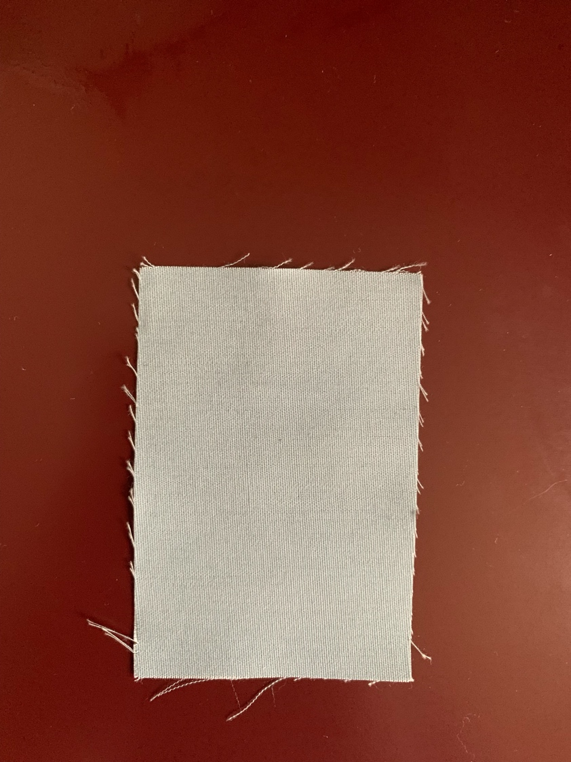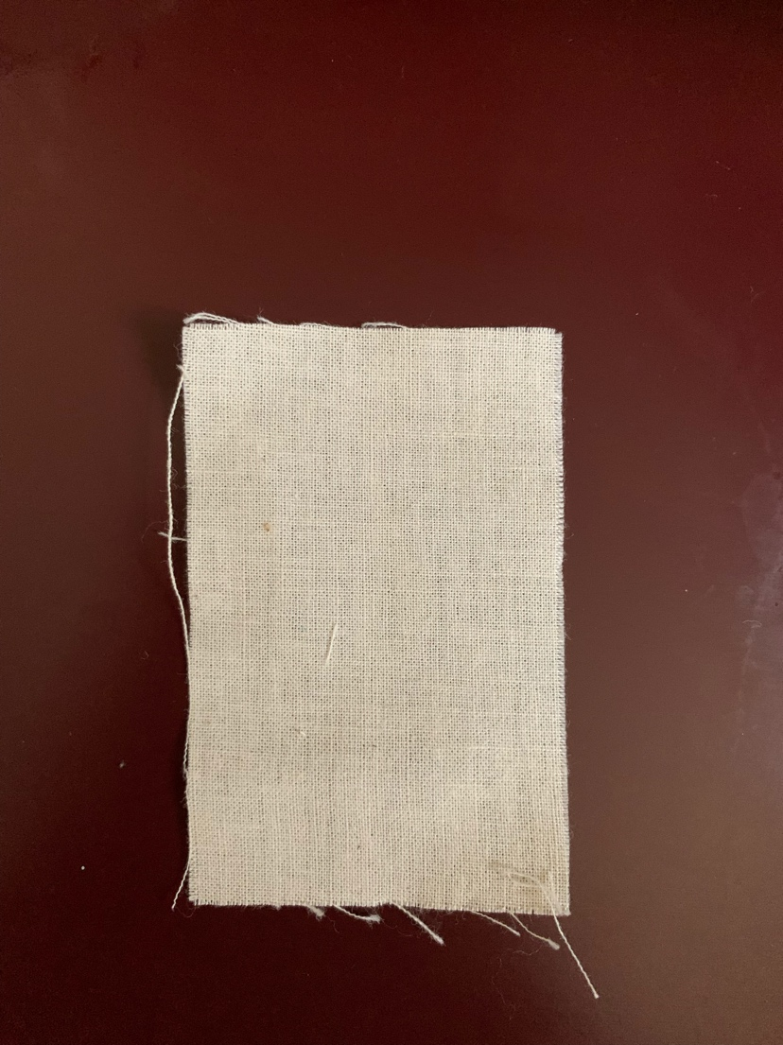Sample 1: 100% Cotton Sample 3: 65% Polyester, 35% Cotton

Sample 2: 100% Polyester

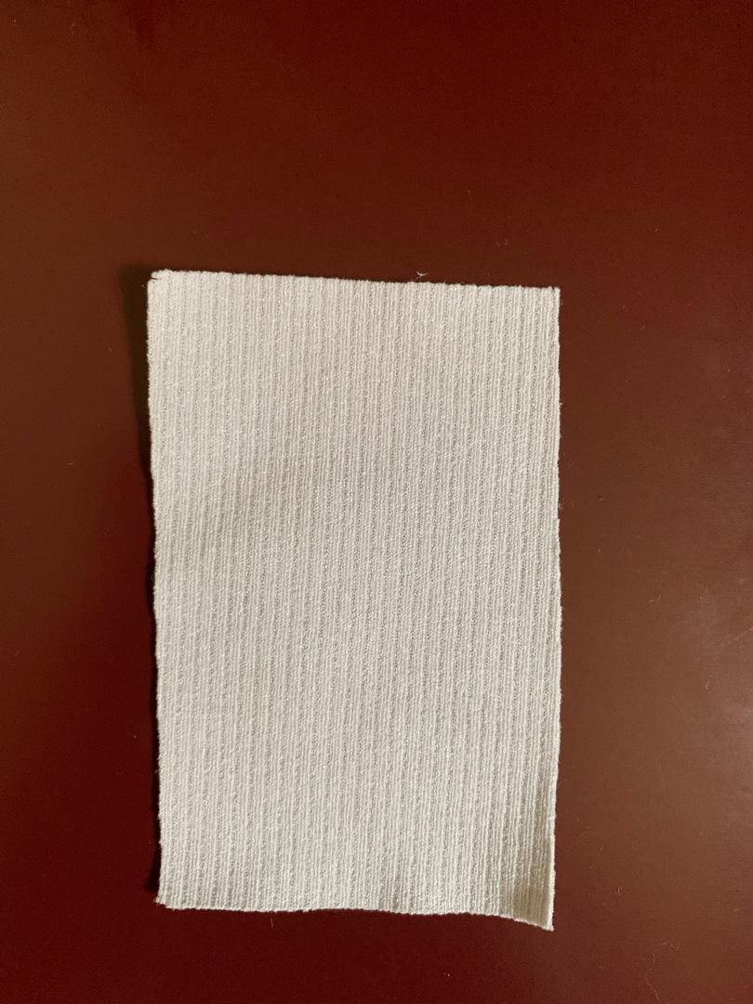

Sample 1 Sample 3

Staining Agents: Staining Agents:

* Cumin • Cumin
* Coca Cola 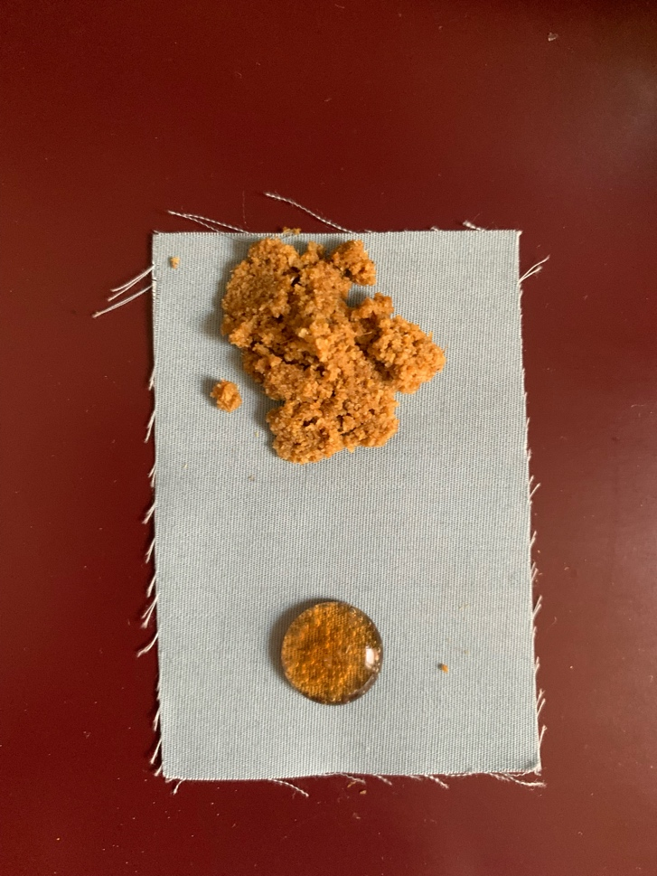 • Coca Cola

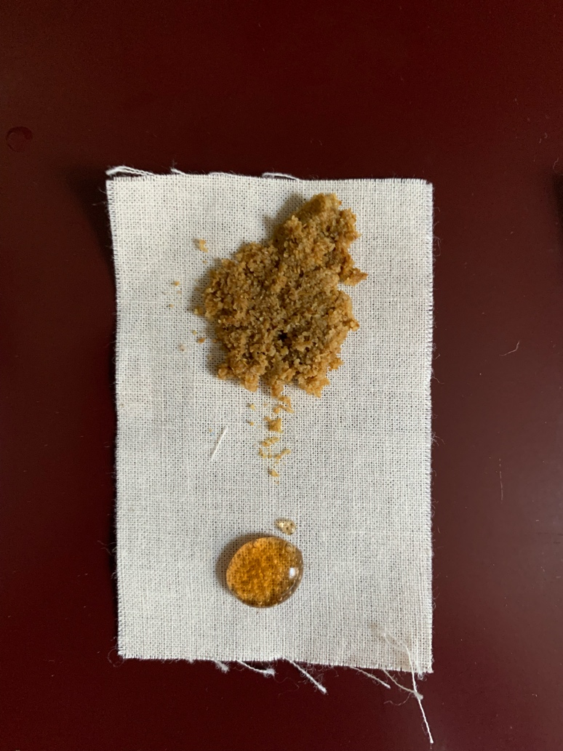

Sample 2

Staining Agents:

* Cumin
* Coca Cola

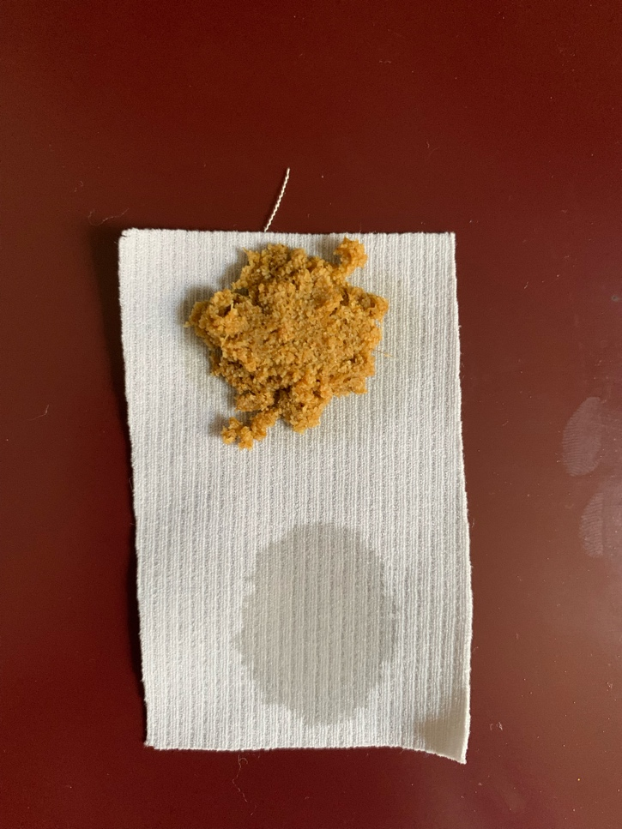

Sample 1 Sample 3

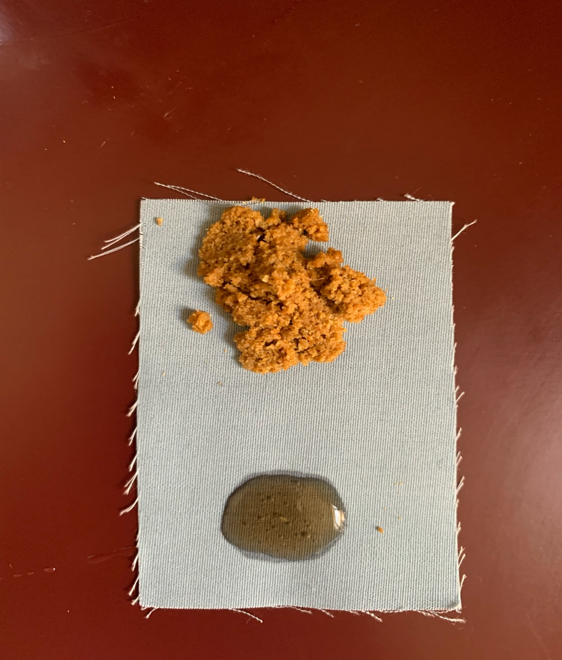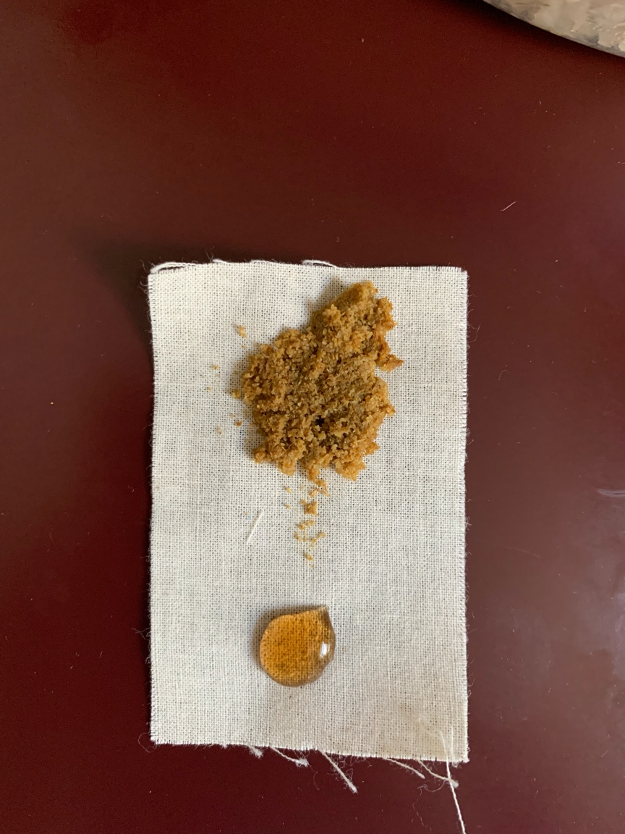10 Min After Staining: 10 Min After Staining:

Sample 2

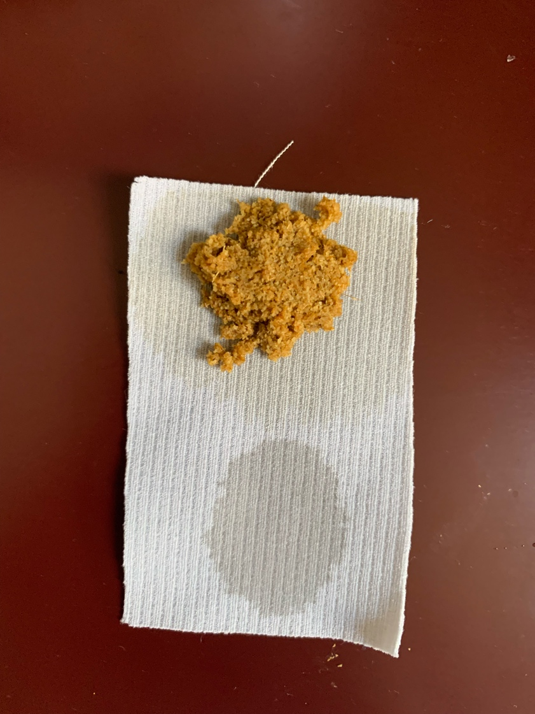10 Min After Staining:

Sample 1 Sample 3

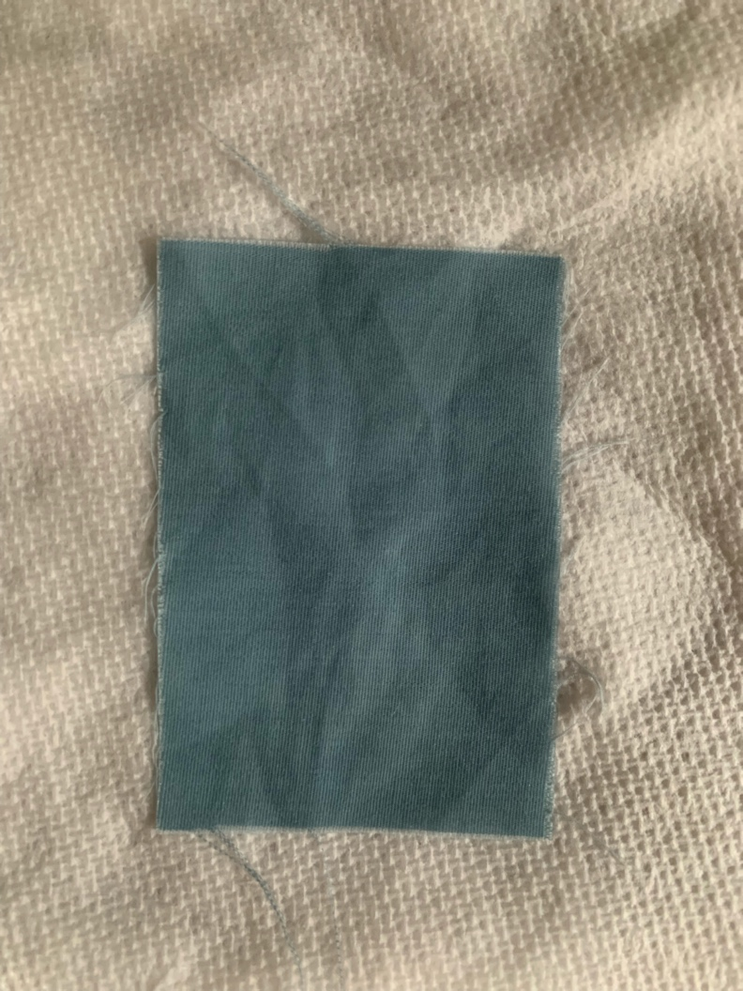10 Min After Washing 10 Min After Washing

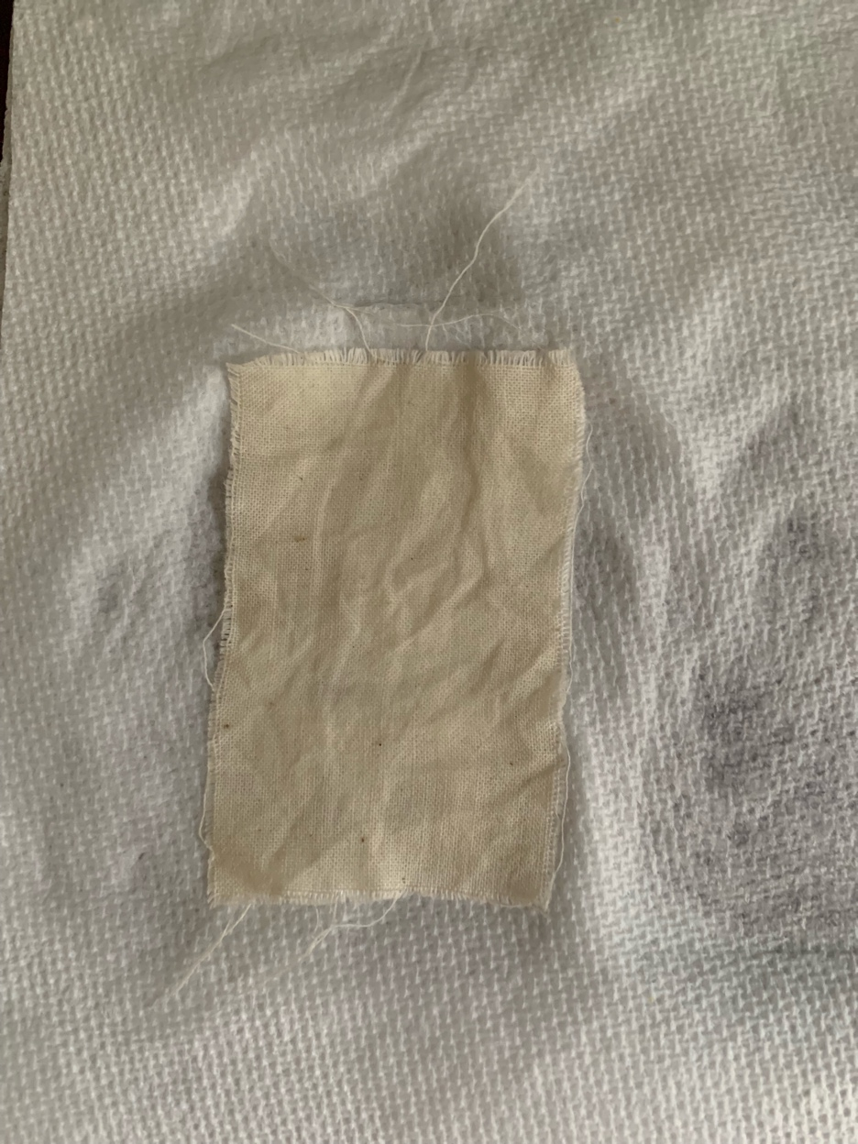

Sample 2

10 Min After Washing

