Purpose
The major objective of process safety management (PSM) for safe ladder usage is to develop a safe method to deploy, train and maintain the ladder. "Using this approach, the process design, process technology, process changes, operational and maintenance activities, and procedures, nonroutine activities and procedures, emergency preparedness plans and procedures, training programs, and other elements that affect the process are all considered in the evaluation." (“Ent Process Safety Management Assignment Template”)
Process Safety Information
1. List the potential Hazards of the ladder usage. the information to be compiled about the ladder, including process intermediates, needs to be comprehensive enough for an accurate assessment of the ladder. (“1910.119 App C - Compliance Guidelines and Recommendations ...”)
- Slip, trip, or fall
- Wet
- Working alone
- Working on uneven surface
- Standing on two tops steps

Pre-starting safety review
Using the what if table make a list of possible accidents that could happen during the handling of the material.
What If? | Answer | Likely hood | Consequences | Recommendations

Slip off top step | Back injury potential | possible | serious | Do not stand on two top steps
Ladder topples on side | Back injury potential | possible | serious | Have someone else hold the ladder
Chemical sitting on top of ladder spills |  | Possible | serious | Read SDS for chemical. Store in a container appropriate to use on a ladder.

Technology of the Process make a flow chart of how the chemical is going to be used.
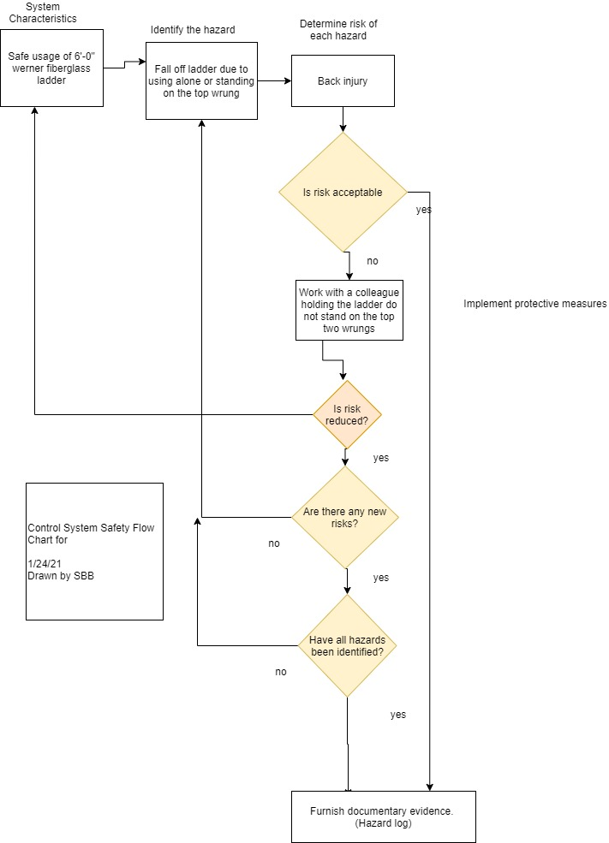

Employee Training
- Read Manual
- Participate in a safety training seminar before using
- Train in ppe usage needed for any other chemical being used with the ladder
- Practice safe ladder usage with a partner
- Select date and time for work to start to be sure your team knows the ladder is in use.

Written Procedures
- Prepare work area.
- Inspect ladder for any wear or damage.
- Tag the ladder out of use if damaged or painted.
- Prepare any ppe needed if a hazardous chemical is being used in association with the ladder.
- A work partner is assigned to hold the ladder in place before anyone climbs the ladder
- prepare chemical to be used on the ladder in the appropriate containers with the appropriate applicators.
- Use the ladder for the assigned task with a partner
- Afterwards clean the ladder
- Put chemical away and store safety
- Clean any ppe used
- Worker cleans up any exposed body areas.
- Clean work area for next usage.
Ladder Maintenance
Handling: Care should be taken to minimize impact loading to FRP ladders. Avoid dropping or stepping on ladders and dropping materials onto FRP ladder rails. (“FIBERGLASS LADDER TECHNICAL MANUAL - WernerCo”) Proper restraining of ladders during transit will prolong the useful life.
Dropping the ladder from a tall height or dropping off of a vehicle during transport can damage a section of the ladder. It should be immediately removed from service and replaced.
Maintenance: The maintenance cycle should be determined by local experience rather than by a national average. This requires the end user to use his/her best judgment in determining when an FRP ladder requires maintenance due to the effects of weathering.
When fiberglass ladders experience extreme UV and weathering and phenomenon called blooming can occur where the fiber is extruding from the surface of the ladder. This will not cause structural damage. But materials such as oil and chemicals can adhere to the bloom causing irritation to the end user.
Manufactured suggested maintenance
MAINTENANCE
"The end user shall use his/her best judgment to determine when a ladder requires maintenance." (“FIBERGLASS LADDER TECHNICAL MANUAL - WernerCo”) A good, general maintenance program should include the following:
"1. All ladders should be cleaned of any build-up of dirt, grime, dust, grease, carbonaceous and other conductive materials." (“FIBERGLASS LADDER TECHNICAL MANUAL - WernerCo”) The cleaning effort ensures retention of the original electrical insulating characteristics and precludes a surface tracking condition. Regular washing and waxing will also greatly reduce the degree of surface degradation and potential fiber bloom. Wax slows down the entry of water but is invisible to U.V. (“FIBERGLASS LADDER TECHNICAL MANUAL - WernerCo”)
2. If the ladder is used indoors, there are fewer environmental concerns unless it is in a chemical environment. In that case, periodic inspection and possible coating may be warranted. Maintenance in a chemical environment requires specific consultation. (“FIBERGLASS LADDER TECHNICAL MANUAL - WernerCo”)
3. Ladders stored out-of-doors for extended periods of time can have the effect of weathering decreased by semi-annual waxing of the rails. Normally a good commercial non-slip paste wax, such as SC Johnson® Paste Wax3, will reduce the possibility of glass fiber prominence.
4. Ladders employed in geographic locales with high U.V. ray exposure can have extended life and reduced potential for glass fiber prominence by periodic coating with certain acrylic lacquers, polyurethane coatings, or similar materials. The U.V. additive employed in the resin formulation is gradually consumed during sunlight exposure. These subsequent coatings replace the U.V. screen or barrier.
5. A spot coating with a highly pigmented polyurethane resin is highly recommended when the ladder surface has been damaged by localized impact or abrasion. If there is any structural damage consult Werner Co. on repair or replacement or discard the ladder. (“FIBERGLASS LADDER TECHNICAL MANUAL - WernerCo”)
6. Ladders in service out-of-doors, where high humidity or high humidity coupled with intense U.V. ray exposure exists, may have their service life increased by applying a lacquer or paint coating and waxing
Inspection.
Complete a ladder inspection upon initial receipt and before each use. Check all working parts to see that they are functioning properly before using a ladder. Where structural damage is found, the ladder needs to be repaired by a competent repair center or returned to the manufacturer for repair.
Tip Over. If a portable FRP ladder has tipped over, inspect for the following damage: Both self and non-self-supporting FRP ladders:
a. Cracks, fractures, splits, gouges, punctures or other structural damage to FRP side rails
b. Rivets that have been sheared, pulled through, uncurled or loosened
c. Components, such as braces that have been buckled, fractured, cracked or damaged Non-self-supporting
FRP ladders:
a. Bent locks, broken flippers on locks and flippers that don't pivot freely
b. Broken end caps and rail closures
c. Bent or dented rungs
d. Rungs that have loosened in their swages and move in or out when hand force is applied e. Bent guide brackets or damaged guide bracket connections Self Supporting
.
Stepladders shall open and close freely, and shall stand on a level floor without rocking.
Exposure to Fire. If ladders are exposed to excessive heat as in the case of fire, the strength may be reduced. After such exposure the ladder should be inspected visually for damage and tested for deflection and strength characteristics. In doubtful cases, refer to the manufacturer.
Corrosive Substances. When ladders are to be subjected to certain acids, alkali solutions, or other corrosive substances, consult the corrosion resistance guide on page four prior to their use. Contact the manufacturer if still in doubt.
Oil and Grease. Equipment shall be free of oil, grease, or slippery materials on climbing or gripping surfaces. Damaged Ladders. Ladders having damage or excessive wear are to be marked and taken out of service until repaired by an authorized repair center or call Werner Co. at the number shown on the back cover for assistance.
Never straighten or attempt to use a bent ladder.
Electrical Insulating Qualities. To ensure the retention of the original electrical insulating characteristics, the ladder shall be maintained in a clean condition. All surface buildup of dirt, dust, grease, grime, carbonaceous, and other conductive materials shall be removed. The presence of such materials will provide a ready path for electrical currents to travel over the surface of the ladder and potentially endanger the user.

Accident plan
- Evaluate worker injury.
- are airways clear?
- Is First aid kit needed
- Call 911 if needed
- Fill in accident report, inform OSHA if needed.
- Inspect work area, make changes to area for a safer use of materials.

Summary
- What did you learn?
- How dangerous is a ladder
- How will using the product add to the workload of your shop?
  - Training managers and staff
  - Cleaning and Maintenance
  - Storage
I learned that the Werner 6’-0” fiber class step ladder is a safe and useful if used correctly. The end user should only set it up on level ground. No-one should work on a ladder alone. The worker should find a partner to hold the ladder anytime they are on it. Never stand on the top two rungs as it is easy to topple the ladder by loosing one’s balance. Use the appropriate accessories to hold tools and materials needed for the project.
A ladder can be a dangerous tool if used alone especially on an uneven surface. It is essential that management train their crew on the safe usage of each ladder in their inventory. Fiberglass ladders are used by electricians as fiberglass does not readily conduct electricity. Care and storage of the ladders is key to ladder longevity and safety.
When the ladder is new it is essential that all management and staff train for the correct usage of the ladder including care, storage, and deployment. A shop that encourages employees to work in teams when a ladder is in use will be a safe location to work.
- After doing this process are you still comfortable using this material or do you want to find a new material? If so, what is the new material and why is it better?
The Werner 6’-0” ladder is a safe tool if used properly. Creating a sign in and out system will enforce the managers to talk to each employee before the ladder is used. This enables management to assign another worker to the task to hold the ladder when in use.
Definitions and standards that relate to the project
OSHA standard | Related to my project
1910.21 definitions | "Ladder means a device with rungs, steps, or cleats used to gain access to a different elevation." (“Definition: Ladder from 29 CFR § 1910.21 | LII / Legal ...”)
 | "Fall hazard means any condition on a walking-working surface that exposes an employee to a risk of harm from a fall on the same level or to a lower level." (“Definition: Fall hazard from 29 CFR § 1910.21 | LII ...”)
 | "Portable ladder means a ladder that can readily be moved or carried, and usually consists of side rails joined at intervals by steps, rungs, or cleats." (“eCFR :: 29 CFR Part 1910 Subpart D -- Walking-Working Surfaces”)
 | "Stepladder means a self-supporting, portable ladder that has a fixed height, flat steps, and a hinged back." (“1910.21 - Scope and definitions. | Occupational Safety and ...”)
 | "Walking-working surface means any horizontal or vertical surface on or through which an employee walks, works, or gains access to a work area or workplace location." (“Definition: Walking-working surface from 29 CFR § 1910.21 ...”)
1910.23(b)(7) | Ladder surfaces are free of puncture and laceration hazards;
1910.23(b)(8) | "Ladders are used only for the purposes for which they were designed" (“1910.23 - Ladders. | Occupational Safety and Health ...”)
1910.23(b)(9) | Ladders are inspected before initial use in each work shift, and more frequently as necessary, to identify any visible defects that could cause employee injury;
1910.23(b)(10) | Any ladder with structural or other defects is immediately tagged "Dangerous: Do Not Use" or with similar language in accordance with § 1910.145 and removed from service until repaired in accordance with § 1910.22(d) or replaced. (“1910.23 - Ladders. | Occupational Safety and Health ...”)
1910.23(c)(1) | "Rungs and steps of portable metal ladders are corrugated, knurled, dimpled, coated with skid-resistant material, or otherwise treated to minimize the possibility of slipping;" (“1910.23 - Ladders. | Occupational Safety and Health ...”)

Werner Fiberglass technical manual, Werner Co, 93 Werner Rd, Greenville PA, Werner 2010
Werner Fiberglass technical manual, Werner Co, 93 Werner Rd, Greenville PA, Werner 2010
Werner Fiberglass technical manual, Werner Co, 93 Werner Rd, Greenville PA, Werner 2010

