Purpose
The major objective of process safety management (PSM) of highly hazardous chemicals is to prevent unwanted releases of hazardous chemicals especially into locations or that could expose employees and others to serious hazards. An effective process safety management program requires a systematic approach to evaluating the whole chemical process. Using this approach, the process design, process technology, process changes, operational and maintenance activities, and procedures, nonroutine activities and procedures, emergency preparedness plans and procedures, training programs, and other elements that affect the process are all considered in the evaluation. Prep.

Process Safety Information
1. List the Hazards of the Chemicals Used in the Process get from SDS the information to be compiled about the chemicals, including process intermediates, needs to be comprehensive enough for an accurate assessment of the material.

Pre-starting safety review
Using the what if table make a list of possible accidents that could happen during the handling of the material.
What If? | Answer | Likely hood | Consequences | Recommendations

Technology of the Process make a flow chart of how the chemical is going to be used.
I suggest you use excel, LUCID charts or draw.io to make the flow chart.
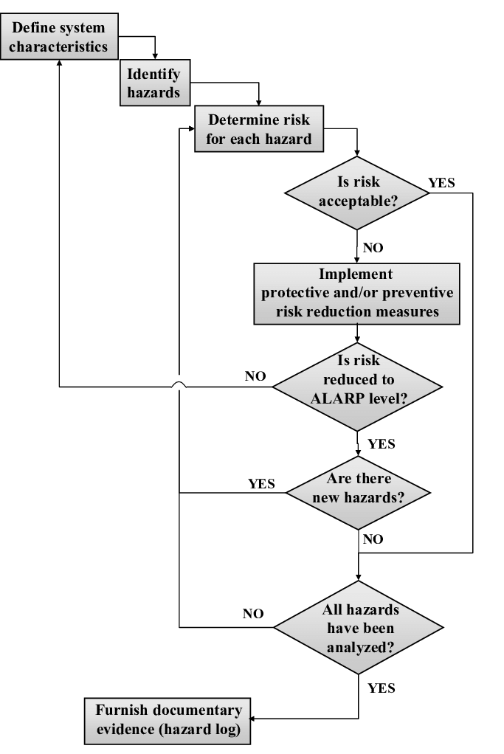

Employee Training
Make a list of the process you would take to training your employees. Use the SDS information as a guide.

Written Procedures
Make a list of the process you would take for the handling of the material from arrival at your venue through storage after it is used. Use the SDS information as a guide.

Accident plan
Read your what if list. Use the list and your SDS to create an accident plan.

Summary
What did you learn?
(After doing this process are you still comfortable using this material or do you want to find a new material? If so, what is the new material and why is it better?)

