Purpose
The major objective of process safety management (PSM) of highly hazardous chemicals is to prevent unwanted releases of hazardous chemicals especially into locations or that could expose employees and others to serious hazards. An effective process safety management program requires a systematic approach to evaluating the whole chemical process. Using this approach, the process design, process technology, process changes, operational and maintenance activities, and procedures, nonroutine activities and procedures, emergency preparedness plans and procedures, training programs, and other elements that affect the process are all considered in the evaluation. Prep.

Process Safety Information
1. List the Hazards of the Chemicals Used in the Process get from SDS the information to be compiled about the chemicals, including process intermediates, needs to be comprehensive enough for an accurate assessment of the
- fire and explosion characteristics
- reactivity hazards,
- the safety and health hazards to workers, and
- the corrosion and erosion effects on the process equipment and monitoring tools.
Current material safety data sheet (MSDS) information can be used to help meet this but must be supplemented with process chemistry information, including runaway reaction and over-pressure hazards, if applicable.
Hazards from contact with or inhalation of harmful fluids, gases, mists, fumes, and dusts 2. Fire or explosion hazard 3. Biological or microbiological (viral or bacterial) hazards – From EN 1050 (1996) ❑ Flammables (ignition, fire, explosion/detonation) ❑ Chemicals (toxicity, corrosion, off-specification) ❑ Pollutants (emissions, effluents, ventilation)

Pre-starting safety review
Using the what if table make a list of possible accidents that could happen during the handling of the material.
What If? | Answer | Likely hood | Consequences | Recommendations

- Lifting gallon containers material spills  - Material on skin  - Material splashes in eyes  - Poor ventilation, inhale | 1. Back injury potential  2. burn skin or eyes  3. same  4. ingestion to lungs | 1.remote  2. Possible  3. possible  4. remote  R | - Minor  - Minor  - Serious  - Serious | - do not lift over waist.  - Where protective gloves and clothing  - Wear protective goggles.  - Wear respirator

Technology of the Process make a flow chart of how the chemical is going to be used.
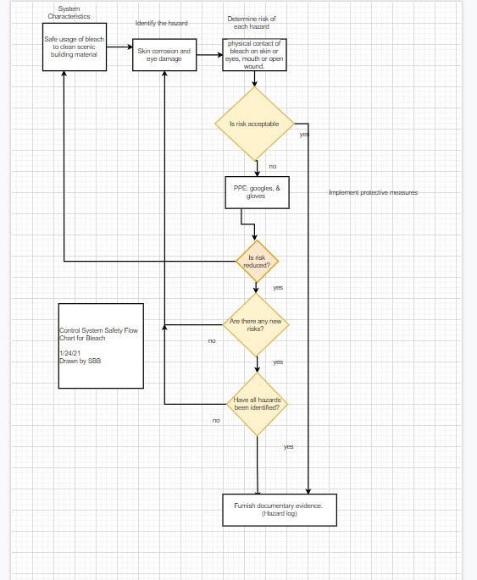

Employee Training
- Read sds.
- Set time limit for working with chemical daily.
- Train in ppe usage
- Select work location with ventilation.
- Select date and time for work to start and end.

Written Procedures
- Prepare work area.
- Don ppe
- Move chemical to work area.
- Use chemical.
- Clean area
- Put chemical away.
- Clean work area
- Clean worker

Accident plan
- Evaluate injury are airways clear?
- First aid kit
- Call 911
- Fill in accident report, inform OSHA if needed.
- Inspect work area, make changes to area for a safety use of materials.

Summary
- What did you learn?
- How toxic is your material?
- How will using the product add to the workload of your shop?
  - Training managers and staff
  - Cleaning and Maintenance
  - Storage
- After doing this process are you still comfortable using this material or do you want to find a new material? If so, what is the new material and why is it better?

