Purpose
The major objective of process safety management (PSM) of equipment is to prevent employee injury. Using this approach, the process design, process technology, process changes, operational and maintenance activities, and procedures, nonroutine activities and procedures, emergency preparedness plans and procedures, training programs, and other elements that affect the process are all considered in the evaluation. Prep.

Process Safety Information
1. Some dust created by power sanding, sawing, grinding, drilling, and other construction activities contains chemicals.
known to cause cancer, birth defects or other reproductive harm. Some examples of these chemicals are:
• lead from lead-based paints,
• crystalline silica from bricks and cement and other masonry products, and
• arsenic and chromium from chemically treated lumber.
Your risk from these exposures varies, depending on how often you do this type of work. To reduce your exposure to
these chemicals: work in a well-ventilated area, and work with approved safety equipment, such as those dust masks
that are specially designed to filter out microscopic particle.

2. electrical hazards cord well maintained no cuts, knots, or splices.

3. Safe handling of tool.

4. Safe environment of work area.

5. Use in dry environment.

Pre-starting safety review
Using the what if table make a list of possible accidents that could happen during the handling of the material.
What If? | Answer | Likely hood | Consequences | Recommendations

- Worker breathes dust.  - Worker cuts cord with tool.  - Worker mishandles tool.  - Poor ventilation. | 1. inhale non-respirable particles.  2. tools stops mid cut.  3. Tool cuts worker.  4. ingestion of respirable particles. | 1. possible  2. Possible  3. possible  4. possible | - serious  - serious  - Serious  - Serious | - Wear dust mask.  - Proper cord maintenance.  - Tool training before use.  - Wear a respirator.

Technology of the Process make a flow chart of how the chemical is going to be used.
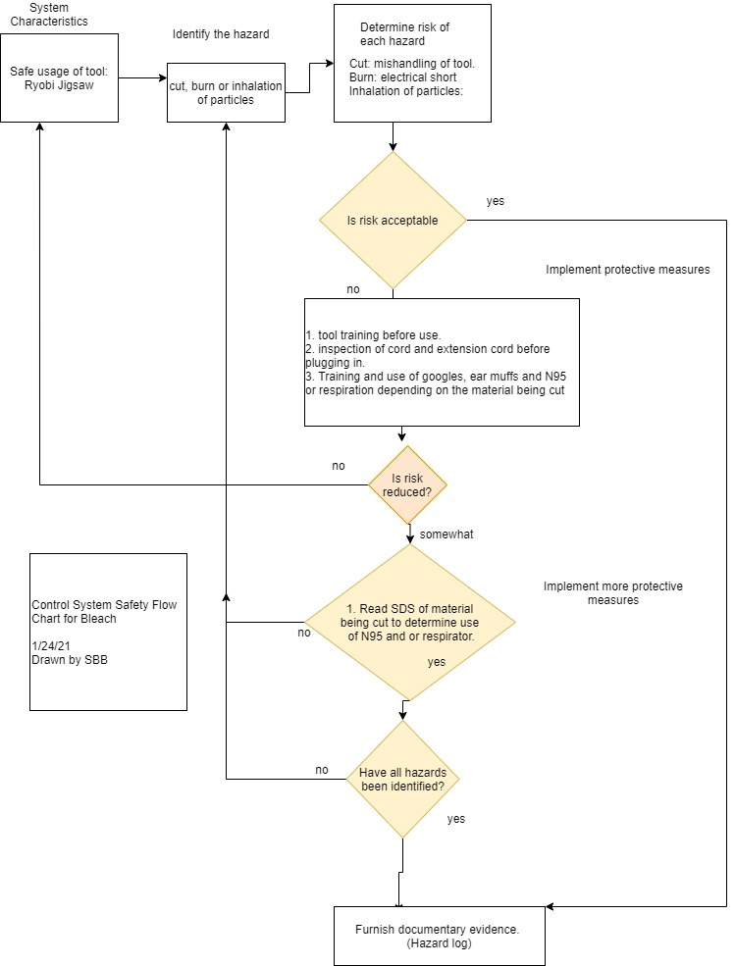
ALARP, which stands for "as low as reasonably practicable", or ALARA ("as low as reasonably achievable"), is a term often used in the regulation and management of safety-critical and safety-involved systems.[1][2] The ALARP principle is that the residual risk shall be reduced as far as reasonably practicable. In UK and NZ Health and Safety law, it is equivalent to SFAIRP ("so far as is reasonably practicable").
For a risk to be ALARP, it must be possible to demonstrate that the cost involved in reducing the risk further would be grossly disproportionate to the benefit gained.[3] The ALARP principle arises from the fact that infinite time, effort, and money could be spent in the attempt of reducing a risk to zero. It should not be understood as simply a quantitative measure of benefit against detriment. It is more a best common practice of judgement of the balance of risk and societal benefit.

Employee Training
- Read manual.
- Create tool safety check list. *
- Train worker in safe usage of tool
- Set up workspace around the tool.
- Train in ppe usage: goggles, ear protection, dust mask and respirator.
- Select work location: should be dry, well-lit with ventilation.
- Select date and time for work to start and end if the tool is a hazard to others working in the shop.
- Participate in tool training.
- Participation in daily workspace cleanup of dust and excess materials.

Written Procedures
- Prepare work area.
- Check tool safety list.
- Don ppe
- Use tool.
- Clean area after work is competed daily.
- Put away.
- Clean work area
- Clean worker

Accident plan
- Evaluate injury are airways clear?
- First aid kit: cut and burn supplies. Neosporin and bandages.
- Call 911
- Fill in accident report, inform OSHA if needed.
- Inspect work area, make changes to area for a safety use of materials.
- Update accident plan before employees use tool.

Summary
- The jigsaw is a well-made tool if it is used correctly. Tool training is an essential ingredient to keeping workers safe in the shop.

* Tool Check list
- Read manual and get trained before first use.
- Check cord for cuts, nicks, splices, or knots. (if cord is damaged tag out and inform shop foreman)
- All fittings are tight.
- All guards in place.
- Correct blade selected for material being cut.
- Read SDS of material to use adequate PPE and or ventilation.
- Clean work area as needed: floor and worktable.
- Use proper vises and clamps for material before cutting.
- Keep hands away from cutting area.
- Be sure neighboring areas is informed of any SDS safety issues.
- Be sure material is cleaned of nails and staples.

