Window Display Comparison
Erik Ortiz
Visual Merchandising
New York City College of Technology

SCAMPER Model of Analyzing Visual Displays
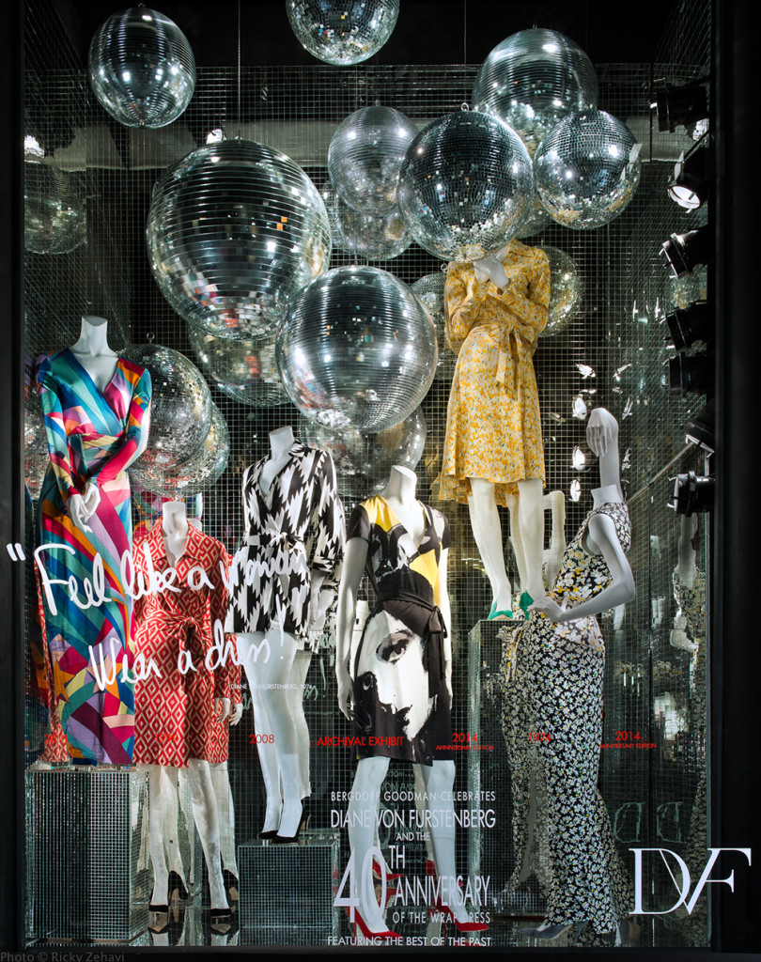

Figure 1. Bergdorf Goodman DVF’s wrap dress 40th anniversary window display (Zahavi, 2016).

Substitute- Exchange one expected idea for another (Bell & Ternus, 2012).
In the DVF window display above, one would replace the disco balls with mirrors and silver confetti.
Combine- Cross-merchandise (Bell & Ternus, 2012).
In the DVF window display above one would make sure that all mannequins are outfitted with DVF shoes, handbags, and jewelry. Although celebrating the 40th anniversary of the dress, it is beneficial to show the dress with other items that are also available to buy.
Adapt- Take an item that is intended to have a specific use and adapt it to better fit your
presentation (Bell & Ternus, 2012).
In the DVF window display above, one would use large number 40s as chairs and mannequin holders to further emphasize the point of the 40-year anniversary DVF is celebrating.
Modify- Magnify or minify (Bell & Ternus, 2012).
In the DVF window display above, one would shrink the size of the disco balls into different sizes to give a more random feel
Putting to other uses- unexpected uses for objects to grab attention (Bell & Ternus, 2012).
In the DVF window display above, one would change all the mannequins from plain mannequins with no head to mannequins made out of mirrors. It is meant for the women passer byers to be able to see themselves in the garment.
Eliminate- Quit while ahead (Bell & Ternus, 2012).
In the DVF window display above, one would remove the excessive amount of disco balls to clear up some of the clutter.
Reversing/Re-arranging- Present merchandise in an unexpected way (Bell & Ternus, 2012).
In the DVF window display above, one would hang mannequins from the ceiling with their feet on the ceilings and their head close to the ground. The wrap dresses with me kept down with invisible wire. There would be a mirror on the floor so the display is right side up when looked at through the mirror.
Bells Method of Analyzing Visual Displays

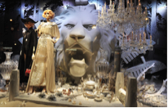
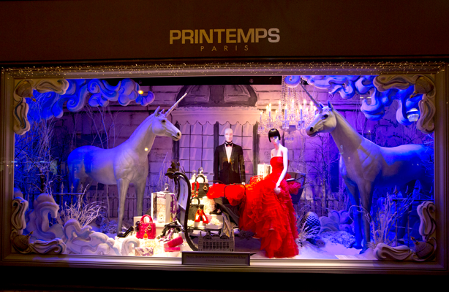
Figure 2. Dior for Printemps Paris 2012 Figure 3. Printemps Chanel Christmas 2011
Holiday window display (Nelson, 2012) window display (Brack, 2011)

LOOK, COMPARE, IMPROVE

LOOK- at competing stores and their visual displays presentations (Bell & Ternus, 2012).

- Both window displays come from Printemps Holiday Display in Paris.
- The first is a Dior window display from 2011. It features a male mannequin and a female mannequin on a sled surrounded by bags and shoes and two unicorns.
- The second is a Chanel ad from 2012. It features two female mannequins standing with chandeliers and fine china items placed on a boardwalk over sand. Behind everything is a large lion head protruding from the back wall.

COMPARE- the merchandise presented (Bell & Ternus, 2012).

- Both portray a dream state or a fantasy
- Both are cluttered with items.
- The centerpiece of the Dior window display is a beautiful red ball gown with matching red and white leather bags and shoes. Behind the female mannequin, the male mannequin is suited in a pristine black tuxedo with bowtie and white shirt.
  - This display is synergetic because it all helps shift focus to the gown. Besides the unicorns, the clutter is other available items.
  - The merchandise is clearly visible and at the front of the window.
- The Chanel window display features one mannequin wearing a sequin and fringe gown with a silk train. The other mannequin is wearing a long black silk cape and black bathing suit underneath with a black hat on her head.
  - The clutter is decoration instead of items that can be purchased.
  - The gown that is featured is hard to distinguish because it is the same color as the background.
IMPROVE- combine the best presentation techniques with your own ideas (Bell & Ternus, 2012).

- In the Dior window display, one would remove the unicorns and add more mannequins featuring different Dior looks to go with the gown. The lighting works well to guide the shopper’s eye to the gown. The lighting would be mimicked on the other looks so the viewer has more than one item to draw their attention.
- In the Chanel window display, one would remove all of the fine china and chandeliers. The tiger would be moved to one side and the mannequins to the other, facing the tiger, staring at it head on. This display exudes strength, and seeing the mannequins against the tiger would help express that.

References
Bell, J. A., & Ternus, K. (2012) Silent selling: Best practices and effective strategies in visual merchandising. New York: Fairchild Books.
Brack, T. (2011). Paris Review: Christmas windows at Galeries Lafayette and Printemps. Retrieved from http://www.eurocheapo.com/blog/paris-review-christmas-windows-at-galeries-lafayette-and-printemps.html
Nelson, M. (2012). An up-close look at Christian Dior’s Christmas windows for Printemps. Retrieved from http://www.globalblue.com/destinations/france/paris/christian-dior-printemps-christmas-windows/
Zehavi, R. (2016). “Feel like a woman, wear a dress!” Bergdorf Goodman’s Diane von Furstenburg Window Display. Retrieved from (http://thebwd.com/diane-von-furstenberg-feel-like-woman-wear-dress-window-display/)

