Routes—Area—Movement—Profile
- Routes (Arrows on maps)
  - Plotting ingress and egress routes
  - Assessing movement around the site
  - Defining the crowd management plan

- Creating drawings of flow of (only show locations of concern.)
  - ingress normal and emergency
  - circulation normal and emergency
  - egress normal and emergency

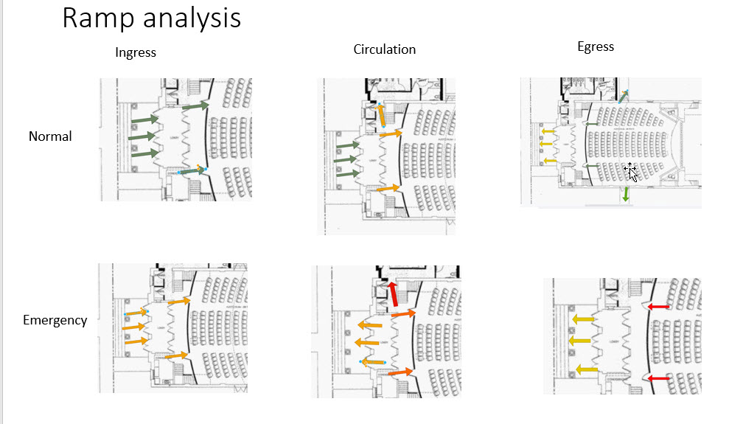

Profile
Profiling is not used to label an audience member, but to be used as a tool in case of an emergency where that specific individual may need more time or motivation to exit the theatre.

Family setting
Ushers should also observe and profile the audience as they arrive. Usher should identify, elderly, disabled, babies and very young guests. The usher should note the seating locations. The ushers report the head usher who will then create a plan of how to help these specific audience members exit the building in case of an emergency.

Young audience setting
Ushers should also observe and profile the audience as they arrive. Usher should identify, rowdy, angry, or inebriated guests. The usher should note the seating locations. The ushers report the head usher who will then create a plan of how to help these specific audience members exit the building in case of an emergency.

Summary
This document presents possible locations the audience could be at risk during three spans of time. Pre-show, intermission and post show audience exiting. The RAMP diagrams compare normal to emergency egress.

- Preshow has a low probability of risk because the audience arrives between 6:30-7pm to take their seats. They will not be crowding the corridors. During an emergency the front steps pose a risk as well as the audience theatre entrances as the location has the narrowest openings of the entire audience side of the venue. Possible solutions: post ushers at the interior doors to guide the audience flow for emergency situations. Post ushers near the exterior stairs to observe audience and guide as needed.
- Intermission has yellow flags during an emergency on the exits from the lobby to the stair. Orange flags on the interior audience exits to the lobby and a red flag near the lobby restroom corridor. Possible solutions for each condition:
  - Lobby exits to outdoors: pinch doors to stay wide open so audience does not need to push on the door, they only need to proceed through the opening.
  - Interior lobby doorways: Post an usher at each door to hold open, the ushers will observe and guide the audience member to the exterior doors in a calm cool voice.
  - Assign an usher to the restroom corridor. They will announce the audience need to proceed to the nearest exit. The usher will discourage entry into the hallway. A second usher will knock on the restroom doors, enter, then encourage audience members to leave the restroom, exit the corridor to the common lobby exits.

