Executive summary

This project will be examining Theatre fires in the United States between 1797 and 1900 and the resulting theatre fire laws. The hypothesis is that more stringent fire laws and building methods are required due the experience of fires in near or around theatres built in America. Theatres burning down due to a conflagration which will influence the creation of regulations and laws that effect the building, running and maintaining of theatres in the United States.
The resources that will provide the data include newspaper articles from local newspapers for historical references. Books and articles that discuss the topic.

This era with include the Iroquois Theatre fire in New York City that is a clear example of what happens when safety is not a priority.

The local newspapers from 1797-1900 will be read. The headlines data searches will be used to locate the articles that refer to fires in live performance venues. The information will be accumulated, interpreted, and discussed as a research paper.

The predicted outcomes will be an observation of current fire regulations and how similar or different are they fro the ones created at the turn of the century.

Understanding and recognizing the importance of the current regulations as a consequence of the earlier tragedies; will present the impact of regulations we take for granted in the present.

Project Description
The researcher is exploring the outcomes of theatre fires happening in the united states between 1796 and 1900. Many newspapers have microfiche copies of newspapers beginning in 1797. This is also the era of large cities being built throughout the United States. Portable venues such as pageant wagons will not be included in the capture of data. The rise of permanent performance venues and their impact on fires in the United States will be
addressed. Th stringent fire laws and building methods required are due the experience of fires in near or around theatres built in America. These outcomes Influenced the building, running and maintaining of theatres in the United States.

Methods
- Interlibrary search using datanet and bibliotek
- Microfiche for available newspapers including:
- Los Angeles Times
- New York Times
- New York Post
- Philadelphia Eagle

Deliverables

- Schedule of research and writing
- Completed document
- Citation list
- Tables of data collected
- List of documented Theatre fires 1797-1900

Required resources
- Access to Datanet and bibliotek through enrollment in LIB 4500 spring 1991
- Type writer
- Apple2E computer
- Truck for transportation to libraries

Budget

Item | Estimate amount | Total spent
Interlibrary research | 200.00 | 132.00
Travel | 400.00 | 345.00
Computer usage | 200 | 200.00
printing | 80.00 | 075.00
Estimate | $880.00 Total | $828.00

Schedule/Calendar

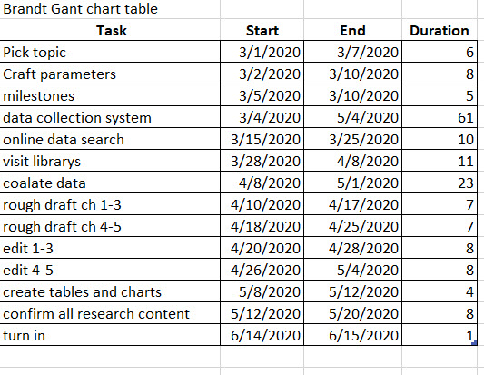
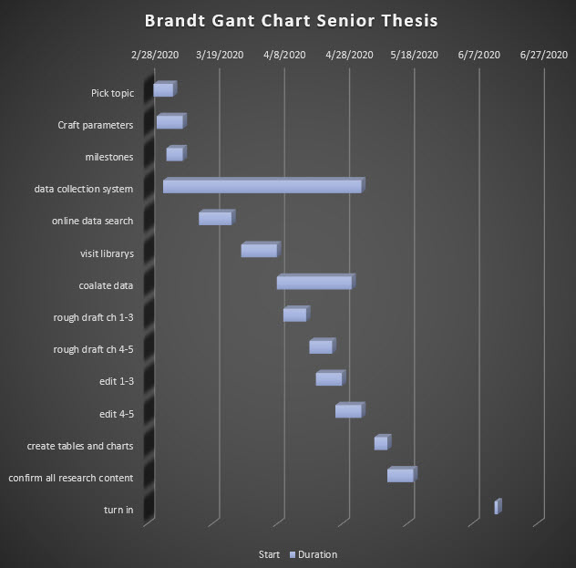

Proposed table of contents

- Proposal
- Culmination project agreement
- Era of fires: 1797-1900 examinations of fires in order of year
- Data
- Gant Chart with table

