Introduction
- Thesis example: The addition of sensors monitoring the audience progress through the experience will provide a consistent path for the audience to follow.

- Description of the experience systems. Choose a hominal or computational system and define the vocabulary word. Mention your step-by step plan. (Include a citation for each and footnote at the bottom of the page)

- How is integration of audience experience and technology key to the success of your project?

Supporting paragraph 1
Audience interaction plan. Insert your step-by-step chart and present the audience progression.
Description | Trigger | Scenery | Lighting | Sound | Video

Supporting paragraph 2
Show control plan. Insert your flow chart and explain the use of the networked systems.

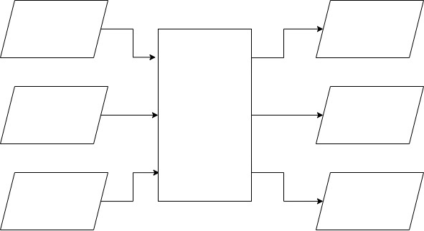

Supporting paragraph 3
Present the sensor types you chose, locations and expected audience interaction. (Use citations from sensor manuals or spec sheets)

Conclusion
Restate your thesis. What technologies did you use. What will be the significant outcome achieved by using your system. If you were to become a show control system designer What technologies do you need to study to complete this goal?

List of five words and their definitions from the terminology list you plan to use in your writing.
Word | Definition

List of three citations you found and plan to use in your writing
Author | Source | Why you think this citation is dependable

