Gantt charts are a useful way to visualize data. In essence, they can be used as a comprehensive timeline for project management.
Word itself is extremely customizable – however, there isn’t a Gantt chart template available in Word by default. Instead, you’ll have to add a Gantt chart to Word manually.
In this step-by-step guide, you’ll learn exactly how to make a Gantt chart in Word with ease.

Step 1: Change Your Page Orientation
After opening a new Word document, you’re ready to begin.
First, you’ll need to set the page’s orientation from Portrait to Landscape. This ensures that the document has enough space for the Gantt Chart without looking cramped.
To do so, go to *Page Layout > Orientation > Landscape *
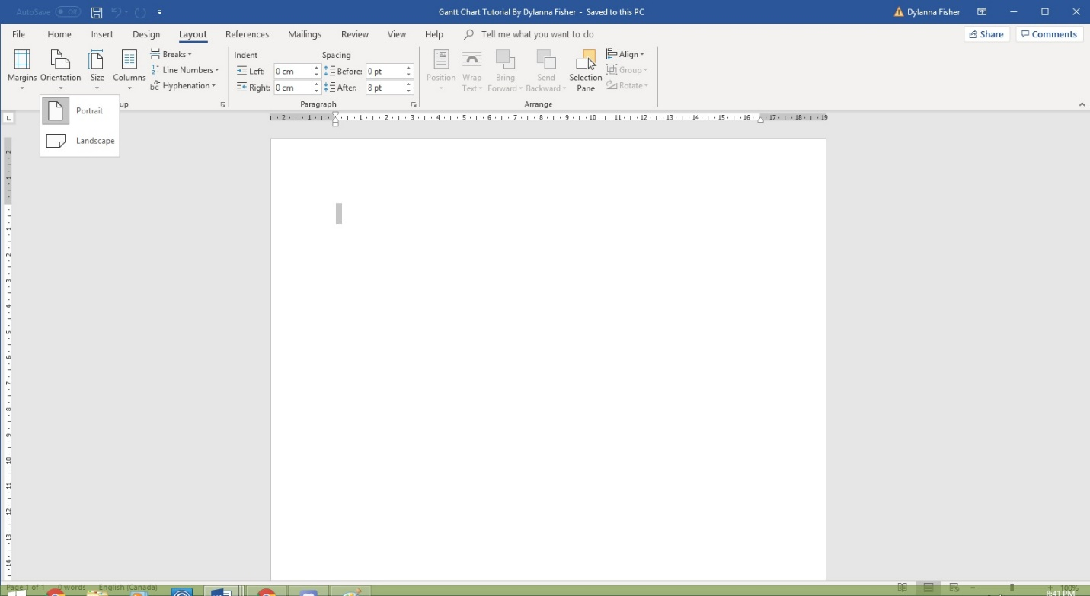
From this step, you need to create a stacked bar chart, which will serve as the base of the Gantt chart.

Step 2: Creating a Stacked Bar Chart
Go to Insert > Chart
To create a Bar graph, click Insert > Charts > Bar > 2-D Bar > Stacked Bar.
From this step, it will open up a menu with a list of available charts.
To find the graph you require click Bar > Stacked Bar > OK
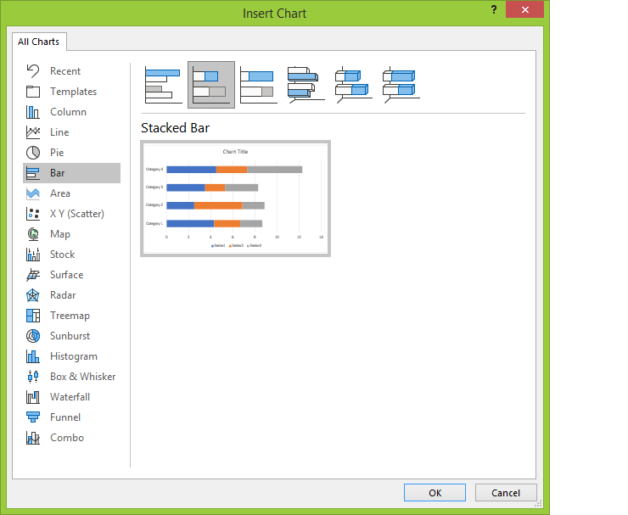
Word will generate a standard stacked bar chart like the one below along with an Excel table window where you can change the placeholder data to your own.

Step 3: Adding Data to Your Chart
This is where you put in your information for your timeline, deadlines, duration, and tasks.
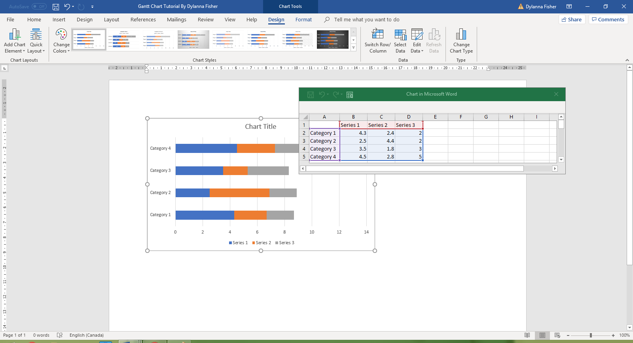
As you type in your information you will also need to type in the series and axis titles.
These are typically project tasks, as well as a start date, end date, and duration for each of those tasks.
Enter the project tasks as you need them in Column A of the excel window which popped up in your Word document.
The chart graphic behind the word document will automatically populate the graph with the information you enter.
Rename the columns with tasks (column A), Start date (Column B), End date (Column C), and duration (Column D).
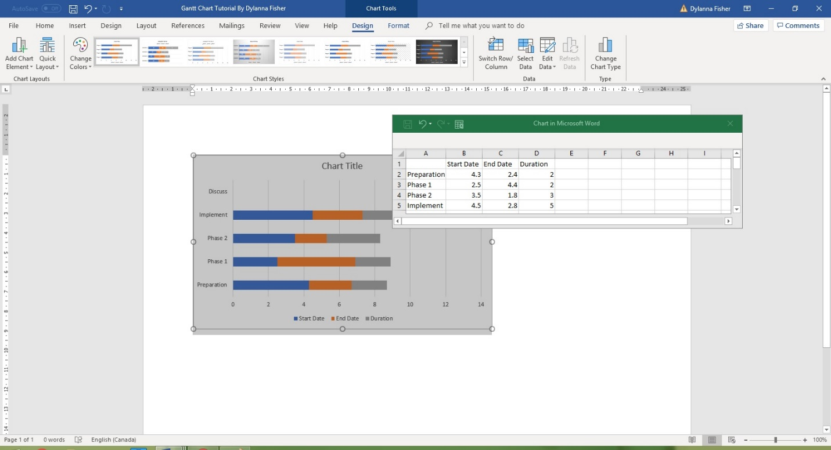
To make the information properly displayed as a date and easier to read, you can choose to format the start date and end date columns.
To do so, Highlight Column b and c > Right-click > Format Cells > Date > Desired Date format
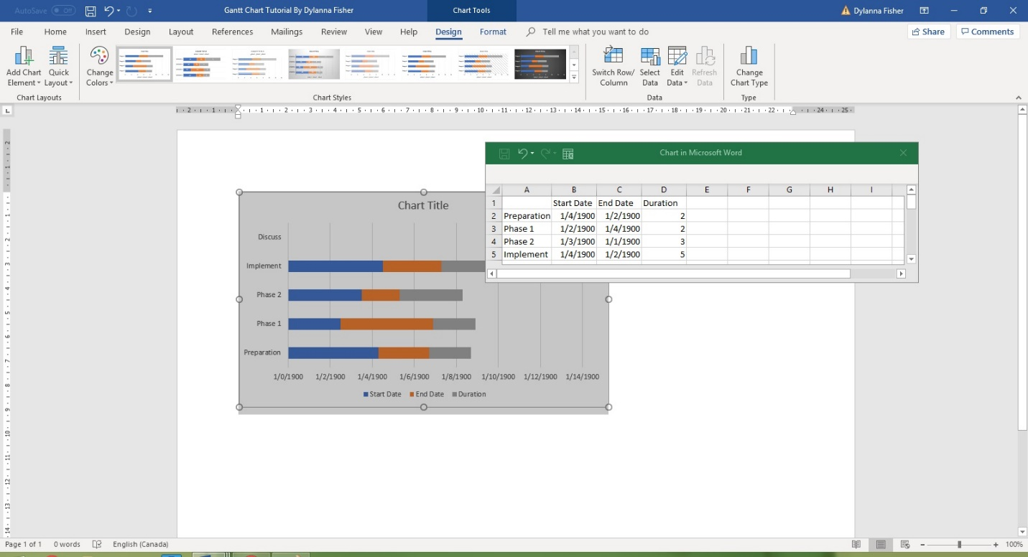
Now the duration data needs to be formatted to save you from doing extra work.
Click the Excel icon on the right-hand corner of the Excel data Window:
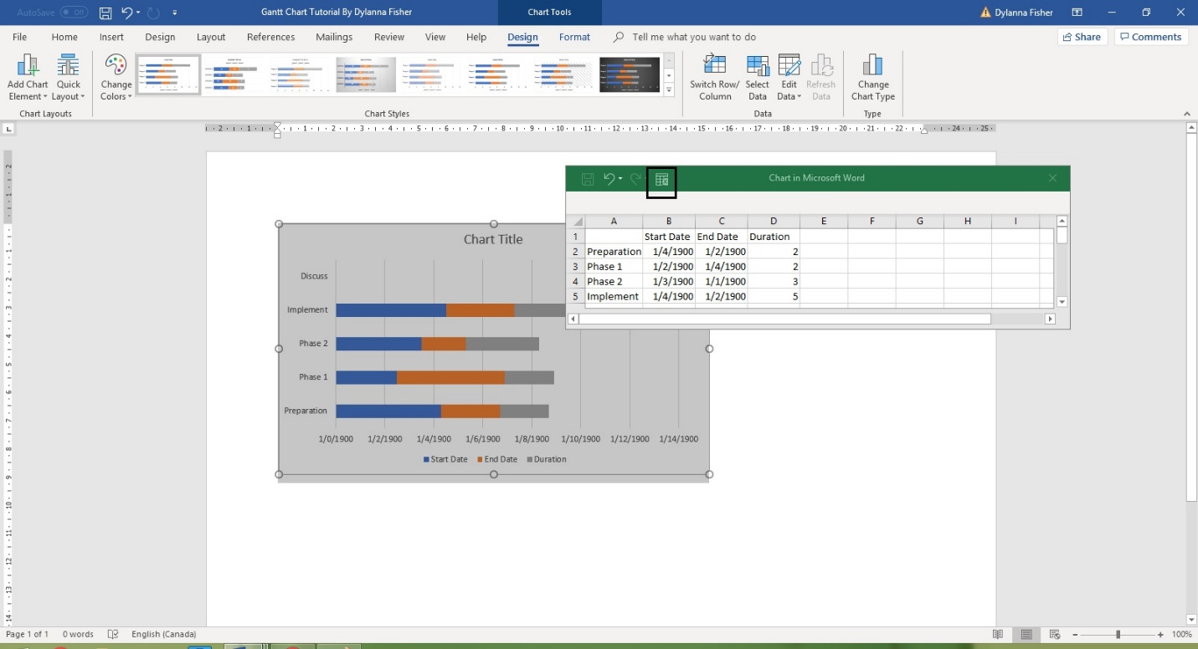
This will open up the Excel window into a whole Excel document with full editing capabilities. From here begin by typing the formula =$C2-$B2 in cell D2 and then continue to do so throughout column D where there is Duration Information.
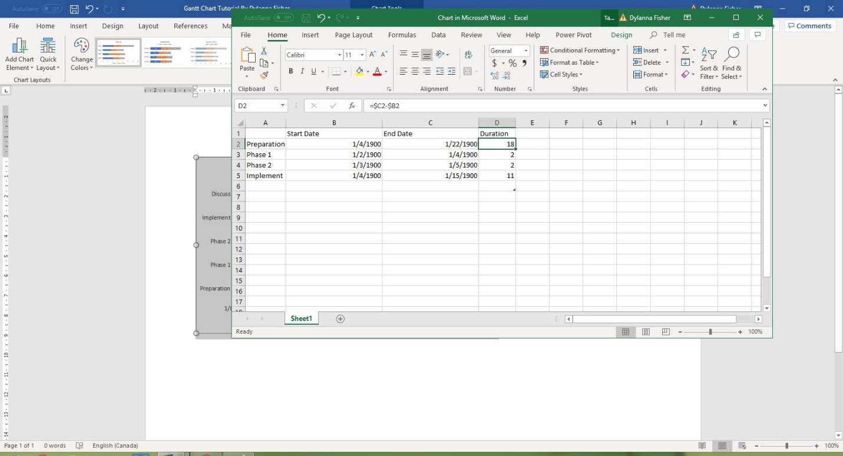
With the duration data inputted properly, the end date data is no longer needed. This is an easy series to delete from your graph.
To remove the end date series select the chart > click on chart filters (Funnel icon to the right of the graph) > Uncheck the End date checkbox > Apply
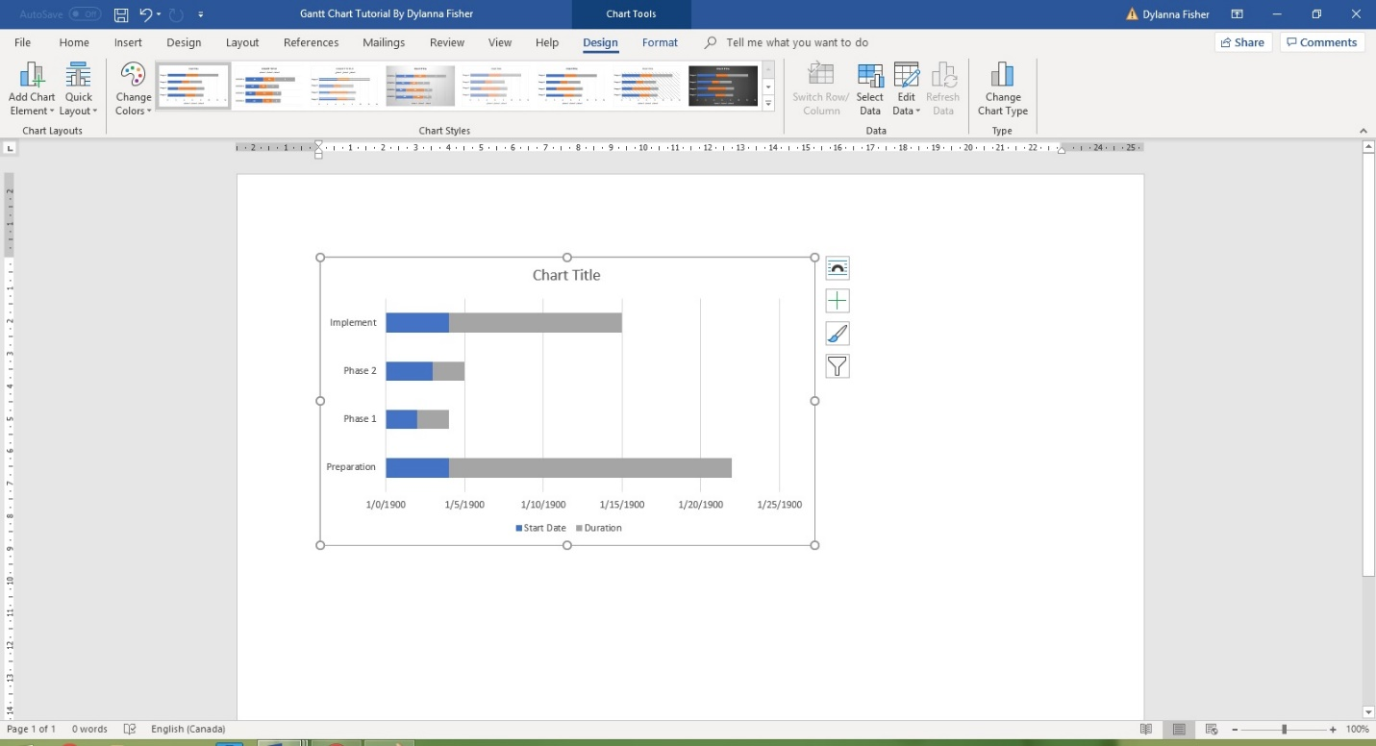
With that all finalized, your graph should start looking like a Gantt chart with only the information for the start date and duration visible but not the end Date.

Step 4: Formatting Your Gantt Chart
Now, to format your bar chart to look like a Gantt chart, you need to make the Start date essentially invisible.
However, it’s merely taking the color away from the fill of the bars for the start date series. This means that only the grey bars will remain visible on your graph.
These represent the tasks within your Gantt chart.
Click on one of the blue bars > Right-click > No fill
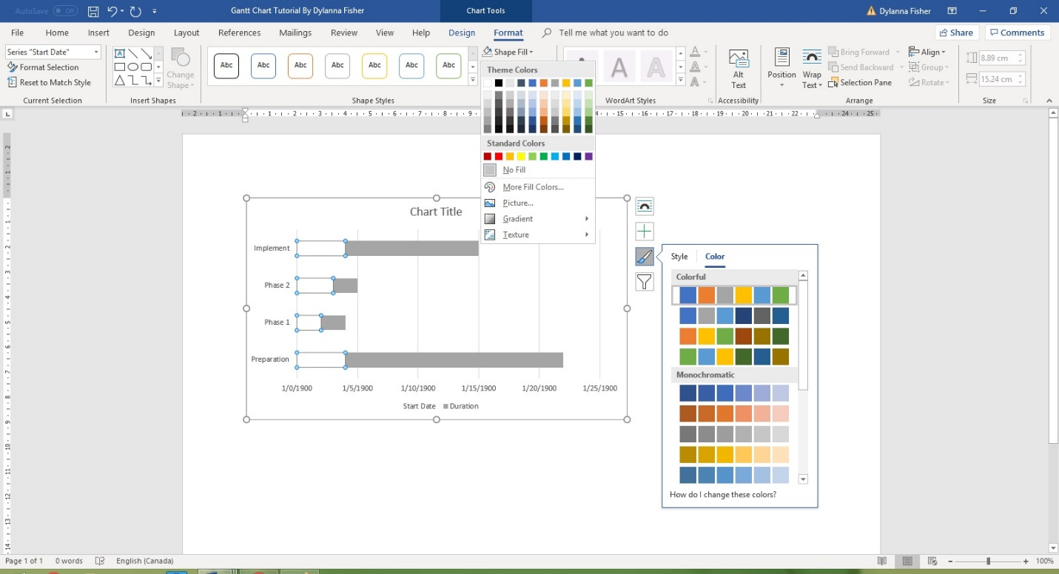
At this point, your graphic is no longer a bar graph but a Gantt graph with the tasks and duration visible.
It should appear as the example screenshot below:
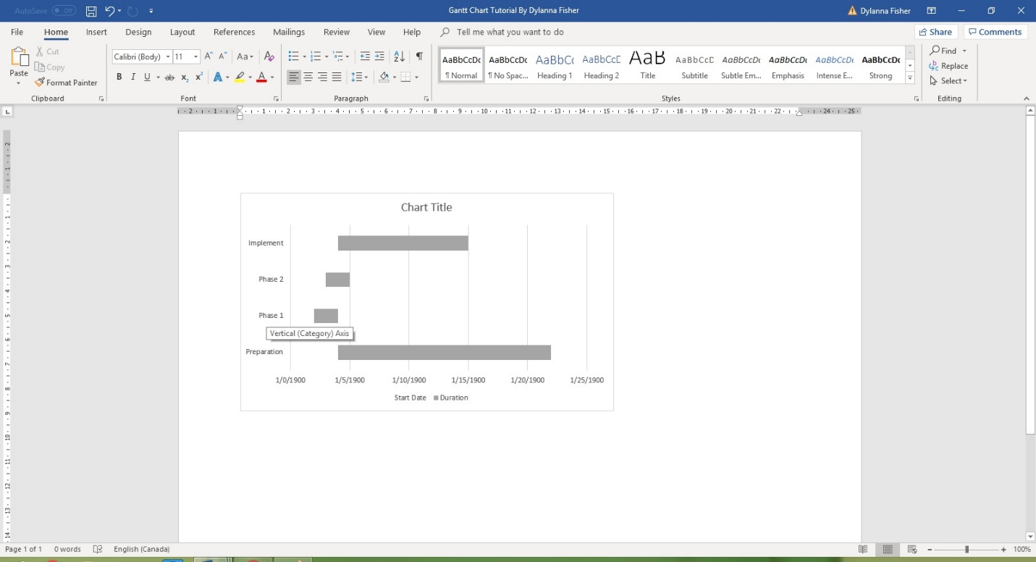

Step 5: Styling Your Gantt Chart
Now that everything within your document looks properly like a Gantt chart should, it’s time to improve the overall design.
This step ensures that your information is visually pleasing, which is important if you want to convey your information in a digestible manner.
You can use the themes menu to change both the chart’s style and color scheme. Colors will just alter the colors of the design, while chart styles will change several formatting aspects including font, hues, and sizing.
Go to Chart tools > Themes > design > chart styles or ***Chart tools > Themes > design > change colors*
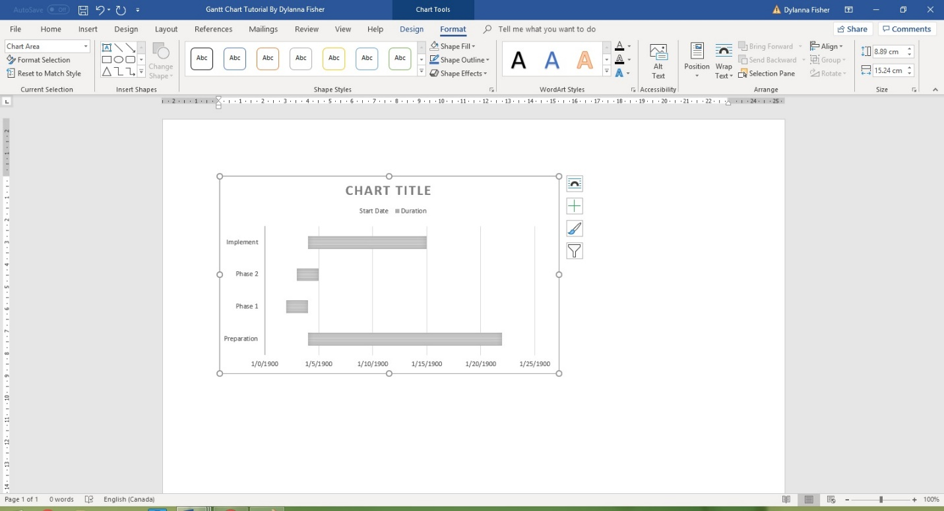
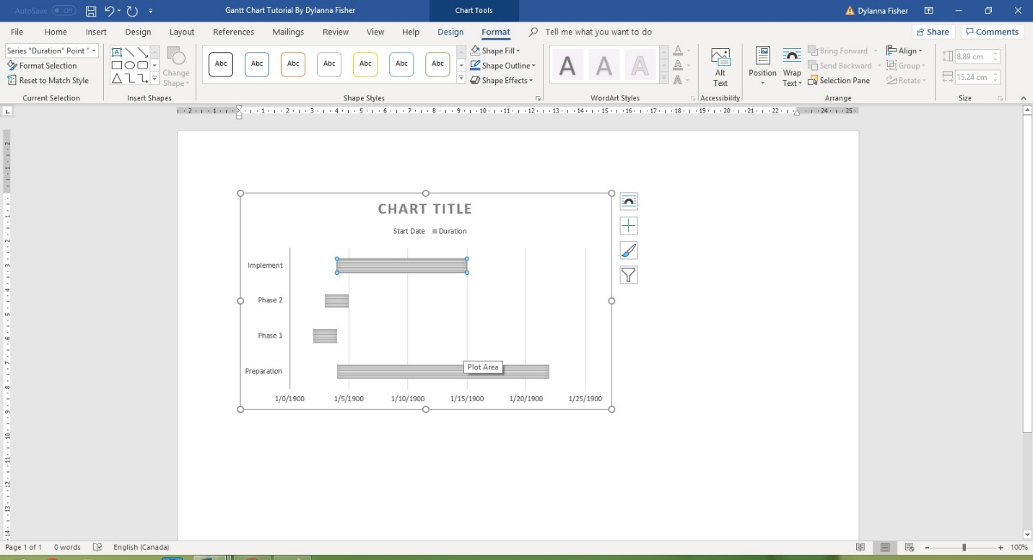
To make your graphic stand out even more from the generic chart styles provided by Word, you can customize each aspect of the Gantt chart to your own taste.
With a variety of styles and effects, the possibilities are endless.
Click Chart Tools Format > Shape Effects and/or Chart Tools Format > quick styles
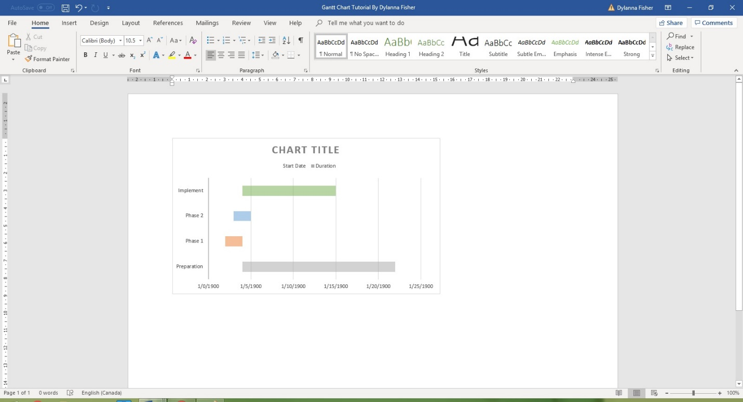
At this point, you may have noted that the tasks are backward. That is an aspect solved in this next step.
Change the order of tasks by Click on list of tasks > Format Axis dialog display > Select Categories in reverse order > Close
