Dez Long

Essay 1: Photo Essay

English 1121 – Prof. Scanlan

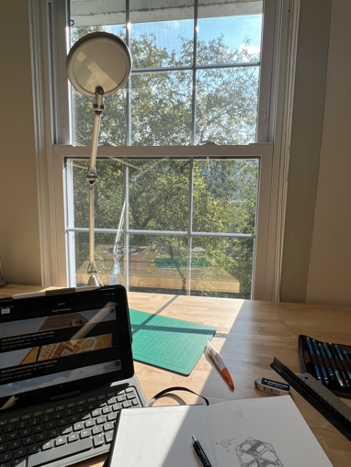09-30-24



Distraction (2023) Passenger (2024) Commute (2024)

A Captured Emotion

Has the constant flow of photographs online taken away from the idea of photography as an art form? According to the Oxford University Press (1857), “the expression or application of human creative skill and imagination…producing works to be appreciated primarily for their beauty or emotional power.” My theory is the importance of a photograph is the emotion that follows the individual viewing it and even then, according to Berger (2013), “the vast majority of people do not consider photography an art, even while they practice, enjoy, use and value it” (17). Popularized by Roland Barthes (1857), punctum and studium, through personal connection and general understanding are how people perceive photographs. My three photographs “Distraction”, “Passenger” and “Commute” were captured to commemorate feelings I had during significant moments in my recent life. While I may have my own emotional attachment to these images, I think due to the composition, dominant impression, and balance, a viewer of the photographs can still find them interesting and their own meaning in them.

The composition of “Distraction” reveals meaning to the common eye within a rather simple photograph. It was captured by me at the beginning of my second year of college in 2023 while I was studying at SUNY Delhi. Pictured is my studio desk that I chose because of its placement in the corner of the room and the window in front of it with a view of the trees and Catskill mountains behind it. The window and my desk lamp take up most of the photo at the top and below it is my wooden desk that shows the beginnings of my first project of my sophomore year. My Ipad, sketch book, a green cutting board, an exacto knife with orange on the handle, mechanical pencil, eraser, ruler and pencil roll all close together in front of me. The photograph is an effort to hold the memory of a new chapter in my life and by capturing it I invite others into what Sontag (2013), would describe as “another person’s (or thing’s) mortality…slicing out this moment and freezing it, all photographs testify to time’s relentless melt” (538). Through the composition of the photo and the title, one can create their own narrative by noticing the window taking up the photo and even the light reaching out onto the desk are distracting me from the work in front of me.

The dominant impression of a photograph can cause the eye to wonder from the first noticeable object, creating a sense of wonder. The photo “Passenger” was captured after I had opened a moving box in my boyfriend’s new apartment that I would now be spending a lot of time in due to me transferring to City Tech from SUNY Delhi. It is another new beginning for me but this time I have someone along with me for the ride. The dominant impression of the photo are two small white skeleton animals, a bear and a dog, on top of other things my boyfriend brought from his parent’s home. There are several colors popping out from the white, black, and brown tones in the photo, blue mittens, and and pops of red, orange, and yellow from his hobby box. The skeleton animals are very close together as if in an embrace, sticking together for their long ride from Vermont to Brooklyn. Sontag declares, “A photograph is both a pseudo-presence and token of absence” (539), the punctum I have for this photograph and moment I am trying to hold onto are only person to me, but the colors and what pops out first to a viewer of the image, can also enact separate feelings within them.

The balance of a photograph can also tell a story to the viewer that is separate to what the photographer was trying to capture. “Commute” relates to balance due to it being split into 3 separate layers within the photograph that are separated by color, all earth tones. The bottom is mostly brown, the dirt and train tracks in the foreground, the middle, which takes up most of the image is hues of green from the trees behind the tracks, and on top, behind the trees are the blue and white of the cloud filled sky. These colors work together to create a calm image. On the other hand, for me it signifies the beginning of a new nerve-wracking part of my life, going to a new college in my third year and a new task of having to commute to class instead of residing on a small campus in upstate New York. Berger states, “The events portrayed are in themselves mysterious or explicable according to the spectator’s knowledge of them prior to his seeing the photograph” (19). When looking at a train track or the colors in the image and how they are arranged may lead to different connections with a viewer.

With these photographs in mind, a photo that is taken from a personal moment can be seen by someone with no relation and still hold value. In the words of Sontag, “After the event has ended, the picture will still exist, conferring on the event a kind or immortality (and importance) it would never otherwise enjoyed” (535). My belief is a moment forever captured by the photographer comes with their own intent of taking the image, however a viewer may look at the contents and come up with their own perception. Barthes declares, “The punctum is about loving, while the studium is about liking.” I appreciate this breakdown of the two words due to it recognizing that whether one finds a deep meaning within a photograph or just look at it on the surface, there is still an importance to a photograph. A photo’s ability to capture emotion not only for the photographer but allowing any viewer to perceive their own connection to it and derive their own meaning is what truly makes it art.

(989 Words)

Works Cited

Berger, J. (2013) Understanding a Photograph. In G. Dyer (Ed.), *Understanding a Photograph* (pp. 17-21). Aperture. https://archive.org/details/understanding-a-photograph-john-berger/page/20/mode/2up

Sontag, S. (2013) On Photography. In D. Rieff (Ed.), Susan Sontag: Essays of the 1960s & 70s (pp. 531-539). The Library of America. https://openlab.citytech.cuny.edu/scanlan-english-1101-d333-spring2018/files/2018/03/Sontag-On-Photography.pdf

Barthes, R. (1981). *Camera Lucida*. Hill and Wang. https://openlab.citytech.cuny.edu/english1121-profscanlan-d533-fall2024/2024/09/11/class-info-for-wednesday-sept-11/

Oxford University Press (1857). Art. In Oxford English Dictionary. Oxford University Press. https://www.oed.com/search/dictionary/?scope=Entries&q=art