Andy Escobedo
03-27-19

Publication: The Verge

Nvidia Ray Tracing and DLSS is the future of gaming and here's why

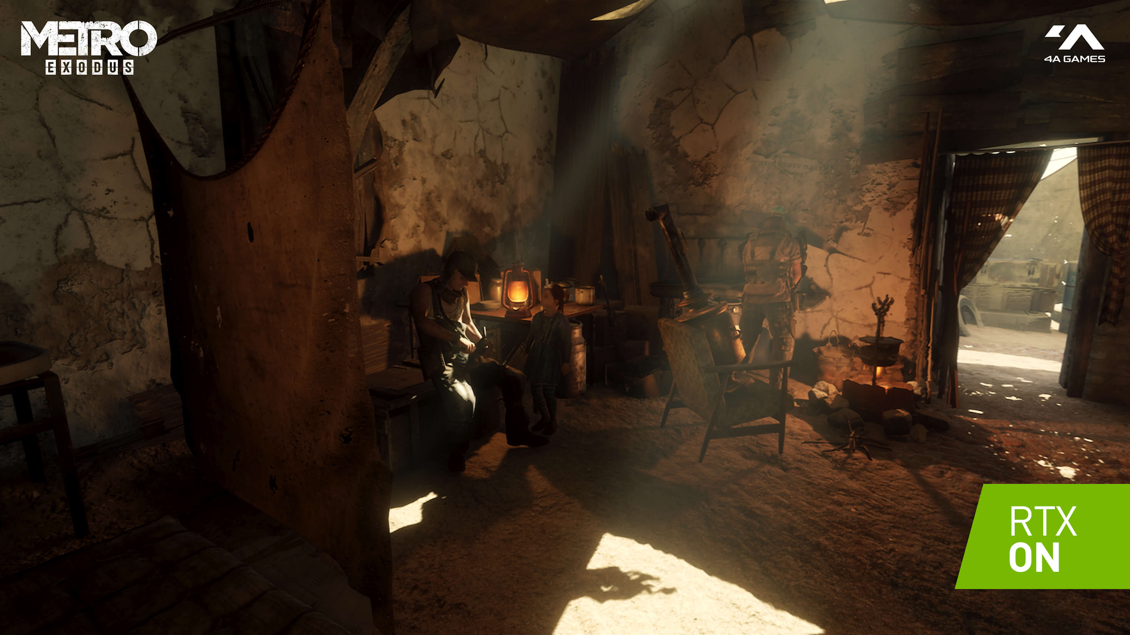

With the greatness of the GTX 1000 series GPUs, we the pc gaming community were craving for the next successor of this beast and Nvidia delivered. After two years Nvidia divulges its new advanced RTX Graphics Processing Unit the 2000 series. Introducing the RTX 2060, RTX 2070, RTX 2080 and RTX 2080 ti which implements new technologies such as Ray Tracing and DLSS only exclusive to the RTX family.

According to Nvidia, the “RTX graphic cards are powered by the Turning architecture which gives up to a 6x faster performance from the previous predecessor of graphics cards.” This was measured by Nvidia and some advantages of owning an RTX GPU is the inclusion of RT Cores(Ray Tracing) and Tensor Core which is a power AI (Artificial intelligence) DLSS(Deep Learning Super Sampling).

Artificial intelligence is essential to the community as this is the first graphics card to include its own dedicated AI. To support my claim An interview was conducted by CACM Staff which includes several questions answered about AI. For instance, the interview by CACM Staff Jeff Dean states that” deep learning AI utilize a neural network to learn and understand a particular algorithm.”This response conveys when AI is successful it can be a powerful tool to any application that can lead to speech, image, langued and most important object recognition. According to the Interview Pedro Felzenszwalb “deep learning has led to breakthroughs in object recognition with the improved accurate recognition of an object is just getting better in the past decade as these advancements surpass expectation.” This statement shows AI has been successful with its algorithm recognition which leads to a potential in the future to what to expect. With these additional power to the graphics card, it can lead to unless potential of the integrated AI that can learn a powerful algorithm and output results that can help remove the stress of the GPU and assist upon it and increase performance.

In addition, the neural network was mention previously and it is associated with AI. Furthermore, According to the article “Brain scientists dive into deep neural networks” by Kelly Servick neural network was “created to act similar to that of a human brain keeping data and improving upon it.” This shows that neural network and AI work together and both utilize the deep learning data to output a result.

You'll probably ask yourself what is Ray Tracing? and why it's so essential? Ray Tracing isn't new, in fact, it's been around for decades; however, Nvidia Ray Tracing provides a real and immersive approach.The advantage of turning on Ray Tracing is having a more realistic lighting in gaming because before this new technology was introduced the game had artificial shadows being cast from a light source. However with ray tracing it open the field of realistic shadow casting and global illumination.According to the Article “Fast ray-tracing of human eye optics on Graphics Processing Unit” by Wei, Qi
Patkar, SaketPai, and Dinesh K.” a new technique which simulate retina eye images by tracing a massive amount of light rays from a object in a three dimensional point of view.”This conveys how ray tracing operates and how this is similar on how ray tracing works in gaming.this is important as in game the GPU is calculating massive amount of rays in a three dimension point of view.

In addition,According to the Article “NVIDIA RTX™ platform” By Nvidia Developer, “Ray Tracing is realistic lighting by simulating the physical behavior of light”.This shows Ray Tracing is a simulation of light and it outputs the behavior that similar to real life but with the cost of performance by enabling this new technology.This is due to the heavy calculation of light rays bouncing off object and simulation that's being repeating.

But fear not as the counter measurement for this would be DLSS Deep Learning Super Sampling. With the Tensor Cores implementation in RTX cards, it will facilitate the taxing stress in the GPU and provide a smoother gaming experience. According to the article “Nvidia RTX DLSS: Everything you need to know” by Jon Martindale DLSS” uses a deep neural network to collect data of the rendered scene and create a high-quality final image while rendering at a lower resolution to make it look like a sharper picture.“This statement conveys that a game would run on a lower resolution and use its deep neural network to achieve a greater picture with the help of its Tensor Cores which would lead to better performance and make gaming more enjoyable. with these new technologies added into the RTX card, it will make your gaming experiences more realist and immersive. But sometimes the images might look worse.

In addition to the implementation of DLSS, one technique Nvidia uses is an infrared image super-resolution.According to the article “Infrared Image Super-Resolution by Combining Compressive Sensing and Deep Learning” by the authors Zhang, Xudong,Li, Chunlai,Meng, Qingpeng,Liu, Shijie,Zhang, Yue,Wang, and Jianyu that the technique is “setting the image at a lower resolution which is the compressed sampling of the image so that when it upscale it uses an infrared image sensor to compress the sensing so that the higher image can be reconstructed.”This statement shows that combining compressive sampling and supersampling the higher resolution with the infrared technique with deep learning can be achieved and this is how DLSS is operated. This is important as gaming at lower resolution would improve performance in gaming and the bonus of DLSS is the better upscaling of the lower image which brings an advantage in gaming either making you more competitive or a smoother gaming experiences.

Furthermore, additional information about Deep learning is according to the article “Deep learning advances super-resolution imaging” by Rita Strack” utilizing deep learning on an image resolution to create a greater super-resolution image from a smaller frame. With the help of artificial neural network it can map input and later map output from the obtained data and predict an output imagine.” this shows that deep learning logs data and creates an output from utilizing deep artificial neural network similar to what is being done in DLSS.

With DLSS being a new technology I believe down the future the AI would get smarter and better providing a promising better picture with less of a performance loss. The sharpness matters as for in a competitive game the gamers will be able to spot players at a distance due to the clearer picture. For instance, Metro Exodus improves on DLSS making it sharper than its Previous blurriness update. With the blurriness gamers were complain as its ruined the gaming experiences so it matters to keep a clean and clear picture to please the gaming community.

Furthermore, with many individuals owning an RTX would just ignore or simply disabling Ray Tracing and DLSS I would like you to give it a try. Yes, it's gonna affect your performance in gaming however you have Tensor and RT Core seating not being utilized. It doesn't have to be set to ultra to experience it can be set to low and you will be able to witness the beautiful illumination of realist ray light and shadowing. perhaps also enabling DLSS to get that extra boost in performance. In addition, you can also enable it in single player games where competitiveness is not required to play but a full solo immersive gameplay and when it comes competitive multiplayer game you can turn it off or set it to low.

Sources Used:
“NVIDIA RTX™ Platform.” NVIDIA Developer, 12 Feb. 2019, developer.nvidia.com/rtx.
https://developer.nvidia.com/rtx

Cardinal, David. “How Nvidia's RTX Real-Time Ray Tracing Works.” ExtremeTech, 21 Aug. 2018, www.extremetech.com/extreme/266600-nvidias-rtx-promises-real-time-ray-tracing.
https://www.extremetech.com/extreme/266600-nvidias-rtx-promises-real-time-ray-tracing

Walton, Jarred. “What Is Ray Tracing, and How Does Nvidia's GeForce RTX Handle the Technology?” Pcgamer, PC Gamer THE GLOBAL AUTHORITY ON PC GAMES, 20 Sept. 2018, www.pcgamer.com/what-is-ray-tracing/.

https://www.pcgamer.com/what-is-ray-tracing/

“DLSS Is Finally Arriving in Games, but How Does Nvidia's Super-Sampling Actually Work?” Digital Trends, 14 Feb. 2019, www.digitaltrends.com/computing/everything-you-need-to-know-about-nvidias-rtx-dlss-technology/.
https://www.digitaltrends.com/computing/everything-you-need-to-know-about-nvidias-rtx-dlss-technology/

CACM Staff “Artificial Intelligence” Source: Communications of the ACM Date: 1 Feb 2017,
http://web.a.ebscohost.com.citytech.ezproxy.cuny.edu/ehost/pdfviewer/pdfviewer?vid=1&sid=42cb2609-a7ab-4aea-ae2d-7a1aa3274d4b%40sessionmgr4009
http://web.a.ebscohost.com.citytech.ezproxy.cuny.edu/ehost/pdfviewer/pdfviewer?vid=1&sid=42cb2609-a7ab-4aea-ae2d-7a1aa3274d4b%40sessionmgr4009

Servick, Kelly. “Brain Scientists Dive into Deep Neural Networks.” Science, American Association for the Advancement of Science, 21 Sept. 2018, science.sciencemag.org/content/361/6408/1177/tab-pdf.
http://science.sciencemag.org/content/361/6408/1177/tab-pdf

Zhang, Xudong,Li, Chunlai,Meng, Qingpeng,Liu, Shijie,Zhang, Yue,Wang, and Jianyu “Infrared Image Super Resolution by Combining Compressive Sensing and Deep Learning.”Aug2018
http://web.b.ebscohost.com.citytech.ezproxy.cuny.edu/ehost/detail/detail?vid=0&sid=184beb8e-0d88-4ec7-a8dc-5a6fffc98ffe%40pdc-v-sessmgr02&bdata=JnNpdGU9ZWhvc3QtbGl2ZSZzY29wZT1zaXRl#db=a9h&AN=131400635
http://web.b.ebscohost.com.citytech.ezproxy.cuny.edu/ehost/detail/detail?vid=0&sid=184beb8e-0d88-4ec7-a8dc-5a6fffc98ffe%40pdc-v-sessmgr02&bdata=JnNpdGU9ZWhvc3QtbGl2ZSZzY29wZT1zaXRl#db=a9h&AN=131400635

Rita Strack “Deep learning advances super-resolution imaging” 31 May. 2018,
https://www-nature-com.citytech.ezproxy.cuny.edu/articles/s41592-018-0028-9
https://www-nature-com.citytech.ezproxy.cuny.edu/articles/s41592-018-0028-9

Wei, Qi,Patkar, SaketPai, and Dinesh K. “Fast Ray-Tracing of Human Eye Optics on Graphics Processing Units.” Computer Methods and Programs in Biomedicine, vol. 114, no. 3, 2014, pp. 302–314.
https://www-sciencedirect-com.citytech.ezproxy.cuny.edu/science/article/pii/S0169260714000534
https://www-sciencedirect-com.citytech.ezproxy.cuny.edu/science/article/pii/S0169260714000534

