Pa Dominic Loppy
ENG 1121
Working Draft of Popular Articles

Professor Kim Liao
3/14/19

Pa Dominic Loppy
3/14/19

New York Times
620 Eighth Avenue,
New York,
NY 10018.

THE PARADOX OF A CITY WITH ZILLION SKYSCRAPERS AND YET A MAJORITY OF IT RESIDENTS STRUGGLE TO PUT ROOFS OVER THEIR HEADS
Homelessness in New York City is the height of irrationality, because after all these year of financial success, homelessness is still prevalence. I believed greed has led to the rise of homelessness in a city with multiple business, the undisputable financial capital of the world. With all the resources we have acquired over the years and technology advance, no living human being should be struggling with housing problem especially in an economic giant city like New York City. I have noticed many people sleeping in subways during winter time and on the concrete pavement during summer and I can't really make a sense of all this unfortunate predicament that befall a city that never sleep. This acronym of a city that never sleep is definitely a reality to many unfortunate New Yorkers. There are currently about
59,000(www.cityandstateny.com/articles/opinion/commentary/homelessness-housing-problem.html) New Yorkers staying in homeless shelters and several thousand more sleeping on the streets, figures fluctuate seasonally. This year’s street homeless winter population count was, 3,675 people. The U.S. Department of Housing and Urban Development, which uses a different methodology, pegged the total homeless population at more than 75,000 in a report released in December. As statistic shows, New Yorkers lack a roof and a pillow to lay their head on, they stay awake till late hours in the night. As a result of this, they ply the trains back and forth for the whole night and blend with sleeping New Yorkers in the morning time when they are going to their regular routines.
Homelessness is a reality in New York City and I'm appealing to the general public and the local government to do something about this unfortunate circumstances. More than half of New York populace are worried of losing their apartment within a month, if they were to lose their job. What I'm trying to stress on is that, New Yorkers are living hand to mouth yet, we heard politicians over and over fooling us about raising the minimum wage to a living wage. How many times do we witness minimum wages and housing prices rise simultaneously?

Location | 12/31/16 | 12/31/17 | 12/31/18 | 12/31/19 | 12/31/20 | 2021*
NYC - Large Employers (of 11 or more) | $11.00 | $13.00 | $15.00
NYC - Small Employers (10 or less) | $10.50 | $12.00 | $13.50 | $15.00
Long Island & Westchester | $10.00 | $11.00 | $12.00 | $13.00 | $14.00 | $15.00
Remainder of New York State | $9.70 | $10.40 | $11.10 | $11.80 | $12.50 | *
General Minimum Wage Rate Schedule

Real Gross Rent History for New York
Date | US Median | New York Median | New York Average
2018 | $1,012 | $1,326 | $1,405
2017 | $996 | $1,313 | $1,301
2016 | $987 | $1,207 | $1,281
2015 | $956 | $1,175 | $1,245
2014 | $924 | $1,133 | $1,203
2013 | $912 | $1,113 | $1,188
2012 | $912 | $1,108 | $1,177
2011 | $927 | $1,105 | $1,179
2010 | $931 | $1,088 | $1,176
2009 | $947 | $1,095 | $1,183
2008 | $899 | $1,033 | $1,112
2007 | $909 | $1,042 | $11,12

Is this illusionary solution we be yearning for over the years? I want every New Yorkers to stand up to lawmakers and let them know that affordable housing for every New Yorker is a must or no office.
Is there still anyone who doubts homelessness is a reality in New York City, follow me to the shelters. I have a certain degree of empathy for homeless people in New York City, this compels me to visit a family shelter in Brooklyn under the canopy of Samaritan Village. The shelter is located at, 652 Willoughby Avenue, Brooklyn New York. At the shelter I had the privilege to talk to Mr. Jones who is living in the shelter for seven months with his stepson who is 17 years old, a nine-year-old son and his wife. I asked Mr. Jones who happen to have a regular job as a janitor, he usually left the shelter early in the morning and comes home late. I asked him, “if you had the opportunity to quit the shelter, would you he?” He answered was “yes” with grin on his face staring at me eye to eye. I then follow up with this question, “how comes you are such a hardworking man yet, living in a shelter with your entire household?” He said it was difficult for him to get another apartment in his previous neighborhood after losing his apartment. I asked him, “why did you lose your apartment?” He answered, “my landlord loses the mortgage to the bank and the new owner terms and conditions were impossible to meet so I and my entire household were evacuated from the apartment”.
For Mr. Jones interview, I was avoiding to be offending him. I figured that he wasn’t ready to delve deeper into the conversation. I also talk to Samar Battle, another household head in the shelter. He is living in the same mentioned shelter above with a girlfriend and a four-year-old son. I asked him, “How long did you live in this shelter?” He responds, “Bro, I have been in this shelter almost a year now, but I’m craving to move out of this place.” He then further continued, “First of all, security harass me and my girlfriend anytime we coming in and going out by making us signing papers.” I told him, “I feel your pain bro.” And he was like, “Thank you.” He further told me being in the shelter is terrible and unpleasant feeling for him and his girlfriend and their little boy. He told me he been to college and was able to acquired ninety-four credits but didn’t graduate. He told me he also gets a felon on his record and this has make it difficult for him to get a reasonable job. I also spoke to a third resident, but I was surprise about the uniformity of their answers.
I would like to further buttress on how majority of New Yorkers are living in compacted apartments because they can't afford to rent one of their own. Many working class New York resident are sleeping in friend’s couches or sharing a room up to four people. This is a tragedy and health hazard.
I felt homelessness is an issue of concern in New York City. I never knew this is how homelessness have eaten very deep to the very fabric of New York City. Sometimes I analyze the paradox of homelessness in a city with multiple skyscrapers, clusters of empty buildings and hotels in Manhattan, but couldn't make an aorta of sense from the pitiful
condition. 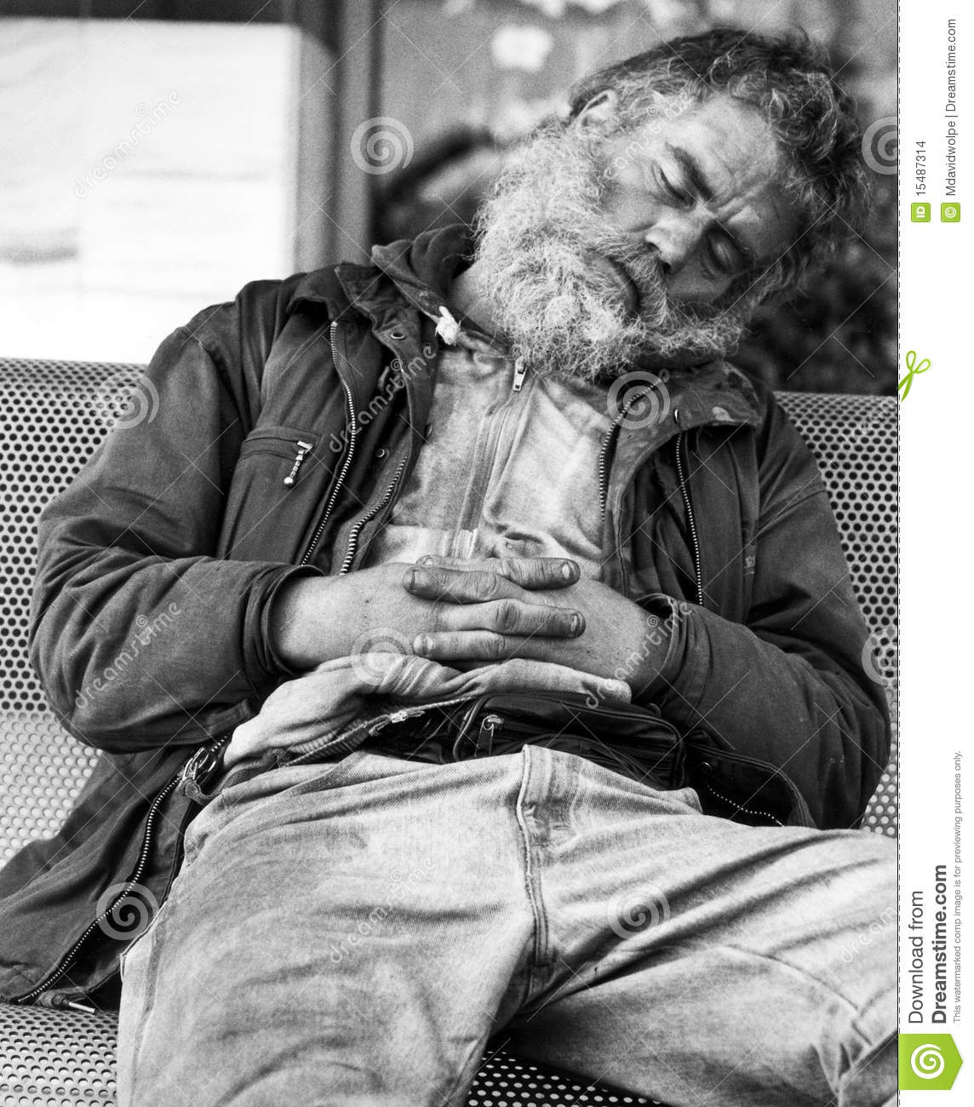
At first, I always blame homeless people in the subways with their smelly garments and nappy hair and reward the system that causes homelessness in most cases, but not now. Not all homeless people are lazy and not all lazy people are homeless. I'm not trying to fully blame the broken system that causes homelessness neither I'm I going to blame homeless people. I understand that some people get into substance abuse and alcohol, as a result, they couldn't be in control of their lives and they end up being homeless in the streets. But the serious fact of the matter is that some hardworking people end up being homeless because the broken system fail to reward them enough to make ends meet. As a result, they end up in the streets of New York City and subways transit desperate and depress. therefore, the only solace they could turn into is drug and alcohol. So the broken system causes a lot of alcoholic and drug addicts.
I can't understand why should people work nine to five, six days a week yet they can't afford to put a roof over their head. This is a pitiful condition. I started having empathy for homeless people when I was working in a family shelter in Brooklyn. Most of these homeless families have a job they report to, yet those jobs can't afford to put a roof over their heads, but those they work and make tons of money for have billions stored for future generations. What an irrational society are we living in. The poor are being exploited by the rich and being fool by politicians.
I started thinking deeply about the issues of homelessness in New York City when I read this article about homelessness from Ben Adler(www.cityandstateny.com/articles/opinion/commentary/homelessness-housing-problem.html). In this article, he breakdown the figures of homelessness in the city year in and out, but the figures seem pitiful. Based on my empirical analysis, the figures seem small but yet dreadful for a develop city like New York City. Base on Adler's article, the average figure of homelessness per annum is fifty-nine thousand. This figure Adler reported exclude those homeless people sleeping in the streets and subways. Adler wrote about how homeless people protested in the heart of Manhattan with boards inscribed with messages to New York City mayor. At this time of protested, mayor Bloomberg was still in office. Well, Adler's article emphasizes on how the preceding mayor's failed to address homelessness in New York City properly and I couldn't agree more.
According to Ben Adler article (www.cityandstateny.com/articles/opinion/commentary/homelessness-housing-problem.html) The current mayor Bill de Blasio is making profound effort to tackle the issues of homelessness but, his effort is being impede by various political factors and also the public not wanting a homeless facility to be constructed in their neighborhoods.
I just want the general public to know that, being without a roof over one’s head, is not a thing one wish for. Having a homeless person as a neighbor should be a pride and a chance to reach out to help. The mayors, prior to Bill de Blasio sworn into office, barely do enough to tackle homelessness in the city of New York.
It has been revealed by research that homeless people are prone to diseases such as HIV, Diabetes, pneumonia and asthma (Journal of Adolescence; www.elsevier.com/locate/jado). This finding has always been true and is increasingly becoming true because homeless facilities are not properly taking care of, therefore, a breeding place for diseases causing organisms. I visited a micro shelter, at 988 Myrtle Avenue, Brooklyn, New York, but, I couldn't believe what I saw with my necked eyes. The facility is totally untidy with twenty people sharing a dorm with tiny beds, little lockers to keep their belongings. What a breeding place for disease causing organisms.
Based on my empirical observation at 988 Myrtle Avenue, Brooklyn, New York, shelter, most of the homeless people in a micro shelter health deteriorate the longer they continue to live in the shelter. My heart really bleeding for this people in micro shelters. Some are over sixty-five years old, I would recommend for them to be in nursing homes instead of such deplorable condition. Some are mentally ill and others could easily be recycling into the society. This could be done by providing a psychiatry to help them quit their old habits of drug abuse. I think this could be a healthy solution for this people to be productive once again and be useful to the society and themselves. Keeping them in such a horrible condition, given them food and unemployment benefits is not helping at all. Most of them still keep their old habits of drug abuse, therefore, the willingness to work for a living continue to diminished. Youth homelessness continue to rise to an unprecedented level, this doesn't tell well about the future of our labor force. Youths are the backbone of our economy, losing one to homelessness and loose drugs in the streets is exposing our city and nation to a gloomy future. Youth empowerment should start with the environment youths are exposed to.
I would like to close my argument by saying that, the system we put in place has fail us and we shouldn't fail ourselves again. We need to come together as a rational and responsible society to solve the issues of homelessness in New York City. As I mentioned earlier, it doesn't make sense for a head of household who is working forty hours a week yet he/she can't afford a roof for the family. This is pathetic! So the earlier the issues of homelessness are address with seriousness the better for our city.

References
(www.cityandstateny.com/articles/opinion/commentary/homelessness-housing-problem.html)
Journal of Adolescence; www.elsevier.com/locate/jado

