Gianna Grieco
Professor Fraad
English 1101
10 December 2019
The Fall of Honeybees
Why Are Honeybee Colonies Weakening, and What Can be Done About it?

Throughout recent years, Honeybees have been living a very live fast die young type of lifestyle. The life of a honeybee has been transformed into a not so popular way of life and there are many reasons why.
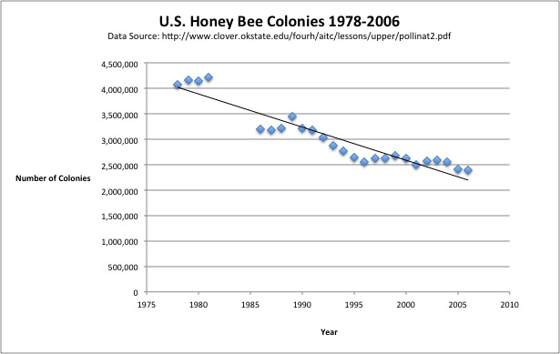

To begin, the human race has been the main cause of all inflicted pain on honeybees. With the uses of electromagnetic pollution, the tiny magnetite crystals found in a honeybee’s abdomen are being affected. These tiny “compasses” are obstructed by electromagnetic fields in which pulls the honeybees in congregation areas. According to the article, “ How Humans Are Hurting Honey Bees' Ability to Reproduce” Entomologist Sebastian Shepard “ worries that power lines may be an exception to the rule”. What this means is that even though most of the electromagnetism caused by humans that is detected by honeybees is barely enough to kill the bee strong sources such as power lines may debunk that point. Sebastian Shepard believes strong enough power lines can enforce real damage onto the honeybees electromagnetic radar abdomen.

Secondly, the population of honeybees found in the United States of America are known to be Italian natives. These Italian honey bees are known to have a known vulnerability towards a parasite by the name of the Varroa Mite. This parasite in particular are known to suck the blood from the honeybees body slowly killing them. Pesticides have also been a known problem ion which negatively impacts a honey bees lifespan. These toxic chemicals have the ability to kill a bee by just them coming in contact with the pesticide when landing on a flower.

Habitat loss has become a severe problem in the honeybee community. When a honeybee colony is destroyed this forces the honeybees to either move shelter or be left without one since they are all being destroyed. Honeybees have a very important job in keeping us humans healthy, the irony of this situation is by doing our daily human activities we are slowly killing off a species that helps us the most. Honeybees are in charge of all things pollination. Pollination is the transference of pollen from the male part of the flower to the female stigma of a different flower. Without pollination, many crops would suffer and began to wilt or not grow at all.

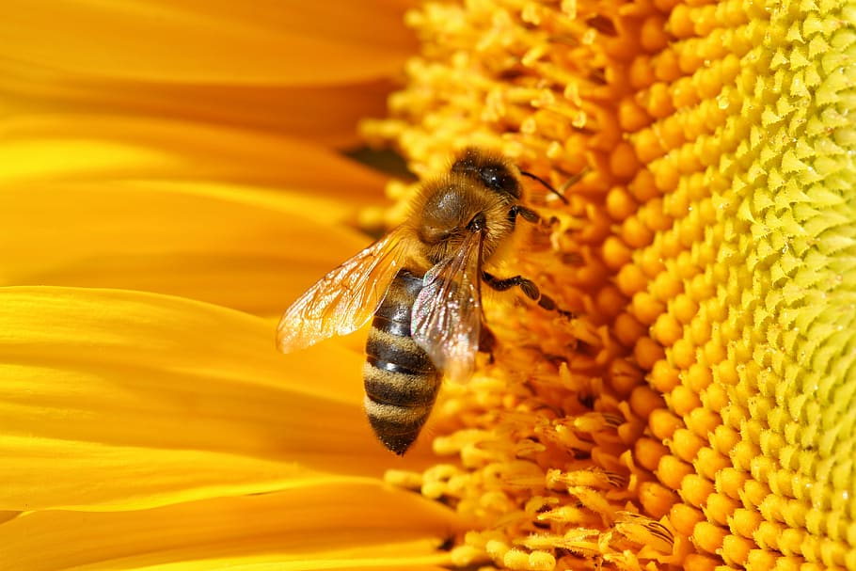
According to recent studies, scientists are researching alternatives for the food production aspect if the extinction of honey bees occurs. Honeybees are in charge of making the delectable treat known as honey but also like mentioned before gives life to many other crops. A wildlife biologist of the U.S. Geological Survey known as Sam Droege states, “ … embrace the thousands of North American wild bee species, which are excellent pollinators, rarely sting, and are typically the size of a grain of rice. The drawback for some people is that none of the wild bee species produce honey.”. With this there is always a plan B for the continuation of pollination but we may need to develop a new source of honey or in this case derive the honey from other countries.

On the contrary, a master of commercial beekeeping by the name of Darren Cox brought up the argument of colony collapse disorder. What this condition is known for is having honeybees “ die at far faster rates than normal as a host of other ailments, such as deformed wing virus and deadly pathogens, exact a toll.”What Cox proves is that not only are the effects of humans causing a decline in the honeybee community, but also congenital conditions are causing a halt to honey bee procreation. With the condition of deformed wing virus the honeybees diagnosed will not be able to fly from flower to flower in order to gain themselves a collection of nectar. Nectar is the main food source of a honeybee, without nectar the honeybee will slowly deplete and soon starve to death.

According to the article, “ Honeybee Survival Is In Jeopardy” the author Steve Volk states, “ Today we pump roughly 2.5 times more chemical pesticides, fungicides and herbicides into the environment than we did when Silent Spring was published. But the number of regulatory labs has decreased, leaving more chemical inputs in the environment and far fewer scientists to study them.”.With the presence of this quote, the author introduces the idea of incorporating more regulatory labs in order to balance the use of chemicals found in pesticides. This idea can also be seen as a solution to the problem of pesticides killing off a percentage of the honeybee community.

In order to prevent the honeybee population from declining even more, solutions may be implemented into today’s everyday society. As a community, we may all come together to help the honeybee population stay vital in which would keep our nation alive and well. One way our population can help the honeybees is by doing more research or limiting the use of pesticides in honey bees' natural habitat. With the limit of pesticides we would be able to keep the health of the flowers the honeybees will later pollinate and we would undo the harm of honeybees coming in contact with harmful chemicals found in pesticides.

When looking at solutions for habitat loss there are many options to solve this problem. To go about solving this problem the human race would have to put an end to destroying bee hives that they come across. The most popular places for beehives to be found are attracted to buildings, homes, and sometimes in trees. By the decreasing of cutting down trees and leaving beehives alone to prosper we are eliminating one of the major causes of honeybee depletion.
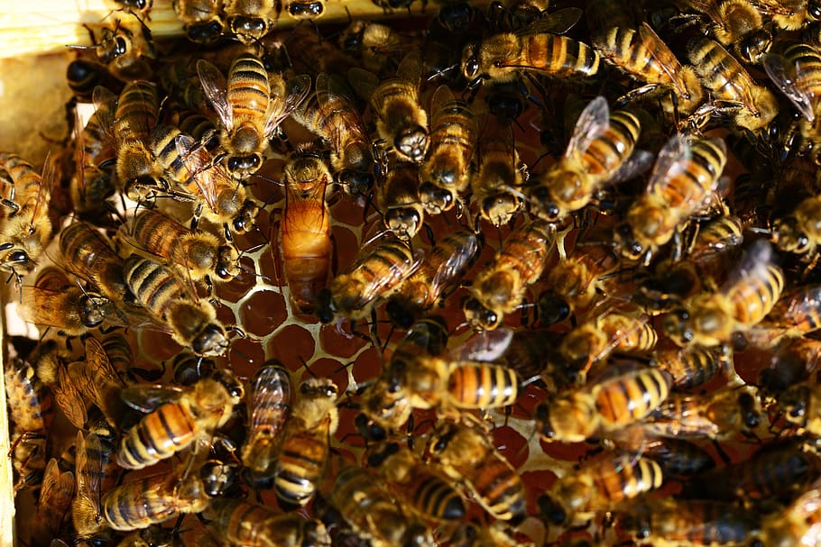
All in all, in order to keep both the honeybees and the human race happy we will have to work together. Without the honey bees, humans will not have access to specific crops, sweet treats such as honey, and the beautiful creations made from honeycombs. Honey Bees on the other hand need us humans to help protect them from our murderous activities. Honeybees would have nothing to worry about if we did not introduce harmful chemicals, destroy their homes, and make changes to their electromagnetic radar they have had since the beginning of time.
Works Cited

1) “Honeybees.” The Most Misunderstood Natural Resource, http://www.uvm.edu/~mdestroi/The Most Misunderstood Natural Resource.html.

2) Varma, Anand, and Konrad Wothe. “How Humans Are Messing Up Bee Sex.” How Humans Are Hurting Honeybees' Ability to Reproduce, 11 Sept. 2018, https://www.nationalgeographic.com/animals/2018/09/honey-bee-sex-mating-pesticides-humans-news/.

3) Volk, Steve. “Honeybee Survival Is In Jeopardy.” Discover Magazine, Discover Magazine, 16 May 2019, https://www.discovermagazine.com/planet-earth/honeybee-survival-is-in-jeopardy.

4) Zuckerman, Catherine. “What Happens If the Honeybees Disappear?” National Geographic, 3 Oct. 2017, https://www.nationalgeographic.com/magazine/2017/10/explore-animals-bees/.

