Why Choose to be euthanized ?  Have you begun feeling like you are a burden to your loved ones or caregiver? Are you tired of being in pain that nobody else seems to understand? Do you still feel like life is worth living?  Euthanasia allows you to regain your independence by taking control of your life and steering it in the direction you want it to go. There is no need endure endless pain with no near end in sight, by opting for euthanasia you are opting to end your suffering. Ending your suffering does not have to be a sad moment for you. Euthanasia allows you to arrange your death and gives you time to reflect on what means the most to you, it also gives you the chance to think about what you would like your last words to your loved ones to be.  If your lifestyle has drastically changed since your diagnosis and you are no longer happy in life or with the quality of your life, you have the power to change that with euthanasia. |  | Address  2301 Memory Lane Sunshine New York, 11902  contact us  The Phone Company | (123)-456-7890 | Emanie Maitland  ENG 1101  Cipriani |  | Is Euthanasia right for you?  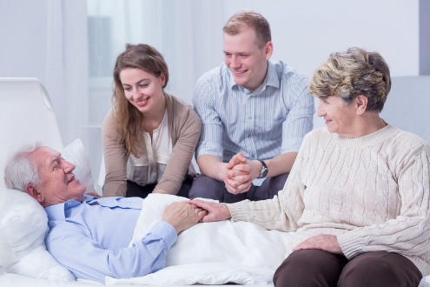  If you have been battling a terminal disease euthanasia may be the right choice for you. Euthanasia allows you the opportunity to make final preparations and maximize the rest of your remaining time with loved ones. By making the decision to be euthanized you are deciding when, where and how you will pass on into the next life and more importantly you get to have all your loved ones nearby as transition on.

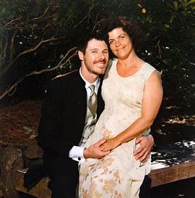  Jil Finnegan detailed her last days of her euthanasia journey in a Youtube video posted January 17,2018 by Mercury News. Jil had cancerous tumors on her vocal cords, in her back, neck and, stomach that caused her to be in pain constantly. She no longer wanted to suffer and wanted control of her life back and with the help of her husband Geoff she decided to be euthanized on their 14th wedding anniversary. Jil was content with her decision to be euthanized because she got to die in what she deemed a peaceful way with her loved ones surrounding her as she slept. |  | disclaimer  Despite the many benefits that euthanasia can provide it may negatively affect family members that have a hard time accepting your decision to be euthanized. Family members that are unable to accept your decision may experience depression.  Euthanasia may not be right for you if you are a religious person because you would be willingly ending your life, which goes against some religious values. It may also not be right for you if you are choosing euthanasia in order to save your family money. Before choosing euthanasia, you should be sure to maximize your treatment options and determine if this is the right decision for you. |  | “I am extremely grateful for euthanasia, without it I would be terrified”  - Jil Finnegan (euthanasia participant )-

