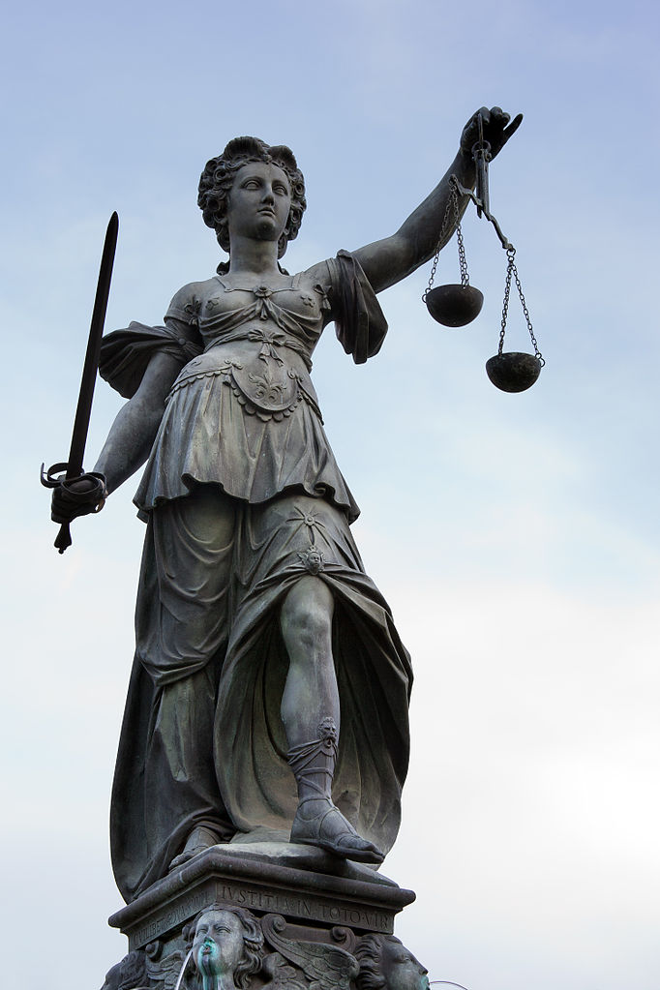
Law Through Literature
CC BY-NC-ND 3.0 1: Frankfurt on the Main: Gerechtigkeitsbrunnen (Fountain of Justice), detail of the Lady Justice as seen from the northwest by Mylius

ENG3401, D614
MW 4:00PM-5:15PM
N505A

Professor Ellis
Office/Hours: Namm N520, Th 3:00PM-5:00PM or by appointment.
jellis@citytech.cuny.edu
http://dynamicsubspace.net

Course Description
We will explore issues of law, its systems, its application, and its challenges through works of literature. The way in which we will read and access the literary works assigned as readings will be part of our conversations. The cultural and historical context for the works we read will comprise an important aspect of our thinking and in-class discussion. Finally, we will consider how literature can and does influence the development of law. In order to be successful in this course, students are required to maintain the reading schedule and come to class prepared to discuss the assigned reading. It is highly recommended that students approach the course with their curiosity and an eagerness both to learn and demonstrate what they have discovered on their own initiative. The catalog course description, objectives, and prerequisites are attached.

Required Texts
- Charles Dickens, The Pickwick Papers (Chapter XXXIV: “Is Wholly Devoted To A Full And Faithful Report Of The Memorable Trial Of Bardell Against Pickwick”). http://www.gutenberg.org/ebooks/580.
- Cory Doctorow. Homeland. 2013. http://craphound.com/homeland/download/.
- Cory Doctorow. Little Brother. 2008. http://craphound.com/littlebrother/download/.
- E.M. Forster. A Passage to India. 1924. https://archive.org/details/ost-english-apassagetoindia.
- Franz Kafka. The Trial. 1925. Translated by David Wyllie in 2003. https://www.gutenberg.org/ebooks/7849.
- Herman Melville. Billy Budd, Sailor. 1924. http://gutenberg.net.au/plusfifty-a-m.html#melville.

Required Resources
- Computer access, word processing software, and a means of saving your work securely.
- Access to your City Tech email.
- Access and account at openlab.citytech.cuny.edu.
- Flash drive for saving your work and/or having scratch space for in-class project work.
- Cloud-based storage for saving a backup of all your work.

Recommended Resources
- Law and Literature, journal, http://www.jstor.org.citytech.ezproxy.cuny.edu:2048/journal/lawliterature.
- Law, Culture, and the Humanities, journal, http://citytech.ezproxy.cuny.edu:2048/login?url=http://search.ebscohost.com/login.aspx?direct=true&db=hus&jid=ABD&site=ehost-live.
- Law & Humanities, journal, http://citytech.ezproxy.cuny.edu:2048/login?url=http://search.ebscohost.com/login.aspx?direct=true&db=lgs&jid=3PX8&site=ehost-live.
- Law, Text, Culture, journal, http://www.lexisnexis.com.citytech.ezproxy.cuny.edu:2048/hottopics/lnacademic/?verb=sr&csi=246883.
- Yale Journal of Law and the Humanities, journal, http://www.lexisnexis.com.citytech.ezproxy.cuny.edu:2048/hottopics/lnacademic/?verb=sr&csi=151693.
- Chicago Manual of Style 16th Ed. Guide, Purdue OWL, https://owl.english.purdue.edu/owl/resource/717/1/.
- Law & Humanities Blog, http://lawlit.blogspot.com.
- Techdirt, https://www.techdirt.com.
- The Electronic Frontier Foundation, https://www.eff.org.
- The Founding Documents of the United States, https://www.congress.gov/founding-documents.
- City Tech Legal Studies Student Resources, http://www.citytech.cuny.edu/academics/deptsites/legalstudies/resources.aspx.
- Laura Portwood-Stacer, “How to Email Your Professor (Without Being Annoying AF),” https://medium.com/@lportwoodstacer/how-to-email-your-professor-without-being-annoying-af-cf64ae0e4087#.1m6lc0rkd.

Grading
Assignment | Description | Percentage of Final Grade
Daily Writing and In-Class Activities | Due before the beginning of our next class, write a 250-word summary of the reading and in-class discussion. Submit your summary as a comment to the appropriate blog post on our OpenLab site. | 25%
Research Paper | Using what you have learned in our class and research done on your own to write a 2,500-word essay that analyzes a cultural artifact we did not read in class in terms of the issues of law raised within the work. You may choose as your paper’s topic any kind of cultural artifact: a novel, short story, album/song, movie, television series (a single episode or story arc only—do not write about an entire series unless cleared by the professor), video game, art, etc. It should cite your primary source, and at least ten library-sourced resources (these may or may not be what you include on your abstract’s working bibliography). | 20%
Research Paper Abstract | Before writing your research paper but after you have thought about the topic you would like to research, write a 250-word abstract that summarizes what you plan to write about. In addition to the abstract, include a working bibliography in Chicago format of at least ten library-sourced resources you might use to support your research paper’s argument. | 15%
Research Presentation | Create and deliver a 5-minute summary presentation of your research paper. Use PowerPoint to create your presentation’s visual component. On the day of your presentation, arrive prepared with your presentation’s script and copy of your presentation on a flash drive for quick loading, and dressed appropriately in business or business casual attire. | 20%
Final Exam | The final exam will be an essay-based exam that evaluates your recall of the novels read in the class and application of class lecture and outside readings to the analysis of the novels read in the class. | 20%

Attendance and Lateness Policy
The expectation for successful and respectful college students is to arrive on time and attend all classes. The college permits students to miss 10% of a class (three absences) for whatever reason. In our class, each additional absence will reduce your final grade by 10 points (equivalent of a full letter grade). Missing too many classes will obviously result in failure of the class. Also, an absence does not excuse you from any assignments or exams. Use your absences wisely. Arriving late or leaving early will, depending on the specific situation, count as a full or partial absence.

Required Format for Papers
While there will be exceptions that we will discuss in class, all writing submitted online or on printed paper should follow Chicago professional style, because this is the standard style for the main journal in the field, Law and Literature. The Purdue OWL has a Chicago style guide here: https://owl.english.purdue.edu/owl/resource/717/1/.

Policy for Late Papers
Assignments submitted late or exams taken late will incur a 10-point reduction for each day that they are late. However, no assignments will be accepted after the last day of class. If a student knows that work cannot be completed on time, he or she should contact me or visit my office hours to discuss.

College Policy on Academic Integrity
Students who work with information, ideas, and texts owe their audience and sources accuracy and honesty in using, crediting, and citing sources. As a community of intellectual and professional workers, the College recognizes its responsibility for providing instruction in information literacy and academic integrity, offering models of good practice, and responding vigilantly and appropriately to infractions of academic integrity. Accordingly, academic dishonesty is prohibited in CUNY and at New York City College of Technology, and is punishable by penalties, including failing grades, suspension, and expulsion. The complete text of the College policy on Academic Integrity may be found in the catalog.

Tentative Class Schedule
Week | Day | Date | In-Class Work | Reading for Class | Due Before Class
1 | M | 8/29 | Introductions. | Syllabus.
 | W | 8/31 |  | “Law and Literature,” Wikipedia.
2 | M | 9/5 | No Class.
 | W | 9/7 |  | Dickens, The Pickwick Papers, Chapter XXXIV and “The Pickwick Papers,” Wikipedia. | Summary of previous class’ reading and discussion.
3 | M | 9/12 |  | Kafka, The Trial, Chapters 1-3 | Summary of previous class’ reading and discussion.
 | W | 9/14 |  | Kafka, The Trial, Chapters 4-6 | Summary of previous class’ reading and discussion.
4 | M | 9/19 |  | Kafka, The Trial, Chapters 7-End | Summary of previous class’ reading and discussion.
 | W | 9/21 |  | Melville, Billy Budd, Chapters 1-16 | Summary of previous class’ reading and discussion.
5 | M | 9/26 |  | Melville, Billy Budd, Chapters 17-End | Summary of previous class’ reading and discussion.
 | W | 9/28 | Introduce Research Paper and Research Presentation | Forster, A Passage to India, Chapters I-VII | Summary of previous class’ reading and discussion.
6 | M | 10/3 | No class.
 | W | 10/5 |  | Forster, A Passage to India, Chapters VIII-XVI | Summary of previous class’ reading and discussion.
 | Th | 10/6 | Monday schedule. | Forster, A Passage to India, Chapters XVII-XXVI | Summary of previous class’ reading and discussion.
7 | M | 10/10 | No class.
 | W | 10/12 | No class.
8 | M | 10/17 | Reminder: Research Paper and Presentation | Forster, A Passage to India, Chapters XXVII-End | Summary of previous class’ reading and discussion.
 | W | 10/19 |  | Doctorow, Little Brother, “The Copyright Thing” and Chapters 1-4 | Summary of previous class’ reading and discussion.
9 | M | 10/24 |  | Doctorow, Little Brother, Chapter 5-9 | Research Paper Abstract Due.  Summary of previous class’ reading and discussion.
 | W | 10/26 |  | Doctorow, Little Brother, Chapters 10-14 | Summary of previous class’ reading and discussion.
10 | M | 10/31 |  | Doctorow, Little Brother, Chapters 15-18 | Summary of previous class’ reading and discussion.
 | W | 11/2 |  | Doctorow, Little Brother, 18-End and Afterwords and Bibliography | Summary of previous class’ reading and discussion.
11 | M | 11/7 |  | Doctorow, Homeland, Chapters 1-3 | Summary of previous class’ reading and discussion.
 | W | 11/9 |  | Doctorow, Homeland, Chapters 4-7 | Summary of previous class’ reading and discussion.
12 | M | 11/14 |  | Doctorow, Homeland, Chapters 8-9 | Summary of previous class’ reading and discussion.
 | W | 11/16 |  | Doctorow, Homeland, Chapters 10-11 | Summary of previous class’ reading and discussion.
13 | M | 11/21 |  | Doctorow, Homeland, Chapters 12-13 | Summary of previous class’ reading and discussion.
 | W | 11/23 |  | Doctorow, Homeland, Chapters 14-End and Afterwords and Bibliography | Summary of previous class’ reading and discussion.
14 | M | 11/28 | Research and Review
 | W | 11/30 | Research and Review
15 | M | 12/5 | Research and Review
 | W | 12/7 | Research Paper Presentations |  | Research Paper Due.  Research Presentations delivered according to random assignment.
16 | M | 12/12 | Research Paper Presentations
 | W | 12/14 | Research Paper Presentations
17 | M | 12/19 | Last day of class.  Final Exam

