To: Professor Ellis
From: An Awesome Student
Date: 29 Sept. 2016
Subject: Expanded Definition of Quantum Computing

Quantum Computing

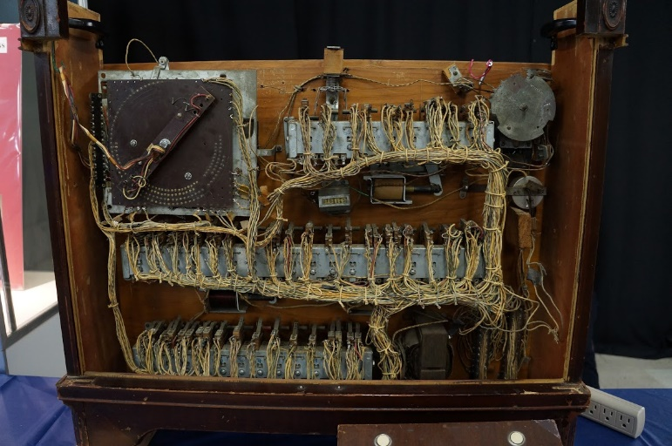
Lorem ipsum dolor sit amet, consectetur adipiscing elit. Quisque varius interdum sapien. Praesent luctus risus in nunc fermentum, vel iaculis arcu ullamcorper. Nulla molestie nisi iaculis arcu ultrices, vitae fermentum neque sodales. Fusce quis ex aliquet leo maximus volutpat. Vestibulum in enim et nisl viverra suscipit efficitur et justo. Fusce fringilla vitae lacus eget vehicula. Vestibulum magna orci, hendrerit a nunc et, tristique tincidunt turpis. Vestibulum ac rhoncus mi. Morbi ut tempus ex. Nullam quis lorem mi. Nulla facilisi. Nulla sed gravida velit. Nam nec est quis neque lacinia ullamcorper sed sed metus.

Discussion of Definitions

Vivamus feugiat iaculis dui ut feugiat. Curabitur neque ex, auctor accumsan efficitur et, efficitur eget lorem. In ipsum tortor, commodo in egestas vitae, tempus sed ex. Cras non mauris pharetra velit auctor egestas. Curabitur vel dolor quis dui pellentesque auctor. Aliquam sagittis massa pretium ligula pellentesque congue. Maecenas hendrerit, risus molestie semper suscipit, turpis diam auctor eros, sed efficitur turpis arcu ac eros. Class aptent taciti sociosqu ad litora torquent per conubia nostra, per inceptos himenaeos. Nullam quis lacus egestas, finibus lorem faucibus, pulvinar nisi. Proin eros tortor, egestas dictum massa nec, fermentum consectetur eros. Quisque pellentesque lectus lorem, vehicula pretium ante hendrerit sit amet. Suspendisse ut molestie magna, a bibendum turpi.

Definition by Bannett Nam imperdiet diam a nunc varius dapibus. Suspendisse et neque purus. Suspendisse potenti. Morbi vehicula massa sapien. Morbi facilisis neque in lacus consequat, id vehicula sapien blandit. Maecenas nunc mi, scelerisque et consequat ac, mattis sit amet sem. Praesent mattis rutrum tellus vel finibus. Donec quis magna sit amet neque tempor maximus et nec lacus. Integer sollicitudin ligula in odio interdum, ut tempor massa rutrum. Donec aliquam mauris nec lacus efficitur fringilla. Proin vitae hendrerit eros, vitae consectetur massa. Pellentesque imperdiet eget mi eget imperdiet. Curabitur rutrum condimentum sem, nec viverra metus pulvinar et. Praesent vulputate odio et egestas pellentesque.

Definition by Derrida Integer vehicula pretium est, id porta dui consequat non. Nullam dignissim dolor nec quam auctor, at porttitor mauris aliquet. Donec tincidunt venenatis fringilla. Pellentesque nec hendrerit diam. Nam vehicula condimentum sollicitudin. Suspendisse ac nisl eleifend, viverra nulla sit amet, ullamcorper velit. Nulla at ante sit amet libero rhoncus porttitor. Sed faucibus massa vel euismod elementum. Fusce tempus odio sem, in aliquam odio dictum tristique. Nunc cursus blandit condimentum. Nullam auctor ex vel tellus accumsan suscipit.

Discussion of Context

Curabitur a vestibulum arcu. Duis malesuada molestie purus quis sollicitudin. Cras nec leo cursus quam rutrum blandit sit amet porta dui. Donec vitae nisl eu dui ultricies efficitur. Duis dictum dui non tortor fermentum eleifend. Sed justo mauris, scelerisque vel consequat vel, imperdiet in ligula. Cras sed sem ac eros dapibus mattis quis vel turpis. Sed a dui dignissim, pharetra arcu sit amet, dignissim erat. Nullam eget massa consequat, consectetur lectus non, gravida augue. Maecenas sed efficitur ex. Etiam vestibulum tortor sapien, in commodo justo pulvinar faucibus. Sed diam orci, tempor vitae hendrerit et, laoreet at ligula. Sed posuere mi at vehicula gravida. Pellentesque habitant morbi tristique senectus et netus et malesuada fames ac turpis egestas. Quisque imperdiet metus vel orci sollicitudin, quis auctor arcu semper. In tempus non tellus eu viverra.

Context Usage by Briggs-Somethingsomething Nunc viverra posuere nisl, non condimentum velit fermentum fermentum. Aliquam ut velit scelerisque leo feugiat semper eget sed mauris. Vivamus lobortis, nisi in laoreet pretium, sem purus pulvinar odio, euismod volutpat felis magna a ipsum. In accumsan ex orci, sit amet ornare tortor convallis eu. Fusce convallis, ipsum ut pulvinar pulvinar, libero mi malesuada mi, nec vestibulum enim ex ut nisl. Sed aliquam a purus sed ullamcorper. Phasellus molestie nibh at lectus accumsan eleifend. Integer congue, leo sed cursus placerat, nulla enim interdum sapien, sit amet consequat ligula nisl commodo lacus. Fusce lobortis ex sed massa ornare, id fringilla ex lobortis. Praesent sed mi turpis. Proin at enim odio. Nunc purus turpis, bibendum a lorem quis, pulvinar fringilla risus. Maecenas egestas risus quis ex suscipit, at laoreet quam pretium. Nunc id dolor dignissim, euismod lacus vitae, iaculis nisl.

Context Usage by Plato Vivamus id pretium tellus. Morbi tristique congue quam, imperdiet finibus tortor volutpat nec. Cum sociis natoque penatibus et magnis dis parturient montes, nascetur ridiculus mus. Aliquam justo libero, dictum et ligula sit amet, rhoncus imperdiet velit. Nam finibus velit at diam laoreet, nec pretium elit accumsan. Nunc in nulla id orci maximus ullamcorper vitae nec mi. Pellentesque laoreet, lectus ut porttitor dictum, erat magna luctus enim, sit amet tincidunt magna ex id enim. In interdum malesuada pellentesque. Vestibulum tristique tincidunt odio, at eleifend ligula tristique sit amet. Phasellus auctor risus at vehicula lacinia. Mauris est dolor, suscipit eget tempus fringilla, pharetra sit amet massa.

References

Ellis, J. W. (2014, April 9). How to build a sparring lightsaber with parts from Home Depot and spare parts (with thoughts on learning and haptics) [Web log post]. Retrieved from https://dynamicsubspace.net/2014/04/09/how-to-build-a-sparring-lightsaber-with-parts-from-home-depot-and-spare-parts-with-thoughts-on-learning-and-haptics/.
Ellis, J. W. (2014, April 9). How to build a sparring lightsaber with parts from Home Depot and spare parts (with thoughts on learning and haptics) [Web log post]. Retrieved from https://dynamicsubspace.net/2014/04/09/how-to-build-a-sparring-lightsaber-with-parts-from-home-depot-and-spare-parts-with-thoughts-on-learning-and-haptics/.
Ellis, J. W. (2014, April 9). How to build a sparring lightsaber with parts from Home Depot and spare parts (with thoughts on learning and haptics) [Web log post]. Retrieved from https://dynamicsubspace.net/2014/04/09/how-to-build-a-sparring-lightsaber-with-parts-from-home-depot-and-spare-parts-with-thoughts-on-learning-and-haptics/.
Ellis, J. W. (2014, April 9). How to build a sparring lightsaber with parts from Home Depot and spare parts (with thoughts on learning and haptics) [Web log post]. Retrieved from https://dynamicsubspace.net/2014/04/09/how-to-build-a-sparring-lightsaber-with-parts-from-home-depot-and-spare-parts-with-thoughts-on-learning-and-haptics/.
Ellis, J. W. (2014, April 9). How to build a sparring lightsaber with parts from Home Depot and spare parts (with thoughts on learning and haptics) [Web log post]. Retrieved from https://dynamicsubspace.net/2014/04/09/how-to-build-a-sparring-lightsaber-with-parts-from-home-depot-and-spare-parts-with-thoughts-on-learning-and-haptics/.
Ellis, J. W. (2014, April 9). How to build a sparring lightsaber with parts from Home Depot and spare parts (with thoughts on learning and haptics) [Web log post]. Retrieved from https://dynamicsubspace.net/2014/04/09/how-to-build-a-sparring-lightsaber-with-parts-from-home-depot-and-spare-parts-with-thoughts-on-learning-and-haptics/.

