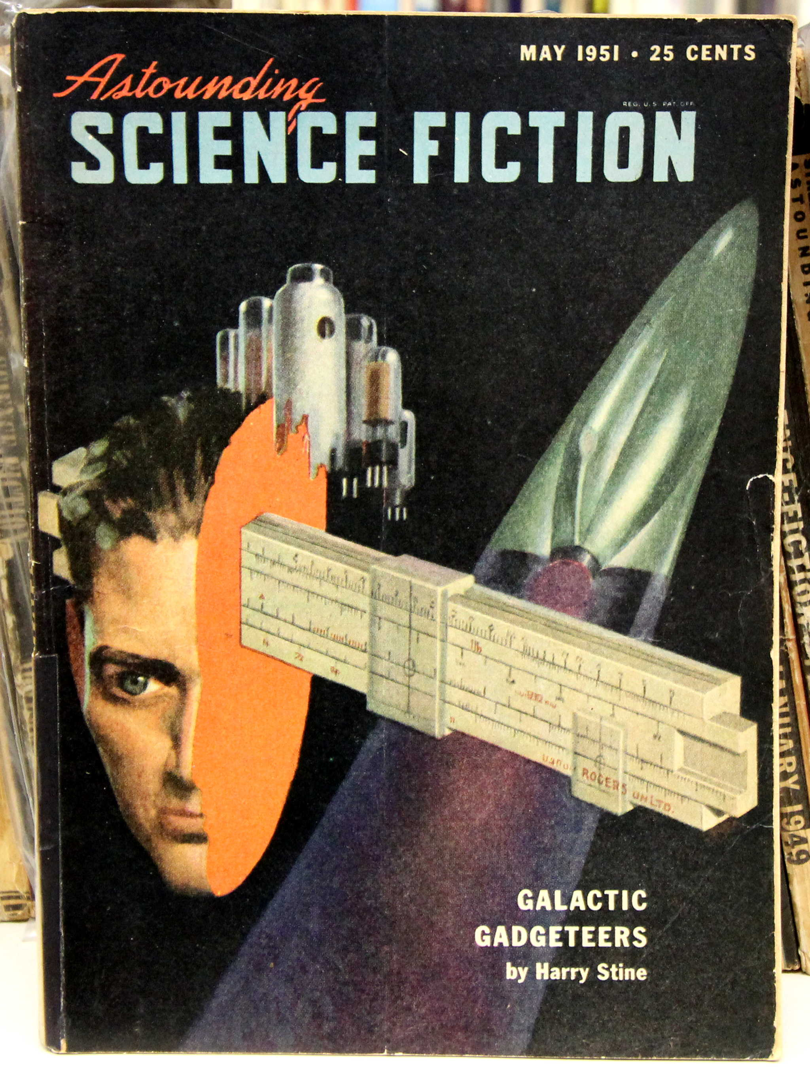
Technical Writing

ENG2575, E274
Th 6:00PM-8:30PM
N601B

Professor Ellis
Office/Hours: Namm N520, Th 3:00PM-5:00PM or by appointment.
jellis@citytech.cuny.edu
http://dynamicsubspace.net

Course Description
Technical Writing is about managing complexity. It is about providing the right information, in the right way, for the right audience. It is about communicating technical ideas using sound rhetorical choices and synergistic modalities (e.g., WOVEN, or written, oral, visual, electronic, and nonverbal). Also, technical communication depends on professionalism and ethical considerations. In this class, you will learn and practice all of these things as well as gain advice about how to leverage what you know to excel in your career field by demonstrating how much more you can do and how much more value you bring to your business by developing these skills and creating a portfolio of documents that demonstrate what you have learned. The catalog course description, objectives, and prerequisites are attached.

Required Texts

- Laura Portwood-Stacer, “How to Email Your Professor (Without Being Annoying AF),” https://medium.com/@lportwoodstacer/how-to-email-your-professor-without-being-annoying-af-cf64ae0e4087#.1m6lc0rkd.
- “What is Technical Communication?”, http://wps.prenhall.com/wps/media/objects/5547/5681092/pdfs/CH01.pdf.
- Frank O’Hara, “A Brief History of Technical Communication,” http://www.msubillings.edu/cotfaculty/fullon/_notes/History%20of%20Technical%20Communication%20(2).pdf.
- David McMurrey, Online Technical Writing, https://www.prismnet.com/~hcexres/textbook/.
- Purdue OWL, Professional and Technical Writing, https://owl.english.purdue.edu/owl/section/4/16/.
- Purdue OWL, APA Style, https://owl.english.purdue.edu/owl/section/2/10/.
- Other brief readings will be assigned as part of in-class assignments and exercises.

Required Resources
- Computer access, word processing software, and a means of saving your work securely.
- Access to your City Tech email.
- Access and accounts at openlab.citytech.cuny.edu and other designated web sites.
- Flash drive for saving your work and/or having scratch space for in-class project work (always bring this to class).
- Cloud-based storage for saving a backup of all your work.
- Google Drive/Gmail account for collaborative writing.

Grading
Assignment | Description | Percentage of Final Grade
500-Word Summary | Individually, you will write a 500-word summary of a technical or scientific article that demonstrates: 1. ability to identify key processes and concepts in a professional science or technology article. 2. ability to describe complex processes and concepts clearly and concisely. 3. an awareness of audience. The summary should cite the article and any quotes following APA format. | 10%
750-Word Expanded Definition | Individually, you will write a 750-1000 word expanded definition of a technical or scientific term, with cover memo, which demonstrates: 1. correct memorandum format. 2. knowledge of the etymology and historical development of the term. 3. examples of the term's use in various written contexts. 4. ability to compare and contrast various uses of the term. 5. use and citation of sources with proper attribution. 6. awareness of audience. At least three library-sourced citations are required and should be cited following APA format. | 10%
1500-2000-Word Instructional or Training Manual | Individually, you will write a 1500-2000-word instructional or training manual that demonstrates: 1. ability to explain a task/process in clear, concise language. 2. selection and definition of appropriate terminology and concepts. 3. awareness of the intended user/audience. 4. knowledge of instructional manual format. All diagrams, illustrations, or photos must be created by the student and integrated into his or her manual. Any outside sources cited should be documented according to APA format. | 15%
1500-2000-Word Formal Product or Service Proposal | A 1500-2000-word formal product or service proposal that demonstrates: 1. knowledge of the product or service offered, of pertinent market forces, and of the potential customer base. 2. the proposer's qualifications to deliver the product or service described. 3. knowledge of research methodology and the ability to describe that methodology. 4. proper proposal format. At least six library-sourced citations must be included (non-library-sourced citations are encouraged, but they do not count toward the six library-sourced sources). Any outside sources cited should be documented according to APA format. | 15%
Collaboration: Seven-to-Ten-Minute Oral Presentation to Sell a Product or Service | As a team, select one member’s product/service proposal as the basis for your team’s presentation. Collaboratively, your team will create and deliver a seven- to ten-minute oral presentation designed to sell a product or service to an audience of potential customers that demonstrates: 1. knowledge of oral presentation techniques and conventions. 2. the ability to organize a presentation effectively. 3. the ability to incorporate various media into the presentation, including appropriate computer software. 4. knowledge of the product or service offered, of pertinent market forces, and of the potential customer base. 5. the ability to communicate the value of the product or service in clear, spoken English. 6. the ability to answer audience questions. 7. the ability to collaborate productively with a partner or partners. A presentation script and PowerPoint visual presentation are required and will be submitted as part of the assignment. | 10%
Collaboration: Website Advertising a Product or Service | To support your team’s collaborative presentation, your team will create a web page advertising a product or service that demonstrates: 1. knowledge of the product or service offered, of pertinent market forces, and of the potential customer base. 2. basic knowledge of web page design and composition, including appropriate software. The website will be based on your presentation and it is encouraged to be integrated into your presentation (perhaps to demonstrate how your team is promoting your product or service). All graphics, logos, design, and text must be created by your team. | 10%
Collaboration: Report on Collaboration | Each team will write an informal report on their group's progress with the oral product service proposal or oral analytical research report that demonstrates: 1. the division of labor among group members. 2. the adequate progress of each group member. 3. the group's adequate cooperation. 4. an awareness of a supervisory audience. It is each team’s responsibility to track your progress and keep notes that can be integrated into this report. | 10%
Daily Writing Assignments | At the beginning of class, students will be tasked with responding to a question or topic relating to technical communication. Students will have 15 minutes to write a response and some of these will be shared during discussion. | 10%
Final Exam | Comprehensive essay-based exam over class lecture, discussion, and assignments. | 10%

Attendance and Lateness Policy
The expectation for successful and respectful college students is to arrive on time and attend all classes. The college permits students to miss 10% of a class (1.5 absences three absences) for whatever reason. In our class, each additional absence will reduce your final grade by 10 points (equivalent of a full letter grade). Missing too many classes will obviously result in failure of the class. Also, an absence does not excuse you from any assignments or exams. Use your absences wisely. Arriving late or leaving early will, depending on the specific situation, count as a full or partial absence.

Required Format for Papers
While there will be exceptions that we will discuss in class, all writing submitted online or on printed paper should follow APA MLA professional style. In particular, your writing should always include a “name block,” a title, and your writing. If you quote or cite writing by others, it should be properly cited and included as an entry on a concluding “Works Cited” list. Search Google for “Purdue OWL APA MLA” for guidelines and sample papers.

Policy for Late Papers
Assignments submitted late or exams taken late will incur a 10-point reduction for each day that they are late. However, no assignments will be accepted after the last day of class. If a student knows that work cannot be completed on time, he or she should contact me or visit my office hours to discuss.

College Policy on Academic Integrity
Students who work with information, ideas, and texts owe their audience and sources accuracy and honesty in using, crediting, and citing sources. As a community of intellectual and professional workers, the College recognizes its responsibility for providing instruction in information literacy and academic integrity, offering models of good practice, and responding vigilantly and appropriately to infractions of academic integrity. Accordingly, academic dishonesty is prohibited in CUNY and at New York City College of Technology, and is punishable by penalties, including failing grades, suspension, and expulsion. The complete text of the College policy on Academic Integrity may be found in the catalog.

Tentative Class Schedule
Day | Date | In-Class Work | Reading for Class | Due Before Class
Th | 8/25 | Discuss the syllabus and policies.  What is Technical Communication? In-class LEGO project.
Th | 9/1 | 500-Word Summary | Readings 1 and 2
Th | 9/8 | 500-Word Summary | Reading 3
Th | 9/15 | 750-Word Expanded Definition |  | 500-Word Summary
Th | 9/22 | 750-Word Expanded Definition
Th | 9/29 | 750-Word Expanded Definition
Th | 10/6 | No class. School follows a Monday schedule.
Th | 10/13 | 1500-2000-Word Instructional or Training Manual |  | 750-Word Expanded Definition
Th | 10/20 | 1500-2000-Word Instructional or Training Manual
Th | 10/27 | 1500-2000-Word Formal Product or Service Proposal |  | 1500-2000-Word Instructional or Training Manual
Th | 11/3 | 1500-2000-Word Formal Product or Service Proposal
Th | 11/10 | 1500-2000-Word Formal Product or Service Proposal
Th | 11/17 | Form collaborative teams.  Collaboration: Website Advertising a Product or Service |  | 1500-2000-Word Formal Product or Service Proposal
Th | 11/24 | No class.
Th | 12/1 | Studio time.
Th | 12/8 | Studio time.
Th | 12/15 | Last day of class.  Team Presentations delivered during first half of class.  Final exam during last half of class. |  | Collaboration: Website Advertising a Product or Service  Collaboration: Seven-to-Ten-Minute Oral Presentation to Sell a Product or Service  Collaboration: Report on Collaboration

