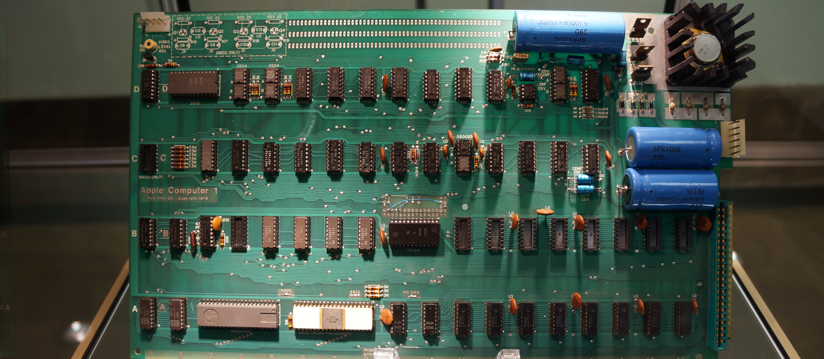

Project 2: Team-Based Technical Communication Portfolio Project
Dr. Jason W. Ellis, New York City College of Technology, CUNY

Introduction

Working in a team of students, cooperate and collaborate on a set of technical documents for a specific type of technology: vintage computer. Some of your work will be hands-on and some will be research-based. As a team, you will create a portfolio of documents. Besides creating documents using the writing process, you will want to be mindful of rhetoric and your intended audience for each document, which will form the basis of the essay-based final exam on the last day of class.

Deliverables

- Mission Statement and Team By-Laws. This one page document should set out the mission of your team as if it were a business doing specific kinds of work relating to this project, and it should set out the rules or by-laws of how your team does work, collaborates, and holds team members accountable.
- Meeting minutes for each in-class meeting and out-of-class meeting. These will be submitted to the professor by email at the beginning of each week for those meetings that took place the previous week.
- Research report on your team’s selected vintage computer system. Your research report should include an executive summary, introduction, background on the manufacturer, background on competitors, a discussion of the computer, its peripherals, and software, an annotated bibliography, and works cited list.
- Bid (or proposal) addressed to the computer manufacturer in response to the call for proposals. Building on your research in the previous report, create an unsolicited proposal to the manufacturer for producing a superior set of sales documents for your team’s assigned computer: brochure and owner’s manual (instructions/how to setup and turn on the computer with an appendix on optional peripherals). Follow the guidelines in the AMA Handbook 114-115 and example on 115-124.
- Tri-fold brochure that attempts to persuade buyers to purchase your computer. It should be printed on both sides and in color. Combine images (of your making) and words (of your composing) to sell buyers on the computer. Build on your previous research.
- Owner’s manual that validates purchase, encourages learning the system, and briefly demonstrates how to setup the computer and turn it on. An appendix should illustrate some optional peripherals that expand the computer’s capabilities and open the possibility of future purchases by the new computer owner. Draw on your past research and brochure in the production of this document. Think about different ways to produce an effective and useful manual beyond a straightforward approach (lateral thinking—think outside the box).
- Document testing report that follows the basic format of a lab report (http://writing.engr.psu.edu/workbooks/laboratory.html). Gather usability feedback from at least two other students in class and two people outside of class by having each respondent provide answers to a questionnaire and interview based on a comparison of effectiveness of your deliverables (brochure and owner’s manual) and similar examples that you can find elsewhere online or in your research.
- Presentation of your team’s research and deliverables. It should be no longer than 10 minutes long and no less than 9 minutes 30 seconds. This part of the product will require practice. All team members are required to speak during the presentation. The team will need to think about the presentation space and the awkward arrangement of the classroom and SmartBoard in order to effectively design how to give a strong presentation. Following each presentation, there will be a Q&A session with questions from peers and the professor.

Grading

As a portfolio-based assignment, your final grade on this project is determined by your portfolio and presentation at the end of the semester. However, teams are required to submit drafts of their milestone assignments leading up to completion of the project. If these milestone assignments are not completed on time, this will lead to a reduced grade on the project for each team member. If any team member is found not to be contributing or fails to fulfill their delegated tasks in a timely manner, it is the responsibility of the other team members to immediately talk with the professor immediately about their concerns so that a resolution can be determined as quickly as possible for all students involved. Each team member is tasked with thinking about and discussing with their teammates the rhetorical decision making that goes into each component of the project. Who is each deliverable’s audience(s)? What rhetorical appeals are being used and for what reason? How is multimodality being utilized to improve audience engagement and attention? At the end of the project, each student will have an opportunity to explain the team’s rhetorical decision making and rhetorical challenges in an essay-based final exam, which is exam administered to each student individually.

Tentative Schedule

Week | Day | Date | Announcements | Reading | Due
7 | W | 10/14 | Student-led introduction to the reading.  Introduce Project 2. | Reading from OpenLab. | OpenLab: Post reading summary during first ten minutes of class.
8 | M | 10/19 | Student-led introduction to the reading.  Setup teams.  Setup Google Drive shared folder for each team.  Create first agenda based on the work on the assignment sheet. In future meetings, your team will decide on an agenda for each meeting. This should define what you intend to accomplish and discuss.  Create first meeting minutes memo in Google Drive shared folder. Each meeting, a different team member should maintain the minutes.  Develop your team’s mission statement and internal rules. | Reading from OpenLab. | OpenLab: Post reading summary during first ten minutes of class.
 | W | 10/21 | Student-led introduction to the reading. | Reading from OpenLab. | OpenLab: Post reading summary during first ten minutes of class.
9 | M | 10/26 | Student-led introduction to the reading.  Assign subject computer to each team.  Begin research report on your team’s computer. | Reading from OpenLab. | OpenLab: Post reading summary during first ten minutes of class.  Mission Statement and Team By-Laws due. Turn in one copy printed, and turn in one copy as a PDF emailed to the professor.
 | W | 10/28 | Student-led introduction to the reading. | Reading from OpenLab. | OpenLab: Post reading summary during first ten minutes of class.
10 | M | 11/2 | Student-led introduction to the reading.  Midterm grades available. | Reading from OpenLab. | OpenLab: Post reading summary during first ten minutes of class.
 | W | 11/4 | Student-led introduction to the reading. | Reading from OpenLab. | OpenLab: Post reading summary during first ten minutes of class.
11 | M | 11/9 | Student-led introduction to the reading.  Begin writing a bid to produce documentation (informational tri-fold brochure, instruction manual, and testing report) for your team’s computer. | Reading from OpenLab. | OpenLab: Post reading summary during first ten minutes of class.  Research report due. Turn in one copy as a printed and stapled document, and turn in one copy as a PDF emailed to the professor.
 | W | 11/11 | Student-led introduction to the reading. | Reading from OpenLab. | OpenLab: Post reading summary during first ten minutes of class.
12 | M | 11/16 | Student-led introduction to the reading.  Begin creating an informational tri-fold brochure for your team’s computer. | Reading from OpenLab. | OpenLab: Post reading summary during first ten minutes of class.  Bid due. Turn in one copy as a printed and stapled document, and turn in one copy as a PDF emailed to the professor.
 | W | 11/18 | Student-led introduction to the reading. | Reading from OpenLab. | Beginning of class writing: summary of reading.
13 | M | 11/23 | Student-led introduction to the reading.  Begin creating owner’s manual. | Reading from OpenLab. | OpenLab: Post reading summary during first ten minutes of class.  Informational tri-fold brochure due. Turn in one copy as a printed and folded document, and turn in one copy as a PDF emailed to the professor.
 | W | 11/25 | Student-led introduction to the reading. | Reading from OpenLab. | OpenLab: Post reading summary during first ten minutes of class.
14 | M | 11/30 | Student-led introduction to the reading.  Develop testing methodology for your two documents and test them with at least two students in class who are not in your team.  Using testing results begin writing testing report on the model of a lab report. | Reading from OpenLab. | OpenLab: Post reading summary during first ten minutes of class.  Instruction manual due. Turn in one copy as a printed and stapled document, and turn in one copy as a PDF emailed to the professor.
 | W | 12/2 | Student-led introduction to the reading. | Reading from OpenLab. | OpenLab: Post reading summary during first ten minutes of class.
15 | M | 12/7 | Student-led introduction to the reading.  Perform final revisions to your previously drafted documents, and prepare your 10 minute presentation for the following week. | Reading from OpenLab. | OpenLab: Post reading summary during first ten minutes of class.  Testing lab report due. Turn in one copy as a printed and stapled document, and turn in one copy as a PDF emailed to the professor.
 | W | 12/9 | Student-led introduction to the reading.  Perform final revisions to your previously drafted documents, and prepare your 10-minute presentation for the following week. | Reading from OpenLab. | OpenLab: Post reading summary during first ten minutes of class.
16 | M | 12/14 | Project 2 Team Presentations. |  | Project 2 Portfolio from each team due at the beginning of class. Turn in one copy printed, three-hole punched, and bound in a pocket folder with fasteners, and turn in one copy as a PDF emailed to the professor.
 | W | 12/16 | Project 2 Team Presentations.  Handout final exam writing prompt.
17 | M | 12/21 | LAST DAY OF CLASS.  Final exam during class.
 |  |  | Final grades available on CUNYfirst after midnight on 12/29.

