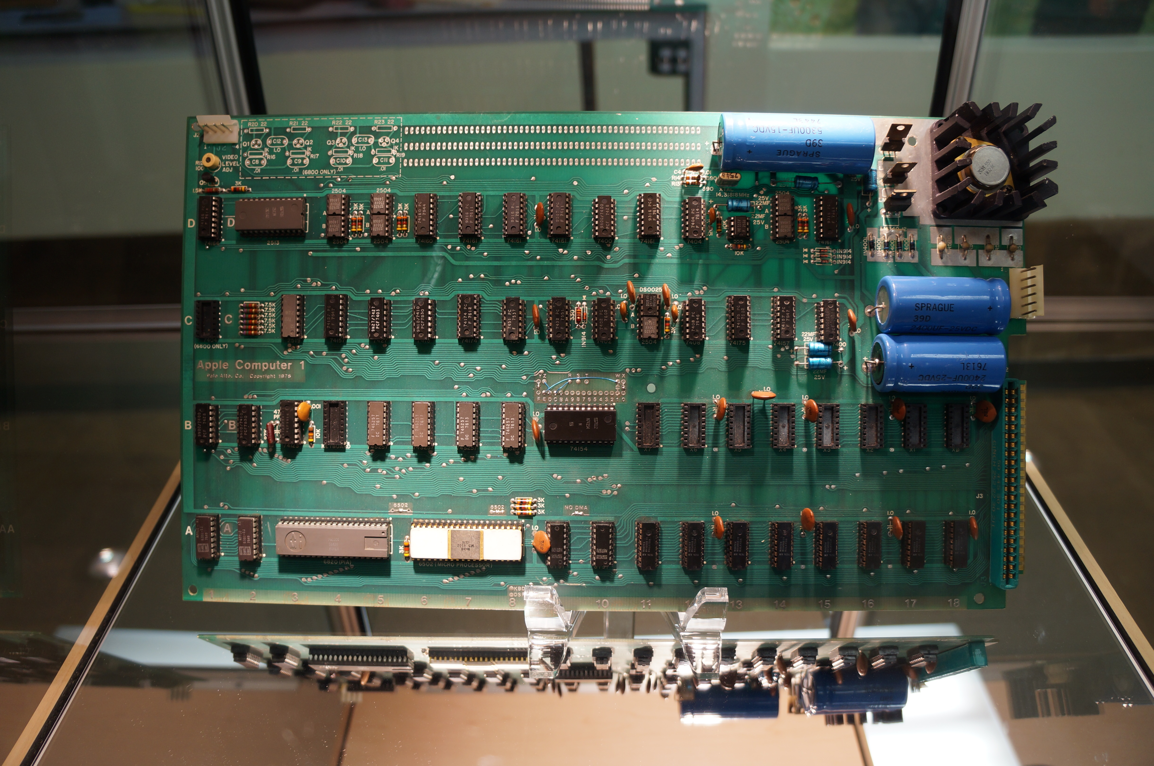

Project 1: Job Application Portfolio

Dr. Jason W. Ellis, New York City College of Technology, CUNY

**Introduction**

Create a portfolio of job application documents, including: a memo on the career that you seek, a memo on your program of study at City Tech preparing you for that career, a research memo on a company/job ad, a personal LinkedIn.com profile, a letter of application for that job, a skills-based resume for that job, and a chronological/work-experience resume for that job, and a letter of resignation (imagining that you have worked at this job for some time and have been offered a job elsewhere).

**Your Job Application Portfolio**

Your job application portfolio should be submitted at the beginning of class on the due date according to the schedule below. Submit it in an inexpensive pocket folder with fasteners (like these <http://goo.gl/LhI5ZK>) labeled on its front as “Job Application Portfolio” with your name beneath this title. Your portfolio should include these documents, three-hole punched and secured by the fasteners:

1. Introductory memo that details the contents of your portfolio.
2. Print out of your job ad.
3. Research memo that discusses the job ad, the company and its culture, specific points about the job ad that you believe should be highlighted (e.g., keywords, certifications, experience, etc.), and how your program of study at City Tech is preparing you for that job.
4. Print out of your LinkedIn.com Profile.
5. Letter of application for that job.
6. Experience-based resume.
7. Skills-based resume.
8. Letter of resignation (imagining that you have worked there for some amount of time and you are transitioning to a new job elsewhere).

**Schedule**

|  |  |  |  |  |  |
| --- | --- | --- | --- | --- | --- |
| 2 | M | 9/7 | No Class. |  |  |
|  | W | 9/9 | Introduce Project One.  Project One: find a job ad. | *AMA Handbook*, Application Letter and Resumes. |  |
|  | Th | 9/10 | Follow a Monday schedule.  Student-led introduction to the reading.  Project One: Research your job ad using the web and library’s databases. | Reading: see email. | **OpenLab: Post reading summary during first ten minutes of class.** |
| 3 | M | 9/14 | No Class. |  |  |
|  | W | 9/16 | Student-led introduction to the reading.  Project One: Create LinkedIn.com Profile and peer review job ad research memos.  Project One: Discuss experience-based resume. | Reading see email. | **OpenLab: Post reading summary during first ten minutes of class.**  **Bring three copies of your job ad research memo to class for peer review.** |
| 4 | M | 9/21 | Student-led introduction to the reading.  Project One: Peer review experience-based resume.  Project One: Discuss skills-based resume. | Reading from *Intercom*. | **OpenLab: Post reading summary during first ten minutes of class.**  **Bring three copies of your experience-based resume to class for peer review.** |
|  | W | 9/23 | No class. |  |  |
| 5 | M | 9/28 | Student-led introduction to the reading.  Project One: Peer review skills-based resume.  Project One: Discuss letter of application. | Reading from *Intercom*. | **OpenLab: Post reading summary during first ten minutes of class.**  **Bring three copies of your skills-based resume to class for peer review.** |
|  | W | 9/30 | Student-led introduction to the reading.  Project One: Peer review letter of application.  Project One: Discuss letter of resignation. | Reading from *Intercom*. | **OpenLab: Post reading summary during first ten minutes of class.**  **Bring three copies of your letter of application to class for peer review.** |
| 6 | M | 10/5 | Student-led introduction to the reading.  Project One: Peer review letter of resignation. | Reading from *Intercom*. | **OpenLab: Post reading summary during first ten minutes of class.**  **Bring three copies of your letter of resignation to class for peer review.** |
|  | W | 10/7 | Student-led introduction to the reading.  Write introductory memo for portfolio.  Peer review any materials with your team that you would like to review again. |  | **OpenLab: Post reading summary during first ten minutes of class.**  **Bring three copies of any job portfolio documents that you would like to have peer reviewed. Talk with your team beforehand to plan this out.** |
| 7 | M | 10/12 | No class. |  |  |
|  | W | 10/14 | Student-led introduction to the reading.  **Introduce Project Two.** | Reading from *Intercom*. | **OpenLab: Post reading summary during first ten minutes of class.**  **Project One Portfolio due at the beginning of class in a three tab folder labeled on the cover as “Job Application Portfolio” in the middle and your name beneath the title. Inside, you should include these things: a memo introducing your portfolio with a list of contents of the portfolio, a print out of your job ad, job research memo, print out of your LinkedIn profile page,**  **skills-based resume, experience-based resume, job application letter, and letter of resignation.** |