Erica Lliguichuzhca
DEN 2315 Pharmacology
Fall, 2019
Dong quai
Dong quai, also named Angelica sinensis, is a medicinal herb from the family Apiaceae that is harvested in the fall and grown in the, “cool high altitude mountains of China, Japan, and Korea” (Wikipedia). This plant is especially known for its root properties and has been used in Chinese traditional medicine for many years. The natural product has and is presently being used to treat menstrual and menopausal symptoms, dysmenorrhea (painful periods), and treat premenstrual syndrome (Memorial Sloan Kettering Cancer Center). Due to the several effects of Dong quai, it is classified as an antiplatelet and anticoagulant.
Angelica sinensis are now sold as a dietary supplement in the form of root powder pills and can even be found in the United States. Although on several labels it states that the root can nourish blood, support healthy energy levels, support female hormonal balance and help with the female reproductive system they are also used for other reasons (Nature’s Way). People also use them for osteoporosis, anemia, as an anti-inflammatory to the digestive system and to reduce cholesterol level (Indigo Herbs).
Several studies were done to support the different benefits of Dong quai. In the Institute of Traditional Medicine, National Yang-Ming University in Taipei, Taiwan, an epidemiologic study was done to determine if Dong quai increases the risk of endometrial cancer risk in breast cancer survivors in the area. It was found that consuming this root decreases the risk of endometrial cancer among women aged 20-79 years old (Wu, Chien-Tung et al). There were also quite a couple of trials done surrounding menopausal symptoms, such as for the treatment of hot flashes during menopause, but all the results were inconclusive. Besides women, a small study was done in men to see if a therapeutic effect exiss in, “treating hot flashes among prostate cancer patients” who are receiving androgen deprivation therapy (Al-Bareeq, Reem J et al). It was found that there were no benefits.
Not everyone can take Dong quai there are significant adverse effects, drug interactions and contraindications that have to be taken into consideration. Those that are pregnant or trying to conceive a baby should not take this root because it may lead to a miscarriage. Also those that are breastfeeding are not advised to take it as well (Memorial Sloan Kettering Cancer Center). It is said that the intake of Dong quai with ACE inhibitors can cause skin to become extra sensitive to sun and possibly lead to skin cancer (Winchester Hospital) . In the same manner, it should not be taken by people going under radiation therapy; it may lead to photodermatitis. Large doses for a prolonged time is not advised because the root contains compounds that are considered carcinogenic. If taking an anticoagulant, like warfarin, the use of this root is not recommended because it may increase the risk of bleeding. One also has to be cautious when taking ginkgo, garlic and ginger; it may slow blood clotting to reduce risk of bleeding and bruising (Wikipedia). Other side effects include the development of breasts in men, fever and diarrhea.
Although not clearly stated, because Dong quai affects the hormones and it acts as an antiplatelet an oral manifestation may be gingivitis. Similarly to oral contraceptives, Dong quai can lead to an increased bleeding of the gums and thus inflamed gingival tissue. Oral contraceptives pills and Dong quai have some similar benefits such as lessening endometrial cancers and help with the treatment of premenstrual syndrome (Plannedparenthood). This syndrome is one of the main reasons Dong quai is taken. In addition, birth control pills can help make periods regular and reduce menstrual cramps like the medicinal herb discussed. Angelica senersis is more attractive to the consumer in that unlike the birth control pill it does not have to be taken strictly everyday at the same time. Dong quai is taken when needed to reduce menstrual cramps and help with PMS. Other than not taking it everyday, another reason women get Dong quai is because that is the only thing they can get to relieve their symptoms since they may not have access to medical insurance. In the same manner, the cost of Dong quai is less than birth control pills. One has to get birth control pills every month and the root only used when needed.
After learning about Dong quai as a health educator, our knowledge about natural products should be somewhat extensive but not as extensive as a prescribed drug. If a patient is currently taking a natural product I would look it up in the drug handbook like it is done with any prescribed drug. If not found in the drug handbook it would be looked up in a valuable source such as a website from an established institution. Because of the reliable sources regarding Dong quai and the ability to ask the right questions about this medicinal herb I believe my comfort level should be sufficient. Not only that, but I would also show the patient where the information about Dong quai was found and discuss with them if they are aware of the possible associated risks. If a patient is taking this medicinal herb I would try my best to inform the patient about the side effects it can have on the body and emphasized how it can affect their gums. When it comes to the treatment plan the information about this product will come up when teaching oral hygiene care. Similarly to the birth control pill, the patient may experience bleeding of the gums when brushing their teeth or flossing. While teaching an OHI I would explain to the patient why they may experience the bleeding; it being either calculus and if not then a side effect of Dong quai.

As it appears in nature :
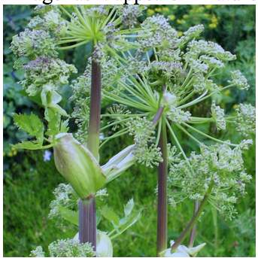
As packaged for consumer use:
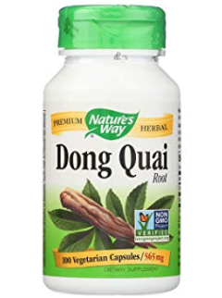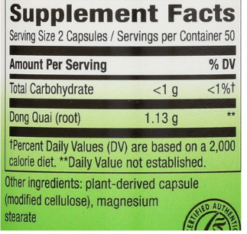

Al-Bareeq, Reem J et al. “Dong Quai (angelica sinensis) in the treatment of hot flashes for men
on androgen deprivation therapy: results of a randomized double-blind placebo controlled
trial.” Canadian Urological Association journal = Journal de l'Association des urologues
du Canada vol. 4,1 (2010): 49-53. doi:10.5489/cuaj.775
Wu, Chien-Tung et al. “The prescription pattern of Chinese herbal products that contain dang-qui
and risk of endometrial cancer among tamoxifen-treated female breast cancer survivors in
Taiwan: a population-based study.” PloS onevol. 9,12 e113887. 8 Dec. 2014,
doi:10.1371/journal.pone.0113887
“Angelica Sinensis.” Wikipedia, Wikimedia Foundation, 17 Nov. 2019,
en.wikipedia.org/wiki/Angelica_sinensis.
“Angiotensin-Converting Enzyme Inhibitors (ACE Inhibitors).” Winchester Hospital,
www.winchesterhospital.org/health-library/article?id=21382.
“Dong Quai.” Memorial Sloan Kettering Cancer Center,
www.mskcc.org/cancer-care/integrative-medicine/herbs/dong-quai.
“Dong Quai Root / 100 Caps.” Dong Quai Root / 100 Caps - Nature's Way®.,
www.naturesway.com/Product-Catalog/Dong-Quai-Root-100-Caps.
“Dong Quai Benefits & Information.” Indigo Herbs,
www.indigo-herbs.co.uk/natural-health-guide/benefits/dong-quai.
Parenthood, Planned. “What Are the Side Effects of Birth Control Pills?” Planned Parenthood,
www.plannedparenthood.org/learn/birth-control-pill/what-are-the-disadvantages-of-the
-pill.

