Esther Glasgow
Professor Thelma Bauer
COMD 1112
May 15, 2020
Virtual Museum Report
This virtual Museum exhibit is quite fascinating. Blue in the graphical details brought me joy, although it is not my favorite color, because I am into interior and spaces and the details that it promotes. Sometimes it is good to take a better look at all that has been put into a design especially in the realm of infrastructure. Without moving anymore further, the name of the piece is, “Metropolitan Museum Interior” by Mark Innerst. In this picture, what I gather is “I got the blues moment” and people engaging in interaction before something opens.
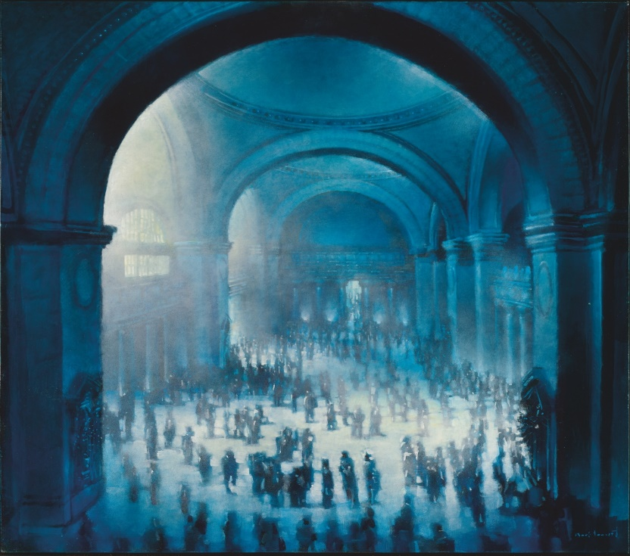

“BLUE NUDES” by Henri Martise
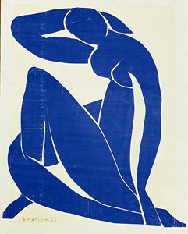
Henri’s masterpiece here depicts his patience, great brain power usage and creativity in this piece. He used gouache painted paper cut outs stuck on paper mounted on a canvas. The structure that he created with the paper reminds me of how some women pose on Instagram portraying their femininity and strength. Abstract pieces coming together to make something realistic was a great idea. It reminds me of our life. We may not be able to put all the puzzle pieces of our life together right then and there (look at her head facing downwards) , but with patience we turn out to be a strong and great masterpiece that’s well equipped to perform.

“CAIN AND ABEL” by Odilon Redon
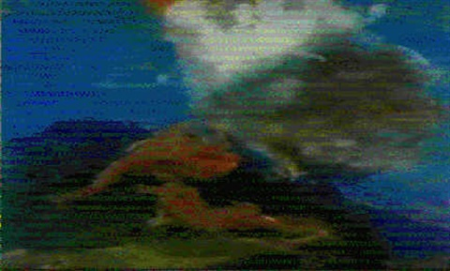
This one was obvious. I chose this as my third because it resembles a life story, that is of course recorded in the BIBLE. Nonetheless, the painter is showing war between two people that look just a like. The colors mesh well together which gives the looker a clear significance of the location as well as the mood.
Note: This was the clearest photograph I could’ve found on the web,

