Weight Watchers
  - Research 1
Esther Glasgow | Digital Media | May 6, 2020

Introduction
Year into year Americans and others around the globe always set a goal that revolves around healthy habits (emotional, mental, and physical) which in the beginning seems fun and enthusiastic until the amount of work is weighed. Throughout this paper I will discuss about a company that serves to help people attain their goals that they have set and let what they learned become a lifestyle. Secondly, how the brand came about: logo creation efforts and explanations and the logo design overall. Last but certainly not least, a summary of what I learned and my opinions. Weight Watchers is more than a program that is designed for people who just want to lose weight.
Weight Watchers was created to help people of different cultures lose weight by developing a positive mindset, emotional stability and maintaining to live a happy and healthy lifestyle. Weight Watchers was developed in a basement right here in Queens, New York by Jean Nidetch to help people make changes necessary to lose weight, motivate them along their journey, developing and maintaining effective behavioral changes and being an inspiration. Now that the nitty gritty of the program is out of the way, get to know the founder Jean Nidetch and understand why she started weight watchers. Jean Nidetch was an oversized stay at home mother who had an overwhelming obsession for eating cookies. In hopes of her feeling confident and wanting to be the best for herself, her husband and her children, she experimented with numerous fad alerts before she followed a regimen prescribed by a diet clinic sponsored by the New York City Board of Health in 1961. She did lose an approximation of twenty pounds; however, there was inconsistency and lack of support, so she decided to do her own thing first believing that she can lose the weight and maintain it. After analyzing that her ‘layout’ was benefitting, she invited her friends and sit it with them. As time moved on, the impact of Nidetch’s plan went abroad. Through the development, it can be inferred that one’s mindset is the anchor to succeeding. In other words, “If you think you can, you can. If you think you cannot, then you can’t.” Another key component was accountability and those that had the same value as her. Her friends were encouraging her to do the same as they were doing and vice versa. The accountability and positive mindset make room for consistency.
Who Designed the Logo?
(Logo Design Development and Changes)

Throughout the development of Weight Watchers, INC formerly known as Weight Watchers International, INC, there was a change in logo, color, tagline and tweaking on their purpose. The brand-new name is WW with the new slogan “Wellness that works.’’ The new WW mission now places less emphasis on weight loss and instead prioritize overall wellness. These changes were primarily made based on science. Changes were also made in the products; there was a line release of kitchen tools and cookbooks called WW Healthy Kitchen and the food products now no longer has artificial sweeteners, preserves and flavoring (like pack seasoning). With the revamp of the logo, the company got a lot of negative feedback especially from the design community. The WW a lone was major because it did not stand for Weight Watchers, neither did it stand for the new slogan or tagline. Rather the stacked WW with the “purple circle, is emblematic of this gear change. The marque represents our heritage and history and what we are going forward’, says the company’s chief Executive, Mindy Grossman.
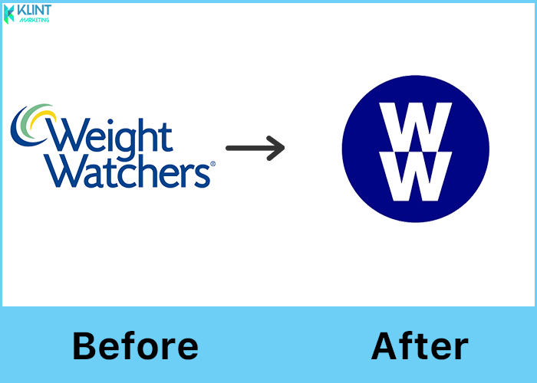

What I Have Learned
What I learned from creation of the company and the development of the logo design is you need the desire to change, go through the process, have accountability and maintain.

Works Cited
Raphael, Rina. “Here’s Why Weight Watchers Changed Its Name.” Fast Company. 24 Sept. 2018, https://www.fastcompany.com/90241019/ww-heres-why-weight-watchers-changed-its-name
https://www.vox.com/the-goods/2018/9/24/17897114/weight-watchers-ww-wellness-rebranding

