FRED EXCEL Add-in Installation
- Extract fred folder to your computer. You should not move this folder after you install the add-in.
- Open Microsoft® Excel® and click on the File tab in the upper left-hand corner of the window.

- Choose from the drop down menu, a window will appear.

- On the left side of the window choose 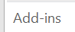.

- On the bottom of the window choose Go. 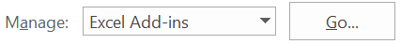

- In the new window, choose 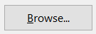 and locate the file fred.xlam that you downloaded and click OK.

- Ensure that the FRED add-in box is checked: and click OK.

- You may be prompted with a security warning. If so, select the allow Macro’s and data connections from the Add-in.

- Close and re-open Excel to verify that the Add-in has been installed correctly.

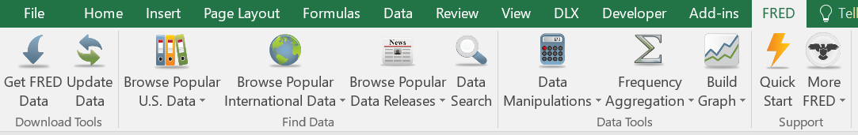

Troubleshooting Installation

- If you receive any of these warning or a similar warnings after installing the add-in

you need to change your Excel security settings. There are two options explained below:

Option 1: Add the fred folder as a “trusted location” (suggested).

Instructions can be found at https://support.office.com/en-us/article/add-remove-or-change-a-trusted-location-7ee1cdc2-483e-4cbb-bcb3-4e7c67147fb4.

Option 2: Enable all data connections.

Instructions can be found at https://support.office.com/en-ie/article/block-or-unblock-external-content-in-office-documents-10204ae0-0621-411f-b0d6-575b0847a795.

- If the add-in does not appear in the toolbar after restarting Excel, try the following:

https://www.excelcampus.com/vba/add-in-ribbon-disappears/

