Trump’s Solar Tariffs Cause a Scramble in the Industry
New York Times, Ivan Penn May 3, 2018
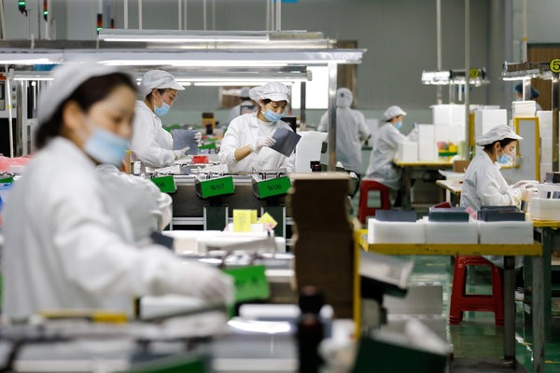
Assembly-line workers at a solar-panel factory in China. To be exempted from American tariffs, solar companies must show that they have a unique technology or offering. CreditChina Network, via Reuters
SunPower is the nation’s No. 2 commercial solar-power company, employing thousands of workers directly and indirectly. But it makes most of its solar panels abroad, and with the tariffs recently imposed by President Trump costing it as much as $2 million a week, SunPower is fighting for an exemption.
One of its rivals, SolarWorld Americas, produces panels domestically. Buffeted by foreign competition, it was behind the original push for the tariffs.
Now the two American companies are merging. It’s all part of the disruption, distortion and uncertainty from an escalating trade offensive aimed primarily at China. In barely three months, the tariffs — the first shot fired by Mr. Trump in that campaign — are fundamentally reshaping the solar industry and its prospects.
A Chinese player announced plans to open a factory in Florida as early as this fall. With its SolarWorld acquisition, SunPower moved to prevent further loss to its business by locating a bigger share of its production in the United States. Both companies are being hit with tariffs on high-efficiency panels they produce in Malaysia.
Those efforts only blunt the negative effects of the industry fallout. While producing more panels in the United States will create a few hundred jobs, the tariffs could cost tens of thousands, largely on the installation side of the business. Dozens of solar companies are now petitioning to be exempted from the tariffs, and a bipartisan group in Congress has introduced a bill to overturn them altogether.
“I think that any action that brings new investment to the United States is welcome,” said Abigail Ross Hopper, president of the Solar Energy Industries Association. “But the tariffs have slowed down the growth of our industry. The growth has been muted, and that means jobs are not being created.” Her group said the tariffs could cost as many as 23,000 American jobs this year.
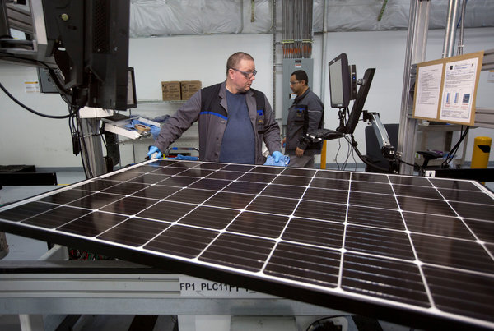
A production operator at the SolarWorld factory in Hillsboro, Ore., in January. SolarWorld filed for bankruptcy twice in the last year because it couldn’t compete against foreign prices. Now it is being acquired.CreditNatalie Behring/Reuters
In addition, the 30 percent tariffs are going to make it more expensive for cities across the country to pursue their goal of promoting solar power as a way to curb carbon pollution.
The solar industry expects to continue adding installations, but growth is estimated to be about 11 percent lower than projections before the tariffs.
Those diminished prospects are what prompted SunPower to bulk up its operations by pursuing the purchase of SolarWorld, based in Hillsboro, Ore. “We understand the goal of the American people and the goal of this administration,” said Tom Werner, SunPower’s chief executive. “We decided that we will be a leader, and we will take a bold move and buy an American enterprise.”
The office of the United States trade representative, which is handling the tariffs, is reviewing the requests from SunPower and other companies for exemptions. No time frame for a decision has been set.
To be excluded, the companies must show that they have a unique technology or offering. SunPower, based in San Jose, Calif., said its products served a need unmet by existing American manufacturers, and were made overseas for proximity to its suppliers, largely in Asia, making the solar panels cheaper.
“We’re kind of collateral damage,” Mr. Werner said of the tariffs.
The upheaval extends to the consumers of solar products, not just the makers. “The industry is in a scramble to figure out what all of the impacts are,” said Rob Freeman, chief executive of Tradewind Energy, which is based in Kansas outside Kansas City and develops industrial-scale solar and wind projects. “I think it’s fair to say it could be worse. I think it’s fair to say it’s a significant negative.”

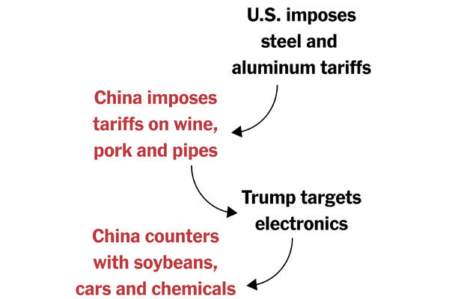

The U.S.-China Trade Conflict: How We Got to This Point
American companies want a level playing field with their Chinese counterparts. China wants to build its industries into sophisticated global competitors. This week, both countries demonstrated a willingness to escalate trade tensions to defend their positions.
The effect of the tariffs on the cost of imported solar panels makes it more difficult to compete with other sources of power like wind, or even makes fossil-fuel plants look attractive again, Mr. Freeman said. “It tips it back in favor of other alternatives,” he added.
And then there are the jobs. SunPower, which is taking over an operation with 280 employees, said it had not determined how many jobs it might add, the company said.
JinkoSolar, a Shanghai company, announced this year that it would start manufacturing in Jacksonville, Fla., and create about 200 jobs. It already has a deal with Florida-based NextEra Energy to supply the parent company of Florida’s largest utility with seven million panels over four years — one of the largest orders to date.
JinkoSolar said it still needed exclusion from the tariffs to bring any significant scale to its American operations. While it will assemble panels in the United States, the solar cells will continue to be produced in Asia and subject to tariffs.
“We would not expand it if we don’t get allowed tariff-free cells,” said Nigel Cockroft, the company’s United States general manager.
Even as those projects bring prospective jobs, the Solar Energy Industries Association pointed to the potential job losses from the suspension or termination of solar projects because of higher costs. It said domestic operations alone could not meet the previous level of demand.
“In some ways, this is showing that the tariff is having some kind of effect, but it doesn’t necessarily grow the U.S. manufacturing market,” said MJ Shiao, global lead for renewables and emerging technologies at Wood Mackenzie, a research and consulting firm with United States headquarters in Houston. “The projects no longer pencil out,” Mr. Shiao said.
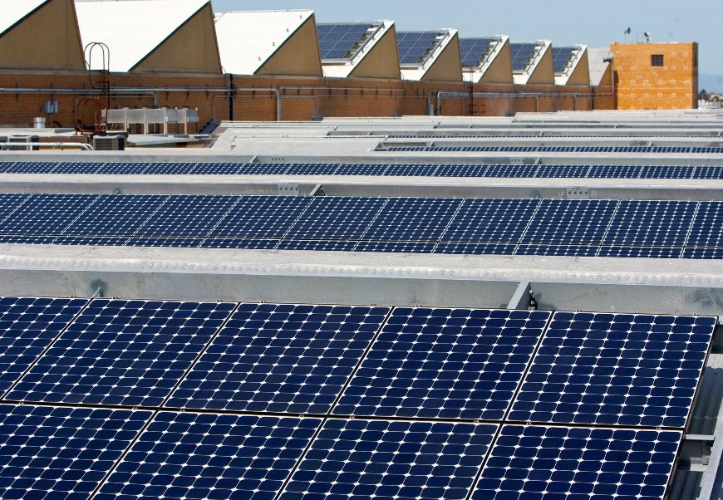
Solar panels on the roof of SunPower’s facility in Richmond, Calif. The company has done most of its manufacturing overseas.CreditKimberly White/Reuters
Solar energy enjoyed a banner year in 2016, when there was a rush to get projects going before a federal tax credit on solar projects was to expire. In that year, it became the nation’s leading source of new electricity generation.
But after that flurry, solar yielded its No. 1 spot even though Congress extended the 30 percent tax credit through 2019. Now the tariffs have added another bump in the road for solar power.
Before the tariffs, the industry was expected to have the capacity to power 13.7 million homes nationwide by 2022, according to the solar industry group. That estimate has been revised downward by more than 10 percent. “There might be some places where solar would have won for new generation that now might revert back to wind or natural gas,” Mr. Shiao said. “In some cases nothing is going to fill that void.”

Ms. Hopper of the industry group said she hoped that Congress would repeal the tariffs with a bill now before lawmakers. Representative Jacky Rosen, a Nevada Democrat, introduced the bill out of concern over the loss of jobs in her state. Two South Carolina Republicans, Representatives Mark Sanford and Ralph Norman, backed the legislation, citing not only jobs but also the added cost the tariffs imposed on business. The bipartisan nature of the effort gives the industry hope that it might find support.
Solar power, which now generates almost 2 percent of the nation’s electricity, has become popular among Democrats and Republicans alike, as people consider ways to have more control over their energy use and to reduce pollution as well as create jobs. “We think that the industry will continue to grow,” Ms. Hopper said. “I think that the outlook is still positive but not quite as positive as it could be.”

