5/14/2015

Red Rose Food and Wine Fest
HMGT 4999 E599

Edgardo J. Bouret

Table of Contents

Event Fact Sheet----------------------------------------------------------------- 2
Overview Schedule of Events-------------------------------------------------- 3
Theme & Décor (theme, décor, staff fact sheet, staff uniform)----------- 4 -9
Venue Fact Sheet---------------------------------------------------------------- 10
Venue Site Diagram------------------------------------------------------------- 11
Exhibitor List--------------------------------------------------------------------- 12 -13
Menu------------------------------------------------------------------------------- 14 - 15

Event Fact Sheet
Event: NY Food and Wine Fund-raising Event
Description: Tasting event with 16 restaurants from The Grand Central Partnership and New York State wineries. Unlimited tastings
Date: Friday, June 12, 2015
Pre-event Load-in on Friday, June 12, 2015 at Midnight
VIP/Press 6:00pm-10pm Grand Ballroom
General 7:00pm-10pm Grand Ballroom
Where: Grand Ballroom at The Roosevelt Hotel - 45 East 45st & Madison Ave, NY, NY 10017
Tickets: VIP $400 pp
GENERAL $100 pp
Box Office: Advanced Online at www.nyfnw.com
Beneficiary: New York City College of Technology: Hospitality Management Department Scholarship Fund.
Sponsored by: TD Bank, FIJI, Williams-Sonoma, Brooklyn Soda Works, New York Spring Water, and Amalgamated Bank.
Event Director: Edgardo J. Bouret
Orientation Meeting: The Campbell Apartment, 15 Vanderbilt Avenue, Grand Central Terminal 9:00am- 10am
Attendees: 500
Restaurants: Ammos Estiatorio, Aretskys Patroon, Benjamin Steakhouse at the Dylan Hotel, Bice Ristorante, Cibo ,Dee Daa, Grand Central Oyster Bar, Kellari Taverna, La Fonda Del Sol, Lexington Brass, Naples 45, Nios , Para Mediterranean Brassierie, The long Room, Tulsi, Zuma

Beverages: Anyelas Vineyards Inc.Brooklyn Soda Works, Laurel Lake Vineyards, Macari Vineyards, New York Spring Water, Sherwood House Vineyards, Serenity Vineyards, Ventosa Vineyards

Overview Schedule of Events

Theme and Décor

Theme: The Overall Theme of the event is New York. Red Roses will be on the tables since they are New York’s State Flower. Some of the Dishes will consist of New York Ingredients like New York’s State Fruit which is Apple, Bay Scallops since they are New York’s State Shell, and Brook Trout since that is New York’s State Fish.

Colors: Red and Gold

Flowers: Red Rose Bouquets

Décor:

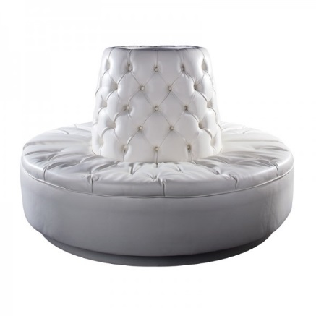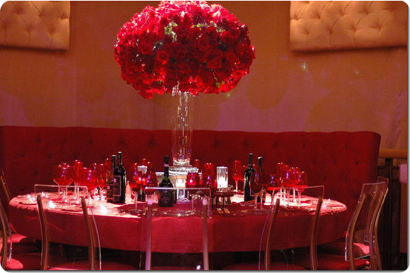
Banquet seat Centerpiece will be on top of banquet seat

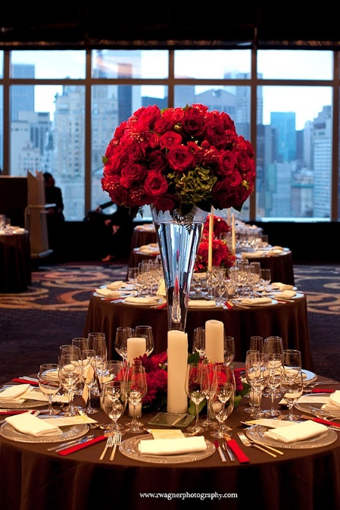
Center piece will be on all exhibitor tables

Staff Fact Sheet

Event: NY Food and Wine Fund-raising Event
When: Friday, June 12, 2015
Time: VIP/Press 6:00pm-10:00pm General 7:00pm- 10:00pm
Where: The Roosevelt Hotel’s Grand Ballroom, 45 East 45st & Madison Ave, NY, NY 10017
Transportation: Grand Central Station @ 42nd Street and Lexington Ave. (Subways & Buses)
Contact: Edgardo J. Bouret, (347) 123-4567 or cell (718) 456-1237

Report to Work: Report to work 15 minutes before your assigned shift. Go to The Roosevelt Hotel Grand Ballroom. Personal belongings will be put in designated area. You will report to your supervisor. You will work the pre-arranged designated shift and management must approve any changes in shifts.

Attire:*
Set-up Attire: Men & Women: During set-up please wear black pants, black rubber soled shoes (slip resistant). We will provide aprons, T-shirts and name tags for volunteers and staff. NO SHORTS.
Event Attire: Women: black pants (no jeans), white blouse or button down, black rubber-soled shoes; Men: black pants (no jeans), white button down and black tie, black rubber-soled shoes. Name tags and aprons will be provided to wear during the event.
* ABSOLUTELY NO PERFUME OR COLOGNE AND SMALL EARINGS FOR WOMEN. NO BODY PIERCINGS, NO EXPOSED TATTOOS (USE CONCEALER MAKE-UP TO COVER TATTOOS) NO HEELS OR STRAP SHOES, NO OPEN-TOED SHOES, NO SNEAKERS, NO TENNIS SHOES, NO FASHION BOOTS.
Food for Staff: Sandwiches and beverages will be provided to staff who work 4 hours minimum during the day. Staff is NOT allowed to taste the food served at the event by restaurants. No one will take a break without permission from the supervisor. NO ALCOHOL CONSUMPTION WHATSOEVER!

STAFF UNIFORM- MEN’S SHOES
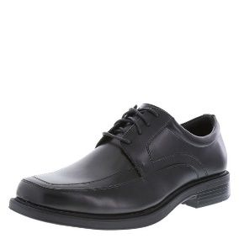1 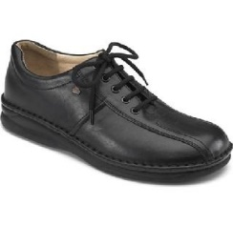2. 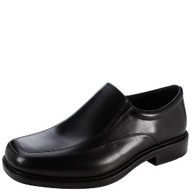3.

STAFF UNIFORM-WOMEN SHOES
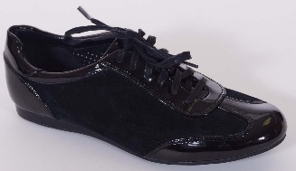 1. 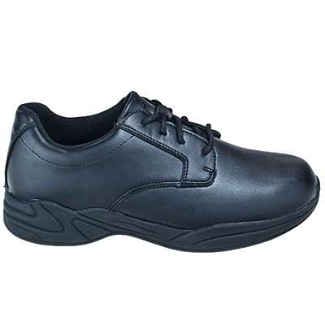2. 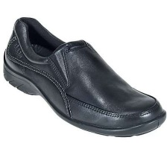 3.

STAFF UNIFORM- PANTS

Men’s Women’s
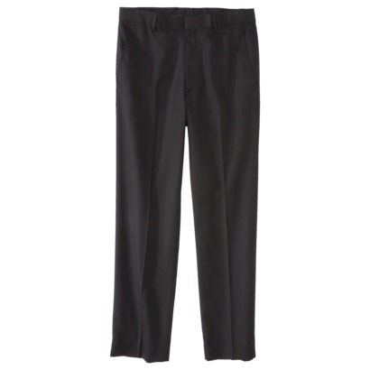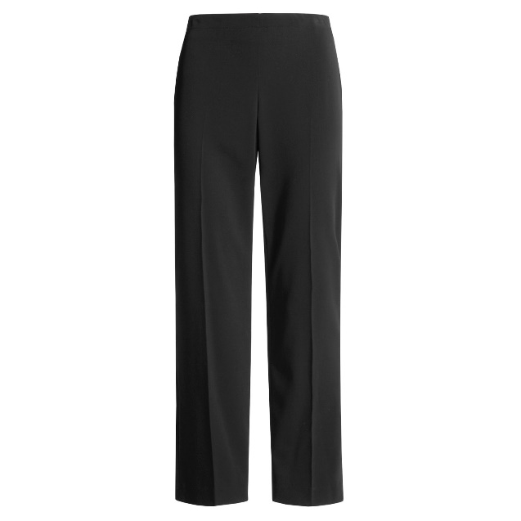

STAFF UNIFORM- WOMEN’S HAIR STYLES
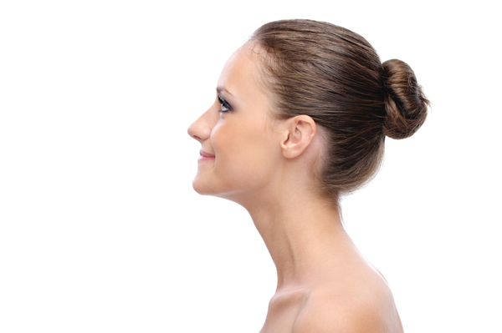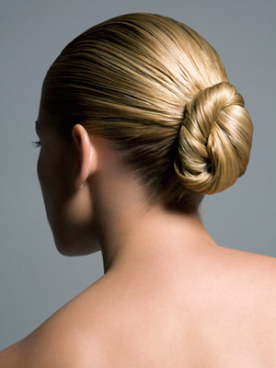

WOMENS EARRINGS

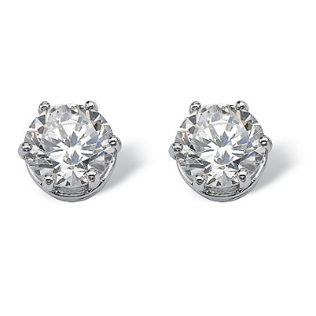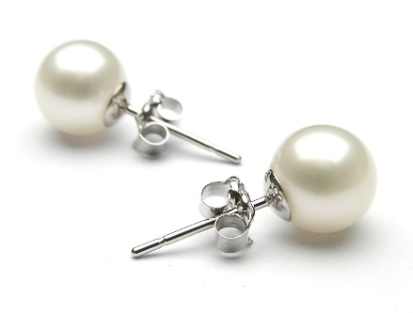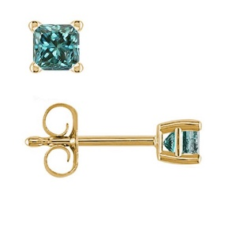

VENUE FACT SHEET
The Roosevelt Hotel Grand Ballroom

Venue: The Roosevelt Hotel
Address: 45 East 45th Street & Madison Avenue, New York, New York 10017
Phone: 212-661-9600, Email: reservations@rooseveltnyc.com
http://www.theroosevelthotel.com/

Transportation: Grand Central Station @ 42nd Street and Lexington Ave. (Subways & Buses)
Décor: Elegant yet casual
Lodging: Yes lodging is available.

Square Ft Ceiling Height Classroom Theater Banquet Reception
Grand Ballroom 5,696 27' (8m) 375 800 560 850

Exibitor List Station number

1. Ammos Estiatorio
2. Aretsky Patroon
3. Benjamin Steakhouse
4. Bice
5. Cibo
6. Dee Daa
7. Grand Central Oyster Bar
8. Kellari Taverna
9. Brooklyn Soda Works
10. New York Spring Water
11. Amalgamated Bank
12. Sherwood House Vineyards
13. Macari Vineyards
14. Laurel Lake Vineyards
15. Ventosa Vineyards
16. Anyelas Vineyards Inc.
17. Serenity Vineyards
18. La Fonda Del Sol
19. Lexington Brass
20. Naples 45
21. Nios
22. Pera Mediterranean Brasserie
23. The Long Room
24. Tulsi
25. Zuma

Exibitor List

26. DJ booth
27. Employee Food Booth

