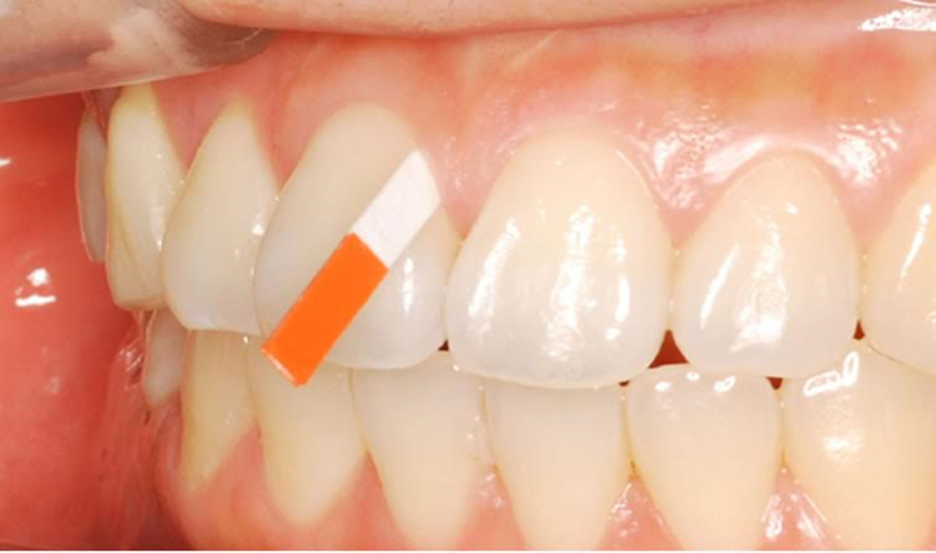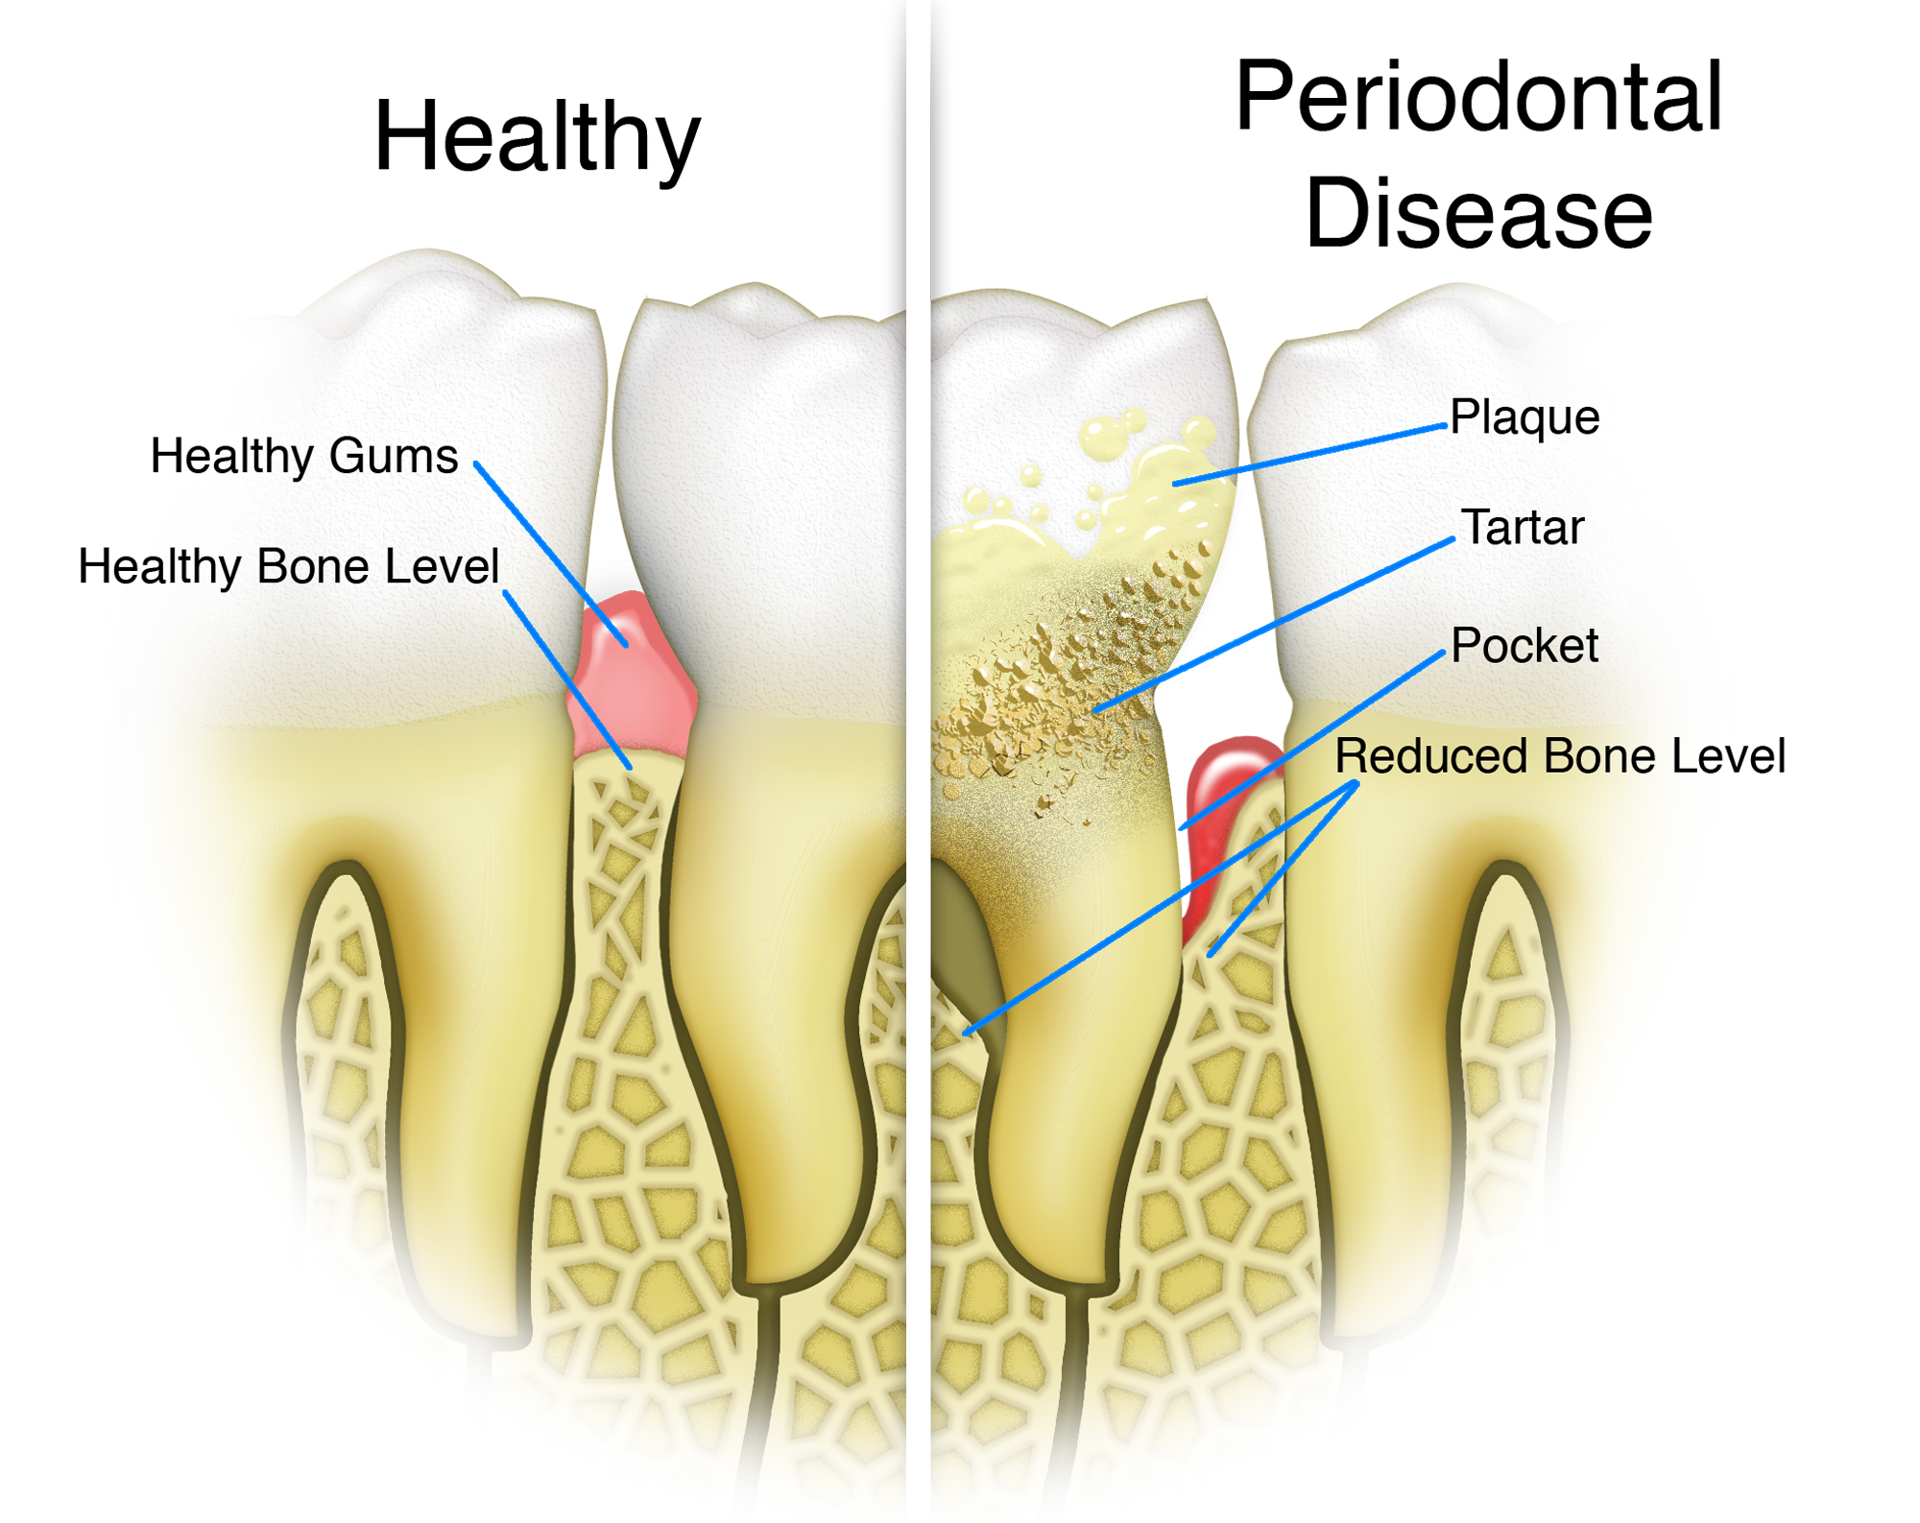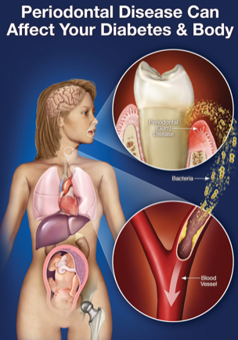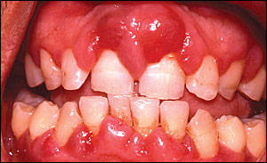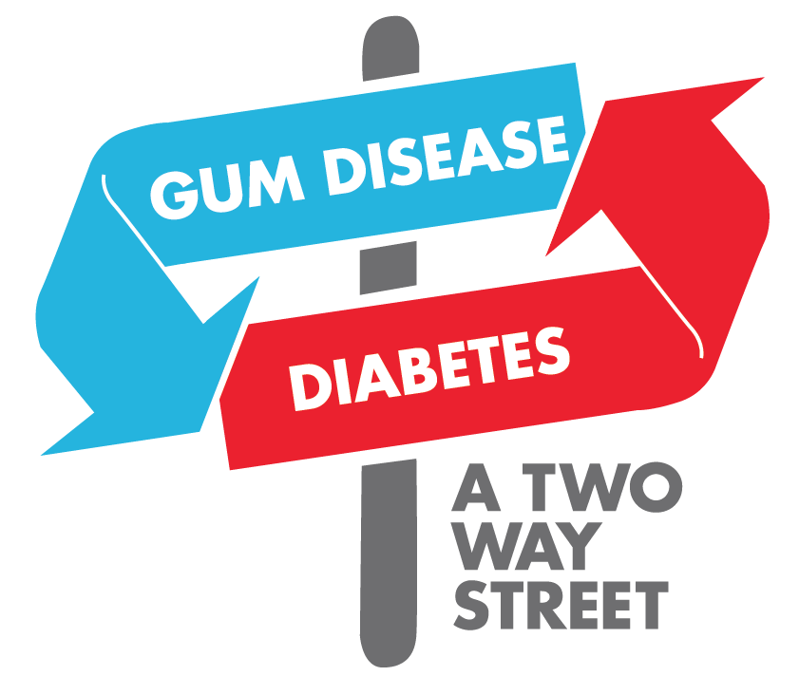

**How Dental Hygienist Will Screen for Diabetes Mellitus in Near Future:**

* Only a small volume of sample is needed. Nearly all patients will have some suitable sites for collecting gingival blood or fluid.
* The GCB is tested with a Glucose monitoring device, to screen the blood sample.
* If Crevicular fluid samples are collected with paper strips, they need to be tested in the laboratory.

**The Role of Gingival Crevicular Fluid (GCF):**

The GCF (fluid that cleanses the surface between the tooth and gingiva) of patients with Diabetes and/or Periodontal Disease, contain high levels of the following inflammatory mediators:

* **Interleukin1b** – Causes bone resorption, induces insulin resistance while decreasing insulin action.
* **Prostaglandin E2** – Causes bone resorption.
* **Tumor Necrosis Factor** – Induces insulin resistance, decreases insulin action; mimics Interleukin & Prostaglandin.

**What is Periodontal Disease?**

* Gingivitis, which is an inflammation of the gums, is the first sign of periodontal disease. If left untreated it can progress to Periodontitis, which causes the destruction of alveolar bone, and can result in tooth loss.
* Periodontal disease is a bacterial infection of the gums, ligaments, and bones, which support your teeth and keep them in your jaw.

*movement of sugar into your cells.*

**What is Diabetes?**

Type 2 Diabetes is a chronic condition that affects the way your body metabolizes glucose; which is one of the body’s main sources of fuel

**With type 2 diabetes, your body either:**

* Resists the effects of insulin — a hormone that regulates the movement of sugar into your cells.
* Does not produce enough insulin to maintain a normal glucose level.

**Type 2 Diabetes Mellitus and Periodontal disease have a bidirectional relationship:**

* Diabetes increases the risk for Periodontitis and the severity of it.
* Periodontal inflammation negatively effects glycemic control and can exacerbate the effects of diabetes.

**How Type 2 Diabetes directly effects Periodontal Disease:**

* Decreases white blood cell levels.
* Increases inflammation.
* Increase/decrease vascularity in the gingival tissues, making Periodontal infection difficult to heal.

**How Periodontal Disease directly effects Periodontal Disease:**

* Infections caused by Periodontal disease increases insulin resistance.
* Treating Periodontal Disease decreases inflammation, and has a positive effect on the patient’s glycemic control.

🙞 🙜

**The Link Between Diabetes Mellitus, Periodontal Disease, and Gingival Crevicular Fluid*.***

**Works Cited**

Chi, A. C., Neville, B. W., Krayer, J. W., DDS, & Gonsalves, W. C., MD. (2010, December 01). Oral Manifestations of Systemic Disease. Retrieved March 23, 2017, from <http://www.aafp.org/afp/2010/1201/p1381.html>

Johnson, G., RDH. (2015, July 10). Retrieved March 21, 2017, from [http://www.rdhmag.com/articles/print/volume-35/issue- 7/features/help-in-explaining-diabetes.html](http://www.rdhmag.com/articles/print/volume-35/issue-%097/features/help-in-explaining-diabetes.html)

Lyle, D. M., RDH, MS. (n.d.). Diabetes Mellitus. Retrieved March 21, 2017, from [http://www.rdhmag.com/articles/print/volume-23/issue- 3/feature/diabetes-mellitus.htmll](http://www.rdhmag.com/articles/print/volume-23/issue-%093/feature/diabetes-mellitus.htmll)

Ortiz, M., RDH, BA. (n.d.). Systemic diabetes. Retrieved March 23, 2017, from [http://www.rdhmag.com/articles/print/volume-31/issue- 6/features/systemic-diabetes.html](http://www.rdhmag.com/articles/print/volume-31/issue-%096/features/systemic-diabetes.html)

Negrato, C. A., Tarzia, O., JovanoviäŒ, L., & Chinellato, L. E. (2013). Periodontal disease and diabetes mellitus. Journal of Applied Oral Science, 21(1), 1-12. doi:10.1590/1678-7757201302106

Preshaw, P. M., Alba, A. L., Herrera, D., Jepsen, S., Konstantinidis, A., Makrilakis, K., & Taylor, R. (2011). Periodontitis and diabetes: a two-way relationship Diabetologia, 55(1), 21-31. doi:10.1007/s00125-011-2342-y

Penmetsa GS, Devi JB, Dwarakanath CD. (2016) Assessment of blood glucose levels in diabetic patients with periodontitis: A three-way method using gingival crevicular, capillary and venous blood. Int Dent Med J Advanced Research ;2:1-4.

M. Meti. (2010, December) Screening for Diabetes Mellitus Using Gingival Crevicular Blood. Journal of Oral Health Research. 1 (4). 160 – 164.

**The Role of the Dental Hygienist**

**If the patient is a Type 2 Diabetic, the following signs may be found during an intra-oral exam:**

* Xerostomia, or dry mouth syndrome
* Severe inflammation & poor healing of the oral tissues
* Fungal infections (due to medication)
* Burning sensation in the mouth/tongue

**When going over medical history with a Type 2 Diabetic patient the following information is vital:**

* What medication are they taking, the frequency and dosage.
* Hemoglobin A1C level – 7% or less is considered good glycemic control, individuals who have fair-poor control have a 50-200% greater risk for Periodontal Disease.

**Diabetic complications that can impair oral self-care and require treatment modifications:**

* Neuropathy- nerve damage that can cause numbness in the hands.
* Retinopathy-Blindness.

**How to avoid Hyperglycemic Emergencies:**

* Thorough medical history review, and blood sugar level check.
* Schedule morning appointments, Hyperglycemia is a greater risk in the afternoon.
* Use anxiety reduction protocol, stress may promote the condition.
* Keep a glucose gel tablet in your office emergency kit.

**Eftyhia Argyros**

**Mariluz Morales**

**Evelina Simuleviciene**