Brooklyn Waterfront Research Center – BWRC
BROOKLYN WATERFRONT RESEARCH CENTER
New York City College of Technology, City University of New York
300 Jay Street, Brooklyn, NY 11201
718-260-5130
The Brooklyn Waterfront Research Center aims to raise awareness about critical issues facing Brooklyn's waterfront through research, teaching, and public programming.
Over the past five years, faculty members at New York City College of Technology have received a series of grants from the National Endowment for the Humanities and the National Science Foundation to support the exploration of one of Brooklyn’s most understudied and underutilized assets: its historic waterfront. Using a multi-disciplinary approach, participants in these grants have examined the past and present of Brooklyn’s industrial waterways from social, political, historical, literary, and scientific perspectives.
The grants the college has received have included two $60,000 faculty development grants from the National Endowment for the Humanities (NEH) to study and develop curriculum on the literature and history of the Brooklyn waterfront. It has also received a $140,000 NEH grant to run a summer institute on the landmarks of Brooklyn’s industrial waterfront for community college teachers from around the country, and a $200,000 grant from the National Science Foundation to create a series of courses at City Tech that investigate the effects of climate change on the Brooklyn waterfront. These courses will be made available to science programs in other colleges and to the secondary schools. The College is currently in the first year of a 3 million dollar U.S. Department of Education Title V grant revamping general education at the college and using the Brooklyn Waterfront as a “living laboratory” for those courses.
The focus on the Brooklyn waterfront coincides with New York City’s Waterfront Vision and Enhancement Strategy (WAVES) that includes a Waterfront Action Agenda developed by the Department of Environmental Protection and a comprehensive waterfront plan, Vision 20/20, produced by the Department of City Planning. These city initiatives and the already-mentioned national grants have created an opportunity to address the needs of its students and neighbors by founding a research center devoted to the interdisciplinary, place-based study of Brooklyn’s historic waterfront. The three-fold mission of this newly formed Brooklyn Waterfront Research Center includes research, education, and public outreach.

Past Projects
A number of past faculty and student projects at City Tech inspire the work of the Brooklyn Waterfront Research Center:
Along the Shore, a faculty development program funded through the NEH’s Landmarks of History and Culture Workshops, brought 25 community college faculty from around the country to our campus to explore the changes and preservation efforts that have come to the landmarks along Brooklyn’s industrial waterfront during the summer of 2010.
Water and Work, an NEH- sponsored faculty development seminar conducted in 2008, broadened faculty understanding and engagement with the history and the ecology of downtown Brooklyn, the immediate environment of the college.
In 2008, students and faculty at City Tech researched, designed, and led the Brooklyn Greenwalk. At each stop on the neighborhood walk, students presented their research on a specific aspect of sustainable technologies in the area, from the Con Edison Cogeneration Plant on Hudson Avenue to the LEED-certified art and performance space known as Galapagos. The Greenwalk was chronicled in a chapter in the following book:

Summerfield, Judith. 2010. Making Teaching and Learning Matter: Transformative Spaces in Higher Education. Springer.

The Waterfront Vision and Enhancement Strategy - WAVES
The Waterfront Vision and Enhancement Strategy was released on March 14, 2011.
The Waterfront Vision and Enhancement Strategy is a two-part plan of action for creating a long-term sustainable blueprint for New York’s 520 miles of waterfront, which includes:
- Vision 2020: New York City Comprehensive Waterfront Plan establishes long-term goals for the next decade and beyond
- New York City Waterfront Action Agenda sets forth 130 priority projects to be implemented within three years
The Waterfront Vision and Enhancement Strategy will reconnect New Yorkers and visitors to the water and reclaim New York City’s standing as a premier waterfront city by transforming the City’s waterfront with new parks, new industrial activities and new housing. And it will capitalize on the City’s waterways – the “Sixth Borough” - to promote water-borne transportation, recreation and natural habitats.
The Waterfront Vision and Enhancement Strategy is a multi-agency effort led by the Mayor’s Office, Department of City Planning, and the New York City Economic Development Corporation to fulfill new requirements established by the City Council for ongoing comprehensive waterfront planning and management.
Vision 20/20
Vision 2020 Citywide Strategies
The plan's strategies for improving the waterfront are organized into eight overarching goals. Click on each for a description of the goal, the challenges and issues related to the goal, and the City's strategies for achieving the goal.
Goal 1: Expand public access.
Goal 2: Enliven the waterfront.
Goal 3: Support the working waterfront.
Goal 4: Improve water quality.
Goal 5: Restore the natural waterfront.
Goal 6: Enhance the Blue Network.
Goal 7: Improve Government Oversight.
Goal 8: Increase climate resilience.

Research Facility Buildings

Overview
As symbols of the Nation's technological progress, research facilities are essential to the discoveries and breakthroughs of yesterday, today, and tomorrow. Thousands of public and private sector scientists and engineers from industries such as pharmaceutical, biomedical, manufacturing, and biotechnology use all types of laboratories and instruments to advance the frontiers of knowledge. At times, an entire facility may be built to support the specialized instruments required for research, including accelerators, light sources, research reactors, neutron beam facilities, plasma, fusion science facilities, genome centers, advanced computational centers, wind tunnels, model testing facilities, hot cells, and launch facilities.
There are many kinds of research facilities. Within the WBDG they are divided into two major groups: Animal Research Facilities and Research Laboratories. Research Laboratories are further categorized by type (e.g., wet labs and dry labs), and by sectors (e.g., academic, corporate, and government labs).

Building Attributes

Example Design and Construction Criteria
For GSA, the unit costs for this building type are based on the construction quality and design features in the following table (PDF 353 KB, 22 pgs). This information is based on GSA's benchmark interpretation and could be different for other owners.

Classification
Research facilities present a unique challenge to designers with their inherent complexity of systems, health and safety requirements, long-term flexibility and adaptability needs, energy use intensity, and environmental impacts.
- Research Laboratories are complex, technically sophisticated, and mechanically intensive structures that are expensive to build and to maintain. Therefore, the design, construction, and renovation of such facilities are a major challenge for all involved.
  - Type: Wet; Dry
  - Sector: Academic; Government; Private Sector
A new model of laboratory design is emerging, one that creates lab environments that are responsive to present needs and capable of accommodating future demands. Several key needs are driving the development of a new model. See WBDG Trends in Laboratory Design for a complete overview.

Case Studies
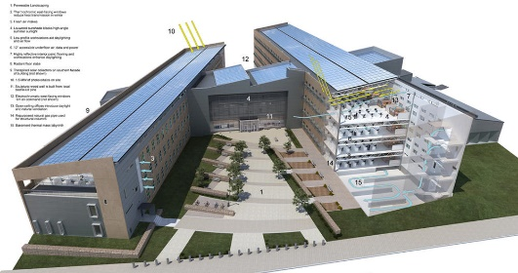
Department of Energy's (DOE) Research Support Facility (RSF) at the National Renewable Energy Laboratory (NREL) - http://www.aiatopten.org/node/103
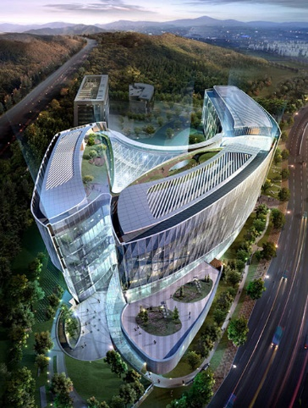
Pangyo Global R+D Center: DRDS - http://www.designersparty.com/entry/Pangyo-Global-RD-Center-DRDS
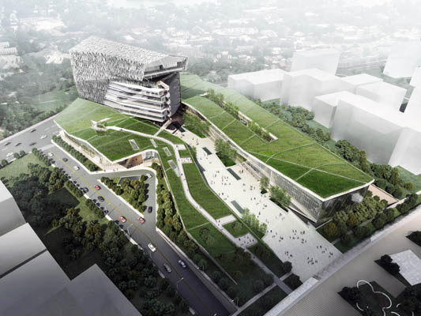
Taiwan Center for Disease Control - http://www.studioshift.com/index.php?/institutional/taiwan-centers-for-disease-control/
Program Development:
Classrooms/Computer Labs *Shared Workspace*
Meeting/Conference Rooms
Seminar/Auditorium Space
Event Space
Library/Archives
Food Prep/Cafeteria
Lounge/Eating Space
Pantry
Offices
Rental Space
Sources:
http://bwrc.commons.gc.cuny.edu/about/
http://bwrc.commons.gc.cuny.edu/projects/past-projects/
http://www.nycedc.com/project/waterfront-vision-and-enhancement-strategy
http://www.nyc.gov/html/waves/html/home/home.shtml
http://www.nyc.gov/html/dcp/html/cwp/cwp_2.shtml
http://www.nyc.gov/html/dcp/html/cwp/cwp_2.shtml
http://www.nyc.gov/html/dcp/pdf/cwp/vision2020_nyc_cwp.pdf
http://www.wbdg.org/design/research.php
http://www.wbdg.org/pdfs/gsa_usc_shell_laboratory.pdf

