Student: Darya Dubouskaya
Faculty adviser: Chloe Smolarski
Technical adviser: Kevin Patton
Date: February 9, 2016

Project Proposal
Title: DYNAMIC

- Description
While studying in Emerging Media program at Entertainment Department at New York City College of Technology I was getting knowledges in electrical engineering, mechanical engineering, computer science, programming and design fields. In my final project I want to gether all my skills in order to build a Sound Sequencer I was thinking about for a long time. This project “Dynamic” will become my main object in portfolio as a first big practical implementation of my skills from college as well as my skills in music.
After graduation I will seek for a position of creative technologist and afterwards creative director. To get the position of creative director I need to have strong knowledge in all my studies and also have an good experience in a field. The final project is a beginning in my career of a practical work. The project “Dynamic” is a sequencer that will use samples, sounds that are loaded or recorded by the user, to create music putting them in 16 steps with custom tempo. The sequencer will be equipped with raspberry pi which will make possible for it to work independently from external computer. This part will be challenging for me as I didn't work with raspberry pi before. Also I would like to install touchscreen and make all surface of the device interactive with user.

- Methods
The device will include computer inside the system to work independently for external ones. I will install Raspberry Pi 2 with software that will be written in PureData. I also will install a touchscreen to control some of the options on the device such as choosing samples, changing settings and changing simple features. All other features will be controlled by pressing buttons and turning knobs. Users will be able to upload more samples using SC card. I’m also considering to install speakers and make possible the connection to Ableton. All buttons and knobs will have led diodes inside as a design aspect for better work in a dark place.
Case for the sequencer will be made of light ply wood and a two layers of plastic and polished acrylic for the main working area of buttons which will be lighted with blue LEDs.

- Project Deliverables
At the end of the semester I will present working device with manual for it. For the presentation I will also complete my OpenLab portfolio with all documents including my schedule, lists of materials and details, details drawings, sketches and prototypes, tables of the budget as well as my calculations of a power needed for this device and storage. Also for the presentation I will prepare poster with all needed information.

- Schedule
The whole process will take about 2 months. I’m planning to finish the project before May to have an extra time in case if I will need to make some changes or replace some pieces.
The main dependency linkages are getting details and all necessary components and making a software.

Process:
- Generating Idea
- Make a sketch
- List Functionality
- List details
- Order details
- Test all components
  - buttons
  - raspberry pi
  - PureData on raspberry pi
  - touchscreen
- Calculations
  - calculate storage needed
  - calculate power
- PureData software
- Prepare a case
  - 3D Models
  - Laser-cutting file .jpg
    - Acrylic
    - Wood
  - Finishing
    - Polish Acrylic
    - Polish wood and put finish
  - Assembling
  - Fixing
- Assembling
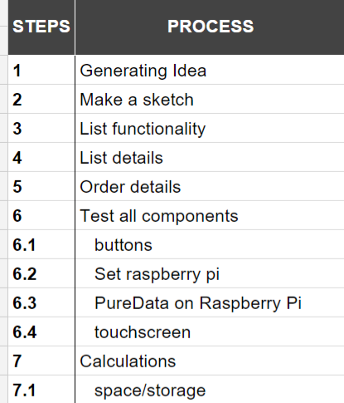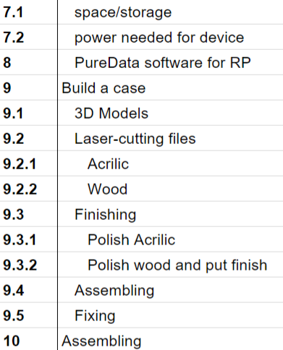
Figure 1. All steps of the process from the Gentt Chart

Some of the procedures in the process will be completely new for me such as writing software in PureData, working with raspberry pi and building a case of acrylic and ply wood. I’m expecting a lot of problems which i’ll face in the process of building device as well as new material that i’ll need to learn. Considering this two aspects I left more days for me to work on the project.

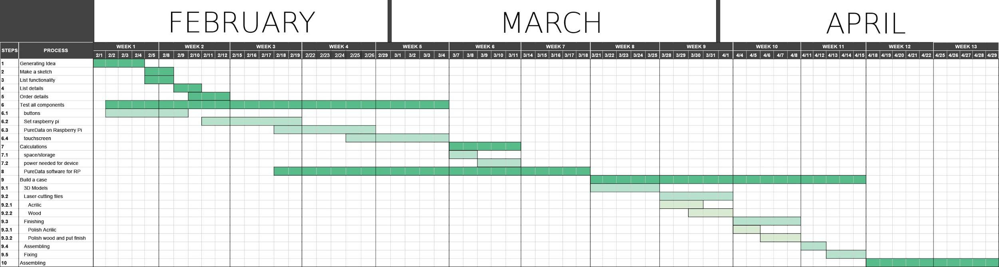
Figure 2. Gantt Chart for 13 weeks of building process.

- Required Resources
For this project I will use open source PureData software and Raspberry Pi software. Also for the presentation I will use MaxMSP to make an interactive projection. I prefer to work on the project in college lab rooms and consider to use some of the tools. However, all detail I will buy by myself.

- Budget
To build the sequencer I will need to get some details such as raspberry pi, lcd touchscreen, buttons with micocontroller, cd card, wires, jacks and other components. The approximate calculations of the expenses for this project shows that it will cost me about $600. This number includes %15 contingency in case of the lost or broken details.

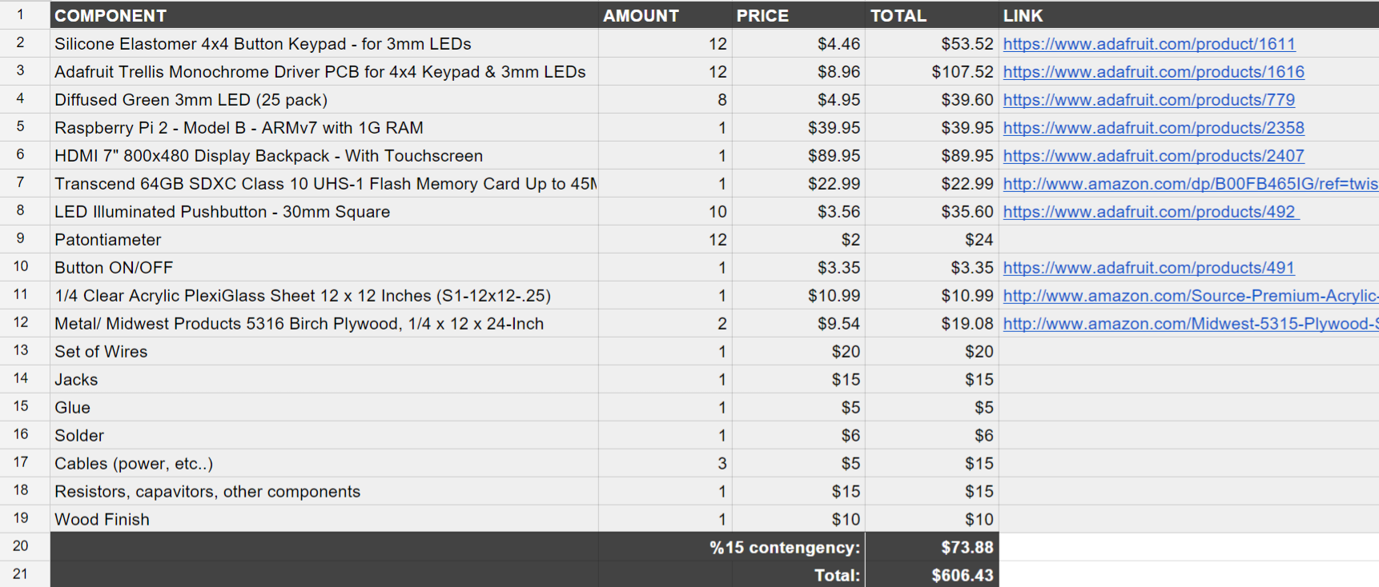
Figure 3. Table of budget estimation.

- Proposed Table of Content

Introduction
Methods
Weekly Shop Reports
Project Budget – estimate vs. actual
Project Calendar – estimate vs. actual
Completed Paperwork
Materials and Labor Estimate
Complete set of construction and installation drawings (CAD and paper copies)
Build Schedule
Load-in Schedule
Research notes, including samples, prototypes, and calculations
Photo archive of set pieces during construction, load-in, tech, performance, and strike
Conclusion
Annotated Bibliography

