New York City College of Technology

Electrical and Telecommunication Engineering Technology Department

Workshop:
Designing an keyboard Instrument using
Using the Arduino Microcontroller

Course: EET 3120 Sensors and Instruments
Submitted to: Prof. Viviana Vladutsecu
Date: May 8, 2015
Submitted by: Damian Robinson

INTRODUCTION
This workshop that I attended is an introduction on how to use the Arduino Microcontroller to build circuit that behaves like a keyboard. There are going to be four push buttons that will when press will give off different sounds. For this to happen we have to program the microcontroller with a source code and build the circuit associated with this code.

Components needed for the circuit
- Arduino /Chipkit UNO 32.
- Breadboard.
- Desktop computer.
- MPEID or Arduino software
- Jumpers (wire).
- 2 – 10 KΩresistors
- 1 – 220Ω resistors.
- 1 – 1MΩ resistor.
- 4- Switch.
- Buzzer, Piezo

Procedures
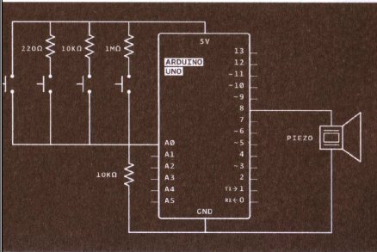
- First we build the circuit shown below on the breadboard.

- Then we make the necessary connections using jumper wires to Arduino board.
- We write the source code inside MPLabIDE software which will be uploaded on to the Arduino Microcontroller.
- Connect the arduino microcontroller to a computer then upload the source code.
- When you finish uploading the source code press the reset button then check if the circuits works by pressing the button.
Source Code

int buttons[6];
// set up an array with 6 integers

int buttons[0] = 2;

int notes[] = {262, 294, 330, 349};
//corresponds to the notes C, D, E and F

void setup() {
Serial.begin(9600);
}

void loop () {
int keyVal = analogRead(A0);
Serial.println(keyVal);

if (keyVal == 1023){
tone(8, notes[0]);
}
else if (keyVal >= 990 && keyVal <= 1010) {
tone(8, notes[1]);
}
else if(keyVal >= 505 && keyVal <= 515) {
tone(8, notes[2]);
}
else if(keyVal >= 5 && keyVal <= 10) {
tone(8, notes[3]);
}

else{
noTone(8);
}
}

Result
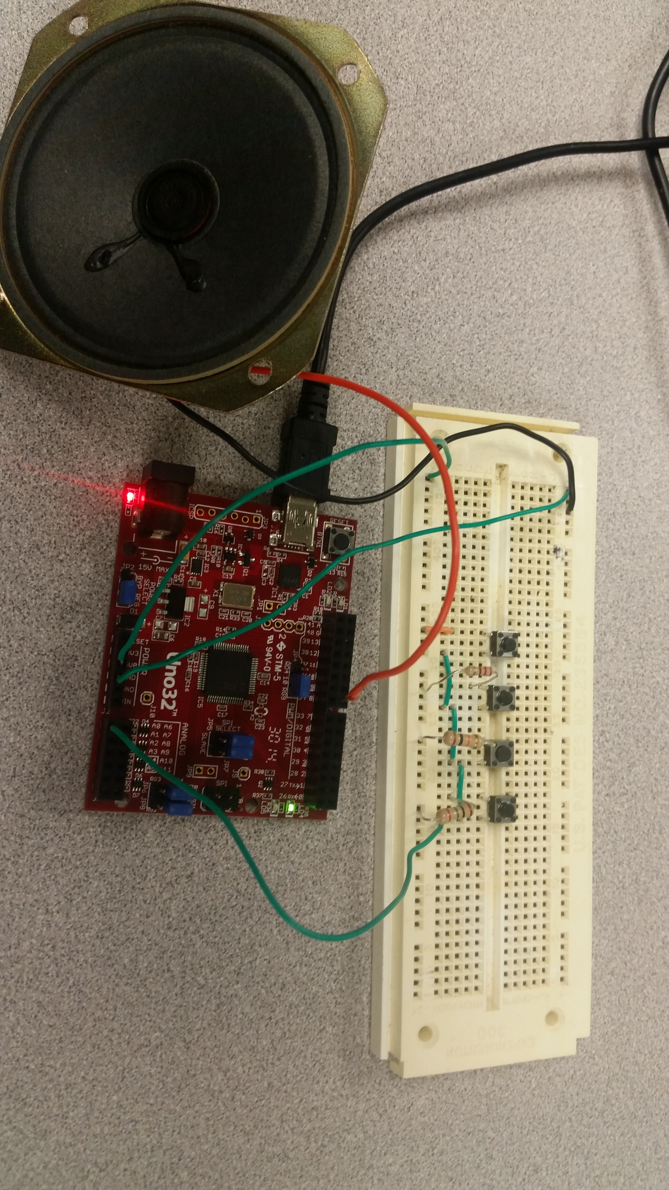.
Figure 2; above shows the result of the Keyboard instrument
CONCLUSION
From this experiment we learned how to design a circuit that can produce different frequency. We used an arduino Microcontroller board to control the circuit and it function. There is a speaker that is part of the circuit which will emit the sound. In order for the microcontroller board to work a code must be written and uploaded to the board.

