New York City College of Technology

Electrical and Telecommunication Engineering Technology Department

Field Trip Reflextion
Course: EET 3120 Sensors and Instruments
Submitted to: Prof. Viviana Vladutsecu
Date: April 29, 2015
Submitted by: Damian Robinson

RE: Reflection of the field trip to City College Grooves School of engineering

On April 30, 2015 I visited the Grove School of Engineering at City College of New York along with my class mates to learn and understand about the various instruments that are use to obtain Data from the atmosphere. We looked at the Lider Instrument which is use to examine the surface of the earth, we also looked at the Microwave Radiometer that looks at temperature, cloud and humidity in the lower troposphere and the Sun Photometer that is use to examine the optical properties of the sun and the sky.
Lider
Lider is a remote sensing method used to examine the surface of the earth. Lider is an acronym for Light Detection and Ranging. The Lider system uses light in the form of pulsed laser to measure ranges to earth. This light pulse combined with other data creates three dimensionals information about the shape of the earth and its surface characteristic.
The Lider System we observed at City College of New York Consist of two (2) lasers, a telescope, Detectors, digitizing system, Data Acquisition and radar interface. For laser (1) it has three channels with wave length at1064nm, 532nm and 355nm with beams on axis to three dichroic mirrors, Laser (2) has five channels with wave lengths at 1064 nm, 355 nm, 532 nm, roman channel at 407 nm for water and a second roman channel for nitrogen. The digitizing system converts signals between 10MHz and 200MHz for signal above 200MHz. The radar system continually search for the presence of any aircraft, if an aircraft is detected the beam will automatically disable and the Lider acquisition will temporary halted.

Microwave Radiometer
The Microwave Radiometer City College of New York is used to provide profiles of temperature, humidity and cloud in the lower troposphere. The radiometer is enclosed in a US style mailbox and mounted. The systems consist of sensors for atmospheric pressure, temperature and humidly, a rain sensor, as well as an infrared radiometer to measure the cloud base temperature. The system consists of a microwave window on top of the instrument enclosure. The incoming radiation is transmitted through the microwave window onto a planar mirror and into an optics antenna.
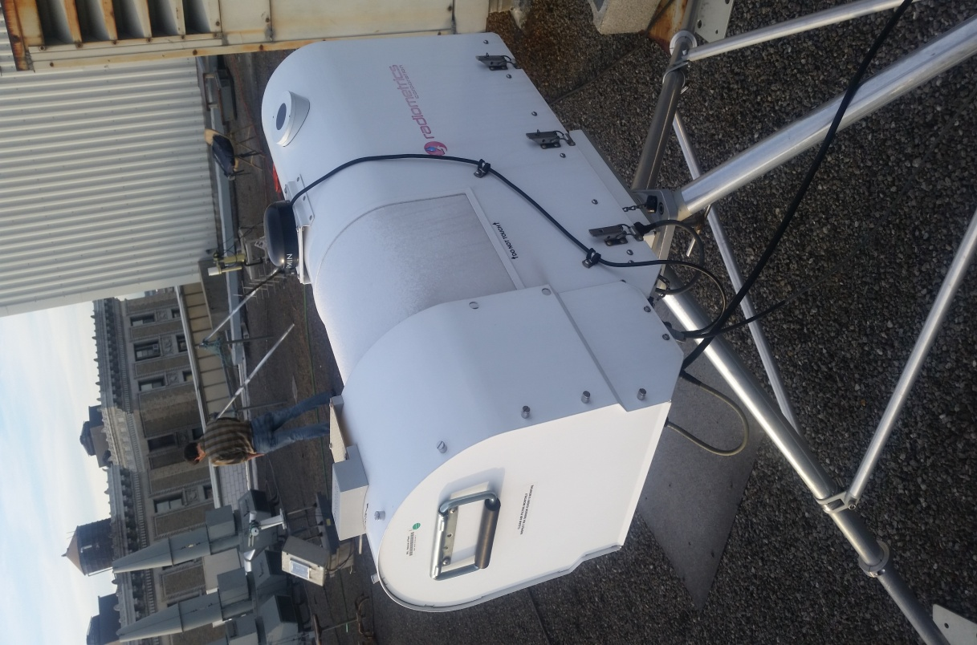

The Sun Photometer
One of the other instruments that we observed on this field trip is the Sun Photometer. This instrument is an automatic sun and sky scanning radiometer that measures the direct solar radiance and sky radiance at the Earth surface. The Sun Photometer takes measurements only during the daylight hours. This instrument is weather proof and requires little maintenance during period of adverse weather conditions. It is self powered with a solar panel and requires very low power to operate.
This instrument automatically computes the position of the sun and tracks its movement; this is done using a four quadrant detector. It measures the optical properties of the atmosphere (sun and sky) and provides quantification and physical optical characterization of the aerosols. The optical head of the sun photometer has two components, one which is the sun collimator without lens and the sky collimator with lenses. The instrument directly measure the incoming solar energy at selected wavelength’
