Darius Richards
10/13/13
Graphic Communications

AIGA “American Institute of Graphic Arts” Field Trip

In our exhibit on AIGA national design center we examined incredible artworks that showed a lot of diversity but also similarities in the work. The “ABC of IT” exhibit focused on the upbringing of famous children books, and explained why they’re important in literature. The exhibit expresses how children books reveal a little bit of information of different societies and cultures shown through their books that are created. In the exhibit it shows how children books helped a lot of kid’s and is giving people a message on how important these books were.

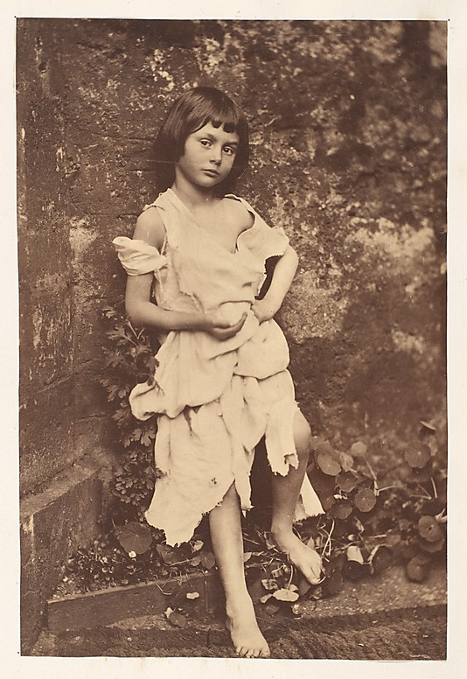
Lewis Carroll

Portraits of Alice Liddell as “The Beggar Maid” 1858

Hand-colored albumen print from glass

16.3 x 10.9 cm

http://www.brainpickings.org/index.php/2012/07/04/story-of-alice/

In Lewis Carroll photograph titled the Beggar’s Maid, which was taken in Deanery Garden at Christ Church, Oxford in 1858. The image is being shown of an amateur portrait of a young girl name Alice Liddell who is wearing rag clothing with her hand placed out. I feel this particular image was powerful because I felt this image gave the audience an insight on how some young children lifestyles were changed during the financial crisis in the 1850’s. Alice Liddell inspired Lewis Carroll to create a mystical story called Alice Adventures, which encouraged many other related works to be created. This story was so popular that it was created into a movie and a children’s book. A black and white film camera on printing paper took the gelatin print photography, which was coated by silver salt in gelatin on glass. This photo has been preserved for years and many more.

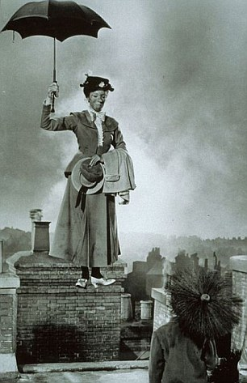
P.L. Traver’s

Film still from Walt Disney’s Mary Poppins 1964

Gelatin silver print

Ashley Bryan
“Let it shine” 2007
Paper-cut outs
In Ashley Bryan’s picture book he uses a die cutting of images to express one of his favorite spiritual songs called “This little light of mines”, in colorful cut out with one black cut out on the cover.

