Open to Buy
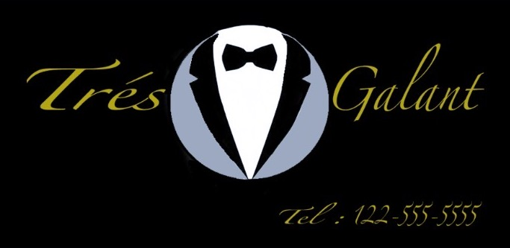

Derian Pryce
Hugo Rodriguez
Ulugbek Zohirov

Table of Contents
Company Bios 3
Abstract 5
Store front 6
Store Layout 6
Target Market / Brand Values 7
Sketches 8
Suit Sizes 13
Colors 13
TRES GALANT SKUs 14
Styles List 15
SKU Chart 17
February 17
March 18
April 19
MAY 20
June 21
Manufacturing 23
Part B 25
Part C 29

Company Bios
Derian Pryce is a Psychoanalyst who graduated from New York City College of Technology with a baccalaureate degree in Business and Technology of Fashion. He was in charge of the target market, V.A.L.S and the organization of the brand direction of Tres Galant. Teaming up with Ulugbek Zohirov and Hugo to bring the best product to your doorstep.
Ulugbek Zohirov is a Marketing Researcher who graduated from the New York City College of Technology with a Baccalaureate degree in Business and Fashion Technology. In this Tres Galant project, he worked on Part B and C of the project and also created the SKU. Ulugbek also teamed up with Derian Pryce and Hugo Rodriguez to finish up rest of the project.
Hugo Rodriguez is a fashion marketer who graduated From the NYC College of technology. He graduated with a bachelor’s in business and technology of fashion. A small time designer and creative director. He worked on bringing the designs and fabrics as well as colors to the project.

Abstract
For our products we believe the garments are best suited for People who are ready to accept any change in the society and they are ready to adapt to it. The products are mostly ready to wear suits for people who wear them daily. our products will be catered to creating an optimal experience for any thinker that wants to buy our suits. The materials that will be used will serve more than just the purpose of style. They will be adaptable to the environment that is currently suited for the consumer, examples of this are but not limited to (Waterproofing, Abrasion resistance and Wrinkle resistance) just to name a few. This will ensure that our customer will get exactly what they need to tackle any situation and feel like they made the right decision when buying a product from our store.

Store front
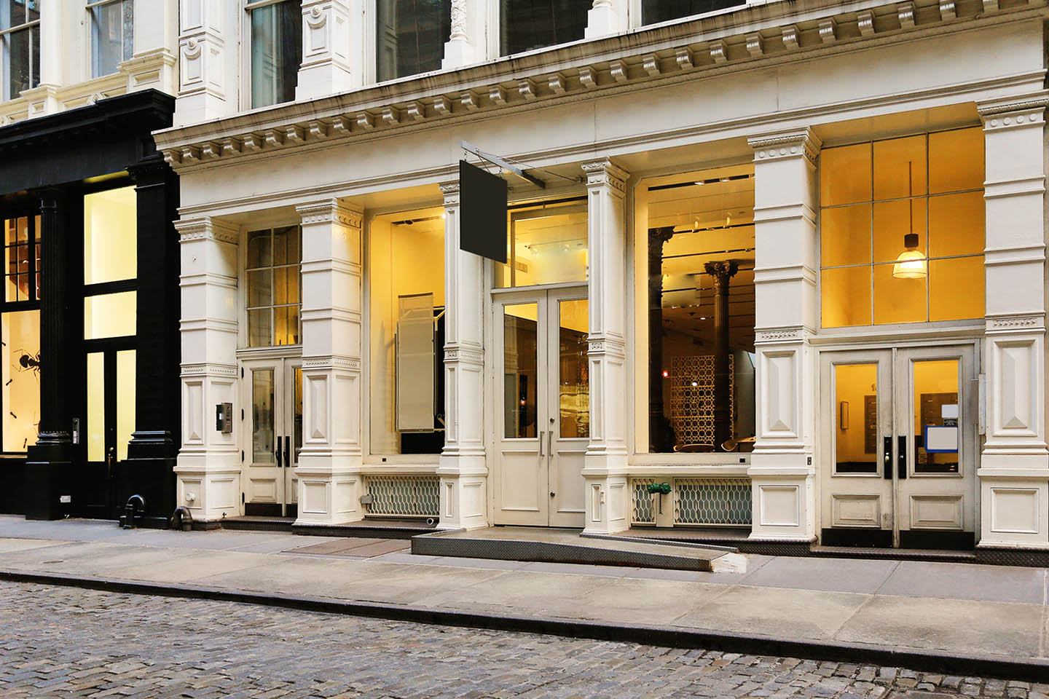

Store Layout
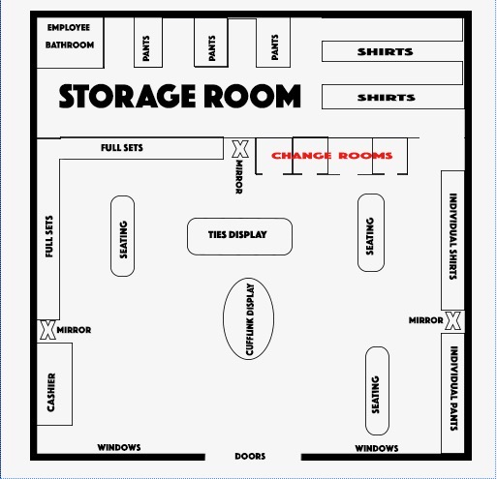
Store Location: 330 W Broadway, New York, NY 10013

Target Market / Brand Values
Our projected consumer characteristics are best represented by the Thinkers category of the VALS system. These individuals are Moderately active in their community and politics. Leisure activities center on home values, education & travel. These individuals tend to be health conscious and politically moderate/tolerant. There is no doubt that the thinker group is mature, open minded and intrinsically motivated. These individuals are looking for value and durability in their products whether it's at home or for their daily adventures. Our brand Tres Galant encapsulates that ideology with our love for resistant materials and classic colors that keeps every wardrobe equipped to handle daily tasks and the occasional large event. This level of diversity and effectiveness often comes with a price that any true thinker has already considered. The Thinkers are an above average consumer of products and have the resources to facilitate any adjustment or need they want fulfilled.
￼ Our brand is catered to the well-educated professional likely in the ages 35-62 categorized as the young professionals and the seasoned veterans of the workforce. These are the individuals likely to be looking to get an edge of the competition, so they are actively looking for reliable ways to maintain their prime efficiency. We carry a variety of suits that are fit for any task imaginable. Our suits are unisex but are tailored toward men. They come in a variety of colors to match any occasion some of which being Thulian which is a rosy color for that Thinker that wants to shine just a little brighter than the average person and Carnation which is a pastel pink nice for an outing in the day time that is casual but not too casual for you to choose more lax clothing. Tres Galant can provide you with the optimal attire for any and every situation

Sketches
The following images are the sketches for the products that Tres Galant will be selling for the Spring 2021. With the sketches Tres Galant also included the types of fabric they will be using for the product and also the description of each product

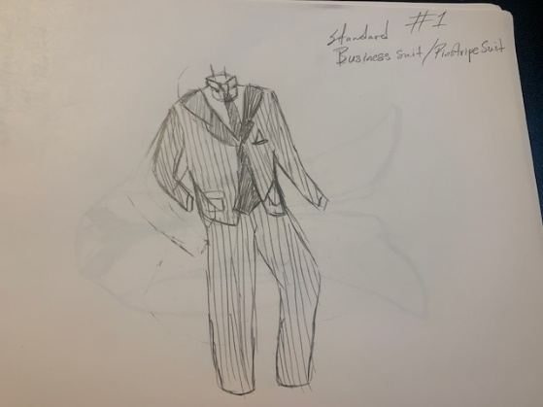
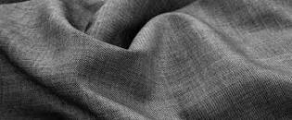
Figure 1: is a pinstripe business suit made with worsted fabric, includes all pieces that come with a suit including jacket, pants, vest and cotton shirt.

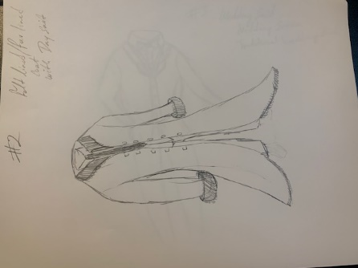
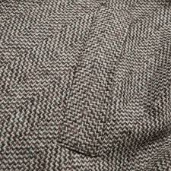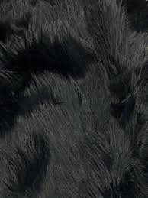
Figure 2: is a Peat coat that provides more than enough warmth. Being insulated with faux fur
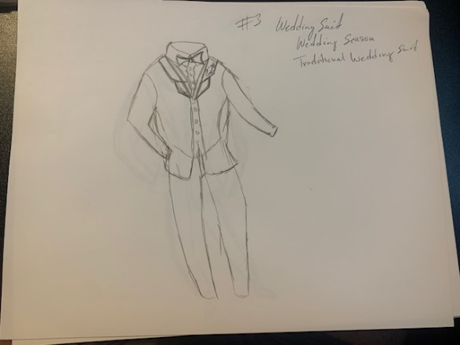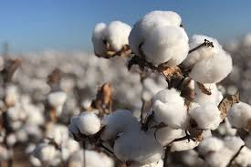
Figure 3: is the traditional tuxedo built for any occasion, whether it’s a formal gathering or a wedding. The traditional tuxedo is made with cotton.
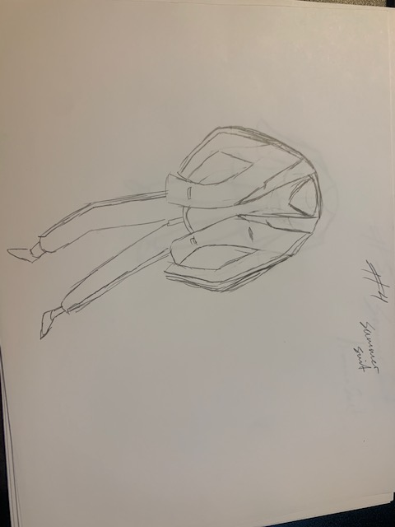
Figure 4: is a summer suit, made from light breathable fabric such as silk. Easily on of the most stylish options for the summer seasons.

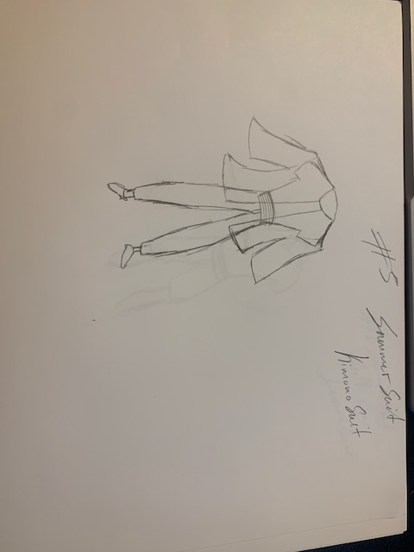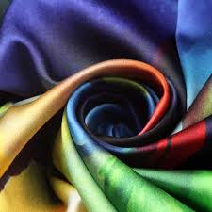
Figure 5: is a new take on the kimono, offered in either silk or satin, it offers a different look from the traditional low thread count suit.
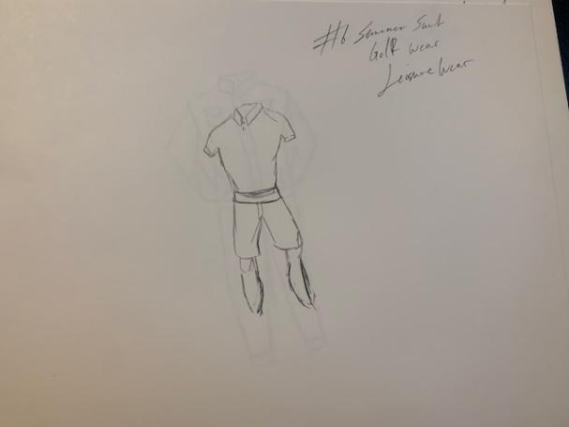
Figure 6: is a style we call golfer, with it being the most versatile outfit style for the summer season, comes in either cotton fabric, silk, satin and fleece.
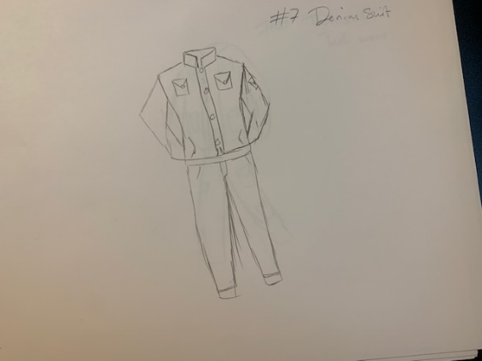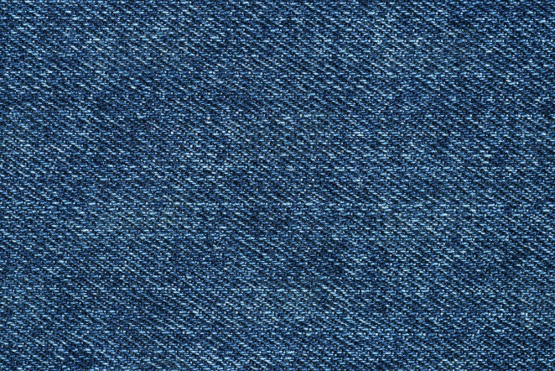
Figure 7: is a denim suit. Everything a traditional cotton suit is made for, but a more rugged denim look and feel. Made from denim cotton.
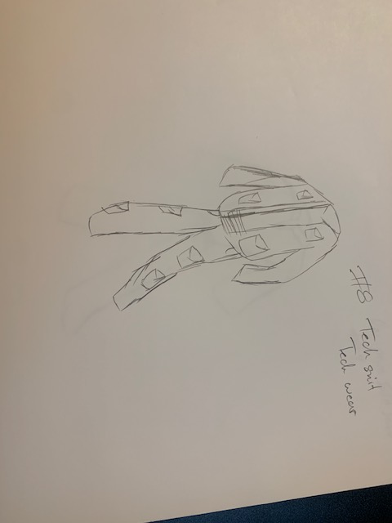
Figure 8: is what we can a tech suit, being the most useful without compromising style and look. Made from a cotton nylon blend for durability and comfort.
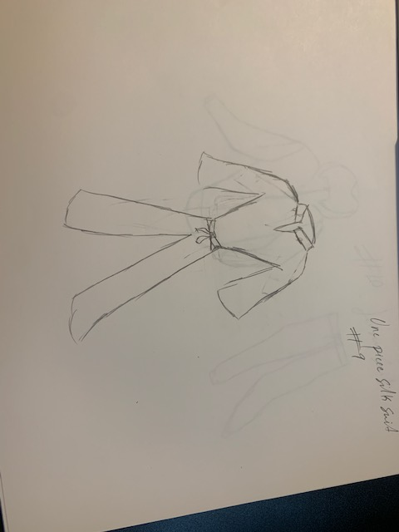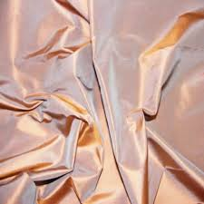
Figure 9: is a new design. A one-piece satin/silk suit.

Suit Sizes
Tres Galant included the US men’s sizes in the SKU to give a better idea of which sizes was ordered. The sizes that was ordered for each product was decided by the most purchased sizes for each product. In the next chart Tres Galant will go in depth of the US sizes and to show what products most suits the customers.
US size | Chest Measurement  (inches) | Waist measurement  (inches) | Shoulder width  (inches) | Sleeve length  (inches)
40 | 40 | 34 | 19 | 18.5
42 | 42 | 36 | 19.5 | 18.75
44 | 44 | 38 | 20 | 19
46 | 46 | 40 | 20.5 | 19.5
48 | 48 | 42 | 21 | 20
50 | 50 | 44 | 21.5 | 20.5

Colors
These are the colors that Tres Galant chose for the products that was ordered with the money received. The colors were chosen based on the Spring 2021 trends. Then the following colors were divided into each month according to the trend for the specific month

Navy Blue | Dark Brown | Black
Dark Grey | Charcoal Grey | Tan
Light Brown | Camel | Light Blue
Bright Blue | Burgundy | Medium Grey
Carnation | Thulian

TRES GALANT SKUs

Tres Galant is well stocked with the merchandise that sells in the brick and mortar store, therefore the overall stocks that are already in the store are valued at $1,236,000.00. As a result, Tres Galant received an additional $6128,000.00 to order more merchandise with new trends for the next 6 months of the Spring season. This amount will help Tres Galant be well stocked for the upcoming holidays, weddings, professional events and etc. To follow up with the money that Tres Galant received, Tres Galant included the monthly spending of the $618,000.00 that also includes monthly charts from February to July. The charts include the sizes, colors, and styles and textile of the products that was ordered with the money they have received.

February | $77,250.00
March | $77,250.00
April | $96,562.50
May | $115,875.00
June | $115,875.00
July | $135,187.50
Total amount for Spring season | $618,000

Styles List
The following is the description of all the products that are included in the SKU for the six-month period for Spring 2021. The description includes the style number, the type of product and also the color of the products that was ordered for each month.
February
01234-Wool business suit (navy)
01235-Fleece business suit (charcoal grey)
01236-Cotton casual suit (black)
01237-Pete coat with faux fur (black)

March
01238-Linen cocktail suit (burgundy)
01239-Knit cardigan with fleece pants (camel, black)
01240-Spandex polo with fleece pants and jacket (burgundy, charcoal grey)
01241-Worsted suit (dark grey)

April
01242-Cashmere suit (light blue)
01243-Polyester jacket (tan)
01244-Knit polo shirt (carnation)
01245-Cotton golfers (every color)
01246-Linen golfers (every color)

May
01237-Satin polos (bright blue)
01248-Cotton tuxedos (black/white)
01249-Velvet suit (thulian)
01250-Cotton short sleeved polo (black)
01251-cashmere cardigan (camel)
01252-fleece tech suit (every color)

June
01253-Satin suits (light blue)
01254-Silk suit (carnation)
01255-Silk Cuban button down (bright blue)
01256-Satin polo (camel)
01257-Satin one-piece suit/jumper (carnation)
01258-Floral silk suit (every color)

July
01259-Silk kimono (every color)
01260-Silk golfers (every color)
01261-Satin shorts (every color)
01262-Satin/silk vests (every color)
01263- jersey suit (every color)
01264- jersey polo (every color)
01265- jersey shorts (every color)

SKU Chart
The following charts are the SKU charts that Tres Galant created to go in depth to explain the products that was ordered for Spring 2021 with the $618,000.00 that they have received. The charts include the Style numbers, color of the products, the sizes along with the season for which they have ordered. The SKU chart also include the SKU number to keep tracks of the products sold and also the number of products that was ordered for each month from February to July.

February
Style # | Color # | Season | US Size | SKU | IRN
01234 | Navy Blue 111 | Spring 2021 | 40 | 01234-111-S21-40 | 001
01234 | Navy Blue 111 | Spring 2021 | 42 | 01234-111-S21-42 | 002
01234 | Navy Blue 111 | Spring 2021 | 44 | 01234-111-S21-44 | 003
01234 | Navy Blue 111 | Spring 2021 | 46 | 01234-111-S21-46 | 004
01234 | Navy Blue 111 | Spring 2021 | 48 | 01234-111-S21-48 | 005
01234 | Navy Blue 111 | Spring 2021 | 50 | 01234-111-S21-50 | 006
01235 | Black 121 | Spring 2021 | 40 | 01235-121-S21-40 | 007
01235 | Black 121 | Spring 2021 | 42 | 01235-121-S21-42 | 008
01235 | Black 121 | Spring 2021 | 44 | 01235-121-S21-44 | 009
01235 | Black 121 | Spring 2021 | 46 | 01235-121-S21-46 | 010
01235 | Black 121 | Spring 2021 | 48 | 01235-121-S21-48 | 011
01235 | Black 121 | Spring 2021 | 50 | 01235-121-S21-50 | 012
01236 | Dark Grey 112 | Spring 2021 | 40 | 01236-112-S21-40 | 013
01236 | Dark Grey 112 | Spring 2021 | 42 | 01236-112-S21-42 | 014
01236 | Dark Grey 112 | Spring 2021 | 44 | 01236-112-S21-44 | 015
01236 | Dark Grey 112 | Spring 2021 | 46 | 01236-112-S21-46 | 016
01236 | Dark Grey 112 | Spring 2021 | 48 | 01236-112-S21-48 | 017
01236 | Dark Grey 112 | Spring 2021 | 50 | 01236-112-S21-50 | 018
01237 | Burgundy 211 | Spring 2021 | 40 | 01237-211-S21-40 | 019
01237 | Burgundy 211 | Spring 2021 | 42 | 01237-211-S21-42 | 020
01237 | Burgundy 211 | Spring 2021 | 44 | 01237-211-S21-44 | 021
01237 | Burgundy 211 | Spring 2021 | 46 | 01237-211-S21-46 | 022
01237 | Burgundy 211 | Spring 2021 | 48 | 01237-211-S21-48 | 023
01237 | Burgundy 211 | Spring 2021 | 50 | 01237-211-S21-48 | 024

March
Style # | Color # | Season | Size | SKU | IRN
01238 | Black 012 | Spring 2021 | 40 | 01238-012-S21-40 | 001
01238 | Black 012 | Spring 2021 | 42 | 01238-012-S21-42 | 002
01238 | Black 012 | Spring 2021 | 44 | 01238-012-S21-44 | 003
01238 | Black 012 | Spring 2021 | 46 | 01238-012-S21-46 | 004
01238 | Black 012 | Spring 2021 | 48 | 01238-012-S21-48 | 005
01238 | Black 012 | Spring 2021 | 50 | 01238-012-S21-50 | 006
01239 | Charcoal Grey 023 | Spring 2021 | 40 | 01239-023-S21-40 | 007
01239 | Charcoal Grey 023 | Spring 2021 | 42 | 01239-023-S21-42 | 008
01239 | Charcoal Grey 023 | Spring 2021 | 44 | 01239-023-S21-44 | 009
01239 | Charcoal Grey 023 | Spring 2021 | 46 | 01239-023-S21-46 | 010
01239 | Charcoal Grey 023 | Spring 2021 | 48 | 01239-023-S21-48 | 011
01239 | Charcoal Grey 023 | Spring 2021 | 50 | 01240-023-S21-50 | 012
01240 | Navy Blue 022 | Spring 2021 | 40 | 01240-022-S21-40 | 013
01240 | Navy Blue 022 | Spring 2021 | 42 | 01240-022-S21-42 | 014
01240 | Navy Blue 022 | Spring 2021 | 44 | 01240-022-S21-44 | 015
01240 | Navy Blue 022 | Spring 2021 | 46 | 01240-022-S21-46 | 016
01240 | Navy Blue 022 | Spring 2021 | 48 | 01240-022-S21-48 | 017
01240 | Navy Blue 022 | Spring 2021 | 50 | 01240-022-S21-50 | 018
01241 | Dark Brown 023 | Spring 2021 | 40 | 01241-023-S21-40 | 019
01241 | Dark Brown 023 | Spring 2021 | 42 | 01241-023-S21-42 | 020
01241 | Dark Brown 023 | Spring 2021 | 44 | 01241-023-S21-44 | 021
01241 | Dark Brown 023 | Spring 2021 | 46 | 01241-023-S21-46 | 022
01241 | Dark Brown 023 | Spring 2021 | 48 | 01241-023-S21-48 | 023
01241 | Dark Brown 023 | Spring 2021 | 50 | 01241-023-S21-50 | 024

April
Style # | Color # | Season | Size | SKU | IRN
01242 | Black 001 | Spring 2021 | 40 | 01242-001-S21-40 | 001
01242 | Black 001 | Spring 2021 | 42 | 01242-001-S21-42 | 002
01242 | Black 001 | Spring 2021 | 44 | 01242-001-S21-44 | 003
01242 | Black 001 | Spring 2021 | 46 | 01242-001-S21-46 | 004
01242 | Black 001 | Spring 2021 | 48 | 01242-001-S21-48 | 005
01242 | Black 001 | Spring 2021 | 50 | 01242-001-S21-50 | 006
01243 | Light Grey 002 | Spring 2021 | 40 | 01243-002-S21-40 | 007
01243 | Light Grey 002 | Spring 2021 | 42 | 01243-002-S21-42 | 008
01243 | Light Grey 002 | Spring 2021 | 44 | 01243-002-S21-44 | 009
01243 | Light Grey 002 | Spring 2021 | 46 | 01243-002-S21-46 | 010
01243 | Light Grey 002 | Spring 2021 | 48 | 01243-002-S21-48 | 011
01243 | Light Grey 002 | Spring 2021 | 50 | 01243-002-S21-50 | 012
01244 | Bright Blue 003 | Spring 2021 | 40 | 01244-003-S21-40 | 013
01244 | Bright Blue 003 | Spring 2021 | 42 | 01244-003-S21-42 | 014
01244 | Bright Blue 003 | Spring 2021 | 44 | 01244-003-S21-44 | 015
01244 | Bright Blue 003 | Spring 2021 | 46 | 01244-003-S21-46 | 016
01244 | Bright Blue 003 | Spring 2021 | 48 | 01244-003-S21-48 | 017
01244 | Bright Blue 003 | Spring 2021 | 50 | 01244-003-S21-50 | 018
01245 | Tan 004 | Spring 2021 | 40 | 01245-004-S21-40 | 019
01245 | Tan 004 | Spring 2021 | 42 | 01245-004-S21-42 | 020
01245 | Tan 004 | Spring 2021 | 44 | 01245-004-S21-44 | 021
01245 | Tan 004 | Spring 2021 | 46 | 01245-004-S21-46 | 022
01245 | Tan 004 | Spring 2021 | 48 | 01245-004-S21-48 | 023
01245 | Tan 004 | Spring 2021 | 50 | 01245-004-S21-50 | 024
01246 | Thulian 005 | Spring 2021 | 40 | 01246-005-S21-40 | 025
01246 | Thulian 005 | Spring 2021 | 42 | 01246-005-S21-42 | 026
01246 | Thulian 005 | Spring 2021 | 44 | 01246-005-S21-44 | 026
01246 | Thulian 005 | Spring 2021 | 46 | 01246-005-S21-46 | 028
01246 | Thulian 005 | Spring 2021 | 48 | 01246-005-S21-48 | 029
01246 | Thulian 005 | Spring 2021 | 50 | 01246-005-S21-50 | 030

MAY
Style # | Color # | Season | Size | SKU | IRN
01247 | Black 011 | Spring 2021 | 40 | 01247-011-S21-40 | 001
01247 | Black 011 | Spring 2021 | 42 | 01247-011-S21-42 | 002
01247 | Black 011 | Spring 2021 | 44 | 01247-011-S21-44 | 003
01247 | Black 011 | Spring 2021 | 46 | 01247-011-S21-46 | 004
01247 | Black 011 | Spring 2021 | 48 | 01247-011-S21-48 | 005
01247 | Black 011 | Spring 2021 | 50 | 01247-011-S21-50 | 006
01248 | Thulian 022 | Spring 2021 | 40 | 01248-022-S21-40 | 007
01248 | Thulian 022 | Spring 2021 | 42 | 01248-022-S21-42 | 008
01248 | Thulian 022 | Spring 2021 | 44 | 01248-022-S21-44 | 009
01248 | Thulian 022 | Spring 2021 | 46 | 01248-022-S21-46 | 010
01248 | Thulian 022 | Spring 2021 | 48 | 01248-022-S21-48 | 011
01248 | Thulian 022 | Spring 2021 | 50 | 01248-022-S21-50 | 012
01249 | Light Blue 033 | Spring 2021 | 40 | 01249-033-S21-40 | 013
01249 | Light Blue 033 | Spring 2021 | 42 | 01249-033-S21-42 | 014
01249 | Light Blue 033 | Spring 2021 | 44 | 01249-033-S21-44 | 015
01249 | Light Blue 033 | Spring 2021 | 46 | 01249-033-S21-46 | 016
01249 | Light Blue 033 | Spring 2021 | 48 | 01249-033-S21-48 | 017
01249 | Light Blue 033 | Spring 2021 | 50 | 012490-033-S21-50 | 018
01250 | Tan 044 | Spring 2021 | 40 | 01250-044-S21-40 | 019
01250 | Tan 044 | Spring 2021 | 42 | 01250-044-S21-42 | 020
01250 | Tan 044 | Spring 2021 | 44 | 01250-044-S21-44 | 021
01250 | Tan 044 | Spring 2021 | 46 | 01250-044-S21-46 | 022
01250 | Tan 044 | Spring 2021 | 48 | 01250-044-S21-48 | 023
01250 | Tan 044 | Spring 2021 | 50 | 01250-044-S21-50 | 024
01251 | Medium Grey 055 | Spring 2021 | 40 | 01251-055-S21-40 | 025
01251 | Medium Grey 055 | Spring 2021 | 42 | 01251-055-S21-42 | 026
01251 | Medium Grey 055 | Spring 2021 | 44 | 01251-055-S21-44 | 027
01251 | Medium Grey 055 | Spring 2021 | 46 | 01251-055-S21-46 | 028
01251 | Medium Grey 055 | Spring 2021 | 48 | 01251-055-S21-48 | 029
01251 | Medium Grey 055 | Spring 2021 | 50 | 01251-055-S21-50 | 030
01252 | Burgundy 066 | Spring 2021 | 40 | 01252-055-S21-40 | 031
01252 | Burgundy 066 | Spring 2021 | 42 | 01252-055-S21-42 | 032
01252 | Burgundy 066 | Spring 2021 | 44 | 01252-055-S21-44 | 033
01252 | Burgundy 066 | Spring 2021 | 46 | 01252-055-S21-46 | 034
01252 | Burgundy 066 | Spring 2021 | 48 | 01252-055-S21-48 | 035
01252 | Burgundy 066 | Spring 2021 | 50 | 01252-055-S21-50 | 036

June
Style # | Color # | Season | Size | SKU | IRN
01253 | Black 100 | Spring 2021 | 40 | 01253-100-S21-40 | 001
01253 | Black 100 | Spring 2021 | 42 | 01253-100-S21-42 | 002
01253 | Black 100 | Spring 2021 | 44 | 01253-100-S21-44 | 003
01253 | Black 100 | Spring 2021 | 46 | 01253-100-S21-46 | 004
01253 | Black 100 | Spring 2021 | 48 | 01253-100-S21-48 | 005
01253 | Black 100 | Spring 2021 | 50 | 01253-100-S21-50 | 006
01254 | Carnation 200 | Spring 2021 | 40 | 01254-200-S21-40 | 007
01254 | Carnation 200 | Spring 2021 | 42 | 01254-200-S21-42 | 008
01254 | Carnation 200 | Spring 2021 | 44 | 01254-200-S21-44 | 009
01254 | Carnation 200 | Spring 2021 | 46 | 01254-200-S21-46 | 010
01254 | Carnation 200 | Spring 2021 | 48 | 01254-200-S21-48 | 011
01254 | Carnation 200 | Spring 2021 | 50 | 01254-200-S21-50 | 012
01255 | Bright Blue 300 | Spring 2021 | 40 | 01255-300-S21-40 | 013
01255 | Bright Blue 300 | Spring 2021 | 42 | 01255-300-S21-42 | 014
01255 | Bright Blue 300 | Spring 2021 | 44 | 01255-300-S21-44 | 015
01255 | Bright Blue 300 | Spring 2021 | 46 | 01255-300-S21-46 | 016
01255 | Bright Blue 300 | Spring 2021 | 48 | 01255-300-S21-48 | 017
01255 | Bright Blue 300 | Spring 2021 | 50 | 01255-300-S21-50 | 018
01256 | Light Brown 400 | Spring 2021 | 40 | 01256-400-S21-40 | 019
01256 | Light Brown 400 | Spring 2021 | 42 | 01256-400-S21-42 | 020
01256 | Light Brown 400 | Spring 2021 | 44 | 01256-400-S21-44 | 021
01256 | Light Brown 400 | Spring 2021 | 46 | 01256-400-S21-46 | 022
01256 | Light Brown 400 | Spring 2021 | 48 | 01256-400-S21-48 | 023
01256 | Light Brown 400 | Spring 2021 | 50 | 01256-400-S21-50 | 024
01257 | Navy Blue 500 | Spring 2021 | 40 | 01257-500-S21-40 | 025
01257 | Navy Blue 500 | Spring 2021 | 42 | 01257-500-S21-42 | 026
01257 | Navy Blue 500 | Spring 2021 | 44 | 01257-500-S21-44 | 027
01257 | Navy Blue 500 | Spring 2021 | 46 | 01257-500-S21-46 | 028
01257 | Navy Blue 500 | Spring 2021 | 48 | 01257-500-S21-48 | 029
01257 | Navy Blue 500 | Spring 2021 | 50 | 01257-500-S21-50 | 030
01258 | Tan 600 | Spring 2021 | 40 | 01258-600-S21-40 | 031
01258 | Tan 600 | Spring 2021 | 42 | 01258-600-S21-42 | 032
01258 | Tan 600 | Spring 2021 | 44 | 01258-600-S21-44 | 033
01258 | Tan 600 | Spring 2021 | 46 | 01258-600-S21-46 | 034
01258 | Tan 600 | Spring 2021 | 48 | 01258-600-S21-48 | 035
01258 | Tan 600 | Spring 2021 | 50 | 01258-600-S21-50 | 036

July
Style # | Color # | Season | Size | SKU | IRN
01259 | Black 101 | Spring 2021 | 40 | 01259-101-S21-40 | 001
01259 | Black 101 | Spring 2021 | 42 | 01259-101-S21-42 | 002
01259 | Black 101 | Spring 2021 | 44 | 01259-101-S21-44 | 003
01259 | Black 101 | Spring 2021 | 46 | 01259-101-S21-46 | 004
01259 | Black 101 | Spring 2021 | 48 | 01259-101-S21-48 | 005
01259 | Black 101 | Spring 2021 | 50 | 01259-101-S21-50 | 006
01260 | Navy Blue 202 | Spring 2021 | 40 | 01260-202-S21-40 | 007
01260 | Navy Blue 202 | Spring 2021 | 42 | 01260-202-S21-42 | 008
01260 | Navy Blue 202 | Spring 2021 | 44 | 01260-202-S21-44 | 009
01260 | Navy Blue 202 | Spring 2021 | 46 | 01260-202-S21-46 | 010
01260 | Navy Blue 202 | Spring 2021 | 48 | 01260-202-S21-48 | 011
01260 | Navy Blue 202 | Spring 2021 | 50 | 01260-202-S21-50 | 012
01261 | Light Blue 303 | Spring 2021 | 40 | 01261-303-S21-40 | 013
01261 | Light Blue 303 | Spring 2021 | 42 | 01261-303-S21-42 | 014
01261 | Light Blue 303 | Spring 2021 | 44 | 01261-303-S21-44 | 015
01261 | Light Blue 303 | Spring 2021 | 46 | 01261-303-S21-46 | 016
01261 | Light Blue 303 | Spring 2021 | 48 | 01261-303-S21-48 | 017
01261 | Light Blue 303 | Spring 2021 | 50 | 01261-303-S21-50 | 018
01262 | Thulian 404 | Spring 2021 | 40 | 01262-404-S21-40 | 019
01262 | Thulian 404 | Spring 2021 | 42 | 01262-404-S21-42 | 020
01262 | Thulian 404 | Spring 2021 | 44 | 01262-404-S21-44 | 021
01262 | Thulian 404 | Spring 2021 | 46 | 01262-404-S21-46 | 022
01262 | Thulian 404 | Spring 2021 | 48 | 01262-404-S21-48 | 023
01262 | Thulian 404 | Spring 2021 | 50 | 01262-404-S21-50 | 024
01263 | Charcoal Grey 505 | Spring 2021 | 40 | 01263-505-S21-40 | 025
01263 | Charcoal Grey 505 | Spring 2021 | 42 | 01263-505-S21-42 | 026
01263 | Charcoal Grey 505 | Spring 2021 | 44 | 01263-505-S21-44 | 027
01263 | Charcoal Grey 505 | Spring 2021 | 46 | 01263-505-S21-46 | 028
01263 | Charcoal Grey 505 | Spring 2021 | 48 | 01263-505-S21-48 | 029
01263 | Charcoal Grey 505 | Spring 2021 | 50 | 01263-505-S21-50 | 030
01264 | Tan 606 | Spring 2021 | 40 | 01264-606-S21-40 | 031
01264 | Tan 606 | Spring 2021 | 42 | 01264-606-S21-42 | 032
01264 | Tan 606 | Spring 2021 | 44 | 01264-606-S21-44 | 033
01264 | Tan 606 | Spring 2021 | 46 | 01264-606-S21-46 | 034
01264 | Tan 606 | Spring 2021 | 48 | 01264-606-S21-48 | 035
01264 | Tan 606 | Spring 2021 | 50 | 01264-606-S21-50 | 036
01265 | Bright Blue 707 | Spring 2021 | 40 | 01265-606-S21-40 | 037
01265 | Bright Blue 707 | Spring 2021 | 42 | 01265-606-S21-42 | 038
01265 | Bright Blue 707 | Spring 2021 | 44 | 01265-606-S21-44 | 039
01265 | Bright Blue 707 | Spring 2021 | 46 | 01265-606-S21-46 | 040
01265 | Bright Blue 707 | Spring 2021 | 48 | 01265-606-S21-48 | 041
01265 | Bright Blue 707 | Spring 2021 | 50 | 01265-606-S21-50 | 042

Manufacturing
Tres Galant uses only the finest wool from around the world and works exclusively with Merino sheep farms when constructing our wool suits. Every year the sheep are shorn, and the fleeces are washed. The different areas of the fleece are classified into different qualities and grades of fiber. The next process is to turn the newly washed (scoured) wool into a yarn that can be woven within a loom. State of the art spinning machines draw the fibers together and spin the wool into various thickness of yarn At Tres Galant the experienced design team produce exclusive collections every season. This is done by creating various colors and designs with the use of a CAD (computer aided design) system which is linked directly with the pattern looms to produce the varying colors and styles that the customer can select. Once a customer has placed an order on a design the yarn goes through various production processes. Tres Galant uses within its production factory several state-of-the-art Karl Meyer warping machine. The threads of yarn in the vertical direction in the cloth (warp) are placed onto a beam of various lengths and density which are then prepared for weaving. Tres Galant use only the very best Dornier rapier looms from Zürich, Switzerland and it is this process in which the horizontal threads (picks) are inserted using the age old process of woven fabrics, shedding, picking and beating, at this very point the fundamental principal of turning yarn into a woven fabric is completed. Fabrics can have all types of varying construction, plain weave, 2 x 2 twill as warp threads pass over and under the weft threads at varying intervals of construction. The woven fabric is collected onto a beam at the front of the loom. Once the woven fabric is removed from the loom, it is then carefully inspected inch by inch on the face and back of the cloth for any faults or broken threads that could have happened during weaving. These highly skilled staff carefully mend any flaws in the cloth which can take up to 12 hours per piece length. The fabric is then washed and pressed into the finished article you see in a suit in store, although there are many other processes which can be applied to fabrics at this stage including, water proofing (Teflon) and atmospheric setting of the fabric so it does not shrink. Our manufactures use the very latest technology in finishing processes to ensure the very highest of standards are achieved. After finishing the fabric is then fully inspected again inch by inch by our quality control team to ensure the customer is going to receive cloth of the very highest standard. It is not until these fabrics have passed all levels of our quality control that they will then be ready for final dispatch to the customer.

Part B of the Open to Buy Project
Using the figures provided you will calculate the following for the Tres Galant.

 | Planned Sales | On Oder | Employee Discount | MD$ | Shortage | EOM | BOM
Feb. | $300,000 | $125,000 | 2% | $8,000 | 2% | $200,000 | $160,000
Mar. | $200,000 | $15,000 | 3% | $12,000 | 4% | $80,000 | $200,000
Apr | $300,000 | $145,000 | 4% | $4,000 | 5% | $110,000 | $80,000
May | $200,000 | $35,000 | 0% | $3,000 | 7% | $90,000 | $110,000
June | $400,000 | $170,000 | 5% | $18,000 | 2% | $210,000 | $90,000
July | $250,000 | $24,000 | 7% | $25,000 | 3% | $70,000 | $210,000

 | Planned Sales | On order | Employee Discount | MD$ | Shortage | EOM | BOM
Feb. | $300,000 | $125,000 | 2% | $8,000 | 2% | $200,000 | $160,000

B1. Open to buy for each month

Planned sales 300,000
+ Planned Reductions 20,000 (Emp Dis (2%) + Markdown $8,000)
+Shortage (2%) =$20,000
0.02 X’s 300,000= $6,000
8,000
0.02 X’s 300,000 =$6,000
6,000+8,000+6,000=$20,000
+Planned EOM Stock 200,000
=Total monthly needs 520,000
-BOM Stock 160,000
=Planned purchase 360,000
-Merchandise on order 125,000
=Open to buy (At Retail) 235,000

B2. Average monthly sales
Monthly Planned Sales/ The Number of months.
(300,000+200,000+300,000+200,000+400,000+250,000)/ (6)
1,650,000/6 = $275,000

B3. Average monthly on order
All Merchandise on order/Number of months
(125,000+15,000+145,000+35,000+170,000+24,000)/ (6)
514,000/6= $85,667

B4. Markdown % for each month
8,000/300,000 x (100) = 2.67%

 | Planned Sales | On order | Employee Discount | MD$ | Shortage | EOM | BOM
March | $200,000 | $15,000 | 3% | $12,000 | 4% | $80,000 | $200,000

B1. Open to buy for each month

Planned sales 200,000
+ Planned Reductions 26,000(Emp. Dis. (3%) + Markdown $12,000)
+Shortage (4%) =$26,000
0.03 X’s 200,000=$6,000
12,000
0.04 X’s 200,000=$8,000
6,000+12,000+8,000=$26,000
+Planned EOM Stock 80,000
=Total monthly needs 306,000
-BOM Stock 200,000
=Planned purchase 106,000
-Merchandise on order 15,000
=Open to buy (At Retail) 91,000

B2. Average monthly sales
Monthly Planned Sales/ The Number of months.
(300,000+200,000+300,000+200,000+400,000+250,000)/ (6)
1,650,000/6 = $275,000

B3. Average monthly on order
All Merchandise on order/Number of months
(125,000+15,000+145,000+35,000+170,000+24,000)/ (6)
514,000/6= $85,667
B4. Markdown % for each month
Markdown / Planned Sales
12,000/200,000 = 0.06 x (100) =6%

 | Planned Sales | On order | Employee Discount | MD$ | Shortage | EOM | BOM
April | $300,000 | $145,000 | 4% | $4,000 | 5% | $110,000 | $80,000

B1. Open to buy for each month

Planned sales 300,000
+ Planned Reductions 31,000(Emp. Dis. (4%) + Markdown $4,000)
+Shortage (5%) = 31,000
0.04 X’s 300,000 =12,000
4,000
0.05 X’s 300,000 =15,000

+Planned EOM Stock 110,000
=Total monthly needs 441,000
-BOM Stock 80,000
=Planned purchase 361,000
-Merchandise on order 145,000
=Open to buy (At Retail) 216,000

B2. Average monthly sales
Monthly Planned Sales/ The Number of months.
(300,000+200,000+300,000+200,000+400,000+250,000)/ (6)
1,650,000/6 = $275,000

B3. Average monthly on order
All Merchandise on order/Number of months
(125,000+15,000+145,000+35,000+170,000+24,000)/ (6)
514,000/6= $85,667

B4. Markdown % for each month
4,000/300,000 x (100) = 1.34%

 | Planned Sales | On order | Employee Discount | MD$ | Shortage | EOM | BOM
May | $200,000 | $35,000 | 0% | $3,000 | 7% | $90,000 | $110,000

B1. Open to buy for each month

Planned sales 200,000
+ Planned Reductions 17,000(Emp. Dis. (0%) + Markdown $3,000)
+Shortage (7%) = $17,000
0 X’s 200,000 = 0
3,000
0.07 X’s 200,000 = $14,000
0 + 3,000 + 14,000=17,000
+Planned EOM Stock 90,000
=Total monthly needs 307,000
-BOM Stock 110,000
=Planned purchase 197,000
-Merchandise on order 35,000
=Open to buy (At Retail) 162,000

B2. Average monthly sales
Monthly Planned Sales/ The Number of months.
(300,000+200,000+300,000+200,000+400,000+250,000)/ (6)
1,650,000/6 = $275,000

B3. Average monthly on order
All Merchandise on order/Number of months
(125,000+15,000+145,000+35,000+170,000+24,000)/ (6)
514,000/6= $85,667

B4. Markdown % for each month
3,000/200,000 x (100) = 1.5%
 | Planned Sales | On order | Employee Discount | MD$ | Shortage | EOM | BOM
June | $400,000 | $170,000 | 5% | $18,000 | 2% | $210,000 | $90,000

B1. Open to buy for each month

Planned sales 400,000
+ Planned Reductions 46,000(Emp. Dis. (5%) + Markdown $18,000)
+Shortage (2%) =$46,000
0.05 x’s 400,000=$20,000
18,000
0.02 X’s 400,000=$8,000
20,000+18,000+8,000=$46,000
+Planned EOM Stock 210,000
=Total monthly needs 656,000
-BOM Stock 90,000
=Planned purchase 566,000
-Merchandise on order 170,000
=Open to buy (At Retail) 396,000

B2. Average monthly sales
Monthly Planned Sales/ The Number of months.
(300,000+200,000+300,000+200,000+400,000+250,000)/ (6)
1,650,000/6 = $275,000

B3. Average monthly on order
All Merchandise on order/Number of months
(125,000+15,000+145,000+35,000+170,000+24,000)/ (6)
514,000/6= $85,667

B4. Markdown % for each month
18,000/400,000 x (100) = 4.5%

 | Planned Sales | On order | Employee Discount | MD$ | Shortage | EOM | BOM
July | $250,000 | $24,000 | 7% | $25,000 | 3% | $70,000 | $210,000

B1. Open to buy for each month

Planned sales 250,000
+ Planned Reductions 50,000(Emp. Dis. (7%) + Markdowns $25,000)
+Shortage (3%) = $50,000
0.07 X’s 250,000 =$17,500
25,000
0.03 X’s 250,000=$7,500
17,500 + 25,000 +7,500=$50,000
+Planned EOM Stock 70,000
=Total monthly needs 370,000
-BOM Stock 210,000
=Planned purchase 160,000
-Merchandise on order 24,000
=Open to buy (At Retail) 136,000

B2. Average monthly sales
Monthly Planned Sales/ The Number of months.
(300,000+200,000+300,000+200,000+400,000+250,000)/ (6)
1,650,000/6 = $275,000

B3. Average monthly on order
All Merchandise on order/Number of months
(125,000+15,000+145,000+35,000+170,000+24,000)/ (6)
514,000/6= $85,667

B4. Markdown % for each month
25,000/250,000 x (100) = 10%

Part C. Solve the following
C1. After careful analysis of the following economic data from the U.S. government the Tres Galant set a sales plan increase for the next season (Feb-July) of 6.2%. Based on this year’s sales plan what is the company’s new projected sale plan for the next season?
PLANNED SALES X’S SALES INCREASE %

Feb-July) =$1,650,000 X’s 6.2% (0.062) =$102,300

Since the store is set for a sales increase by 6.2% over 6 months, the planned increase in sales increased by $102,300 for the next season.

C2. In the prior year same sales period the Tres Galant actual sales of $1,820,000.00. What was the increase/decrease for the sales period and suggest reasons for the change from one season to the next? ACTUAL SALES MINUS SALES INCREASE (IN DOLLARS AND PERCENT)

A. Dollar Amount
1,820,000 -102,300 – 1,820,000 = $1,717,700

B. Percent Amount
102,300/1,717,700
0.59 x (100) = 5.9%
The Percent amount is 5.9% decrease

In the prior year once we subtract this year’s total planned sales from prior increased amount, we get $1,717,700. The percent amount is decreased for the sales period from one season to the next is the decrease of 5.9 percent because in the prior year, the sales were up by 5.9%.

