New York City College
of Technology
Department of Electrical and Telecommunications Engineering Technology
EET 3120-E260[35142]
Experiment #5
Using Op-Amps and Filters to Design a Simple Hearing Aid
Student | Professor.
David R. Perez Ramos | Viviana Vladutescu
Team members
Damian Robinson
Shawn Clarke

MAY 22, 2015

Contents
Introduction: 3
Theoretical Background 3
Procedure: 4
Analysis: 5-8
Conclusion: 9
References: 10

Introduction:
In this lab we will be using Muiltisim and the NI ELVIS II to build a hearing aid circuit. This will give us the experience on how to use amplifier, filters, and how to buffer signal.

Theoretical Background
Devices for the hearing-impaired have a long history. Until the late 19th century, hearing aids were acoustic and offered only modest amplification. They were cartoonish ear trumpets: tubular or funnel-shaped devices supported in one hand that collected sound waves and funneled them to the ear. The development of electrical technologies, however, opened new possibilities for amplification. Using amplifier and filters, we can build applications and devices that help the ears recognize, amplify and filter sounds to turn them into impulses and send them to the brain at approximate range of 64000 to 23000 hertz.
Below is an example of how OP-AMPS work:
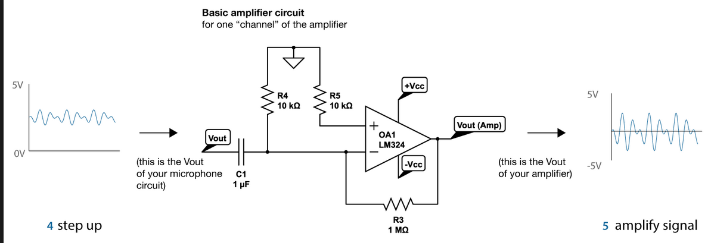
Resistors and capacitors are used to create low-pass and high pass filters to filter the amplified signal.

Inverting OP-AMPS Gain Non – Inverting OP-AMPS Gain
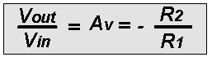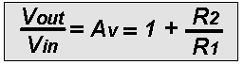

Procedure:
We will starts by building the circuit for this experiment in Multisim to create a simulation and then create the same circuit in the NI ELVIS II board using components to compare with the simulated circuit in Multisim.
Schematic of the Sub circuit for NIELVIS II
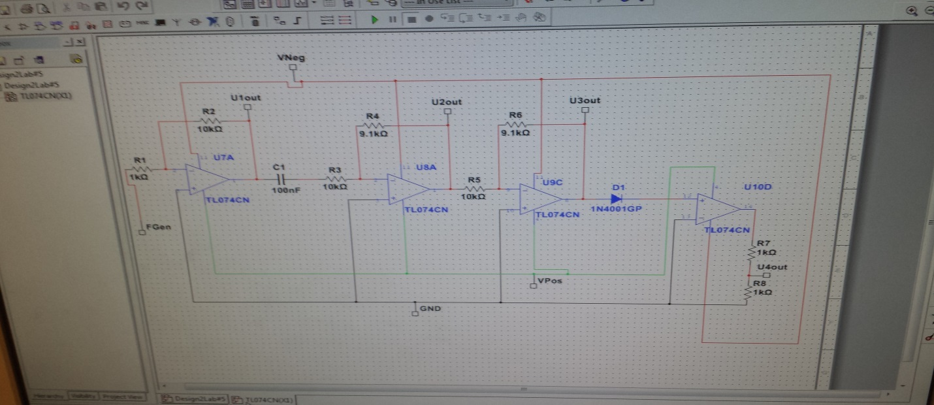
Schematic of Hearing Aid Circuit on NI ELVIS II
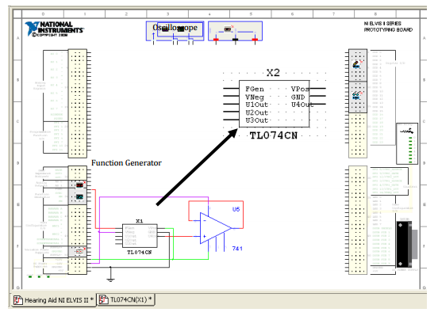
Analysis:
Simulation in Multisim:
We perform the simulation on Multisim and obtain the correspoding waveforms for the simulated circuit. Using an oscillatescope and multimeter from muiltisim.
Schematic of the Sub circuit for NIELVIS II connected with the hearing aid circuit
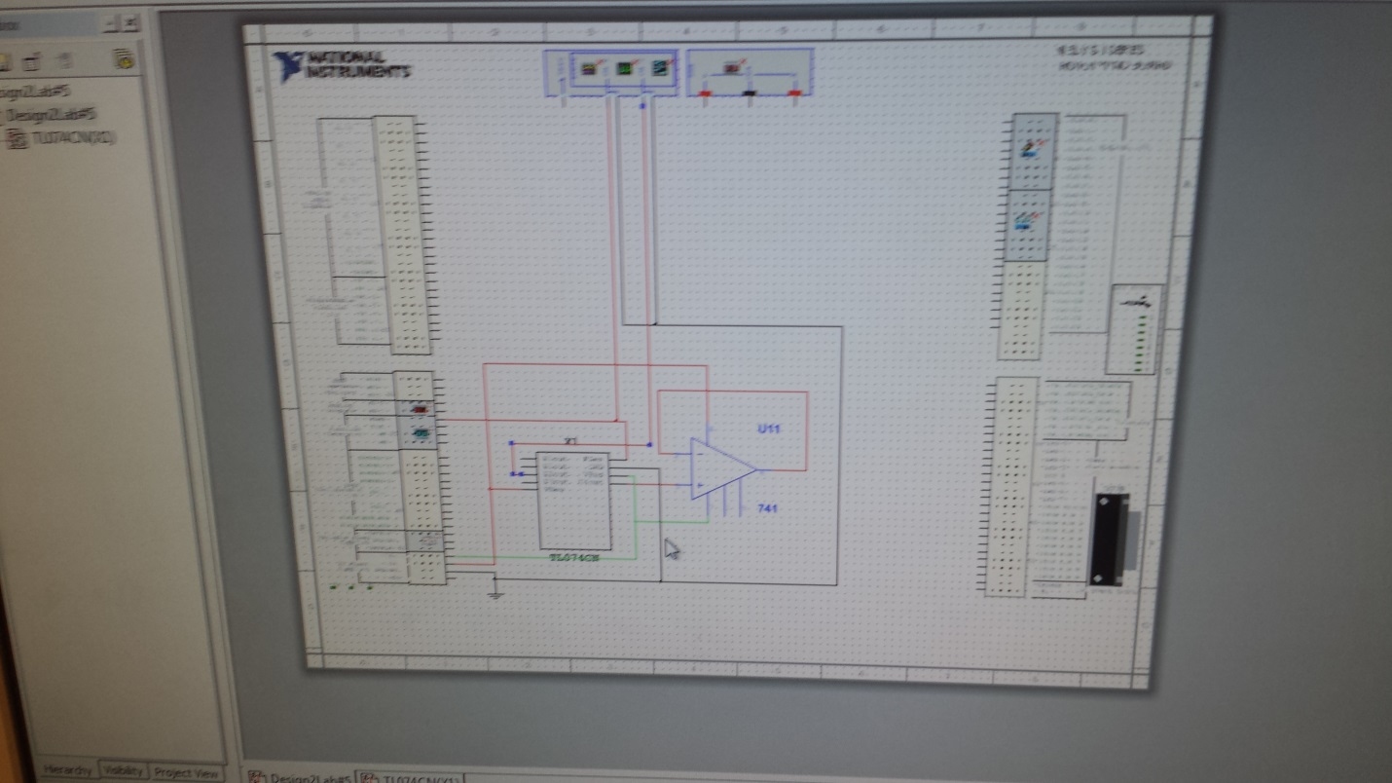
V1 Output
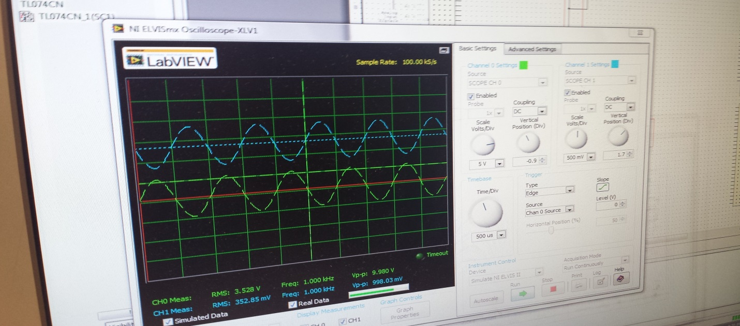
V2 Output
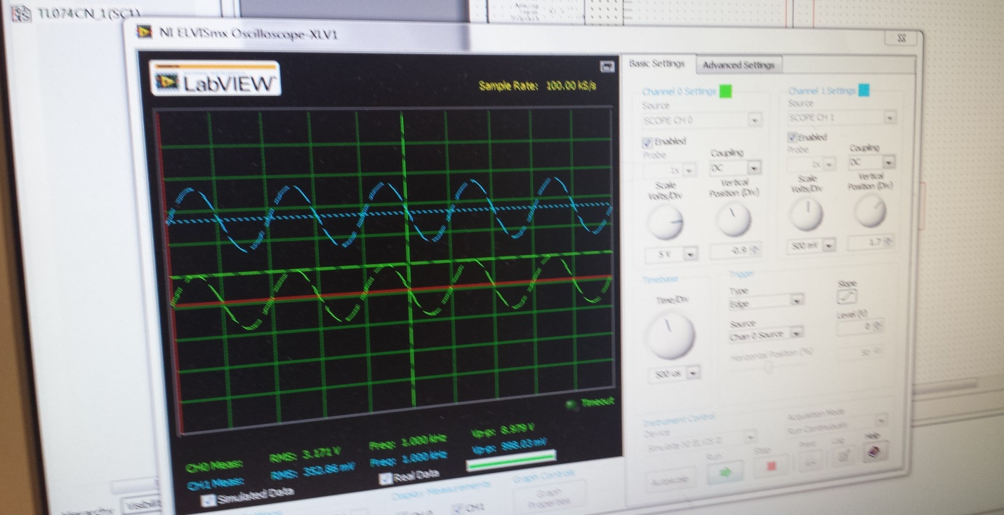

V3 Output
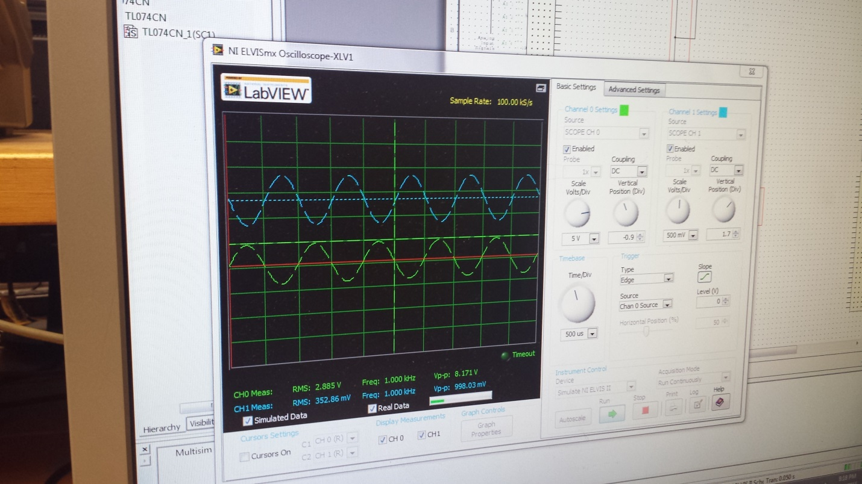

V4 Output
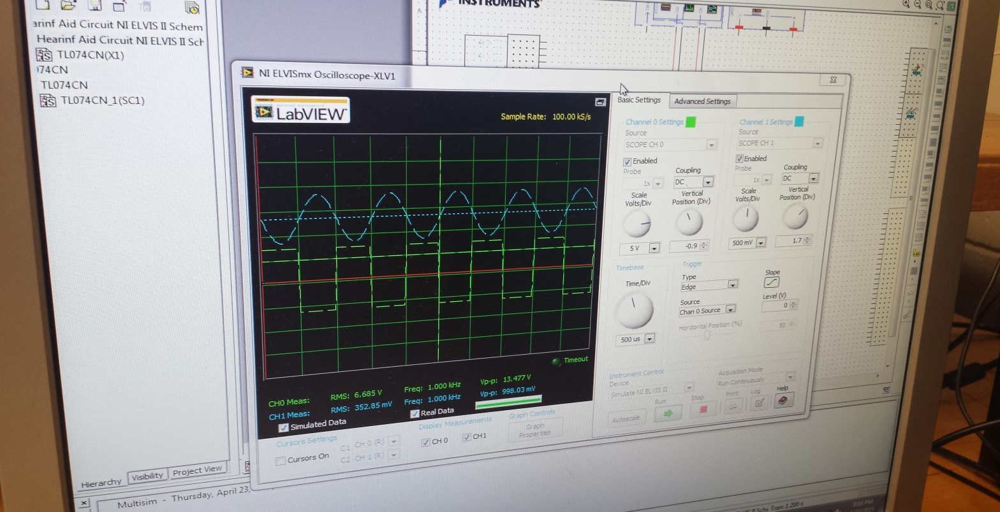
Multisim Simulated Data
Test Number | Frequency | U1 V_{p-p} | U3 V_{p-p} | U4 V_{p-p} | U5 V_{p-p}
1 | 200hz | 12.4V | 7.7V | 10.5V | 9.5V
2 | 500Hz | 12.45V | 8.092V | 11V | 11.2V
3 | 1KHz | 10V | 8.95V | 12.8V | 13.4V
4 | 5KHz | 12.47V | 9.862V | 13.5V | 13.5V
5 | 10KHz | 12.8V | 10.4V | 13.7V | 13V

Prototype on NI ELVIS II:
In this part of the Lab we built the hearing aid circuit on the NI ELVIS II board.
Building the hearing aid circuit on The NI ELVIS II
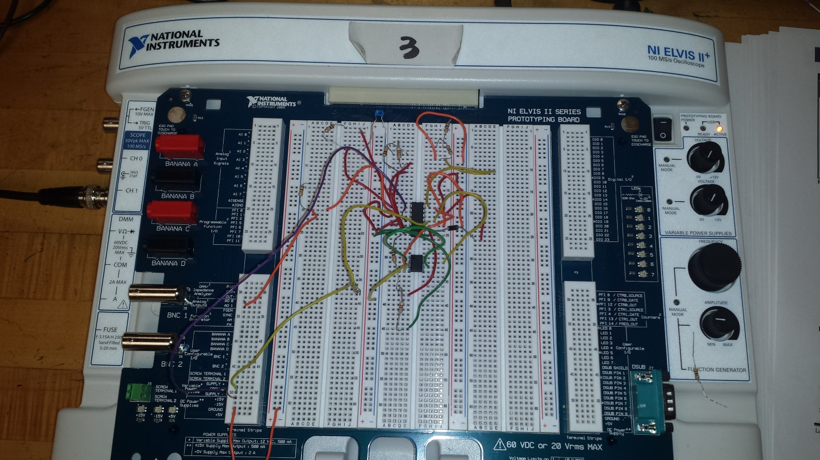
Here we built the hearing circuit on the NI ELVIS II and perform the measurement as we did in the simulated data using oscillatescope and multimeter from the national instrument launcher.
Prototyped Data
Test Number | Frequency | U1 V_{p-p} | U3 V_{p-p} | U4 V_{p-p} | U5 V_{p-p}
1 | 200hz | 1.592V | 0.95V | 1.3V | 1.4V
2 | 500Hz | 1.570V | 1.2V | 1.4V | 1.2V
3 | 1KHz | 1.55V | 1.3V | 1.478V | 1.3V
4 | 5KHz | 1.54V | 1.1V | 1.3V | 1.32V
5 | 10KHz | 1.53V | 1.3V | 1.35V | 1.36V

Conclusion:
This experiment was very interesting and important for us because it allowed us to applied previous knowledge of circuit analysis using OP-AMPS in real world applications. This circuit was very complicated to build, but we managed to get all the components together and make it functional for our purpose. Multisim and NI ELVIS II board are very useful tools to use for the creation of applications and prototype circuit. This was a very good experience for us because it will help us to be more skilled for the coming classes and projects in this carrier of electrical engineering.

References:

Laboratory Manual EET 3120 (Spring 2015) . by Prof. Viviana Vladutescu

