New York City College
of Technology
Department of Electrical and Telecommunications Engineering Technology
EET 3120-E260[35142]
Experiment #4
Wheatstone Bridge and Its Applications
Student | Professor.
David R. Perez Ramos | Viviana Vladutescu
Team members
Damian Robinson
Shawn Clarke

April 27, 2015

Contents
Introduction: 3
Theoretical Background 3-4
Procedure: 4
Analysis: 4-8
Conclusion: 9
References: 10

Introduction:
In this lab we will gain more experience on how to use the NI-ELVIS II workstation. The NI-ELVIS II has 12 integrated instruments installed on it such as Oscilloscope, digital multi-meter, function generator, dynamic signal analyzer. This Lab will be focus on building and troubleshooting a Wheatstone bridge using Multisim and the NI-ELVIS II.

Theoretical Background
The Wheatstone bridge is an electrical bridge circuit used to measure resistance. It consists of a common source of electrical current (such as a battery) and four resistors, three of which are known. The Wheatstone bridge is well suited for the measurement of small changes of resistance.
Wheatstone bridge schematic
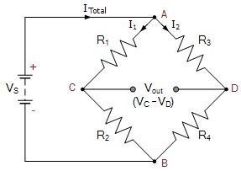
The method used to find when the Wheatstone bridge is balanced is by using the following formula:
$\frac{R1}{R3}+ \frac{R2}{Rx}$ = 1(balanced)
When Balance = R3 = R4; $\frac{R2}{R1+R2}=\frac{R4}{R3+R4}$
R2(R3+R4) = R4(R1+R2)
R2*R3+R2*R4 = R1*R4+R2*R4
R4 = $\frac{R2*R3}{R1}$ = R_{x}
The Wheatstone bridge can be used in many applications using sensors. For example, a ligth detector. We can connect a light-dependet resistor (LDR) to a wheatstone bridge to make a light sensitive switch that turns on when the light intesity being sensed goes higher or lower the pre-set value of VR1.
Example of a Light Detector circuit using a Wheatstone Bridge
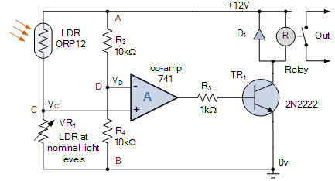
Components used in this lab:
- Multisim 11.0 and above
- NI ELVIS II
- 4 1 KΩ Resistors
- Electrodes (2per team member)
- 2 Alligator to Alligator clips
- Connector Wires

Procedure:
We will used Multisim to build a Wheatstone bridge a measure the components in the circuit. We will be using 4 resistors of 1 KΩ and we will replace a resistor with an arm to see how the measurements of the components change.
Analysis:
Simulation in Multisim:
Our first step was open Multisim and build the circuit on it.
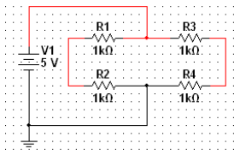
After finishing building the circuit, We used the NI ELVISmx Digital Multimeter within the Multisim software to measure the voltage across each resistor. We applied 5 V to our circuit and measured the voltage across the resistors.

Schematic of our Wheatstone bridge circuit
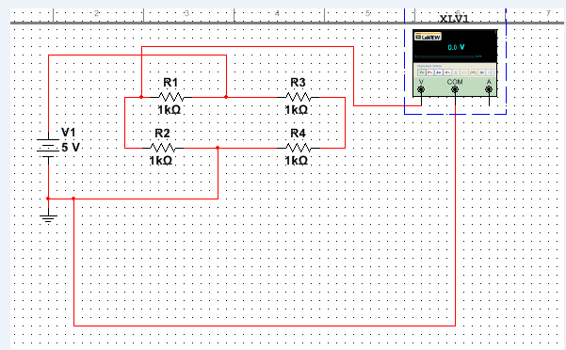

Voltage across R1 and ground
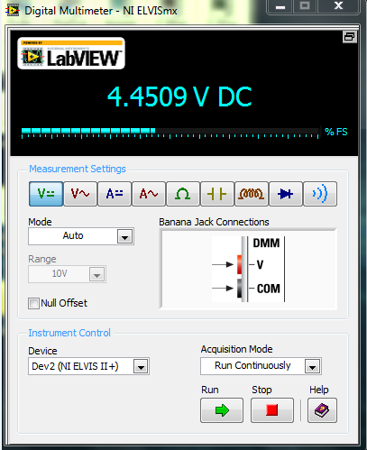
Voltage across R4 and ground
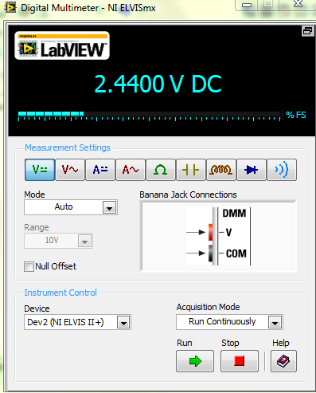
Voltage across R2 and R4
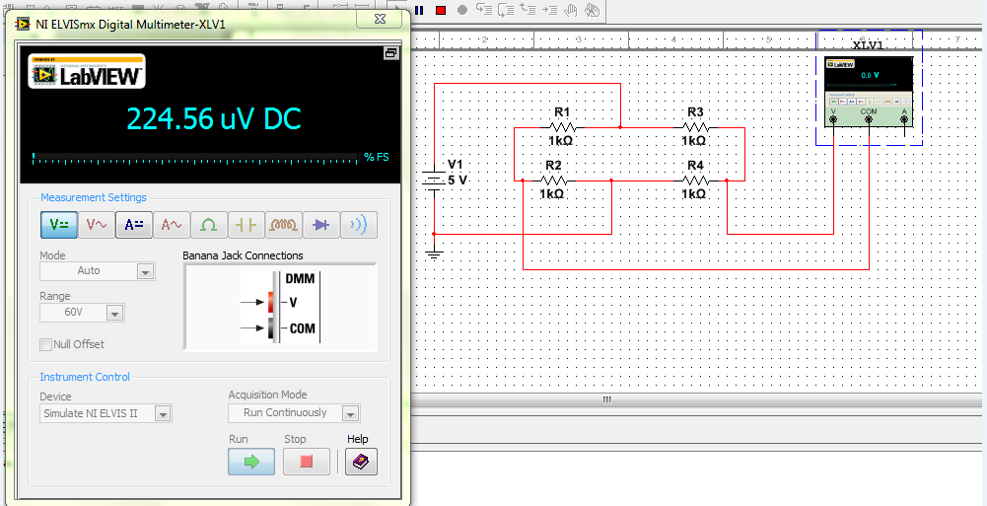
When we measured the voltage across R2 and R4 we obtained a very small amount of voltage almost approaching to zero. This means that the circuit is balanced. This happen because the output voltage of the first voltage divider is V_{b} R₃ / (R₁ + R₃) and the output voltage of the second voltage divider is V_{b} R₄ / (R₂ + R₄) are equal.

Prototype on NI ELVIS II:
In this part of the Lab we built the Wheatstone bridge circuit on the NI ELVIS II board.
Building the Wheatstone bridge circuit on The NI ELVIS II
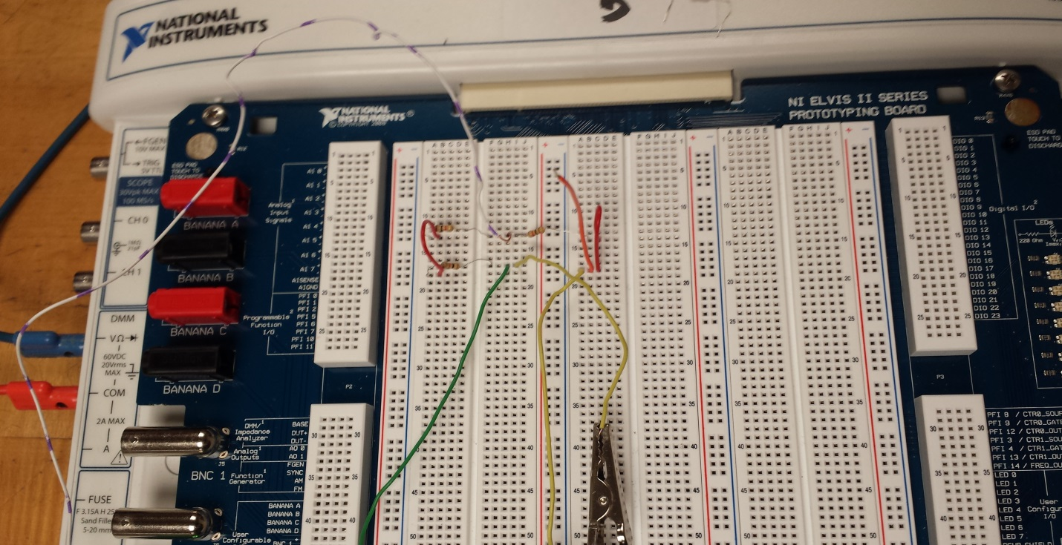
After the circuit was built, we opened the Instrument Launcher of the NI ELVIS II and opened the Digital Multimeter and measured the resistor values. Then we applied the same operation as we did in Multisim to measure the voltage across each resistor with an input voltage of 5V.
Measuring Resistance using DMM on NI ELVIS II
R1 Measured Value R2 Measured Value R3 Measured Value
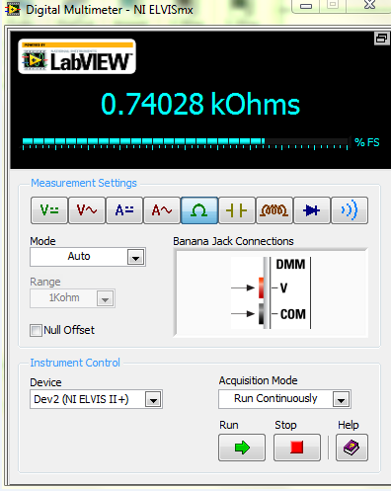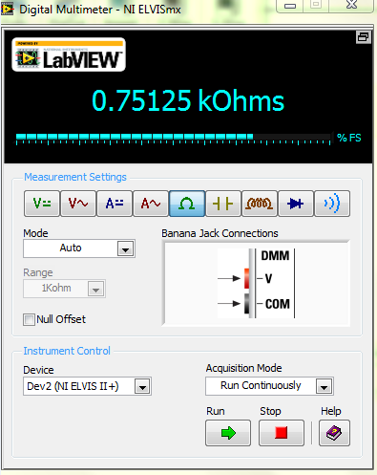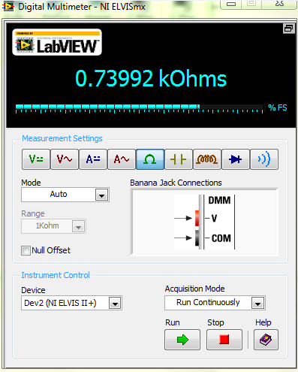
The Lab asked us to calculate R4 instead measured it and then compare it with its actual meaured value.
R4/R3 = R2/R1, R4 = (R3 *R2)/R1, R4 = (0.73992 KΩ*0.75124 KΩ) /0.74028 KΩ =
Calculated Value 0.750KΩ
Actual Value = 0.736 KΩ
After this, we removed R4 and connected one our team members’ arm as a resistor in the Wheatstone Bridge circuit built on the NI ELVIS II. We applied the same operation as before. We measured voltage and resistance across each resistor.
Using arm as a R4 in circuit
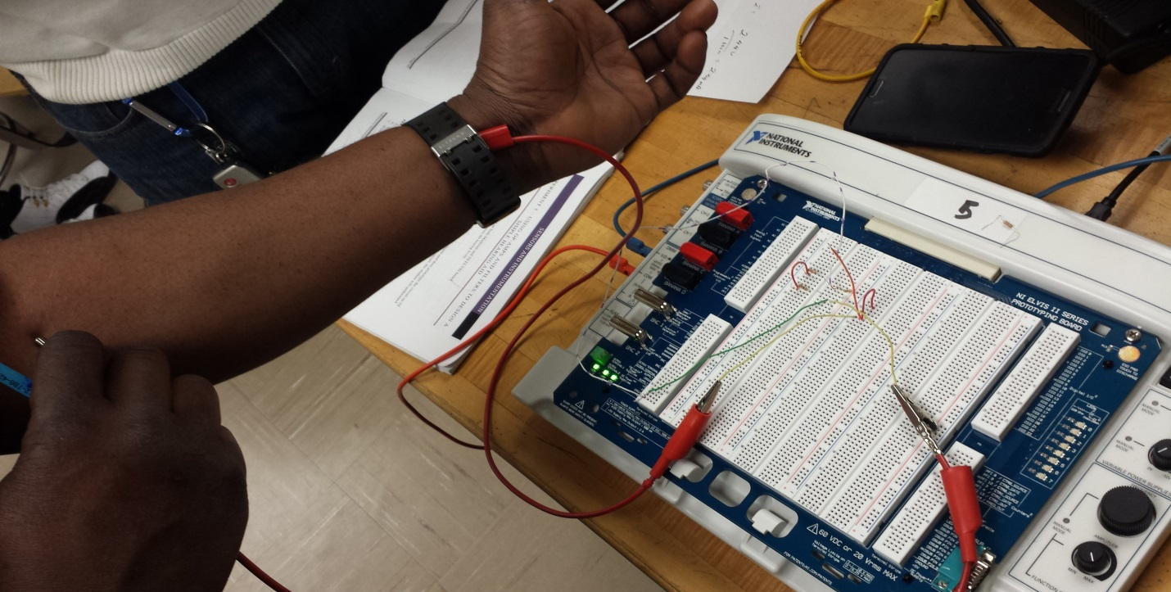

 | V across R1 and Ground | V across R1 and Ground | V across  R2 and R4 | R1 | R2 | R3 | Calculated R4 | R4 Actual
Circuit | 5V | 2.44V | 57.3mV | 0.74KΩ | 0.75KΩ | 0.73KΩ | 0.750 KΩ | 0.73 KΩ
Arm | 4.4V | 4.53V | 2.4V | 0.73KΩ | 0.76KΩ | 0.74KΩ | 3.1 MΩ | 8.2 MΩ

Conclusion:
In this Lab we learned the purpose of the Wheatstone bridge. It is used to measure the value of unknown resistor by comparison to standard resistors and to sense small changes in a resistance transducer. By building this circuit, we gained more experience using the NI ELVIS II and the Miltisim software. This prepares us to be more skilled for future experiments.

References:

Laboratory Manual EET 3120 (Spring 2015) . by Prof. Viviana Vladutescu
"Light Sensor including Photocell and LDR Sensor." Basic Electronics Tutorials. N.p., 15 Aug. 2013. Web. 27 Apr. 2015.

