- Describe the actual sensor in each of the following systems and the basic physical principle or law upon which each works: (a) a tire pressure gage, (b) a toaster, (c) a car mph indicator, (d) a television remote control, and (e) a battery-life indicator on a digital camera.

- A tire pressure gage: Uses a pressure sensor which measure pressure. Could be gases or liquids. It generates a signal as a function of the pressure imposed and such a signal could be electrical. An example of this is a pressure sensor. The way these sensors sense pressure now a days is by measuring the strain produced in an elastic member by the unknown force. Another way these sensors sense pressure is by converting the force to a fluid pressure and measuring that pressure.

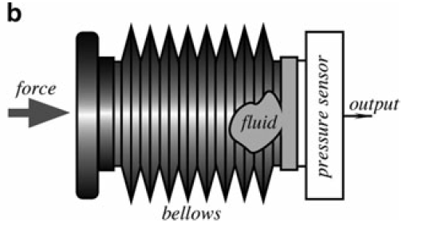
Here is an example of a pressure sensor and how it works. The pressure sensor is combined with a fluid-filled bellows, which is subjected to force. The fluid-filled bellows functions as a force-to-pressure converter by distributing a localized force at its input over the sensing membrane of a pressure sensor.

- Toaster: A toaster frequently uses thermal sensors such as bimetallic strip. Which is use to convert a temperature change into mechanical displacement. Example, bimetallic coil from a thermometer reacts to the heat from a lighter, by uncoiling and then coiling back up when the lighter is removed.

- A car mph indicator: Now a day, a car mph indicator uses electric sensor such as magnetic field sensor. The way this sensor works is it delivers a series of electronic pulses whose frequency corresponds to the (average) rotational speed of the driveshaft, and therefore the vehicle's speed, assuming the wheels have full traction.

- Television remote control: A TV remote uses an infrared sensor. The infrared light is transformed into an electric current, and this is detected by a voltage or amperage detector.
- Battery-life indicator on a digital camera: It is uses electric sensor such as voltages or current sensors. It measures the current or voltage of the battery and compares it to what the batter should put out at full charge.

- An electrostatic particle levitator operates on the principle of balancing the electrostatic force, qE , on a particle with its gravitational force, mg .A new, smaller levitator is proposed with both the levitator and particle scaled down geometrically. Assuming the same charge on the particle, determine by using scaling arguments whether or not the smaller levitator will operate the same as the original one.

Electrostatic force = L^{2;} Magnetic force =L⁴; L will reduce by 100
This will be equal to = Electrostatic force 10⁴; Electromagnetic force 10⁸

- An archaeologist discovers an ancient length-scale bar on which its smallest divisional marks are precisely 10 cm apart. His colleague argues that the civilization that used the bar could measure lengths to accuracy as small as 0.1 cm by carefully reading in between the precise 10-cmmarks. Is the colleague correct?

Ancient length- scale will be 10 cm; this means that it can be measure only as insignificant as 1 cm.

