Dulce Morataya

18 Chapter 10: Information (reset, back-up, safety, support site)
- 18. Restart, Reset, and Back-up

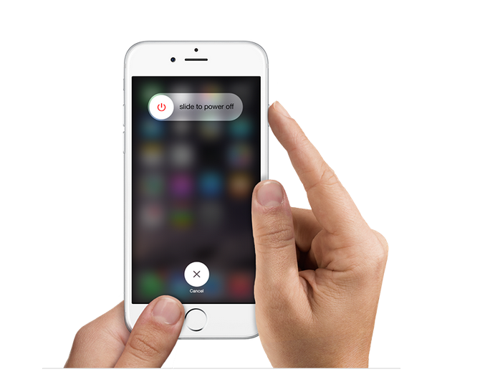

This image is taken from Apple’s support site; it will be useful in allowing me to show in the manual how a user can restart his or her iPhone when need be to do so.

IPhone Support. (n.d.). Retrieved November, 2015, from https://www.apple.com/support/iphone/
18 Chapter 10: Information (reset, back-up, safety, support site)
- 18. Restart, Reset, and Back-up

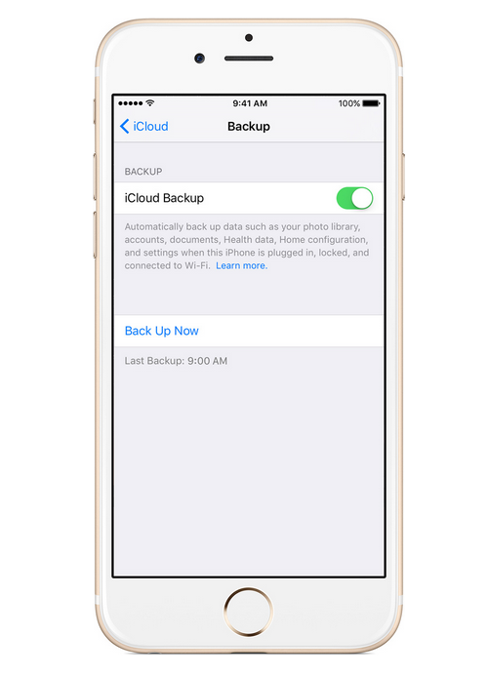

This image is also taken from Apple’s support site; it will be useful in allowing me to show in the manual how a user can back-up his or her iPhone in the case that data was lost.

IPhone Support. (n.d.). Retrieved November, 2015, from https://www.apple.com/support/iphone/

